**CN LAB EXAMINATION REPORT**

**Aim:**

To create and configure a suitable network topology for both LAN and WAN using Cisco Packet Tracer, involving 10-15 computers, switches, and routers. The goal is to simulate the transmission of a message from a computer in one network to a computer in another network, ensuring proper connectivity and communication across different network segments.

**Procedure:**

1. Topology Design:

LAN Configuration:

1. Design a network topology featuring at least 10 computers connected via switches. Ensure proper switch connectivity within the LAN segment.
2. Implement WAN configuration to connect the LAN network to another network using routers. This involves expanding the network to enable communication between different LANs.

2. Network Setup in Cisco Packet Tracer:

Add Devices:

1. Place and connect 10-15 computers within the LAN segment.
2. Add a minimum of 2 switches to connect the computers.
3. Include at least 2 routers to facilitate WAN connectivity.

Configure IP Addresses:

1. Assign unique IP addresses to each computer in the LAN segment, ensuring they are within the same subnet.
2. Configure router interfaces with appropriate IP addresses to enable routing between the LAN and WAN segments.
3. Set up routing protocols or static routes as necessary to ensure smooth communication between different LANs through the WAN.

3. Configuration Steps:

LAN Configuration:

1. Connect the computers to the switches using network cables.
2. Configure unique IP addresses on each computer within the same subnet.
3. Connect the switches to each other to enable network expansion and communication within the LAN.

WAN Configuration:

1. Connect the routers to each other to establish the WAN connection.
2. Configure the router interfaces with IP addresses that support communication across the WAN.
3. Set up routing, either static or dynamic, to ensure that traffic can be routed between different LAN segments.

4. Simulation:

Send a Message:

1. Use Cisco Packet Tracer's simulation mode to monitor and test network activity.
2. Configure and send a message from a computer in one network (e.g., LAN1) to a computer in another network (e.g., LAN2).
3. Capture and verify the message transmission to ensure successful delivery from one network to the other.

Message Transmission:

* A message was successfully sent from a computer in LAN1 to a computer in LAN2.
* The simulation mode in Cisco Packet Tracer confirmed that the message was routed correctly through the WAN and received at the destination computer.

The network topology, IP configuration, routing setup, and message transmission were all verified to be functioning as expected, demonstrating successful inter-network communication.

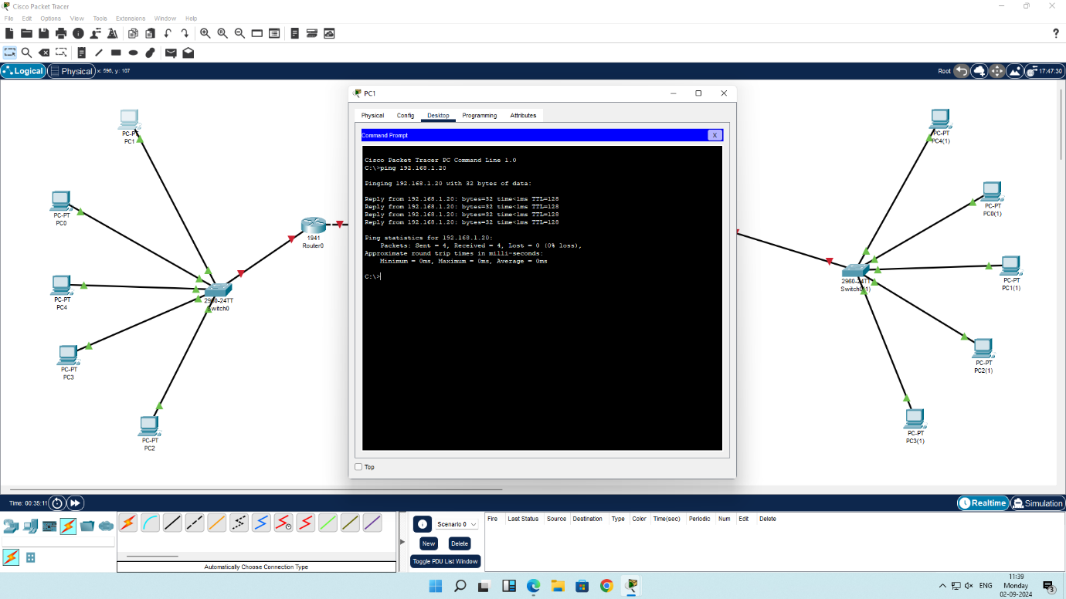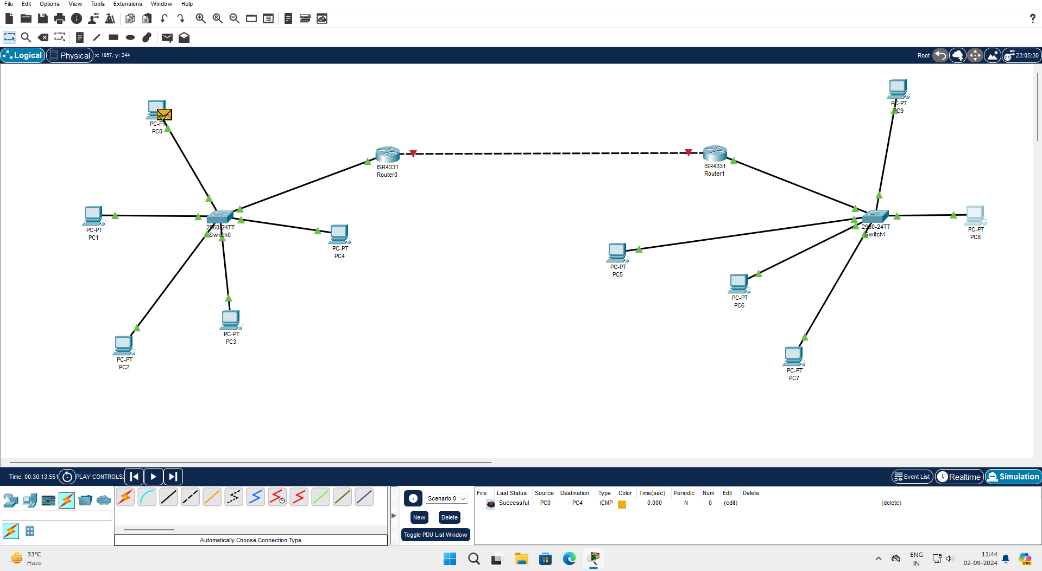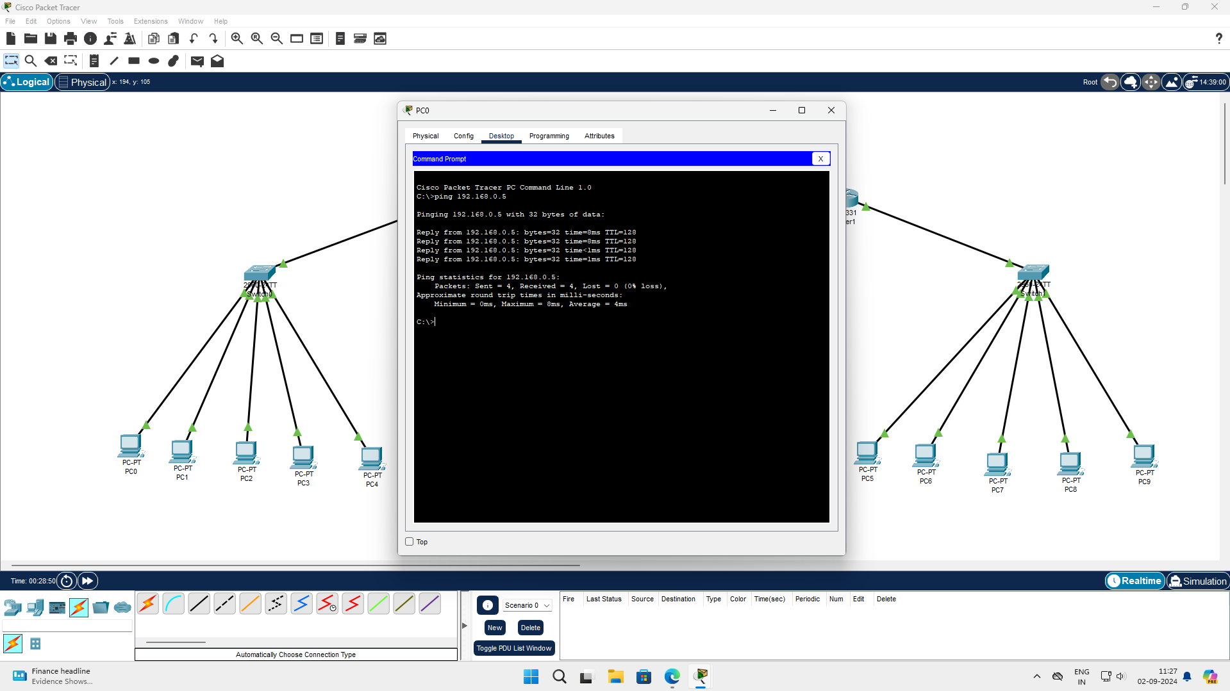

GITHUB :- <https://github.com/kamalavarshini2004/RA2211026050039>

Kamalavarshini R

RA2211026050039

AIML - B