Tribhuvan University
Institute of Science and Technology



A Final Year Project Proposal
On
“Inventra – Inventory Management System”

Submitted To:
Dev Timilsina
Lecturer
Department of Computer Science and Information Technology
Prithivi Narayan Campus
Bhimkalipatan-1, Pokhara

In partial fulfillment of the requirements for the Degree of Bachelor of Science in Computer Science and Information Technology

Submitted By:
Ashok Manandhar [79011869]
Kamal Bhandari [79011884]
Nirmal Poudel [79011894]

February 17, 2025

Supervisor Recommendation
I hereby recommend that this project be prepared under my supervision entitled “Inventra – INVENTORY MANAGEMENT SYSTEM” in partial fulfillment of the requirements for the degree of B.Sc. in Computer Science and Information Technology be processed for the evaluation.

................................................

Dev Timilsina
Lecturer
Prithvi Narayan Campus

Certificate of Approval
This is to certify that this project is prepared by AASHISH PAUDEL, PRAKRITI TIMILSINA and SAGAR TIMILSINA entitled “Inventra – INVENTORY MANAGEMENT SYSTEM” in partial fulfillment of the requirement for the degree of B.Sc. in Computer Science and Information Technology has been well studied. In our opinion it is satisfactory in scope and quality as a project for the required degree.
........................................  Dev Timilsina  Supervisor  Prithvi Narayan Campus | ....................................  Prof. Dr. Hari Prasad Pathak  Campus Chief  Prithvi Narayan Campus
...........................................  External Examiner  IOST, Tribhuvan University | .........................................  Internal Examiner  Prithvi Narayan Campus
.........................................
Chudamani Subedi
B.Sc. CSIT Program Coordinator
Prithvi Narayan Campus

Acknowledgement
The success and outcome of this project required a lot of guidance and assistance from many people, and we feel extremely fortunate to have got all this all along the completion of our final year project. Whatever we have done is only due to such guidance and assistance and we would not forget to thank them. We could not have completed this project without help from our college “Prithvi Narayan Campus” which gave the supportive hands before us academically, also regarding other activities related to Information Communication Technology as well as extra curriculum activities that we got to participate in. It gave us family like environment.
We take this opportunity to express our profound gratitude and deep regards to supervisor Mr. Dev Timilsina for his exemplary guidance, monitoring, and constant encouragement throughout the course of this thesis.
We would also like to appreciate the help of various people providing us with essential data required for our project as well as their time in guiding us to how our project will be more effective in users prospective. We are also grateful to our teachers for their constant support and guidance.
Finally, we would like to express our sincere thanks to all the friends and others who helped us directly or indirectly during this project work. This project was wonderful experience where we have learnt and experienced many beneficial things.

Abstract Page
This project has been submitted to the fulfillment of the requirements for the Bachelor of Science in Computer Science and Information Technology. We, the team members of this project, take pleasure in presenting the detailed project report that will reflect our efforts this semester. Inventra - Inventary Management System aims to address the inefficiencies in traditional record keeping methods as many existing systems face challenges such as stock inconsistencies, unauthorized access, and limited transparency. It provides a centralized, user-friendly platform where individuals can find and manage accurate stock control, billings and efficient daily operations in a Department Store. The system supports stock-in and stock-out operations, sales and purchase recording, and real-time inventory tracking, while higher-level roles manage approvals, reporting, and audit monitoring to prevent misuse. Developed using modern web technologies with a secure database backend, the system includes modules for product management, inventory tracking, automated report generation, audit logging, and role-specific dashboards. In addition, a recommendation system analyzes sales and inventory data to suggest frequently purchased and high-demand products, supporting data-driven procurement and stocking decisions.
Keywords: Inventory Management System, Role-Based Access Control, Stock Management, Sales Tracking, Audit Logs, Recommendation System, Report Generation.

Introduction

Background of the Study
In Nepal, small and medium-sized enterprises (SMEs) form a significant part of the national economy and play a vital role in trade, retail, manufacturing, and service sectors. Despite their importance, many Nepali businesses continue to manage inventory using manual record-keeping methods or basic spreadsheet-based systems. These practices often lack real-time visibility, structured access control, and systematic reporting, resulting in stock inconsistencies, delayed decision-making, and operational inefficiencies [1]. Factors such as limited technological infrastructure, cost constraints, and lack of technical expertise further hinder the adoption of advanced inventory management solutions in the Nepalese context [2].
As per the view of Dr. G. R. Agrawal, one of the management experts of Nepal, “Inventory management is an integral part of financial management. It is inventory maintaining at desired level. Inventory should be effectively managed. The real task of top management is to minimize investment in inventory for the attainment of desired objectives” [3]. This perspective emphasizes the importance of maintaining optimal inventory levels and highlights the role of management in balancing operational efficiency and financial control.
An Inventory Management System (IMS) is an integrated software solution designed to track, organize, and manage inventory throughout the supply chain. According to Speed Commerce, an IMS provides real-time visibility into stock levels and enables businesses to make informed decisions regarding restocking, order fulfillment, and overall inventory control, thereby minimizing costs and maximizing profitability [4].
With the growth of digital platforms and technology-driven business models in Nepal, inventory operations have become more complex, involving multiple users, frequent stock movements, and increased accountability requirements. However, many existing systems used locally do not sufficiently support role-based access control, payment split or analytical reporting, which are crucial for ensuring transparency and preventing unauthorized actions.
Additionally, the lack of intelligent features such as automated report generation and demand-based product recommendation systems limits the ability of businesses to make data-driven procurement decisions. These challenges highlight the need for a secure, affordable, and Nepal-focused inventory system, forming the basis of the “INVENTRA” system.

Problem Statement
In Nepal, many small and medium-sized enterprises (SMEs) continue to manage inventory using manual records or basic spreadsheet-based systems. These approaches lack real-time stock visibility, structured access control, and reliable reporting, resulting in stock inconsistencies, operational delays, and increased risk of errors and unauthorized actions as businesses grow.
Although several inventory management systems are available in the market, most of them are designed for large-scale, private enterprises and are often expensive to implement and maintain. Such systems are not affordable or practical for small and medium-sized businesses in Nepal. Additionally, many existing solutions do not provide adequate role-based access control, audit tracking, automated report generation, or intelligent features such as product recommendation support, limiting their effectiveness for informed decision-making.
The major challenges faced by businesses include:
- Reliance on manual or spreadsheet-based inventory tracking
- Limited real-time visibility and data accuracy
- High cost and complexity of existing inventory systems
- Lack of role-based access control and audit trails
- Absence of analytical reporting and recommendation features.
To overcome these challenges, the proposed INVENTRA, An Inventory Management System aims to deliver a secure, affordable, and user-friendly solution tailored to the operational and financial realities of Nepalese enterprises. The system focuses on improving inventory accuracy, enhancing transparency, and supporting data-driven decision-making.

Objectives
The main objectives of the proposed system are as follow:
- To develop a centralized inventory management system
- To implement barcode-based product identification and billing
- To manage stock across multiple branches efficiently
- To track suppliers, purchases, and product expiry
- To generate accurate reports for decision-making
- To ensure data security and role-based access control

Scope
The scope of the Inventory Management System covers the design and implementation of a web-based solution that supports core inventory operations for small and medium-sized enterprises. The system focuses on simplifying product handling, improving stock visibility, and enabling secure access, reporting, and future scalability while remaining affordable and easy to use.
i. Core Functional Scope
- Product Management: Allows users to add, edit, view, and delete product details such as product name, description, category, unit price, and available stock quantity.
- Low Stock and Expiry Alerts: Provides visual indicators and notifications when stock levels fall below predefined minimum thresholds and when the product expires.
- Search and Filter Functionality: Enables quick searching of products by name or category and filtering of inventory lists to locate items efficiently.
- Dashboard Overview: Displays key inventory metrics, including total products, low-stock items, total inventory value, and recent transactions in a single view.
ii. System Access and Reporting
- User Authentication: Secures system access through a basic authentication mechanism using username and password.
- Inventory Reporting: Generates reports on current stock levels, product lists, and stock movement history, with options to export reports in PDF or Excel formats.
iii. Usability and Accessibility
- Responsive Web Interface: Ensures accessibility across desktops, tablets, and mobile devices through a user-friendly and responsive web interface.
- Sales and Order Fulfillment: Tracks sales order, manages order status, and automatically updates inventory levels after sales transactions.
iv. Future Enhancement Scope
- System Extendibility: Designed to support future features such as mobile applications, API integration with ERP or accounting systems, and AI-based demand forecasting.

Background Study and Literature Review

Background Study
Inventory management is a core function in the supply chain that determines how stock levels are controlled to meet customer demand while minimizing costs. Traditional methods, such as manual record-keeping and spreadsheets, are often error-prone, inefficient, and lack real-time visibility, leading to challenges such as stockouts, excess inventory, and poor decision-making. Most of the current Inventory Management Systems provided in the market rely on employees to record and track products using web-based inventory management applications. These web applications are developed as many researchers and practitioners have faced similar problems with clients whose inventories were managed manually, resulting in time-consuming and inefficient work processes. Research shows that modern inventory management systems, especially cloud-based and ERP-oriented platforms, improve accuracy, operational effectiveness, and scalability by integrating inventory with sales, purchasing, and reporting functions [1], [2]. Studies also explore the use of advanced technologies such as QR/barcode scanning, expiry and low-stock alert systems, and data analytics to further enhance system capabilities and responsiveness to dynamic demand patterns [5].

Review of Existing system
Several inventory management systems have been developed both within Nepal and internationally, each providing insights into effective inventory control practices. Local systems such as Tigg and Delta Inventory are widely used by Nepali SMEs due to their cloud-based platforms, real-time stock tracking, automated reporting, and integration with sales and accounting modules [6], [7]. These systems help small businesses overcome challenges related to limited infrastructure and manual inventory management.
On the international front, platforms like Sortly, Square, and Zoho Inventory provide advanced functionalities, including multi-location management, batch and serial number tracking, mobile accessibility, and predictive analytics [8], [9]. These systems demonstrate how automation, integration, and data-driven decision-making improve inventory accuracy and operational efficiency across diverse industries.

Despite the availability of these solutions, both domestic and international systems often lack context-specific customization, affordability, or flexibility for Nepali SMEs with diverse product types and workflows. This gap underscores the need for INVENTRA, a context-aware inventory management system designed specifically for Nepalese businesses. INVENTRA combines real-time tracking, automated reporting, ERP-style integration, and scalable workflows, drawing from the strengths of both local and international systems while addressing the specific operational requirements of Nepali enterprises.

Comparison to the Proposed System
While existing systems provide essential inventory functionalities, there remains a gap in solutions that are both tailored for Nepali business needs and built on academic best practices. INVENTRA aims to bridge this by combining real-time inventory tracking, automated reporting, ERP-style integration, and customizable workflows tailored to local SME requirements. Unlike many current systems that focus on generic inventory control, INVENTRA emphasizes adaptability, scalability, and enhanced decision-support mechanisms informed by literature on efficient inventory systems. Consequently, the proposed system seeks to improve on key limitations identified in similar projects and align inventory management practices with both local business contexts and global best practices.

Methodology

Requirement Analysis
The Inventory Management System is designed to address the operational and tracking needs of small businesses while ensuring accurate stock management and secure access for all users.

Functional Requirements
The Inventory Management System is designed to support key inventory and business operations efficiently. The core functions focus on secure access, accurate stock tracking, and easy monitoring for all users. By combining real-time updates with automated alert features, the system ensures accountability and transparency in daily inventory activities. Some of the functional features include:
- Growing Businesses Ready to Go Digital - To eliminate manual record-keeping errors, save 60-70% time on inventory tasks, and build a foundation for future business expansion.
- Product and category management - To allow adding, editing, and organizing products with details like name, description, price, and stock quantity.
- Stock-in and stock-out recording - To track inventory movements with automatic quantity updates and complete transaction history for audit purposes.
- Low stock alerts and notifications - To ensure critical stock levels trigger automatic alerts, preventing stockouts and enabling timely reordering.
- Dashboard and reporting - To provide real-time visibility of key metrics including inventory value, low stock items, and recent transactions with PDF/Excel export capabilities.

Non-Functional Requirements
In addition to functional features, the INVENTRA Inventory Management System emphasizes quality attributes that ensure the system is reliable, secure, and user-friendly. These non-functional requirements focus on providing a seamless experience for all users while safeguarding sensitive business and inventory data. High performance, consistent reliability, and strong data security measures are key aspects that make the system practical and trustworthy for small businesses.

Key non-functional features include:
- Usability - Intuitive interfaces designed for admins, managers, and warehouse staff requiring minimal training.
- Security - Protection of sensitive inventory and business data against unauthorized access through encryption and role-based controls.
- Performance - Fast page loads under 2 seconds and responsive operation even with growing inventory volumes.
- Reliability - Consistent, accurate inventory tracking and real-time stock updates without data loss.
- Data privacy - Compliance with data protection standards to safeguard business information and transaction records.

Feasibility Analysis
To further justify the practicality of the proposed INVENTRA Inventory Management System, additional explanations for each feasibility aspect are provided below.

Technical Feasibility
The proposed system is technically feasible using modern, open-source, and widely supported technologies.
- Frontend & Backend - Next.js (React framework with App Router) provides excellent performance, server-side rendering, and API routes for seamless inventory operations.
- Styling - Tailwind CSS ensures fast, responsive, and modern UI development that works across desktop, tablet, and mobile devices.
- Authentication - NextAuth.js with JWT offers secure and simple role-based access control for different user types.
- Database - PostgreSQL is robust, open-source, and works perfectly with Prisma ORM for type-safe database operations including product records, transactions, and user data.
- Real-time Updates - React state management and API polling ensure inventory levels update instantly across all connected devices.
- Report Generation - PDF and Excel export capabilities using standard libraries for generating inventory reports and transaction histories.
All required technologies are mature, free to use, and well-documented, with large community support. No advanced hardware or proprietary software is needed.

Operational Feasibility
The system is operationally feasible and aligns with real-world business workflows.
- Ease of Use - The interface is designed to be intuitive, allowing warehouse staff and managers to perform daily tasks with minimal training.
- Workflow Integration - The system fits naturally into existing inventory processes, from receiving stock to fulfilling orders.
- Minimal Disruption - Businesses can transition gradually from spreadsheets to the digital system without halting operations.
- Staff Acceptance - The user-friendly design and time-saving automation encourage positive adoption by staff members.
The system addresses actual pain points faced by small businesses, making it highly practical for real-world implementation.

Economical Feasibility
The project is economically viable with minimal financial investment required.
- Low Development Cost - Using open-source technologies (Next.js, PostgreSQL) eliminates licensing fees.
- Affordable Hosting - Cloud platforms like Vercel offer free hosting for small applications, or paid plans starting at $5-10/month.
- No Hardware Investment - Web-based access means no need for expensive servers or infrastructure.
- Quick ROI - Expected return on investment within 3-6 months through labor savings, reduced stockouts, and optimized inventory levels.
- Long-term Savings - Projected 15-25% annual reduction in inventory management costs through improved efficiency.

Schedule Feasibility
The project will follow an Agile development methodology, allowing the frontend and backend to be developed in parallel. This approach promotes flexibility, continuous improvement, and regular feedback throughout the development process. The proposed schedule has been carefully designed to be realistic and manageable for a team of three final-year students, ensuring that all project milestones can be completed successfully within the academic timeline.
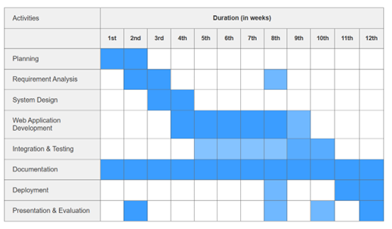
Figure 3.1:Gantt Chart for the Inventory Management system

System Design
The Inventory Management System follows a modern, full-stack web application architecture designed for simplicity, security, performance, and ease of maintenance. It is built as a single-page application (SPA) with server-side capabilities, making it responsive, fast, and suitable for resource-constrained environments like small businesses in Nepal.
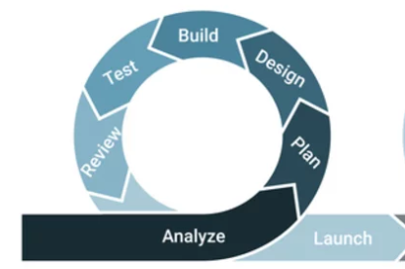
Figure 3.2: Agile Methodology

Development Methodology
The project follows the Agile development methodology with the Scrum framework to build the Inventory Management System in a flexible, collaborative, and efficient manner. Agile is chosen because it allows the team to adapt to changing requirements easily, detect problems early, deliver working features quickly, and work closely together as a small group of three students. This approach suits the academic timeline and helps us create a high-quality system step by step while ensuring continuous stakeholder feedback.
We work in 1-week sprints, where each sprint has a clear goal and delivers a usable part of the system. For example, early sprints focus on user authentication, product management, and database setup, while later sprints add stock tracking, automated alerts, reporting features, and final testing. At the start of each sprint, we plan tasks and decide what to complete. After every sprint, we review the completed work, demonstrate it to the supervisor or peers, and hold a short retrospective to discuss what went well and what we can improve next time.
Every day, the team holds a quick stand-up meeting (10-15 minutes) to share progress, plans, and any difficulties. This keeps everyone on the same page and helps solve issues fast. We use Git (GitHub) for version control each feature is developed in its own branch, reviewed through pull requests, and merged only after checking. Continuous integration ensures that every change is tested quickly and integrated smoothly into the main system. some of key practices we follow:
- 1-week sprints with clear, achievable goals
- Daily stand-up meetings for quick progress updates
- Continuous testing and integration after every change
- Sprint reviews to demonstrate progress and gather feedback
- Retrospectives to reflect and improve our development process
- GitHub for code sharing, branching, and team collaboration

Use Case Diagram
A Use Case is a detailed description of how a user (called an actor) interacts with a system to achieve a specific goal. It outlines the steps involved in each interaction, helping to understand system functionality from the user's perspective.
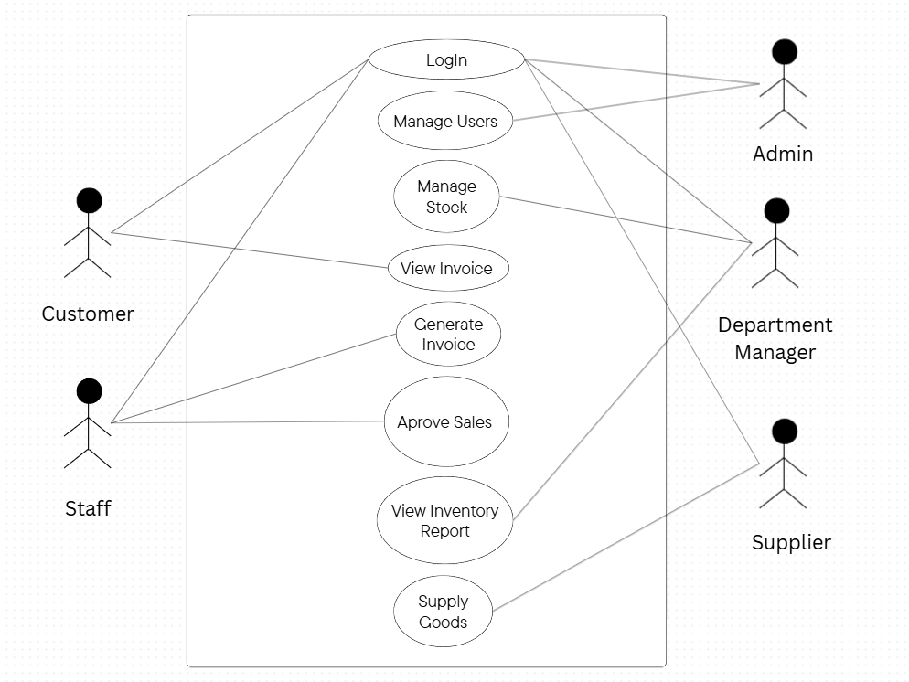
Figure 3.2: Use Case Diagram of the Inventory Management system
In an Inventory Management System, a use case helps map out how different users like admin, store manager, staff, customer, and supplier perform tasks like managing products, tracking stock movements, generating reports, creating purchase orders, and monitoring inventory levels. It visually shows who does what, when, and how, makes the workflow easier to understand and design.

Expected Outcome
INVENTRA, An Inventory Management system is expected to deliver several key outcomes that will make inventory management more efficient, accurate, and data driven. A centralized dashboard will provide real-time insights into stock levels, low stock alerts, inventory valuation, and recent transactions, enabling better decision-making. The system will streamline inventory operations by automating stock-in and stock-out recording with instant quantity updates and complete transaction history. Real-time inventory tracking ensures accurate stock visibility, reducing stockouts, and overstocking situations while improving coordination between warehouse, purchasing, and management teams. Role-based access will help manage user permissions and responsibilities effectively across admin, manager, and warehouse staff roles. Automated report generation and analytics will minimize manual effort and provide insights into inventory turnover, supplier performance, and product trends. Built-in alerting system will notify users when stock reaches critical levels, ensuring timely reordering. The system will feature a responsive, modern UI for seamless use across devices including desktops, tablets, and smartphones, and will be built on a scalable architecture to support future growth, including multiple warehouse locations and advanced features like barcode scanning or mobile applications.
In summary, INVENTRA is designed to enhance inventory efficiency, reduce operational errors, optimize stock levels, and support long-term scalability for businesses seeking modern, reliable inventory management solutions.

References

[1] | U. Natesan, "Cloud based Inventory Management System," International Journal of Advanced Research in Computer and Communication Engineering (IJARCCE), vol. 12, no. 3, pp. 45–50, 2023, doi:, 2007.
[2] | S. Tulli, "Development of Integrated Inventory Management Models for Manufacturing Companies," International Journal of Emerging Trends in Science and Technology EP - 38, vol. 8, p. 15–38, 2021.
[3] | G. Agarwal, Fundamentals of Financial Management, kathmandu: M.K. Publishers, 1980.
[4] | S. Commerce, "Speed Commerce Official Website," Speed Commerce, 2023. [Online]. Available: https://www.speedcommerce.com. [Accessed 1 feb 2026].
[5] | A. Desai, "Enhancing inventory management with progressive,arXiv," Online, 2025.
[6] | Tigg App, "Tigg official page," Inventory Management software for starups and small scaled business, [Online]. Available: https://me.tiggapp.com. [Accessed feb 2026].
[7] | Delta, "Delta Official Page," DeltaTechNepal, 2019. [Online]. Available: https://deltatechnepal.com/.
[8] | Sortly, "Sortly," Sortly, [Online]. Available: https://www.sortly.com.
[9] | Zoho Coporation, "Zoho Inventory – Cloud-based Inventory Software," Zoho Coporation, [Online]. Available: https://www.zoho.com/us/inventory/. [Accessed feb 2006].

