Tribhuvan University
Institute of Science and Technology



Assignment File
On
Trello Project Management Report

Submitted To:
Nilam Thapa Magar
Lecturer
Department of Computer Science and Information Technology
Prithivi Narayan Campus
Bhimkalipatan-1, Pokhara

In partial fulfillment of the requirements for the Degree of Bachelor of Science in Computer Science and Information Technology

Submitted By:
Kamal Bhandari [79011884]

April, 2026

1. Introduction
In modern software development, especially in group-based academic projects, effective project management plays a crucial role in ensuring successful completion within a limited timeframe. For the development of the INVENTRA Inventory Management System case study, our team utilized Trello, a Kanban-based project management tool, to organize, track, and manage all project activities.
The primary goal of using Trello was to bring structure into our teamwork process, ensure clear task distribution, and maintain transparency in progress tracking. Since the project involved multiple components such as documentation, system design, database modeling, and feature analysis, Trello provided a centralized platform to manage everything efficiently.
By using Trello, we were able to convert a complex group assignment into a well-organized workflow, where each task had a clear owner, deadline, and status. This significantly improved productivity and reduced confusion among team members.
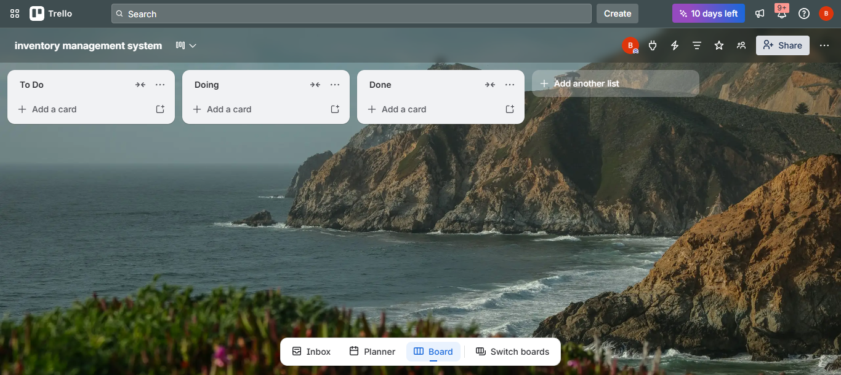

2. Objective of Using Trello
The implementation of Trello in this group project was guided by several key objectives:
- To systematically divide project work among all team members
- To ensure transparency in task assignment and progress
- To improve communication and coordination within the group
- To track the status of each task from planning to completion
- To manage deadlines effectively and avoid delays
- To maintain a structured workflow for software engineering documentation
- To simulate real-world Agile and Kanban project management practices
These objectives helped us not only complete the assignment but also gain practical experience in project management tools used in the software industry.

3. Trello Board Structure and Design
The Trello board was carefully designed to represent different stages of project development. Each list on the board represented a specific phase of work.

3.1 Ideas Section (Brainstorming Phase)
This section was used at the beginning of the project for planning and idea generation. Tasks included:
- Defining the scope of the case study
- Identifying core features of the INVENTRA system
- Selecting tools and technologies for documentation
- Deciding the structure of diagrams and reports
This phase helped the team align their understanding before starting actual development.

3.2 To-Do Section (Planned Tasks)
This section contained all tasks that were planned but not yet started. It included:
- Case study outline creation
- Problem statement writing
- Objectives and goals definition
- System architecture design
- Database design (ER diagram preparation)
- Feature explanation of the inventory system
- Methodology preparation
This acted as a task backlog where all upcoming work was stored in an organized manner.

3.3 In Progress Section (Active Work)
Tasks that were actively being worked on were moved to this section. This helped the team:
- Focus on current tasks without distractions
- Avoid duplication of work
- Identify ongoing responsibilities clearly
Only a limited number of tasks were kept in this section at a time to maintain efficiency.

3.4 Review Section (Quality Checking Phase)
Once a task was completed, it was moved to the review section for verification. This included:
- Checking grammar and formatting of documentation
- Reviewing diagrams and system design
- Ensuring consistency in content
- Correcting errors before final submission
This step ensured quality control and academic accuracy.

3.5 Completed Section (Final Stage)
All finalized tasks were moved here. This provided a clear visual record of completed work and helped track overall project progress.

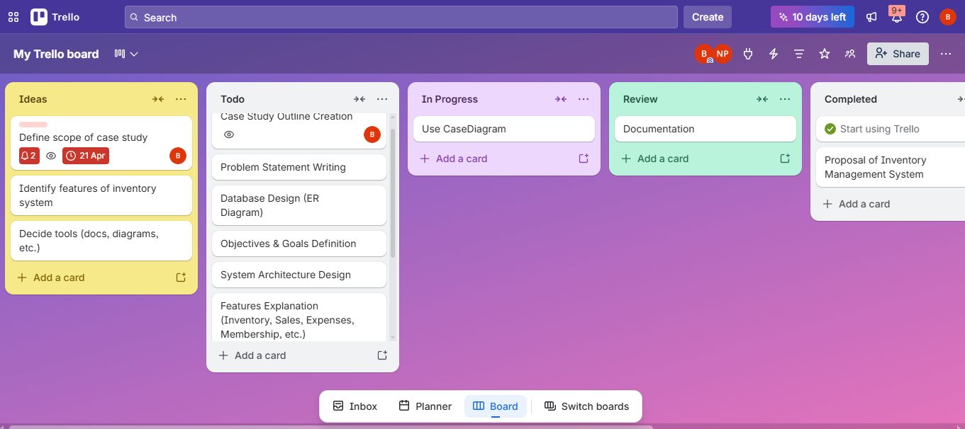

4. Role and Task Division
One of the most important benefits of Trello was its ability to support clear role-based task distribution. Each team member was assigned responsibilities based on their skills and contribution areas.
The roles were divided as follows:
- Documentation Lead – Responsible for writing case study content
- System Designer – Responsible for architecture and system design
- Database Designer – Responsible for ER diagram and database structure
- Feature Analyst – Responsible for defining system functionalities
This structured division ensured:
- Equal workload distribution
- Clear accountability for each task
- Reduced dependency conflicts
- Faster completion of tasks
Each task card in Trello included:
- Task description
- Assigned member
- Deadline
- Checklist of subtasks
- Comments for updates

5. Progress Tracking and Workflow Management
Trello provided a visual workflow that made progress tracking simple and effective. The movement of tasks followed a Kanban flow:
Ideas - ToDo - In Progress - Review - Completed
This system helped us:
- Monitor progress in real time
- Identify bottlenecks in tasks
- Maintain steady workflow
- Ensure no task was left incomplete
The drag-and-drop feature of Trello made it easy to update task status instantly, which improved team coordination significantly.
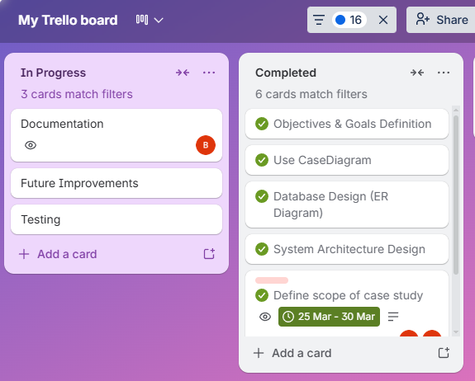

6. Collaboration and Communication
Trello acted as a centralized communication platform for the team. Instead of relying only on messaging apps, all important updates were recorded directly in task cards.
This improved collaboration by:
- Providing a single source of truth for all tasks
- Allowing comments and feedback on each task
- Reducing miscommunication between members
- Keeping all project information organized in one place
This approach closely resembles real-world Agile project management systems used in software companies.
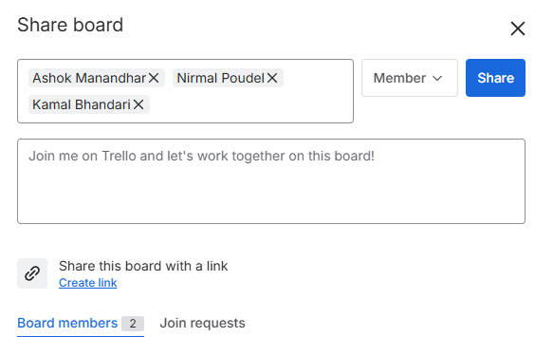

7. Benefits of Using Trello in the Project
The use of Trello provided multiple academic and practical benefits:
- Improved organization of complex project tasks
- Enhanced teamwork and collaboration
- Better time management and deadline control
- Increased transparency in work progress
- Easy identification of completed and pending tasks
- Structured workflow similar to Agile methodology
- Reduced confusion and duplication of work
- Improved productivity and accountability
Overall, Trello helped transform unstructured group work into a well-managed project system.
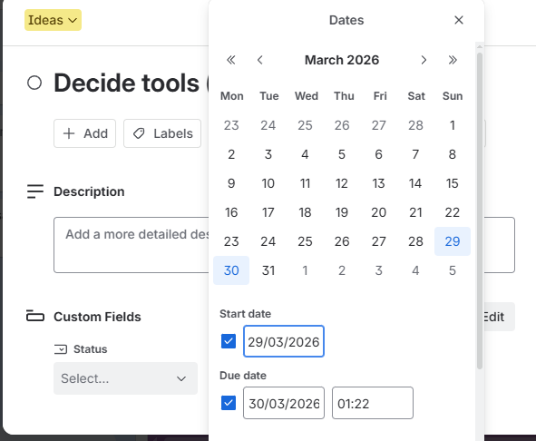

8. Challenges Faced During Usage
Despite its advantages, the team faced some minor challenges:
- Initial learning curve in understanding Trello features
- Requirement of consistent updates from all members
- Occasional delay in moving tasks across lists
- Dependence on internet connectivity
- Need for discipline in maintaining board structure
However, these challenges were gradually resolved through practice and team coordination.

9. Conclusion
The use of Trello in the INVENTRA case study project proved to be highly effective in managing tasks, improving collaboration, and ensuring structured workflow. It allowed the team to implement real-world project management practices in an academic environment.
Trello not only helped in completing the assignment efficiently but also provided practical exposure to Agile and Kanban methodologies used in software development industries. The experience gained from this tool will be valuable for future software engineering and group-based projects.

