TEAM NAME:

**SEQUEL SCOUTS**

***Team***

***Department: I.T: (2017-2021)***

Kandula Anusha

Mail: [mailmeanuanusha@gmail.com](mailto:mailmeanuanusha@gmail.com)

Roll No: 17131A1251

Ph: 8464046267



Borra Kamal

Mail:

[kamalborra124@gmail.com](mailto:kamalborra124@gmail.com)

Roll No:17131A1217

Ph:9573992836



Arisetty Amruth

Mail: [amruth3108@gmail.com](mailto:amruth3108@gmail.com)

Roll No: 17131A1210

Ph: 8309107928



K. Aditya Pavan

Mail:

[adityapavan098@gmail.com](mailto:adityapavan098@gmail.com)

Roll No: 17131A1255

Ph: 9133235693

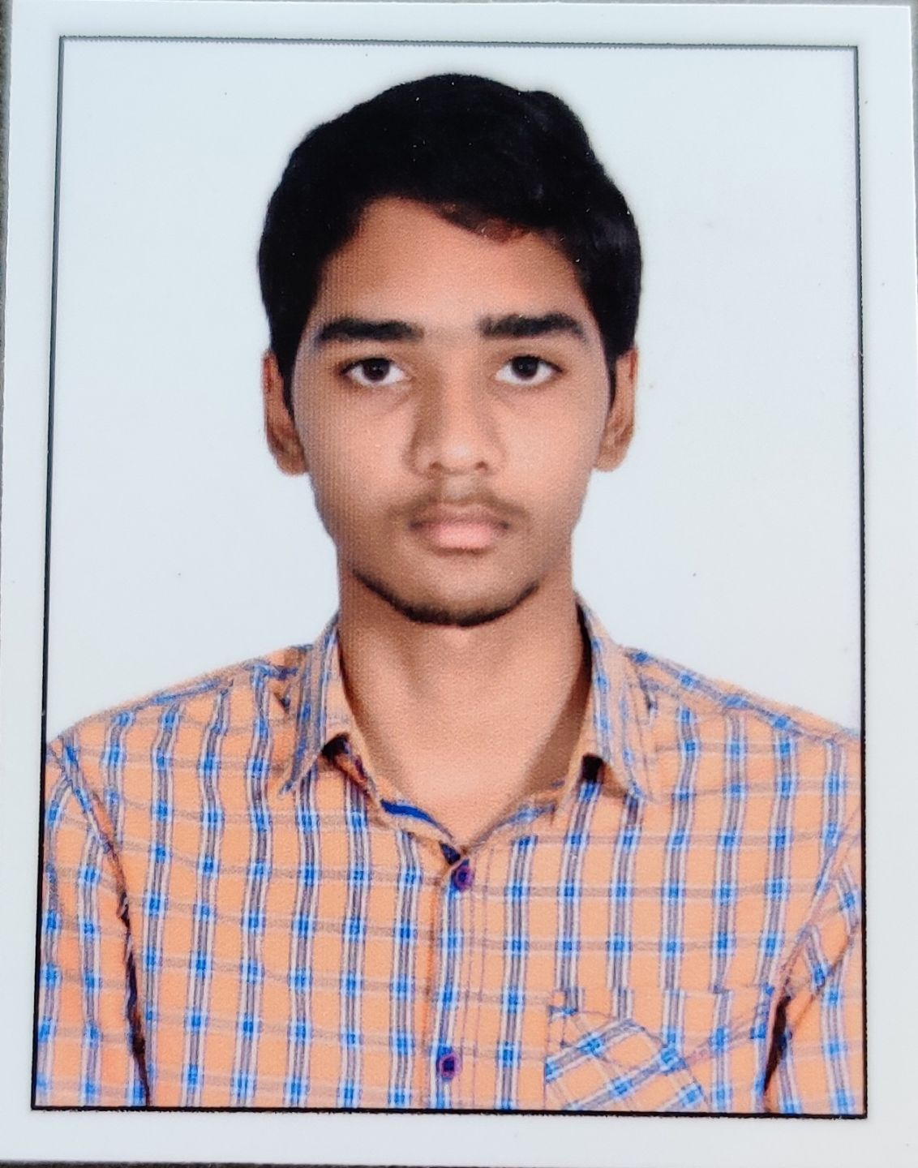

***Project Guide***

**S.** Kanthi Kiran

(Associate Professor)

Mail: [pranalinib@gvpce.ac.in](mailto:pranalinib@gvpce.ac.in)



***Abstract***

This project is to identify the best machine learning model with best NLP model for measuring the genuinity in the news.

***Select domain (s) where your solution can be implemented***

* Fake news detection was a technique which classify news articles as real or fake in social media.

***Describe how your solution helping the selected domains***

* This project helps the society to recognize or distinguish between fake and real news.

***Describe the engineering solution***

* In this project, based on title name, author name, and the news, the nature of news has been predicted.
* It is evaluated on accuracy of your predictions

***Industry or Institutions/Researchers working in this domain or technology:***

**UNESCO, Journalist Institutions**