Feature:- Invite Team Members
Settings---configure---Team Members---

After Sending invite to email id with containing . its not reflecting in UI
Correct EmailID is not showing in UI as well as DB
Email id used- nilesh.deulkar738@gmail.com and Invite.1@gmail.com
Actual result- nileshdeulkar738@gmail.com

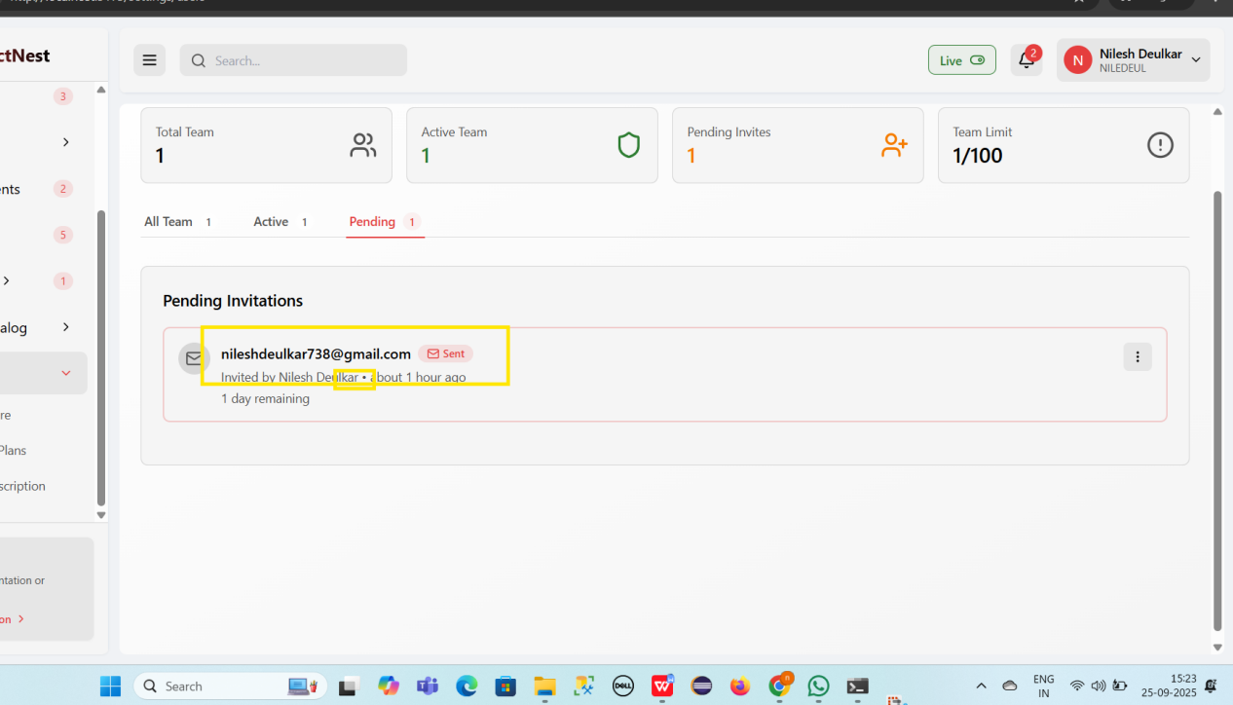
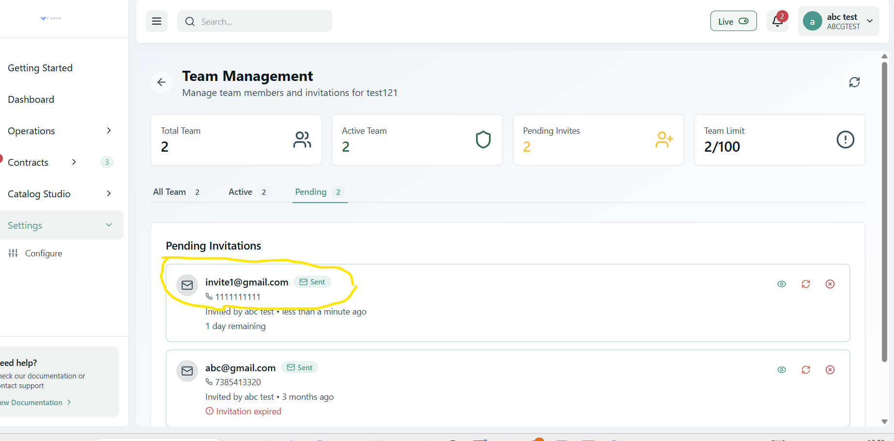

Invite Team member complete flow--

Invite sent to new email id - contractinvesttest@gmail.com
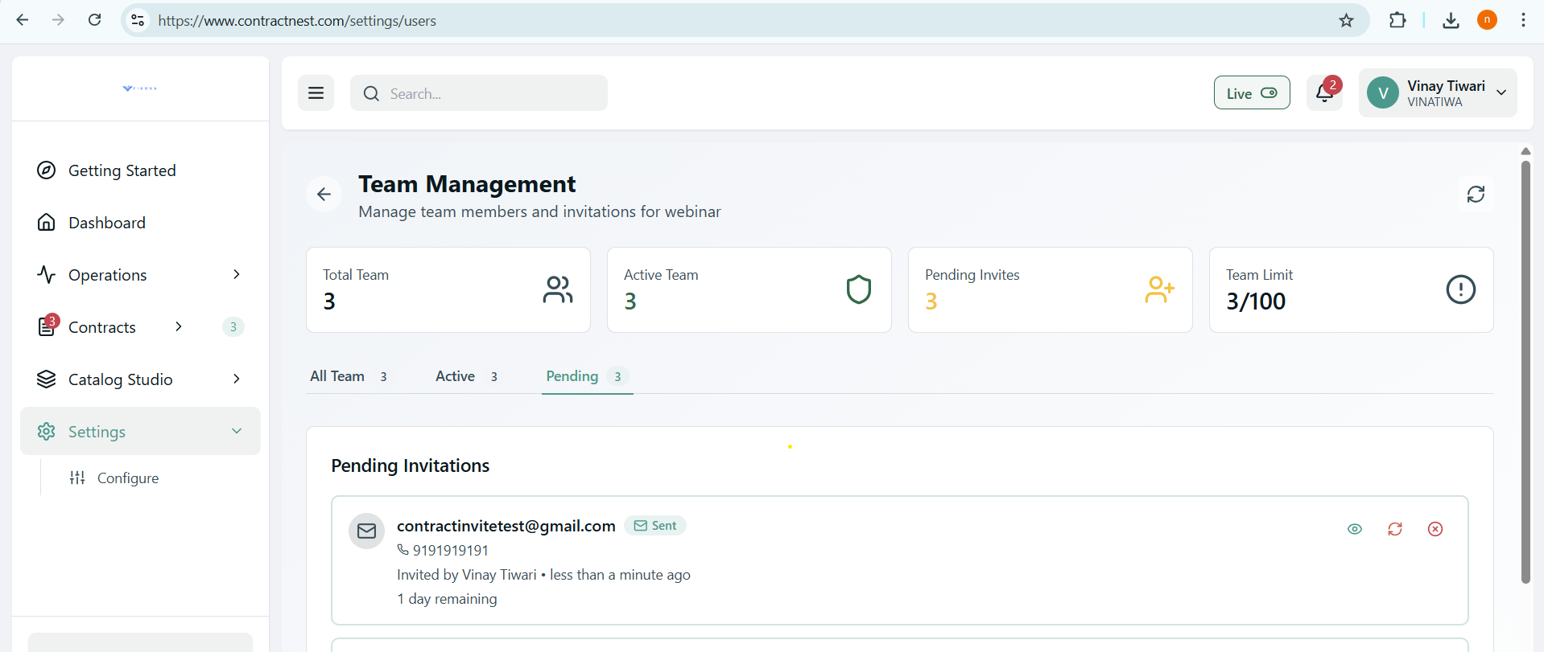

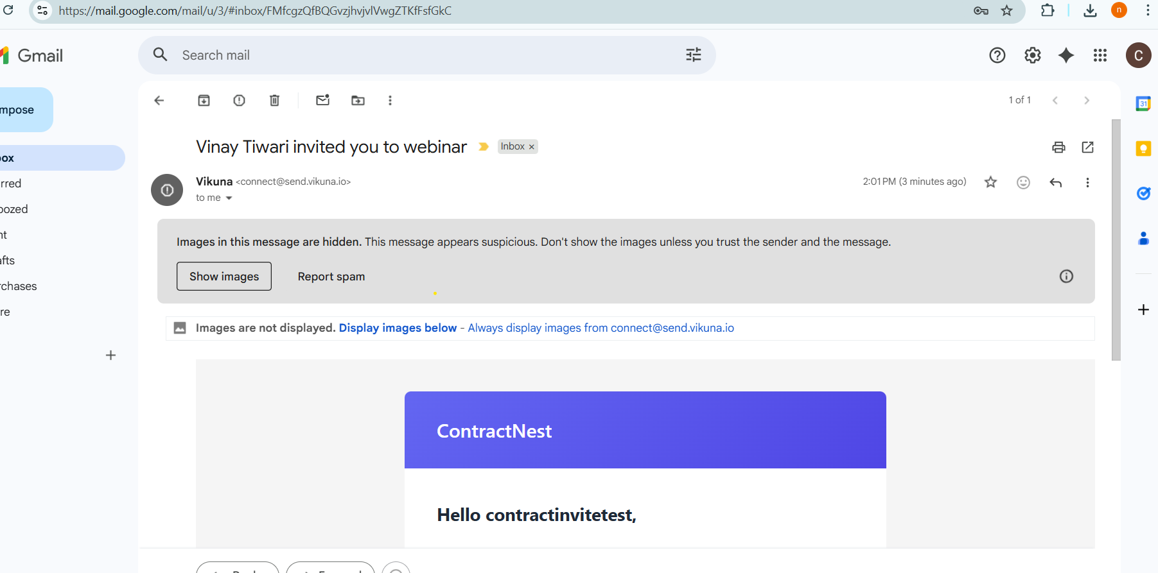

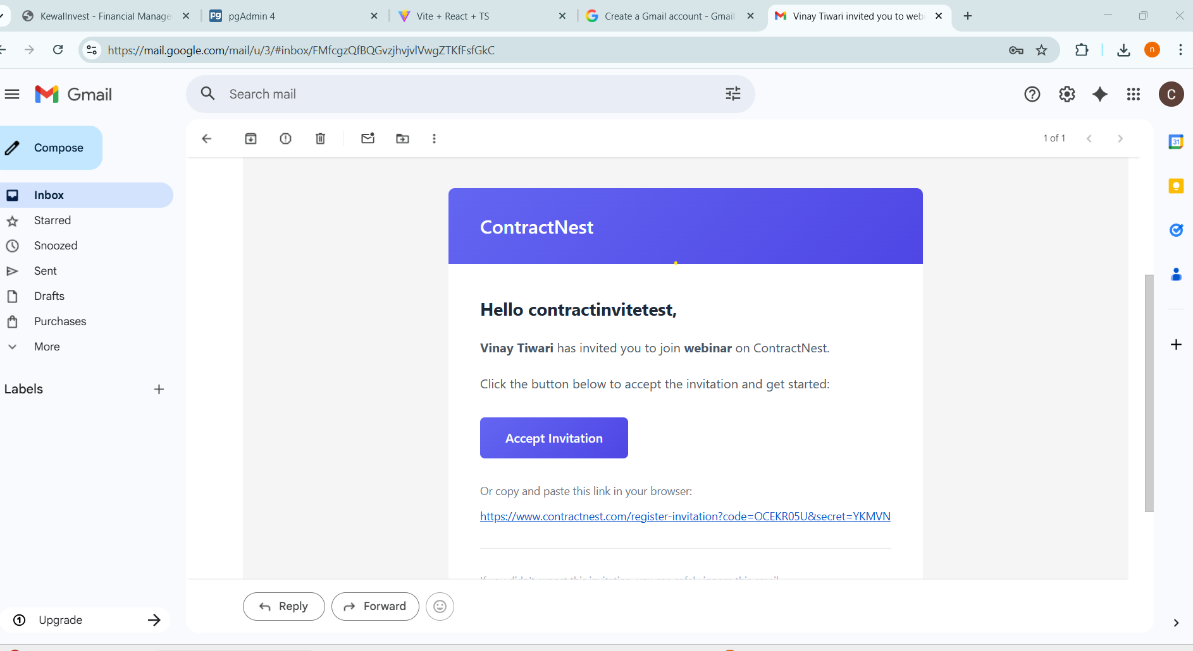

After Sending Invitation and Clicked on Accept its reflecting user already have an account, even user is newly added as invite only and not used before contarctnest
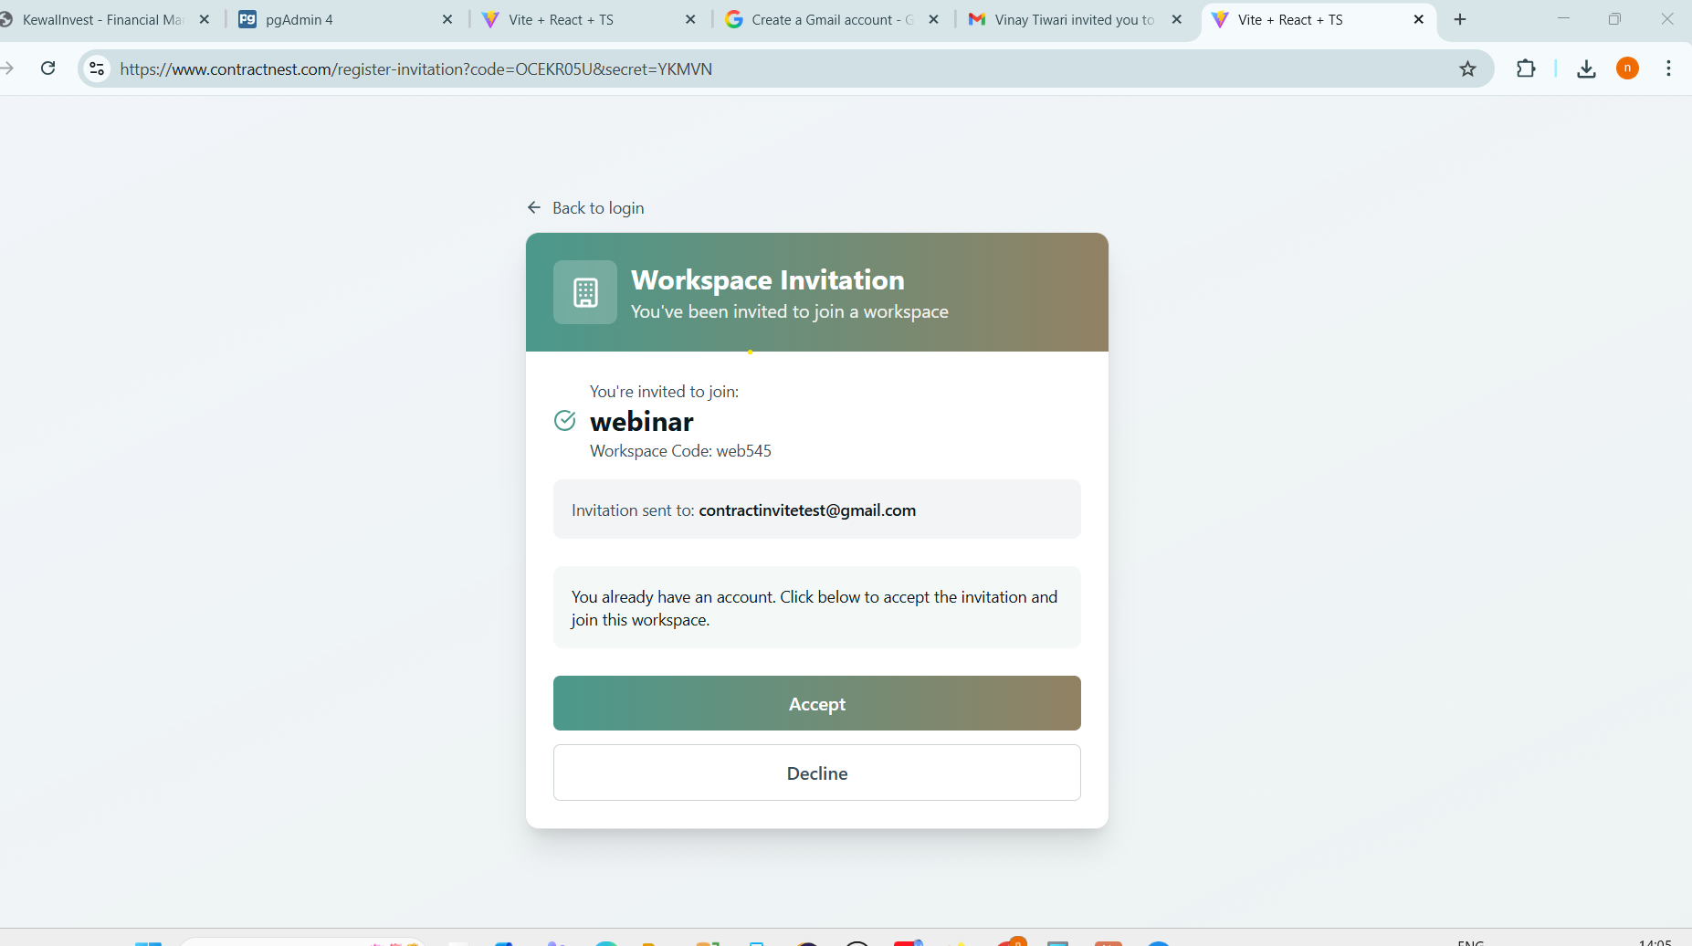

After Click on Accept
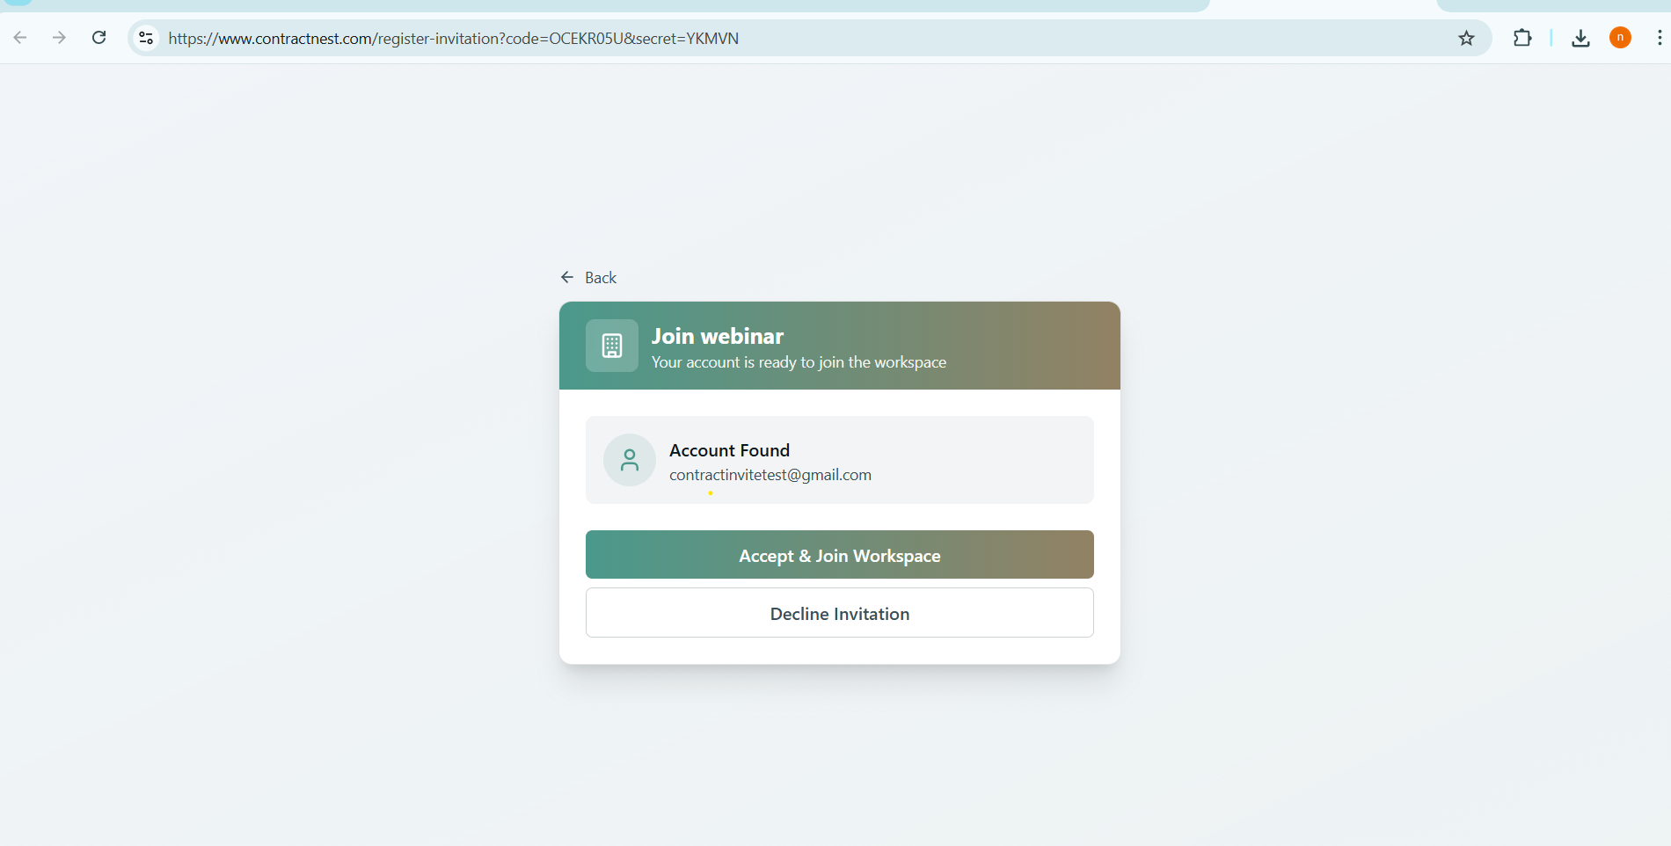

After Click on Accept and join Workspace its redirecting to login page
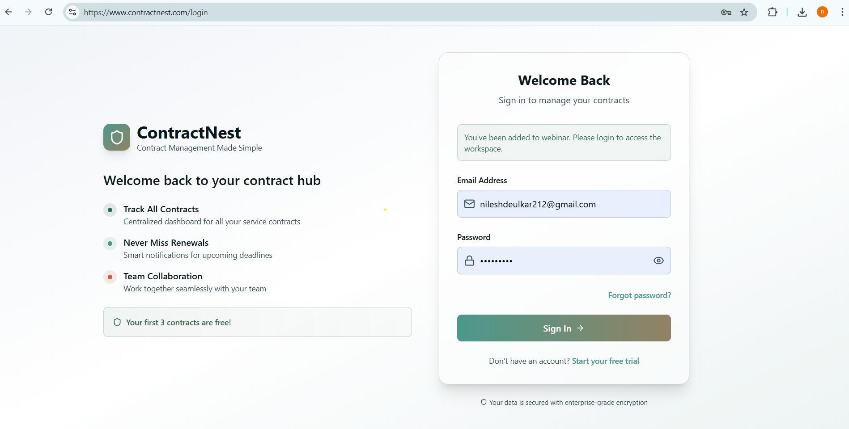

After Click on New registration link it is also redirecting to new loging page
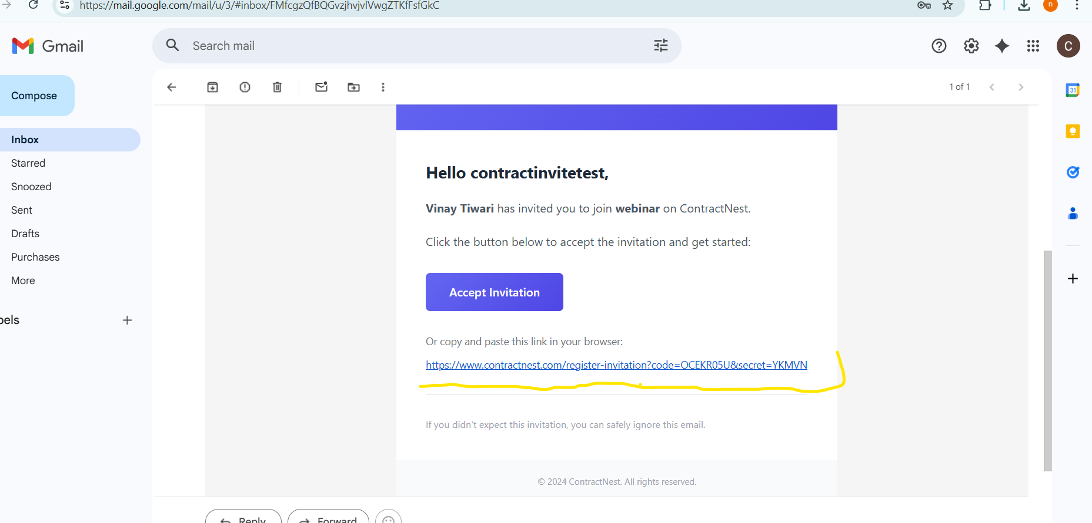
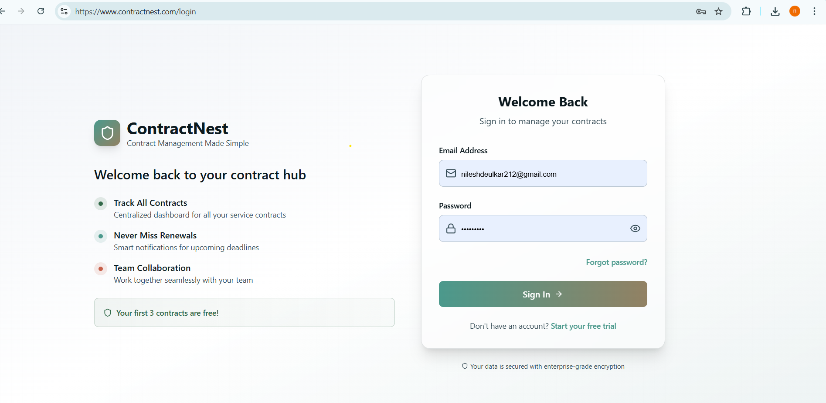
If we send invitation to existing tenant then system automatically create random user profile..
it should have some validation failure if user already in system..
