*Maulana Abul Kalam Azad University of Technology, West Bengal*

[Document subtitle]

2/1/2021

RABINDRANATH SAHU

M.TECH 1ST YEAR



Assignment 1

*OPERATING SYSTEM DESIGN LAB*

*(PGCS 192B)*

1. pwd

pwd stands for Print Working Directory. It prints the path of the working directory, starting from the root.



2. ls

The ls command is used to list files or directories in Linux



1. cd

The cd (“change directory”) command is used to change the current working directory in Linux



1. mkdir

mkdir command in Linux allows the user to create directories

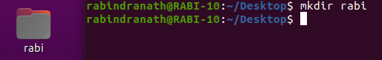

1. rmdir

rmdir command is used remove empty directories from the filesystem in Linux



1. touch

touch is used to create, change and modify timestamps of a file

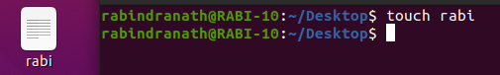

1. man

man command in Linux is used to display the user manual of any command that we can run on the terminal



* mkdir - make directories

1. help

help command says help you to learn about any built-in command.

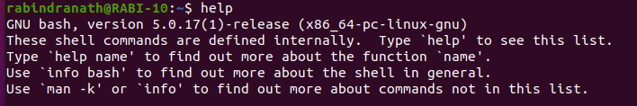

1. cp

cp stands for copy. This command is used to copy files or group of files or directory.

10.mv

mv stands for move. mv is used to move one or more files or directories from one place to another in file system

11.sudo

sudo (Super User DO) command in Linux is generally used as a prefix of some command that only superuser are allowed to run

12. apt-get

sudo apt-get-intall-package

sudo apt-get-update-package

sudo apt-get-upgrade-package

* apt-get is a command-line tool which helps in handling packages in Linux.
* sudo apt-get-install-package is used to install packages in Linux.
* sudo apt-get-update-package is used to update packages in Linux.
* sudo apt-get-upgrade-package is used to upgrade packages in Linux.

13.apt-cache search

Apt-cache is a command-line tool used for searching apt packages on a Linux.

14.hostname

hostname command in Linux is used to obtain the DNS(Domain Name System) name and set the system's hostname or NIS(Network Information System) domain name.



15.ping

The Linux ping command is a simple utility used to check whether a network is available and if a host is reachable. With this command, you can test if a server is up and running.

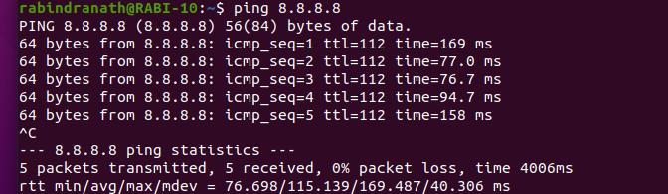

16.chmod

chmod +x filename to allow executable permissions



17.uname

The uname command reports basic information about a computer's software and hardware.



18.locate

locate command in Linux is used to find the files by name.

19.cat

cat command allows us to create single or multiple files, view contain of file



20.df

Linux df command is used to display the disk space used in the file system.

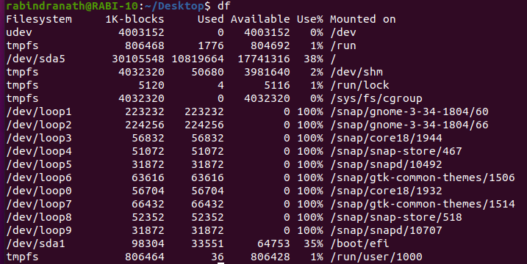

21.du

The du command is a standard Linux command that allows a user to gain disk usage information quickly.



22.zip, unzip

* ZIP is a compression and file packaging utility for Unix



* unzip command extracts all files from the specified ZIP archive to the current directory.



23.top

Top command is used to show the Linux processes. I provide a dynamic real-time view of running system.

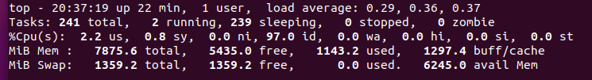

24.ps

Ps is used to viewing information related with the processes on a system which stands as abbreviation for “Process Status”.

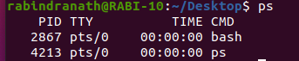

25.echo

echo command in Linux is used to display line of text or string that are passed as an argument.

