Experiment – 11
Portal User
Creating a Portal and Adding Portal Users in Zoho Creator
Department of Computer Science and Engineering
Student Name: Kamalesh V
Roll No: 240701224
Application Name: College (Purchase Request / Procurement Application)

Objective
To create a portal for a Zoho Creator application, to add portal users to it, and to control what each portal user can do by assigning a portal user permission, so that people outside the organization such as requesters and heads of department can use the application securely.

Introduction
A portal in Zoho Creator is an online, self-service gateway through which customers, vendors, and business partners interact with an application without being regular users of the organization. Each portal has its own web address and sign-in page. People are added to the portal as portal users, and every portal user is given a portal user permission, which is a profile that decides which forms, reports, and pages that user can see and what they can do with the data. In this way one application can serve different groups of external users, each seeing only what is meant for them.

Portal Components
Table 11.1: Components of a Zoho Creator portal.
Component | Description | In this Experiment
Portal | Online gateway to the application for external users, with its own URL | Portal of the College application, shown as Public
Sign-in page | Page where portal users log in using their email address | Sign In page with Email Address field and Next button
Portal user | An external person who is allowed to sign in to the portal | ARJUNRAJ and Tony
Portal user permission | Profile that decides what a portal user can access | Requester Portal and HOD

Portal User Permissions
The application already defines four portal user permissions under Settings, and the portal users were assigned from these.
Table 11.2: Portal user permissions of the College application (as listed under Portal User Permissions).
Permission | Description
Customer | Profile has add and view permission
HOD | Finance HOD Portal User - mirrors Finance user permissions
Requester Portal | Requester Portal User - mirrors Requester user permissions
Finance Portal | Portal permission for Finance users to view procurement data
Table 11.3: Portal users added to the portal (as listed under Portal User).
Name | Email Address | Username | Permission
ARJUNRAJ | arjunrajm11@gmail.com | arjunraj | Requester Portal
Tony | tony441007@gmail.com | portal_tony | HOD

Screenshot-based lab record
The following pages contain the actual Zoho Creator screenshots of the portal configuration.

Screenshots 1 – Creating the Portal
The Portal section of Zoho Creator, under Deploy, shows that no portal exists yet. The page describes a portal as an online, self-service gateway for customers and business partners to interact with the application, and offers a Create New button.
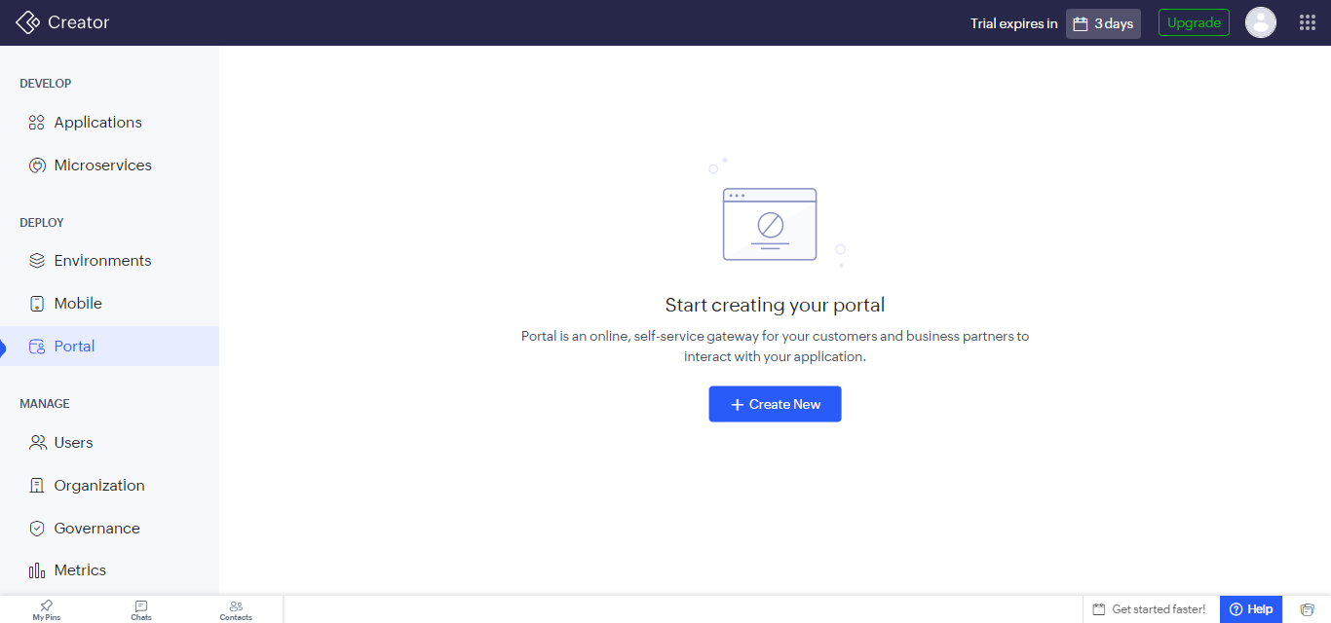
Figure 1: Portal section before a portal is created.
Create New opens the Create Portal page, which offers ready-made portal templates and a Create From Scratch option. The Configure Portal dialog asks for the application the portal should be based on, which is chosen from the Select drop-down before selecting Create Portal.
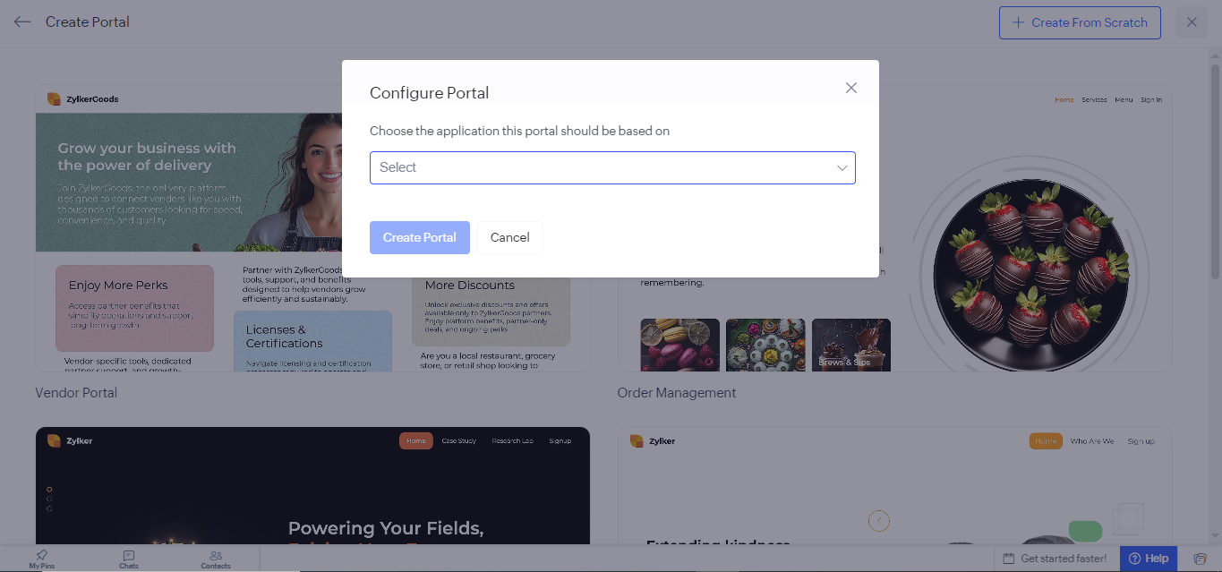
Figure 2: Configure Portal dialog for choosing the application the portal is based on.

Screenshots 2 – Portal Sign-in Page
The portal opens in the portal page builder for the College application, with the Sign In page selected. The page has an Email Address field, a Next button, a Forgot Password link, and a Sign Up link. The left panel offers elements such as Primitives, Navigation, Forms, Sections, Cards, Embed, and Tab for customizing the page.
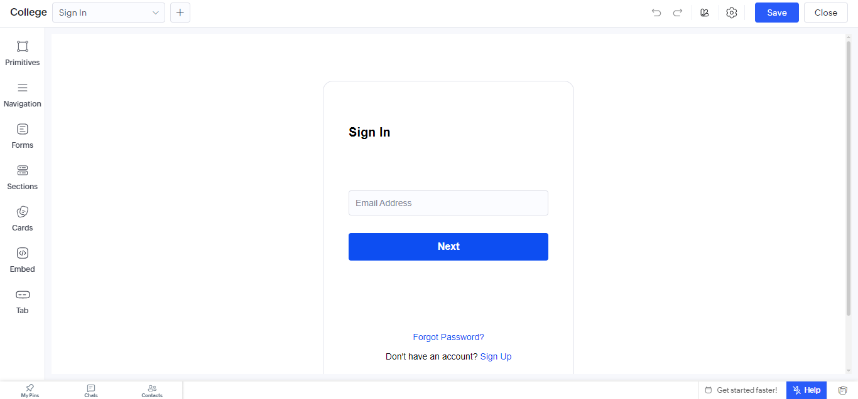
Figure 3: Sign In page of the portal in the page builder.

Screenshots 3 – Adding Portal Users
The portal is shown with the application name College, the label Public, and its web address. Its tabs are Portal User, Authentication, Email Notification, SMS Notification, and Page Customization. Add Portal Users opens a panel where the email address and name of the user are entered, the Send Notification Mail option is ticked so that the user is informed, and a Permission is chosen. Here the user ARJUNRAJ was given the Requester Portal permission.
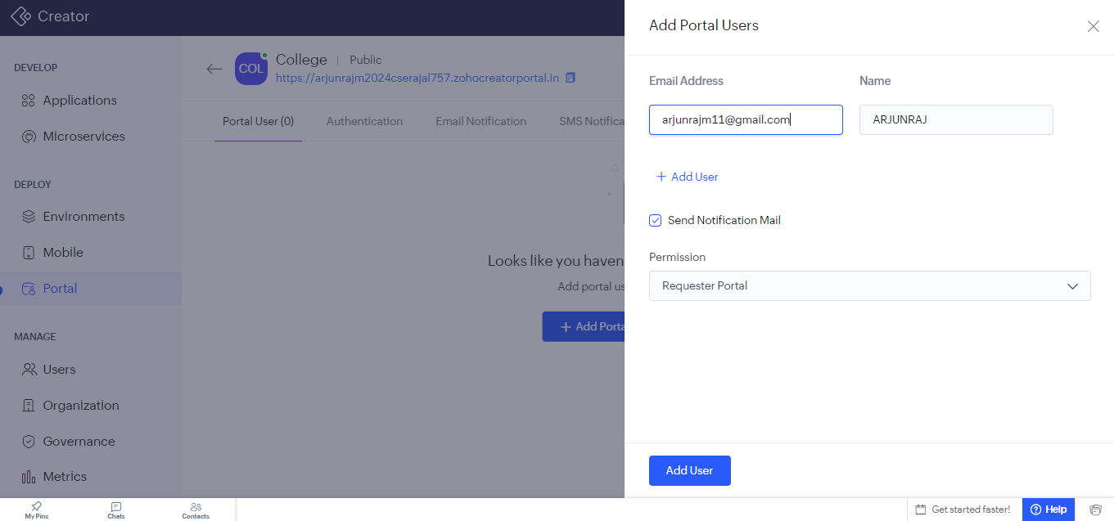
Figure 4: Add Portal Users panel with email address, name, notification option, and permission.
After the users were added, the Portal User tab lists them with their name, email address, username, and permission. Two portal users are present: ARJUNRAJ with the Requester Portal permission, and Tony with the HOD permission.
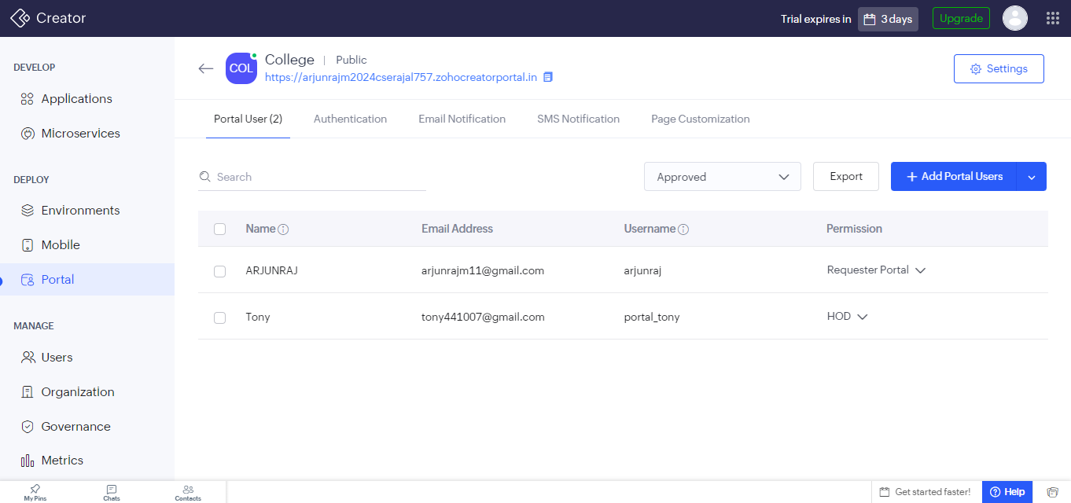
Figure 5: Portal User tab listing the two portal users and their permissions.

Screenshots 4 – Portal User Permissions
The permissions that can be given to portal users are managed in Settings under Portal User Permissions. Four permissions are listed, namely Customer, HOD, Requester Portal, and Finance Portal, and more can be created with Add Permission.
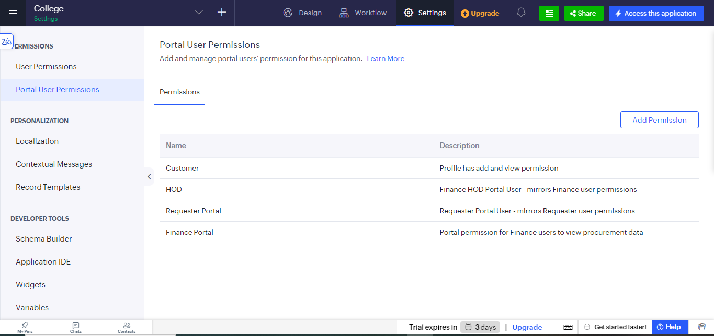
Figure 6: Portal User Permissions page of the College application.

Observation
The portal was created and its users were added without writing any code. Each portal user signs in with an email address and sees only what the assigned permission allows. In this application the requester and the head of department have different permissions, so each group is limited to the part of the purchase process that concerns it. A single portal therefore serves several kinds of external users, and the access of a user can be changed later by selecting a different permission in the Portal User tab.
A portal user differs from the regular users added under Users in Zoho Creator. Regular users belong to the organization and are given user permissions, whereas portal users are outside people who reach the application only through the portal and are given portal user permissions.

Result
A portal was successfully created for the College application and two portal users were added to it: ARJUNRAJ with the Requester Portal permission and Tony with the HOD permission. The portal user permissions Customer, HOD, Requester Portal, and Finance Portal were available to control the access of these users.

