Experiment – 8
Workflow
Workflow Automation using Zoho Creator
Department of Computer Science and Engineering
Student Name: Kamalesh V
Roll No: 240701224
Application Name: College (Purchase Request / Procurement Application)

Objective
To automate business logic in a Zoho Creator application by creating form workflows that run when a record is created or edited, using a Deluge script action to check the available budget for a Purchase Request and an e-mail action to send a notification.

Introduction
A workflow in Zoho Creator is a set of actions that runs automatically when a defined event occurs, so that routine decisions, calculations, and notifications do not have to be performed by hand. A form workflow is defined by three things: the form it belongs to, the record event that starts it (Created, Edited, Created or Edited, or Deleted), and the form event at which it fires, such as the load of the form, a user input on a field, or the successful submission of the form. Once triggered, the workflow can run a Deluge script, send an e-mail, add or update records, show messages, and more.

Workflow Components Used
Component | Description | Used in this Experiment
Form | The form on which the workflow is defined | Purchase Request
Record Event | Whether the workflow runs when a record is created, edited, created or edited, or deleted | Created or Edited
Form Event | The point in the form life cycle at which the actions execute | Load of the form, User input of a field, Successful form submission
Action – Deluge script | Custom logic written in Deluge | budget-check script that sets Budget Status
Action – Send email | Sends a notification message from the application | Record Added or Updated notification
Table 8.1: Workflow components used in the application.

Workflows Configured on the Purchase Request Form
Five workflows were created on the Purchase Request form. All of them are enabled and each runs one action.
Workflow Name | Record Event | Form Event | Actions
Decision Field Access | Created or Edited | Load of the form | 1 Action
calculate | Created or Edited | User input of Items → Quantity | 1 Action
Finance Approval Status Update | Created or Edited | Successful form submission | 1 Action
budget-check | Created or Edited | Successful form submission | 1 Action
Hod_Approval | Created or Edited | Successful form submission | 1 Action
Table 8.2: Workflows on the Purchase Request form (all Enabled, created on 13-Oct-2026).

Screenshot-based lab record
The following pages contain the actual Zoho Creator screenshots of the workflow configuration.

Screenshots 1 – Workflow List
The Workflow section of the application lists the form workflows grouped by the form event at which they run. The Purchase Request form appears under Forms with workflows, while Approval History, Budget, Department, Purchase Request Items, and Vendor appear under Forms without workflows. The tabs at the top give access to Schedules, Approvals, Payments, Blueprints, Batch workflows, and Functions.
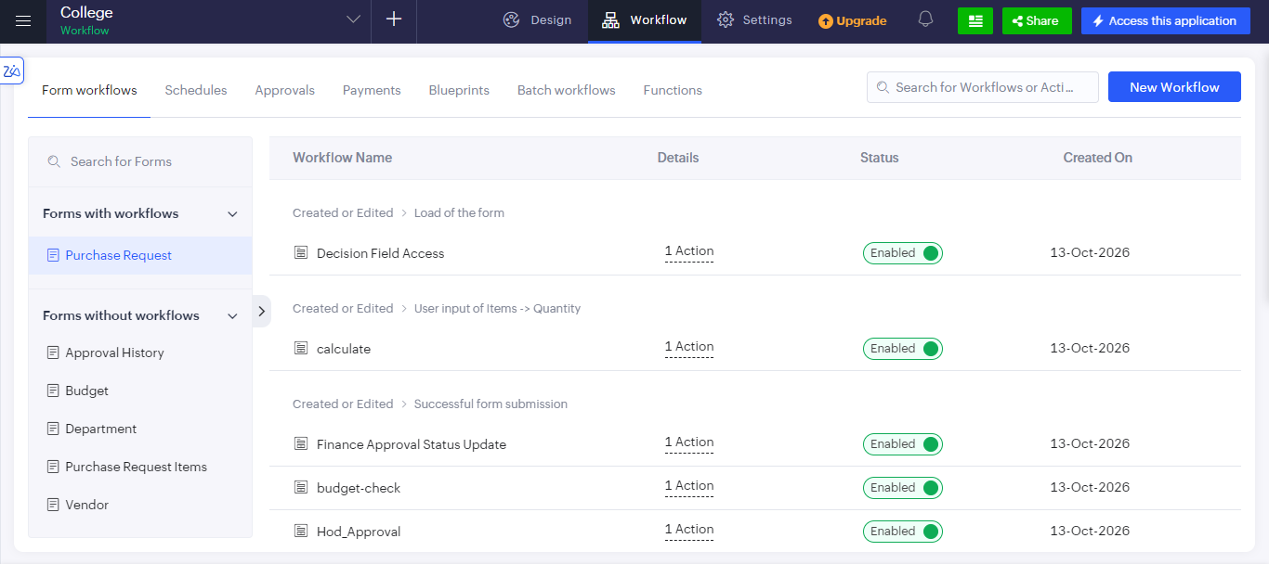
Figure 1: Form workflows of the Purchase Request form, all in the Enabled state.

Screenshots 2 – Creating a Workflow
A new workflow is created with the New Workflow option. The form is chosen, the record event is selected, the form event that triggers the workflow is picked, and the workflow is given a name before Create Workflow is pressed.
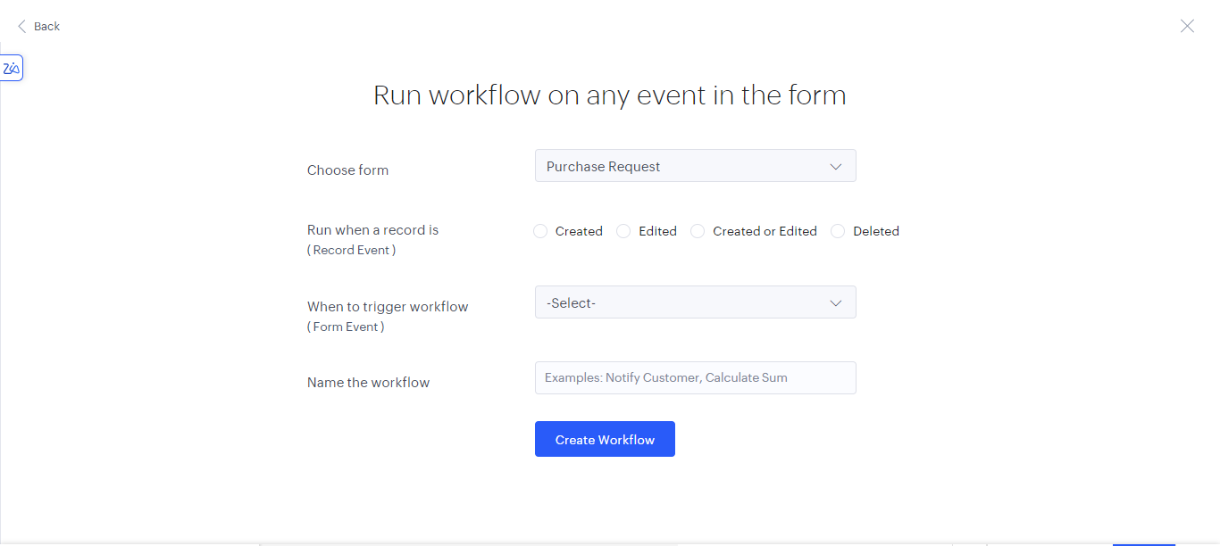
Figure 2: Run workflow on any event in the form — choosing the form, record event, form event, and workflow name.

Screenshots 3 – Workflow Action
The budget-check workflow is attached to Purchase Request → Created or Edited → Successful form submission. It contains the action Execute without condition, which runs a Deluge script as soon as the form is successfully submitted.
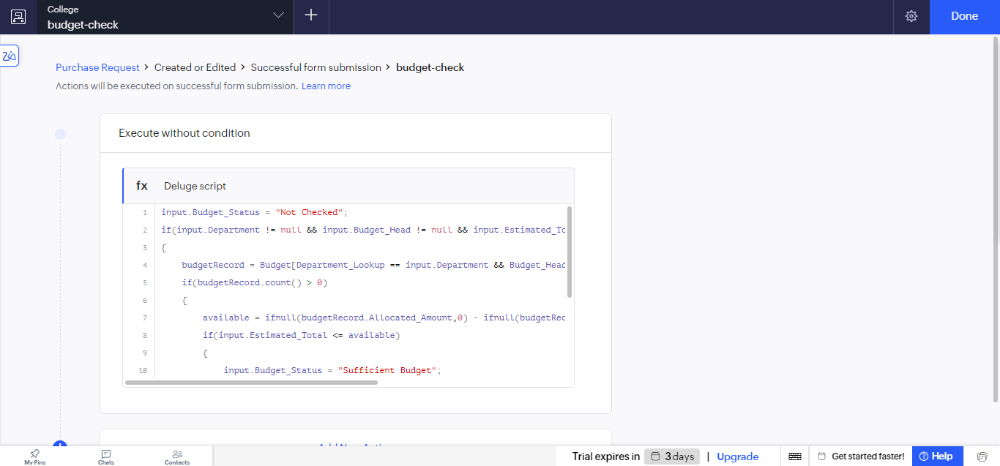
Figure 3: budget-check workflow with a Deluge script action executed without condition.

Screenshots 4 – Deluge Script of the budget-check Workflow
The Deluge script opens in a full-screen editor with a side panel of statements such as Condition and Data Access. It checks whether the estimated total of the purchase request can be met from the budget of the department and updates the Budget Status field.
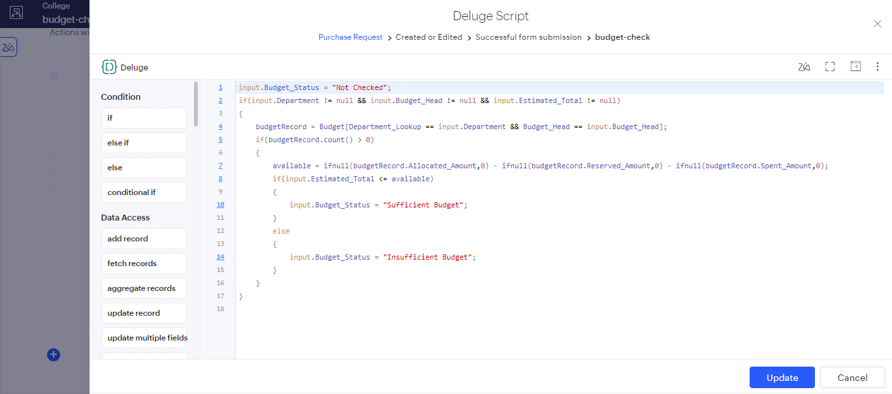
Figure 4: Deluge script editor showing the budget-check script.
The script submitted is given below.
input.Budget_Status = "Not Checked";
if(input.Department != null && input.Budget_Head != null && input.Estimated_Total != null)
{
budgetRecord = Budget[Department_Lookup == input.Department
&& Budget_Head == input.Budget_Head];
if(budgetRecord.count() > 0)
{
available = ifnull(budgetRecord.Allocated_Amount,0)
- ifnull(budgetRecord.Reserved_Amount,0)
- ifnull(budgetRecord.Spent_Amount,0);
if(input.Estimated_Total <= available)
{
input.Budget_Status = "Sufficient Budget";
}
else
{
input.Budget_Status = "Insufficient Budget";
}
}
}

Explanation of the script:
- The Budget Status of the request is first reset to "Not Checked", so that the field always has a defined value.
- The check is carried out only when the Department, Budget Head, and Estimated Total fields are all filled in (not null).
- The Budget form is searched for the record whose Department and Budget Head match the request, using the criteria Department_Lookup == input.Department && Budget_Head == input.Budget_Head.
- If a matching budget record exists (count() > 0), the available amount is calculated as Allocated Amount minus Reserved Amount minus Spent Amount. The ifnull() function treats any empty amount as 0.
- If the Estimated Total is less than or equal to the available amount, Budget Status is set to "Sufficient Budget"; otherwise it is set to "Insufficient Budget".

Screenshots 5 – Send Email Action
A second action of the type Send email can be added to the workflow using Add New Action. The sender address, the recipient, the subject, and the message are configured, and form fields or system variables can be inserted into the message with the Insert fields option. The message shown uses the system variable zoho.loginuserid to report which user added or updated a record in the Purchase Request form.
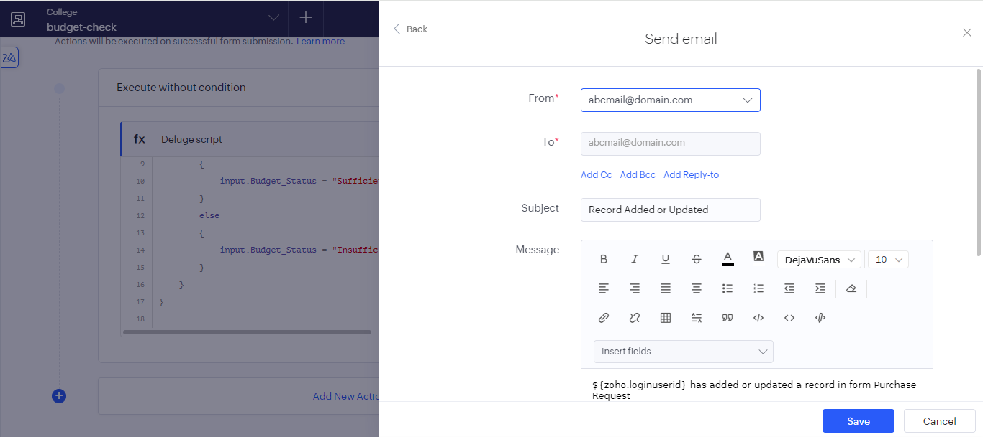
Figure 5: Send email action with From, To, Subject, and Message (rich-text editor and Insert fields).

Observation
The Purchase Request form was automated without any manual intervention. When a request is submitted, the budget-check workflow fires on its own, looks up the department budget, and sets the Budget Status to Sufficient or Insufficient, so the approvers do not need to compare the figures by hand. Other workflows on the same form control field access when the form loads, recalculate values when the item quantity changes, and update the approval status after submission. The e-mail action shows that notifications can be added to the same workflow through configuration alone. Because a workflow is tied to a specific record event and form event, logic can be placed at exactly the point where it is needed.

Result
Workflows were successfully created on the Purchase Request form of the Zoho Creator application. The budget-check workflow, running a Deluge script on successful form submission, correctly determines whether the budget is sufficient, and the Send email action was configured to notify users when a record is added or updated.

