Name: KAMALESH V Roll No: 240701224

EXPERIMENT 1

Form Creation in Zoho Creator

Aim
To create a form using the Zoho Creator platform for collecting and managing user data, and to understand the basic process of designing a form using different fields and input components.

Introduction
Zoho Creator is a low-code application development platform used to create customized business applications with minimal coding. It provides a visual form builder that allows users to collect, organize, and manage data efficiently. Forms can be created using drag-and-drop fields such as text boxes, dropdowns, dates, and other input components.
The collected data can be stored and managed within the application for further processing and automation. Form creation in Zoho simplifies application development by reducing the need for extensive programming.

Objectives of the Study
- To understand the basic process of creating a form using Zoho Creator.
- To learn how to add and configure different fields in a form.
- To understand how forms are used to collect and store data.
- To explore the customization and organization of form fields.
- To develop a simple functional form using the Zoho Creator platform.

Procedure
- Log in to the Zoho Creator platform.
- Create a new application for the required use case.
- Open the Form Builder and start creating a new form.
- Add the required fields such as Single Line, Number, Email, Phone, Date, Dropdown, Radio, and Checkbox.
- Configure the properties and settings of each field according to the requirements.
- Set appropriate validation conditions and mark required fields where necessary.
- Arrange and customize the form fields to obtain the desired form layout.
- Save and preview the form to verify its appearance and functionality.
- Enter sample data into the form and verify that the records are stored correctly.
- Modify the form and field settings if any errors or changes are required.

- Publish the application after completing the form creation and verification.

Illustrative Example
Consider a Student Management System in which student details are collected through a Zoho Creator form.

Implementation using Zoho Creator
    - Create a Student Information form.
    - Add fields such as Student Name, Register Number, Department, Email, Phone Number, Date of Birth, and Gender.
    - Mark important fields as mandatory and apply suitable validation.
    - Store submitted student records in the application database.
    - Generate reports to view and manage student information

Illustrative Form Design

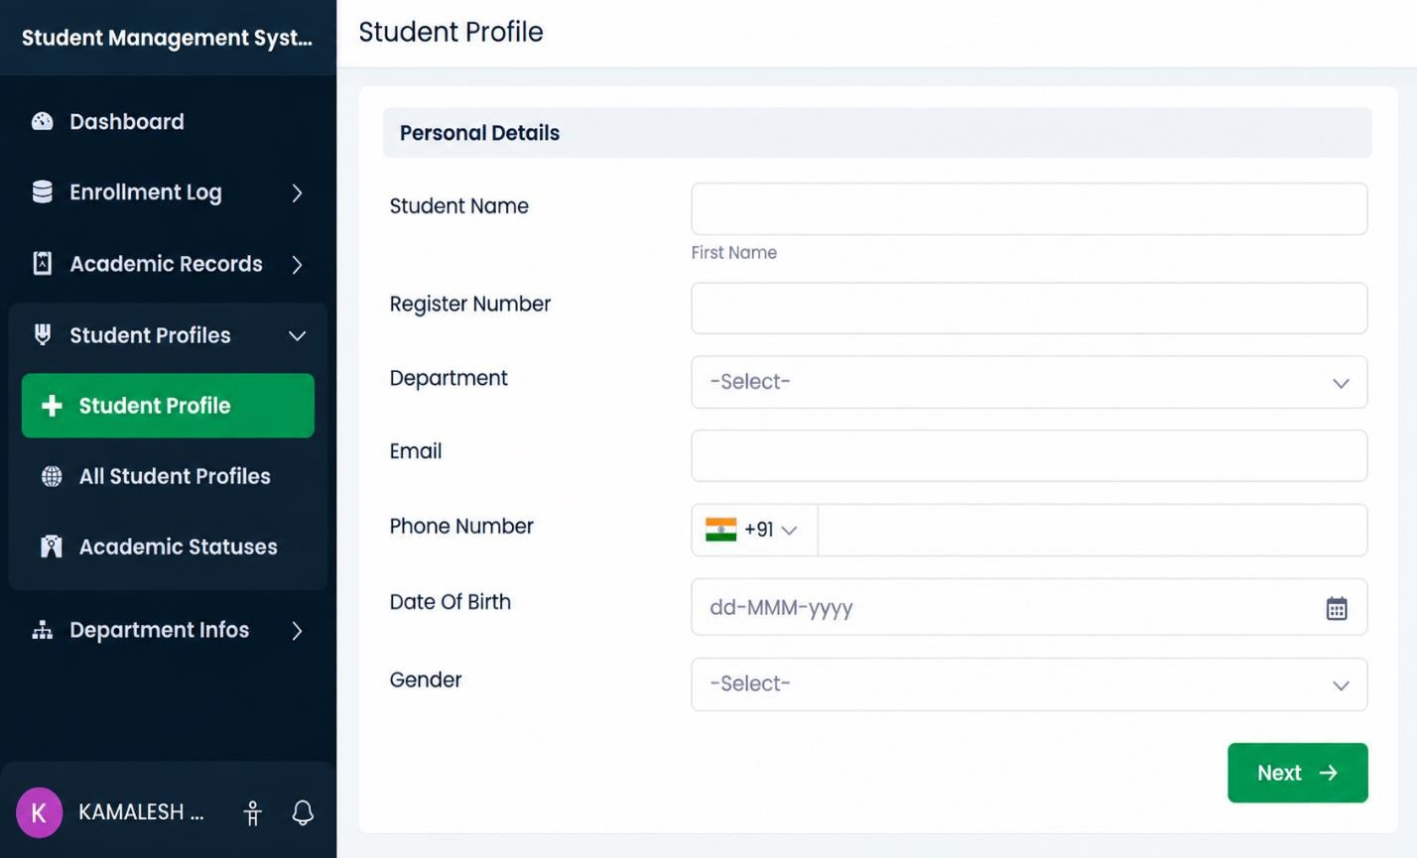

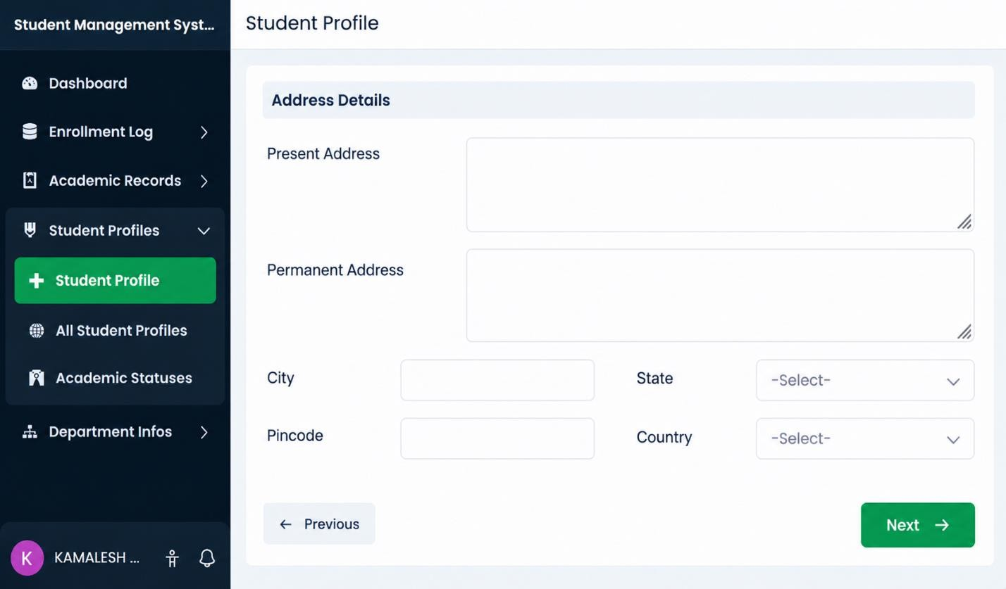

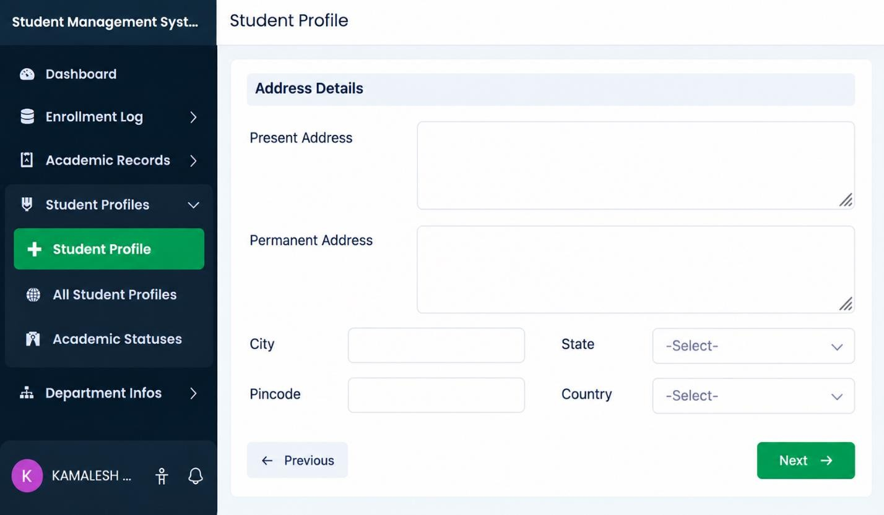

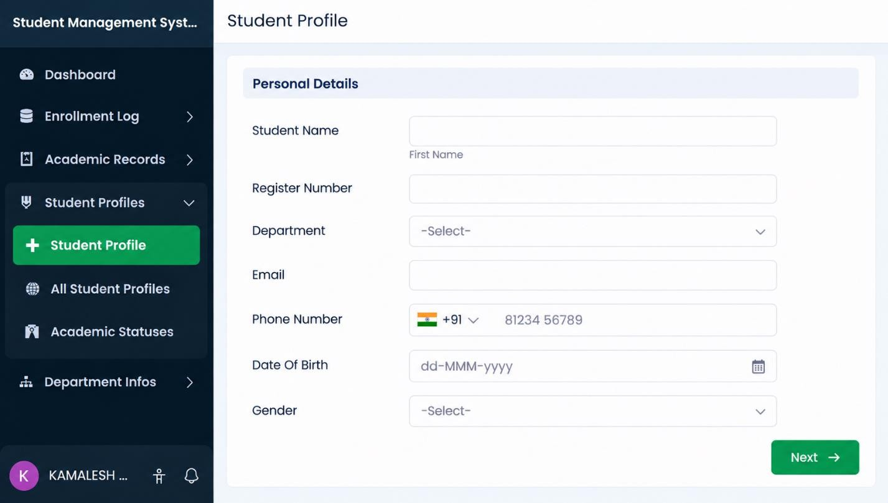

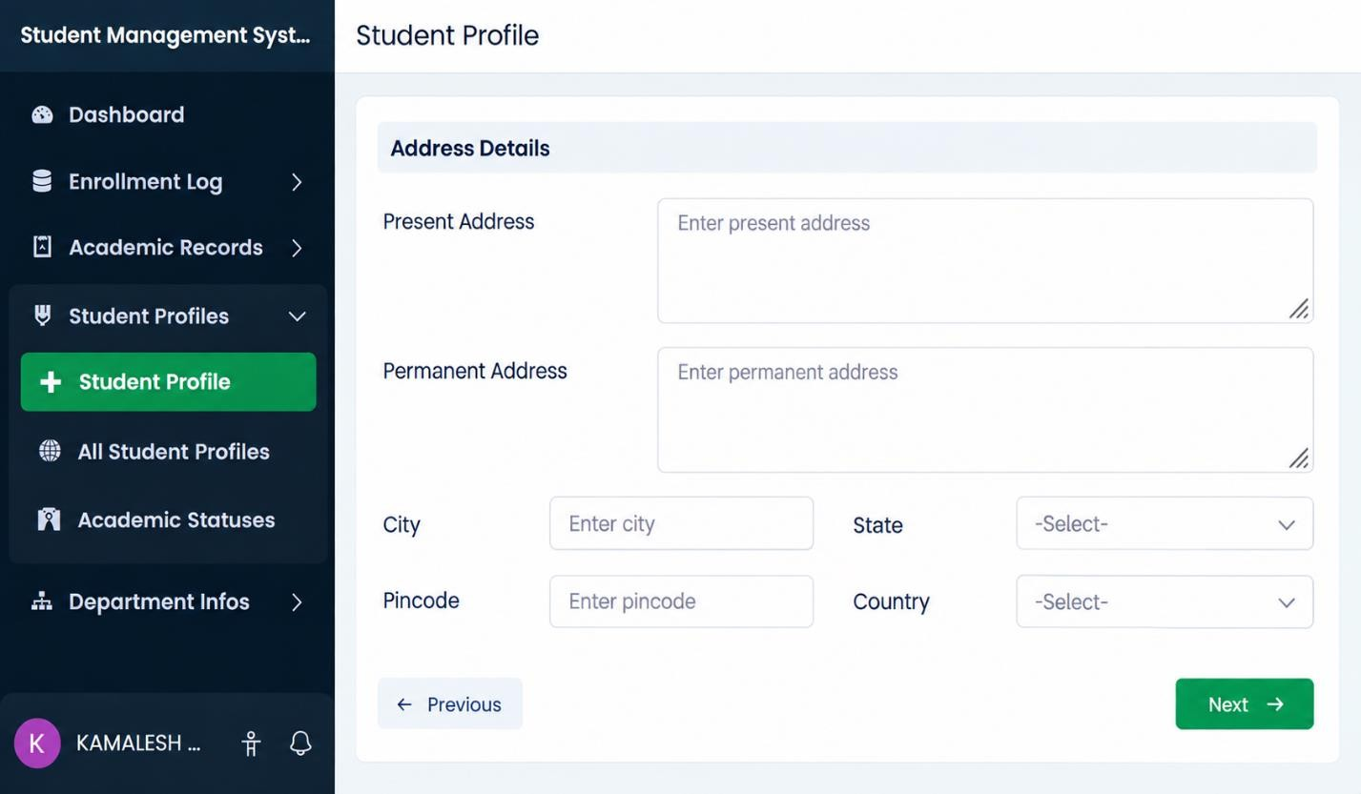

Advantages and Limitations
  - Advantages
    - Visual and simple form-building process.
    - Reduced development time for common applications.
    - Less manual programming is required.
    - Validation features can be configured within forms.
    - Forms and applications can be updated easily.

Limitations
    - Complex customization may require Deluge scripting.
    - Applications depend on the capabilities of the selected platform.
    - Large or highly specialized enterprise systems may need additional development.

Result
The experiment was completed successfully by studying data modelling and creating an interactive form in Zoho Creator. The exercise demonstrated how structured fields, relationships, validation, and visual form design can be combined to collect and manage application data with reduced coding effort.

