EXPERIMENT-3

NAME: KAMALESH. V ROLL NO:240701224

- COMMAND LINE INTERFACE:
PYTHON CODE:

FILE_NAME = "notes.txt"
notes = []

# Load notes from file
def load_notes():
try:
with open(FILE_NAME, "r") as file:
for line in file:
line = line.strip()
if "|" in line:
title, content = line.split("|", 1)
notes.append({"title": title, "content": content})
except FileNotFoundError:
pass

# Save notes to file
def save_notes():
with open(FILE_NAME, "w") as file:
for note in notes:
file.write(note["title"] + "|" + note["content"] + "\n")

def add_note():
title = input("Enter note title: ")
content = input("Enter note content: ")
notes.append({"title": title, "content": content})
save_notes()
print("Note added successfully!")

def view_notes():
if not notes:
print("No notes found.")
return

print("\nYour Notes:")
for i, note in enumerate(notes, start=1):
print(f"{i}. {note['title']} - {note['content']}")

def search_notes():
keyword = input("Enter keyword to search: ").lower()
found = False

for note in notes:
if keyword in note["title"].lower() or keyword in note["content"].lower():
print(f"Found: {note['title']} - {note['content']}")
found = True

if not found:
print("No matching notes found.")

def delete_note():
view_notes()
try:
num = int(input("Enter note number to delete: "))
if 1 <= num <= len(notes):
deleted = notes.pop(num - 1)
save_notes()
print(f"Deleted note: {deleted['title']}")
else:
print("Invalid note number.")
except ValueError:
print("Please enter a valid number.")

def menu():
print("\n--- Advanced CLI Note Manager ---")
print("1. Add Note")
print("2. View Notes")
print("3. Search Notes")
print("4. Delete Note")
print("5. Exit")

load_notes()

while True:
menu()
choice = input("Enter your choice: ")

if choice == "1":
add_note()
elif choice == "2":
view_notes()
elif choice == "3":
search_notes()
elif choice == "4":
delete_note()
elif choice == "5":
print("Exiting application. Goodbye!")
break
else:
print("Invalid choice. Try again.")

OUTPUT:
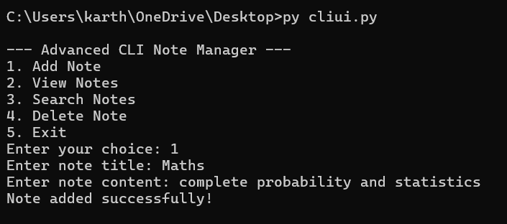

- GRAPHICAL USER INTERFACE:
PYTHON CODE:
import tkinter as tk
from tkinter import messagebox

FILE_NAME = "notes.txt"
notes = []

# ---------- File Handling ----------
def load_notes():
try:
with open(FILE_NAME, "r") as f:
for line in f:
line = line.strip()
if "|" in line:
title, content = line.split("|", 1)
notes.append({"title": title, "content": content})
except FileNotFoundError:
pass

def save_notes():
with open(FILE_NAME, "w") as f:
for n in notes:
f.write(f"{n['title']}|{n['content']}\n")

# ---------- Actions ----------
def add_note():
title = title_entry.get().strip()
content = content_entry.get().strip()

if not title or not content:
messagebox.showwarning("Input Error", "Title and content are required.")
return

notes.append({"title": title, "content": content})
save_notes()
refresh_list()
title_entry.delete(0, tk.END)
content_entry.delete(0, tk.END)
messagebox.showinfo("Success", "Note added successfully!")

def delete_note():
selected = notes_list.curselection()
if not selected:
messagebox.showwarning("Selection Error", "Select a note to delete.")
return

index = selected[0]
deleted = notes.pop(index)
save_notes()
refresh_list()
messagebox.showinfo("Deleted", f"Deleted note: {deleted['title']}")

def search_notes():
keyword = search_entry.get().lower().strip()
notes_list.delete(0, tk.END)

for n in notes:
if keyword in n["title"].lower() or keyword in n["content"].lower():
notes_list.insert(tk.END, f"{n['title']} - {n['content']}")

def refresh_list():
notes_list.delete(0, tk.END)
for n in notes:
notes_list.insert(tk.END, f"{n['title']} - {n['content']}")

# ---------- UI ----------
root = tk.Tk()
root.title("GUI Note Manager")
root.geometry("420x500")

tk.Label(root, text="Note Title").pack(pady=5)
title_entry = tk.Entry(root, width=45)
title_entry.pack()

tk.Label(root, text="Note Content").pack(pady=5)
content_entry = tk.Entry(root, width=45)
content_entry.pack()

tk.Button(root, text="Add Note", width=20, command=add_note).pack(pady=8)

tk.Label(root, text="Search").pack(pady=5)
search_entry = tk.Entry(root, width=45)
search_entry.pack()
tk.Button(root, text="Search Notes", width=20, command=search_notes).pack(pady=5)

tk.Label(root, text="Your Notes").pack(pady=5)
notes_list = tk.Listbox(root, width=55, height=12)
notes_list.pack(pady=5)

tk.Button(root, text="Delete Selected Note", width=25, command=delete_note).pack(pady=10)

# ---------- Start ----------
load_notes()
refresh_list()
root.mainloop()

OUTPUT:

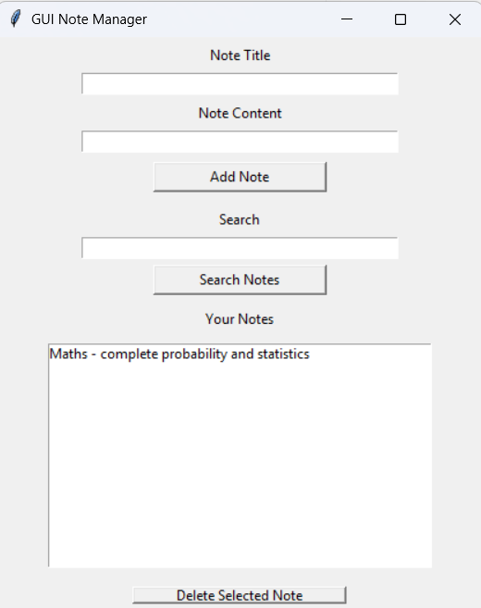
- VOICE USER INTERFACE:
PYTHON CODE:
import speech_recognition as sr import os

def rename_file_from_voice_command(command): try:
words = command.lower().split(" ")
if "rename" in words and "to" in words:
rename_index = words.index("rename") to_index = words.index("to")

# Extract old and new filenames
old_name = words[rename_index + 1] new_name = words[to_index + 1]

# Check if file exists
if not os.path.exists(old_name):
print(f"Error: File '{old_name}' not found.") return

# Rename file
os.rename(old_name, new_name)
print(f"✅ File renamed from '{old_name}' to '{new_name}'")

else:
print("Invalid command format. Say: 'Rename oldfile.txt to newfile.txt'")

except Exception as e:
print(f"Error: {e}")

def listen_for_command():
recognizer = sr.Recognizer() mic = sr.Microphone()

print("🎤 Listening for command to rename a file...") with mic as source:
recognizer.adjust_for_ambient_noise(source) audio = recognizer.listen(source)

try:
command = recognizer.recognize_google(audio) print(f"🎙️ Command received: {command}")
rename_file_from_voice_command(command) except sr.UnknownValueError:
print("❌ Sorry, I couldn't understand the command.") except sr.RequestError as e:
print(f"⚠️ Could not request results from Google Speech Recognition service; {e}")

if name == " main ": listen_for_command()

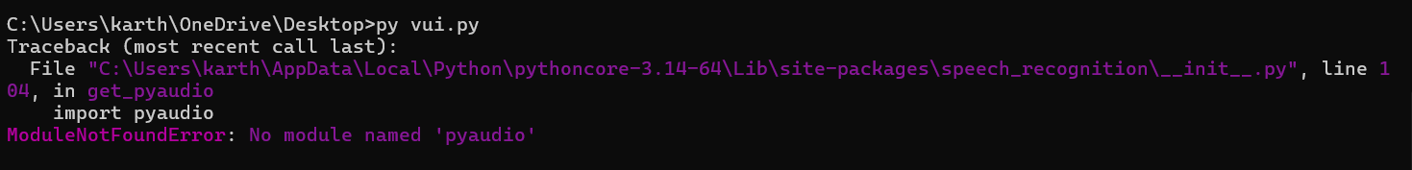

- USER SATISFACTION COMPARISON:
PYTHON CODE:
def survey():
print("Rate your satisfaction with the following interfaces (1-5):")

# Get user input for each interface try:
cli_satisfaction = int(input("CLI (1-5): ")) gui_satisfaction = int(input("GUI (1-5): ")) vui_satisfaction = int(input("VUI (1-5): "))

# Ensure valid ratings
if not (1 <= cli_satisfaction <= 5 and 1 <= gui_satisfaction <= 5 and 1 <= vui_satisfaction <= 5): print("Please enter ratings between 1 and 5 only.")
return

# Display the ratings
print("\nYour satisfaction ratings:") print(f"CLI: {cli_satisfaction}")
print(f"GUI: {gui_satisfaction}")

print(f"VUI: {vui_satisfaction}")

# Calculate the average satisfaction
avg_satisfaction = (cli_satisfaction + gui_satisfaction + vui_satisfaction) / 3 print(f"\nAverage Satisfaction Score: {avg_satisfaction:.2f}")

except ValueError:
print("Invalid input! Please enter numbers between 1 and 5.")

# Run the survey function
if name == " main ": survey()
