Roll No : 240701224 Name : Kamalesh V

Experiment No : 1
User Interface And Design
COMAPARSION OF UI DESIGN BETWEEN TWO FIGMA
CREATION
Bad Design :
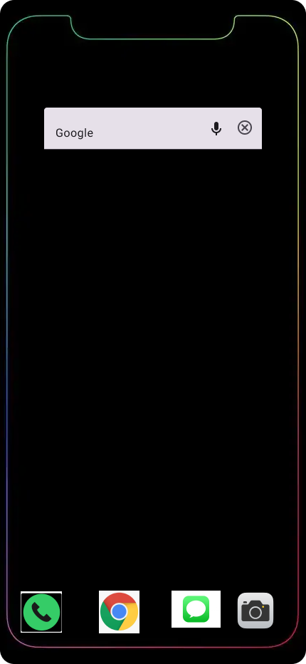
Good Design :

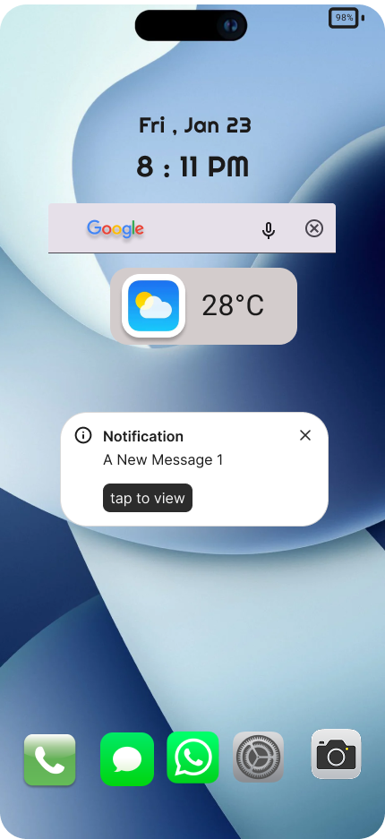

Bad Design(iPhone):
Design Style:
- Too much empty space in the middle → screen looks incomplete and wasted.
- Icons at bottom look floating randomly (no dock/background bar).
- No wallpaper / branding / identity, making it look like a dummy screen.

Content:
- Only Google search bar + 4 icons → content is too minimal.
- No useful widgets like:
  - time/date
  - weather
  - calendar
  - notifications
- Overall content gives a blank + unfinished feel.
Navigation:
- Bottom apps are not in a proper navigation system (no dock bar).
- Apps are not grouped (no folders, no organization).
Purpose:
- Looks like a sample layout, not a real usable interface.

Good Design(Featured iPhone):
Design Style:
- Clean wallpaper background → looks modern and attractive.
- Consistent color theme (light blue + soft gradients).
- Proper spacing & alignment → everything is balanced.
- Dock icons look uniform with consistent shape and size.
Content:
- This screen gives useful content at one glance.

Navigation:
- Search bar placed in reachable area (not too high).
- Notification card gives quick action (tap to view).
Purpose:
- searching quickly
seeing weather
viewing notifications
opening important apps fast

Key Differences:
1. Focus
- Bad Design: No clear focus → user feels confused about what to do first.
- Good Design: Clear focus on time/date → search → weather → notifications, guiding the user naturally.

2. Design Aesthetics
- Bad Design: Looks plain and incomplete, with a distracting border and weak theme consistency.
- Good Design: Looks clean, modern, and visually balanced with a consistent color theme and smooth widgets.

3. Content Depth
- Bad Design: Very shallow content → only basic apps and search, no real information.
- Good Design: Rich content → includes useful daily info like weather and notification preview along with apps.

4. Target Audience
- Bad Design: Not suitable for general users because it lacks usability and clarity (feels like a prototype).
- Good Design: Suitable for normal smartphone users who want quick access to important updates and apps.

