User Interface and Design
CS23A34
Experiment 8 : Create storyboards to represent the user flow for your application using Balsamiq.

Roll no : 240701224
Name: Kamalesh. V

User Profile Management System with Bulk Registration

Wireframe:
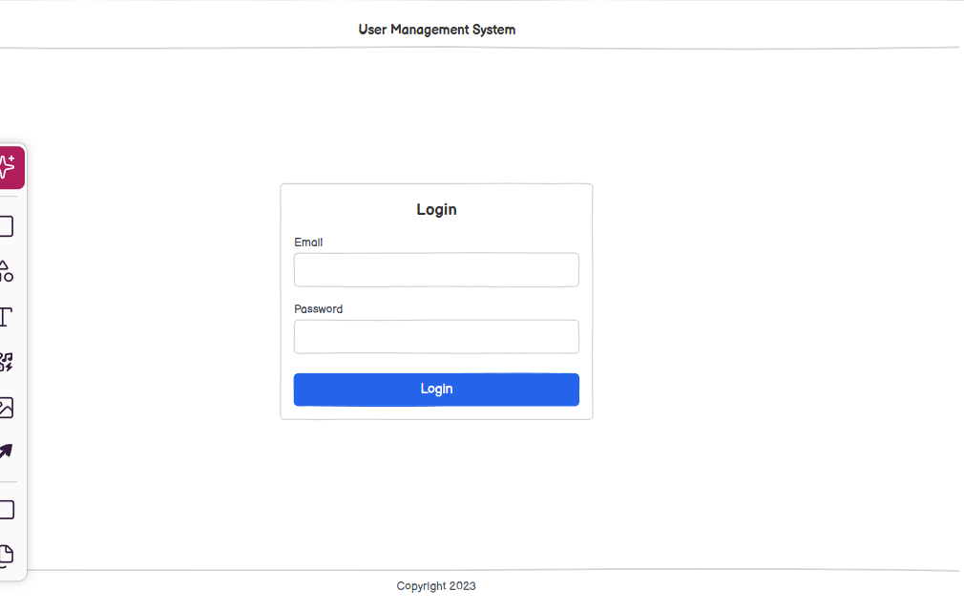
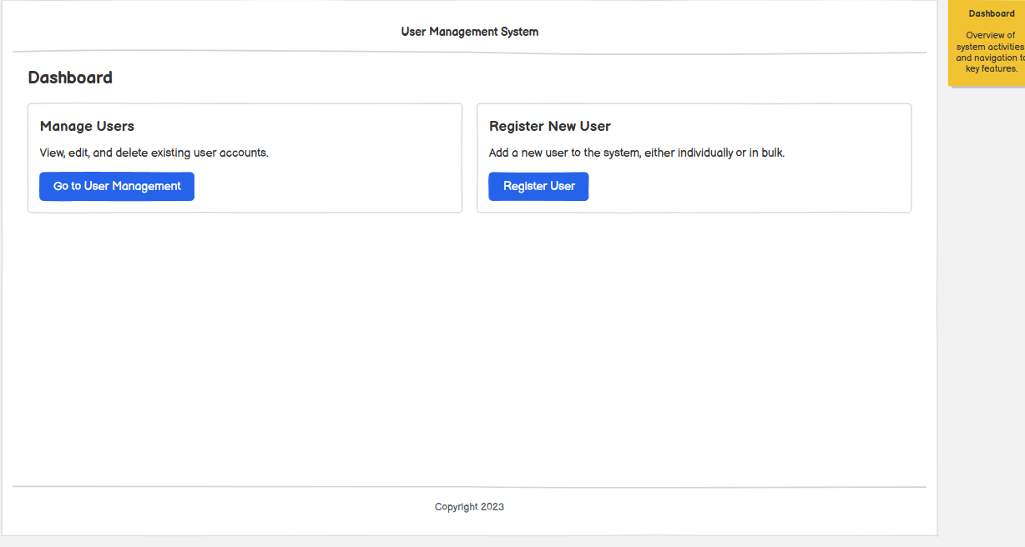

Description:
The storyboard represents the flow of an admin logging in, accessing the dashboard, performing bulk user upload, validating data, viewing results, and managing user profiles efficiently.
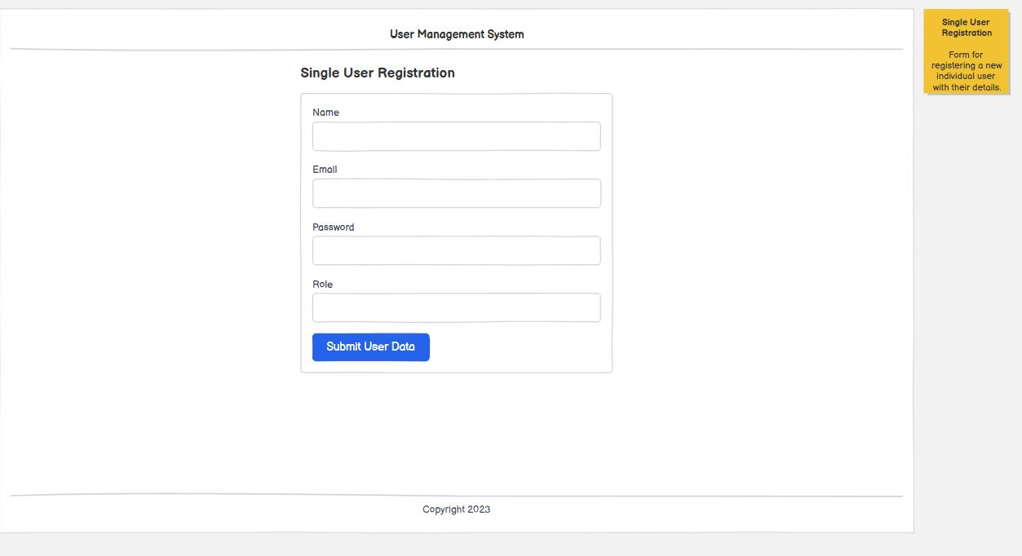
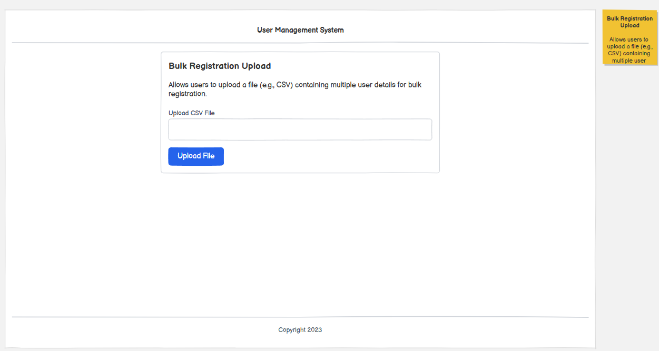
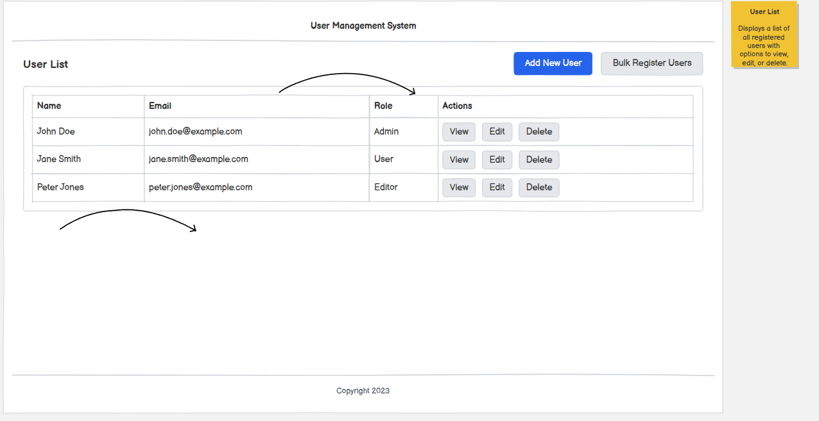

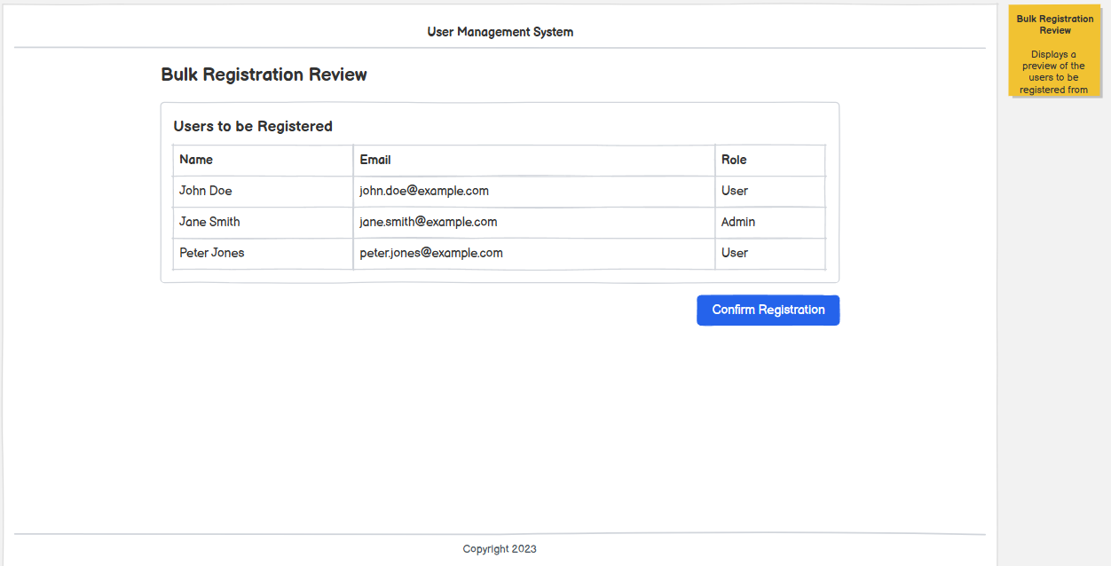

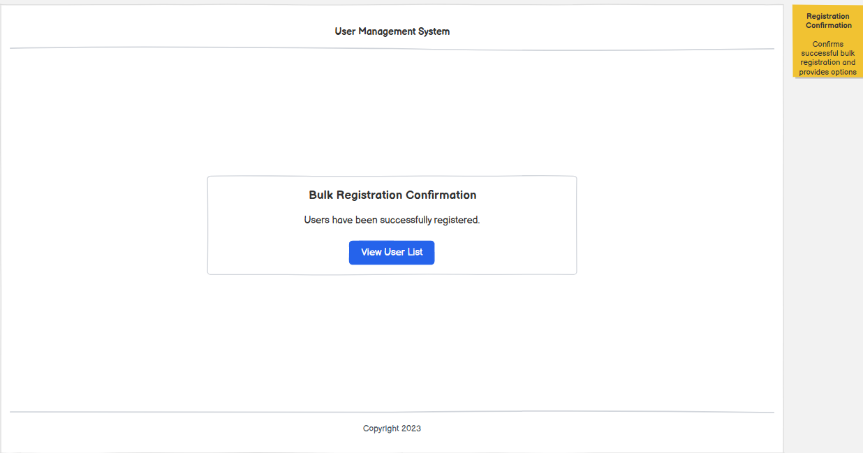
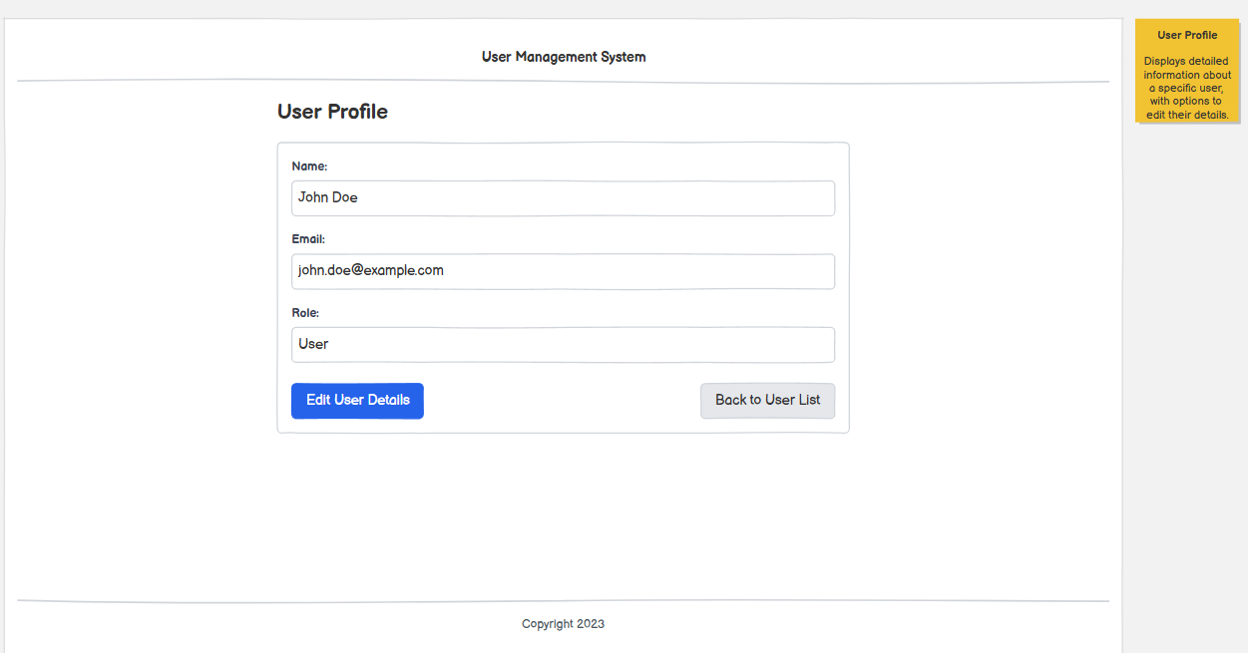

Story Board Details:
1 . Login Module
  - Allows users (Admin) to securely log in.
  - Requires:
    - Email
    - Password
  - After successful login, the user is redirected to the dashboard.

2 . Dashboard Module
  - Displays system overview:
    - Total Users
    - Active Users
    - Inactive Users
  - Provides navigation options:
    - Manage Users
    - Bulk Upload

3 . Bulk Upload Module
  - Enables uploading multiple users at once.
  - Features:
    - File upload
    - Role selection
    - Upload button
    - Template download option
  - Reduces manual data entry.

4 . Validation Module
  - Validates uploaded data.
  - Displays:
    - Valid records
    - Invalid records
  - Provides options:
    - Proceed (continue upload)
    - Cancel (stop process)

5 . Result Module:
- Shows upload summary:
- Total records
- Successfully added users
- Failed records
- Allows downloading error reports.

6 . User Management Module
  - Allows managing all users.
  - Features:
    - Search users
    - Filter by role
    - View user list
    - Download error report
  - Supports actions like edit, delete, activate, deactivate.

7 . User Flow
- User logs in
- Dashboard is displayed
- Admin selects bulk upload
- Uploads file and assigns role
- System validates data
- Admin proceeds after validation
- Results are shown
- Admin manages users

