CS23A34
User Interface and Design

Roll no: 240701224
Name : Kamalesh. V

Aim:
Experiment with different layouts and color schemes for an app. Collect user feedback on aesthetics and usability using GIMP(GNU Image Manipulation Program (GIMP).

Initial Design :
Home Page:

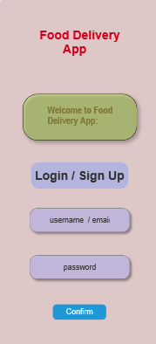
Login / Sign Up Option
- Button labeled: “Login / Sign Up”
- Allows users to either:
  - Log into an existing account
  - Register as a new user
Page 2 : Food Page

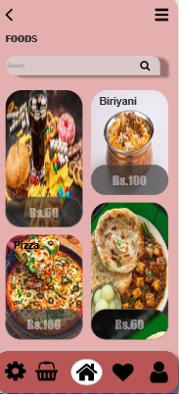
Header Section
- Includes:
  - Back Button (←) → Navigate to previous screen
  - Menu Icon (☰) → Opens navigation options
- Title: “FOODS”
- Positioned at the top

Search Bar
- Allows users to search for food items
- Includes:
  - Input field
  - Search icon
- Improves usability and quick access

Food Items Display
- Food items are shown in a grid layout
- Each item includes:
  - Food image
  - Food name (e.g., Biriyani, Pizza)
  - Price (e.g., Rs.60, Rs.100)

Page 3:
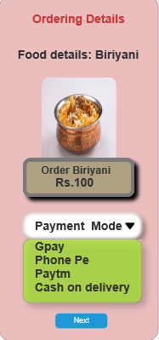
Function
- User can view order details
- Select payment method
- Click Next to continue

Page 4:

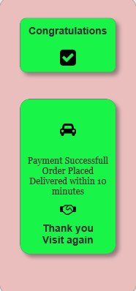

Function
- Confirms successful order
- Shows delivery information
- Gives feedback to the user

After User Feedback:
Page 1:
Home page :

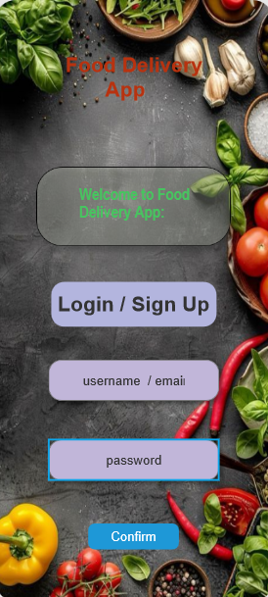
Components
- App title: Food Delivery App
- Welcome message
- Login / Sign Up button
- Input fields:
  - Username / Email
  - Password
- Confirm button
Improvements
- Added background food image
- Improved text visibility
- Better button styling

Page 2:
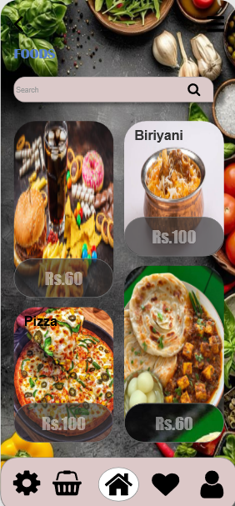
Components
- Header: FOODS
- Search bar
- Food items with:
  - Image
  - Name
  - Price
- Bottom navigation bar
Improvements
- Added attractive food background
- Improved card design & shadows
- Better image clarity

Page 3:
Components
- Title: Ordering Details
- Food details: Biriyani
- Food image
- Price: Rs.100
- Payment options:
  - GPay
  - PhonePe
  - Paytm
  - Cash on delivery
- Next button
Improvements
- Improved contrast with background
- Better highlight for price section
- Clear payment dropdown design

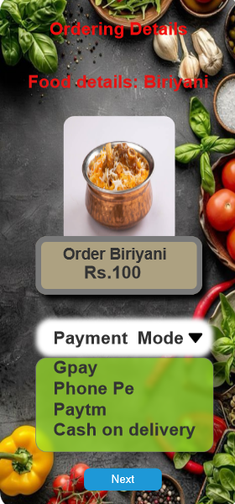`

Page 4:
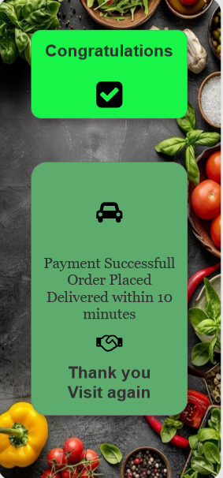

Components
- Message: Congratulations
- Success icon
- Text:
  - Payment successful
  - Order placed
  - Delivery within 10 minutes
- Thank you message
Improvements
- Added background food theme
- Enhanced success color (green)
- Improved readability and layout

Google Form :
Feedback:
