User Interface and Design
CS23A34
Roll no: 240701224
Name: Kamalesh. V

Experiment – 9
Design and Implementation of Input Validation Form using HTML, CSS, JavaScript (Validator.js)

AIM:
To design an input form that validates user data such as email, phone number, and password, and displays appropriate error messages using HTML, CSS, and JavaScript with Validator.js.

OBJECTIVE:
- To understand client-side validation.
- To validate user inputs in real-time .
- To improve user experience using error handling.

SOFTWARE REQUIREMENTS:
- Web Browser (Chrome / Edge) .
- Code Editor (VS Code / Notepad++).
- Internet (for Validator.js CDN) .

STEP 1: Create HTML Form
OUTPUT:
- A contact form is displayed with:
  - Email field
  - Phone number field
  - Password field
  - Submit and Reset buttons

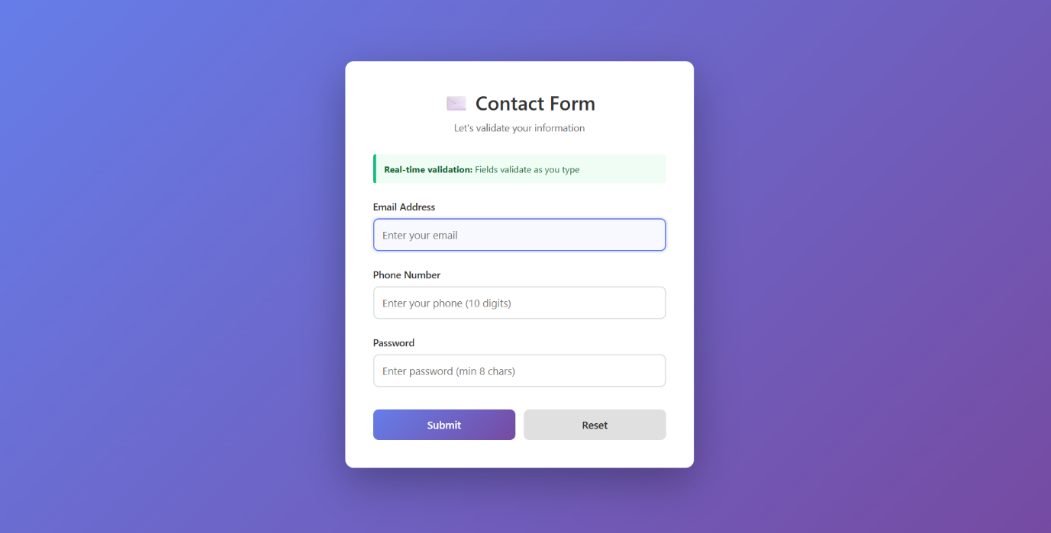

STEP 2: Apply CSS Styling
OUTPUT:
- Form is centered on screen .
- Background gradient applied .
- Input fields styled .
- Error messages appear in red.
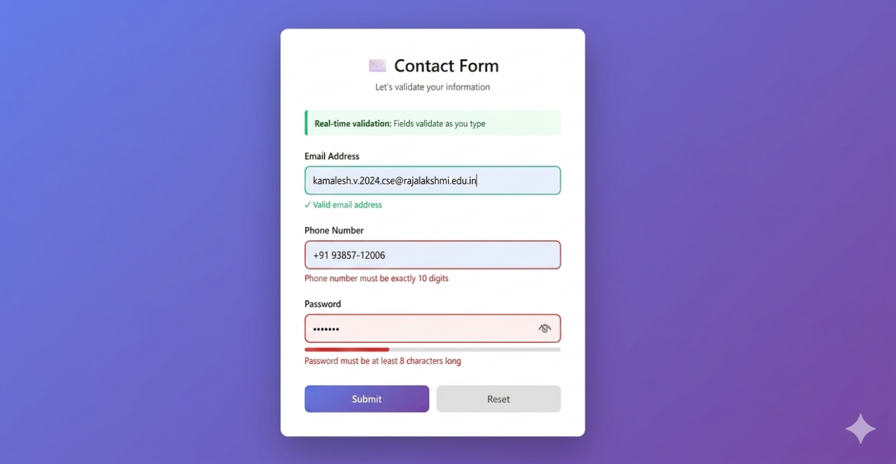
STEP 3: Add JavaScript Validation
OUTPUT (INVALID INPUT):
- Email shows error if format is wrong.
- Phone shows error if not 10 digits .
- Password shows error if less than 8 characters.

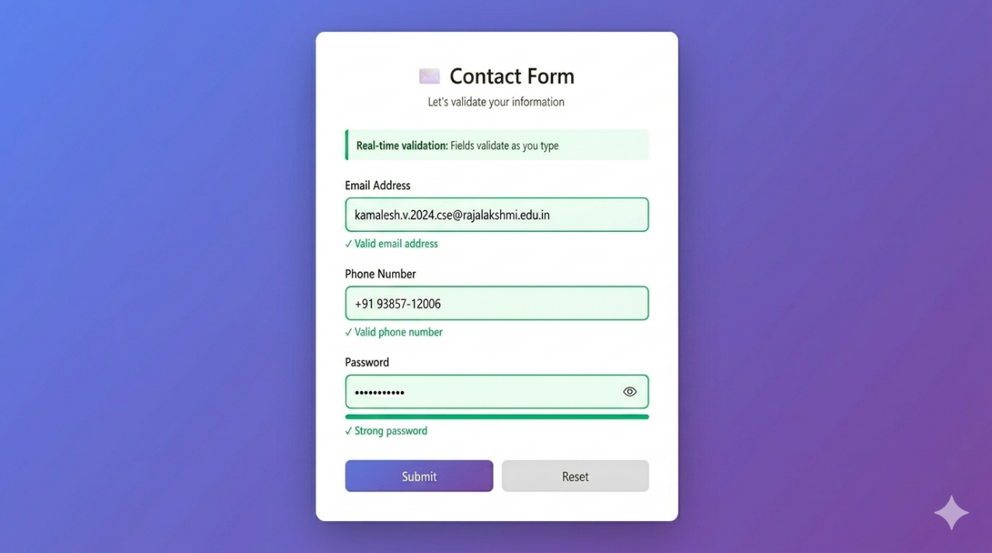

STEP 4: Valid Input Handling
OUTPUT (VALID INPUT):
- All fields show green border
- Messages like:
  - “Valid email address”
  - “Valid phone number”
  - “Strong password”

STEP 5: Final Submission
OUTPUT:
- Success message displayed:
“Form validated successfully”
- Option to submit another response



