Experiment -2
NAME: KAMALESH. V ROLL NO:240701224
Design a UI where users recall visual elements (e.g., icons or text chunks). Evaluate the effect of chunking on user memory.
EXPERIMENT: VISUAL MEMORY RECALL USING “SPOT THE DIFFERENCE” GAME
Objective:
Design a UI where users recall visual elements and evaluate the effect of chunking on user memory using a game-based approach.
FRAME 1: INTRODUCTION PAGE
Analysis of the Introduction Screen
This screen introduces the user to the Memorial Task – Spot the Difference game and sets the cognitive context for the experiment.

1. Purpose of the Screen
- Introduces the concept of visual memory recall.
- Explains that the task is based on spotting differences between images.
- Prepares users for a memory-based activity.

2. Chunking Strategy Applied
- Information is divided into short paragraphs instead of long text.
- Key ideas such as game objective, memory focus, and chunking concept are clearly separated.
- This reduces cognitive load and improves comprehension.

3. Visual & UX Design
- Simple background with minimal distractions.
- Clear heading “Memorial Task” draws attention.
- “NEXT” button provides clear navigation to the next stage.

4. Cognitive Benefit
- Gradual introduction helps users understand the task before performing it.
- Chunked explanation improves information retention.

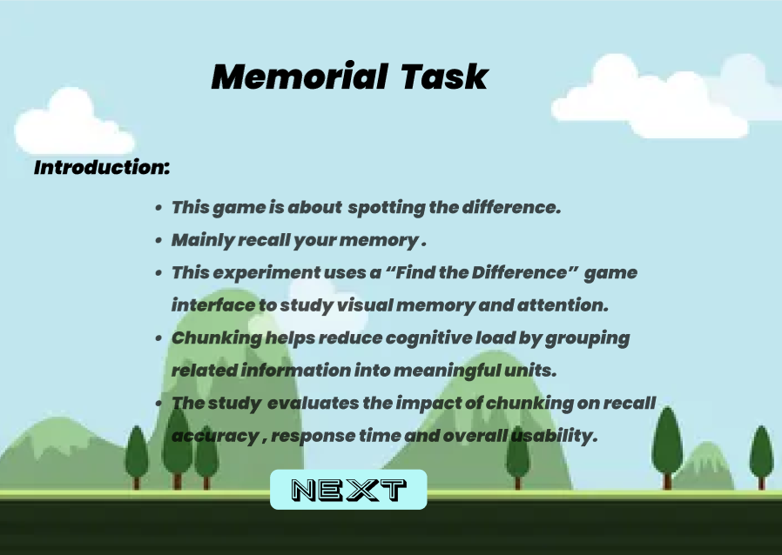
FRAME 2: INSTRUCTION PAGE
Analysis of the Instruction Screen
This screen provides step-by-step instructions for playing the Spot the Difference game.

1. Purpose of the Screen
- Guides users on how to perform the task correctly.
- Sets clear rules to avoid confusion during gameplay.

2. Chunking of Instructions
- Instructions are presented as bullet points.
- Each bullet focuses on a single action:
  - Observe images carefully
  - Find differences
  - Click on changed elements
  - Accuracy over speed

3. Visual Hierarchy
- Instructions are placed centrally for readability.
- “START” button is highlighted to indicate the next action.

4. Cognitive & UX Benefits
- Chunked instructions reduce mental effort.
- Clear sequencing improves task execution.

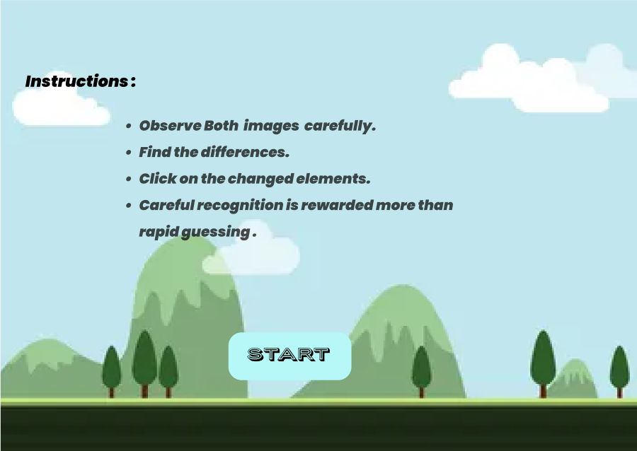
FRAME 3: GAME SCREEN – OBSERVATION PHASE
Analysis of the Spot the Difference Game Screen
This screen represents the visual encoding phase, where users observe two similar images.

1. Purpose of the Screen
- Allows users to observe and memorize visual elements.
- Users begin forming mental representations of the scene.

2. Chunking in Visual Design
- Images are placed side by side, enabling easy comparison.
- Visual elements are grouped naturally (furniture, toys, decorations).
- This grouping helps users remember elements as chunks rather than individual objects.

3. Interactive Elements
- “GO” button indicates transition to recall phase.
- Clean layout avoids unnecessary distractions.

4. Cognitive Benefit
- Chunked visual layout supports short-term memory encoding.
- Enhances pattern recognition and spatial memory.
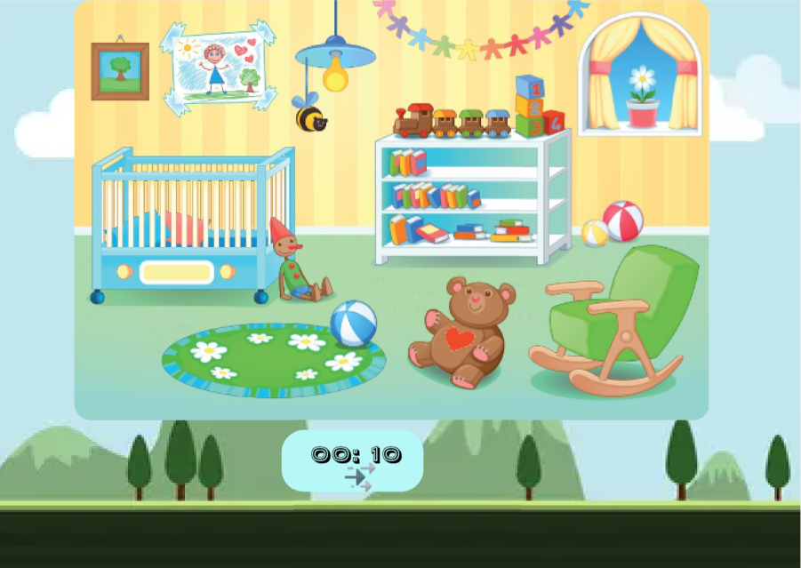
FRAME 4: RECALL PHASE
Analysis of the Recall Screen
This screen tests the user’s ability to recall and identify differences.

1. Purpose of the Screen
- Evaluates visual memory retrieval.
- Users actively recall previously seen differences.

2. Chunking Strategy
- Differences are placed within related areas of the image.
- Users recall changes by focusing on grouped regions.

3. Interaction Design
- Users click on detected differences.
- “SUBMIT” button finalizes their recall choices.

4. Cognitive & UX Benefits
- Encourages accurate recall rather than guessing.
- Tests effectiveness of chunked memory storage.

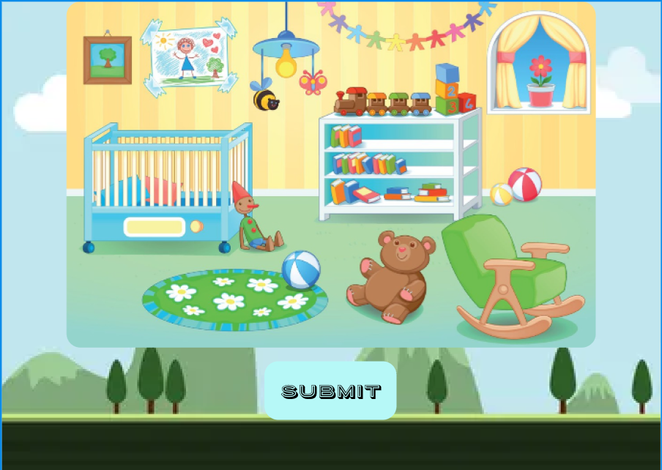

FRAME 5: FINAL SCORECARD
Analysis of the Scorecard Screen
This screen provides feedback on the user’s performance.
1. Purpose of the Screen
- Displays final recall score.
- Summarizes user performance clearly.

2. Score Presentation
- Score shown as 5/6, indicating correct differences found.
- A circular progress indicator visually represents performance.

3. Feedback & Motivation
- Simple, uncluttered design focuses attention on results.
- Helps users understand how well they performed.

4. Cognitive & UX Benefits
- Immediate feedback reinforces learning.
- Visual score representation improves result comprehension.
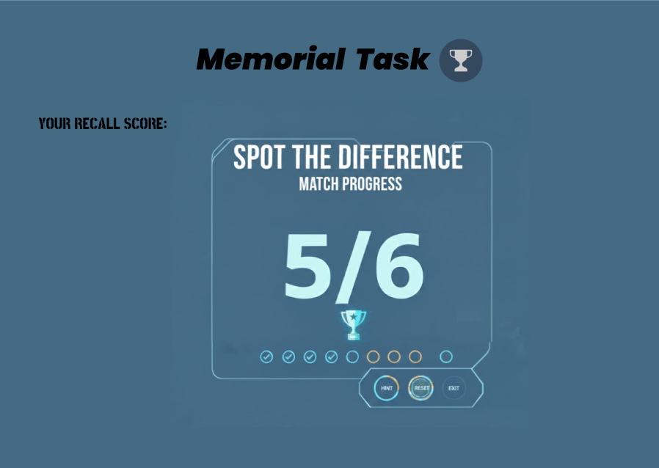

PROTOTYPE LINK:
https://www.figma.com/proto/XoW9CVmWxC7spY5R2mT387/Memorial-Task?node-id=7-10&t=W050shToA6kQWp6l-0&scaling=scale-down&content-scaling=fixed&page-id=0%3A1&starting-point-node-id=7%3A10

