EXPERIMENT - 4

AI – Study plan

ROLL NO: 240701224 NAME: KAMALESH. V
Create a prototype with familiar and unfamiliar navigation elements. Evaluate ease of use with different user groups using proto.io

Screen 1:
Home page for AI-Study plan
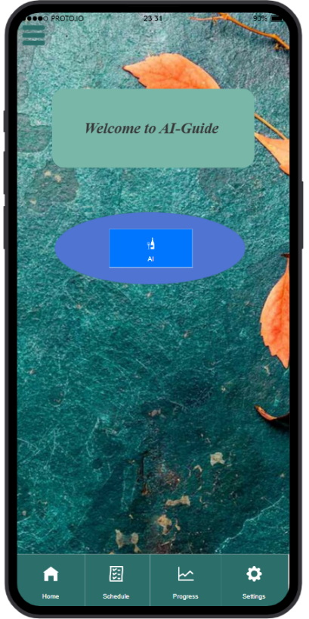
Home page:

Unfamiliar Element:

AI Floating Interaction:
o Instead of traditional navigation, users receive intelligent suggestions.
o Represents smart, AI-driven navigation assistance.

Familiar Icons:

Profile Image (Top Section):
o Represents the user’s account identity.
o Used to display or edit personal information.

Home Icon (Bottom Left):
o A widely recognized navigation icon.
o Clicking it takes the user back to the Home screen.

Text Labels (Profile, Student Name):
o Standard UI elements used for identification and user information display.

Screen 2:
Progress page:
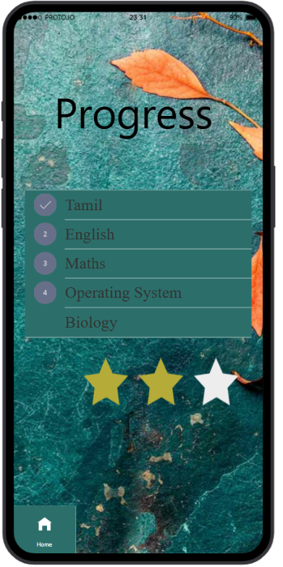
Familiar Icons:
- Subject List (Tamil, English, Maths, OS, Biology):
o Standard list view used in educational apps.
- Star Rating :
o Represents performance level.
o Common rating indicator in many applications.
- Home Button:
o Navigates back to dashboard.

Screen 3:
Menu page:

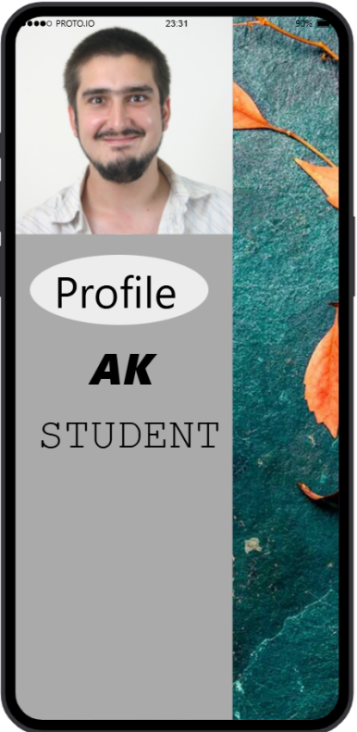

Screen 4:
Scheduling Page:

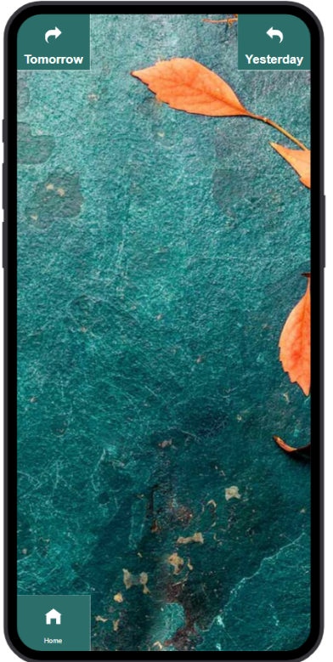

Familiar Icons:
- Tomorrow Button (Top Left):
o Used for navigating to the next day’s plan.
- Yesterday Button (Top Right):
o Used for navigating to the previous day’s plan.
- Home Icon (Bottom):
o Returns user to dashboard.

Unfamiliar Navigation:
- Swipe Gesture Navigation:
o Swipe Left → Tomorrow’s Plan
o Swipe Right → Yesterday’s Plan
o This gesture-based navigation replaces traditional button-only navigation.

Screen 5:
Scheduling Page 1:

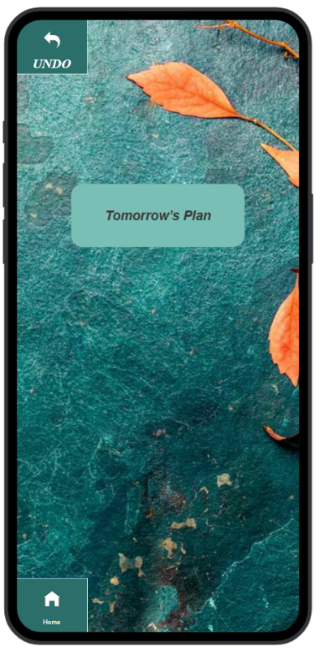

Tomorrow’s Plan Page

Familiar Icons:
- Undo Button (Top Left):
o Allows user to return to previous screen.
- Home Button (Bottom):
o Returns to Home screen.

Screen 6:
Scheduling page 2:

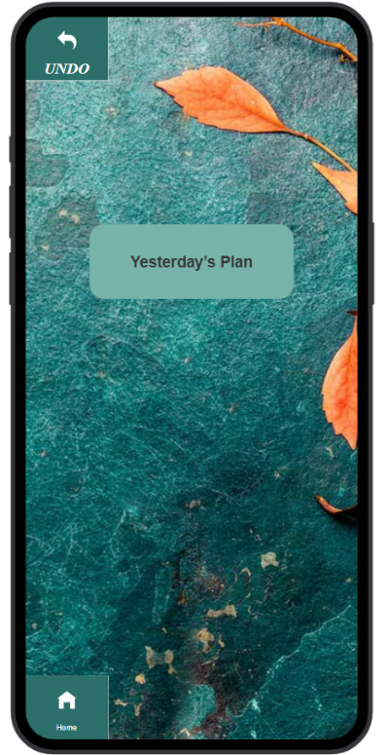

Yesterday’s Plan Page

Familiar Icons:
- Undo Button (Top Left)
- Home Button (Bottom)

Unfamiliar Navigation:
- Accessed via Swipe Gesture
- Gesture-based movement between days

Screen 7: AI suggestion page:

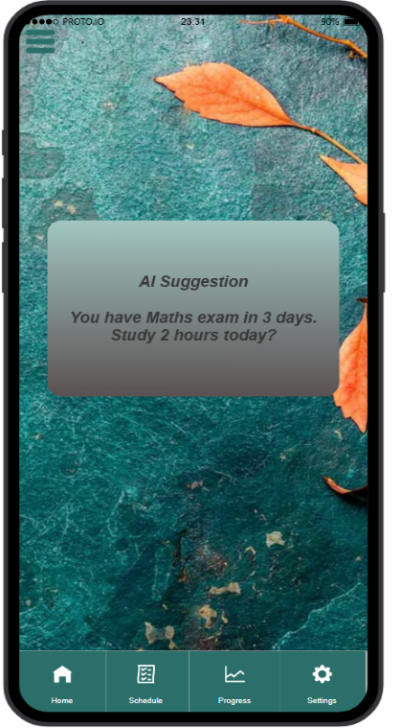

Unfamiliar Navigation Element:

1.AI Suggestion Dialog Box:
  - o Displays smart recommendation:
“You have Maths exam in 3 days. Study 2 hours today?”
    - Context-aware suggestion system.
Not commonly seen in basic study planner apps.

2.Dynamic Assistance Feature:
o Instead of user manually searching for schedule, AI recommends tasks automatically.

Prototype Link: https://pr.to/BSHIPN/

