CS23A34
USER INTERFACE DESIGN EXPERIMENT-5
ROLL NO: 240701224
NAME: KAMALESH. V
Aim
To analyze the user interaction process in a ticket booking in bus application and represent it using a user flow diagram in Lucidchart.

User Flow Description
- App Launch
  - Start
  - Open the app
  - Enter / Confirm location
  - Search bus (Enter source & destination)

- Bus Selection
  - View available bus list
  - Select bus
  - View bus details (time, fare, seat availability)
  - Select date
  - Select seats

- Passenger Details & Checkout
  - Enter passenger details
  - Review booking details
  - Proceed to checkout

- Login Decision
  - If not logged in → Log in / Sign up
  - If logged in → Confirm contact details

- Payment Process
  - Select payment method
  - Enter payment details
  - Confirm booking
  - Ticket confirmation (E-ticket generated)

Conclusion
The experiment demonstrates how a structured user flow improves clarity and usability in a bus ticket booking system. The login decision ensures user authentication before payment. Proper step-by-step navigation from bus selection to payment confirmation enhances user experience and ensures successful ticket booking

FLOWCHART

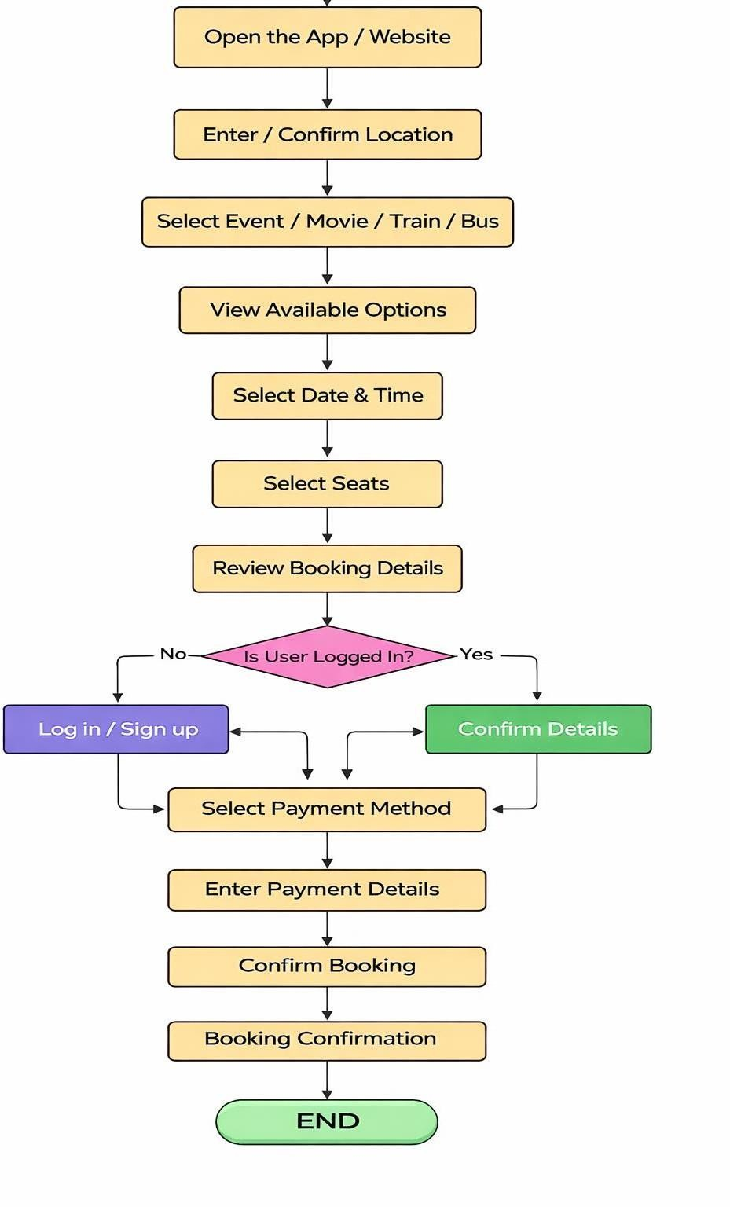

Wireframe:

