**PROJECT**

How To Create Brand Name , Brand Mail , And Brand Logo In Canva.

Step 1:

Select a brand name for own brand .

Step 2:

Create a new mail for our own brand.

Step 3:

Create a brand logo using canva.

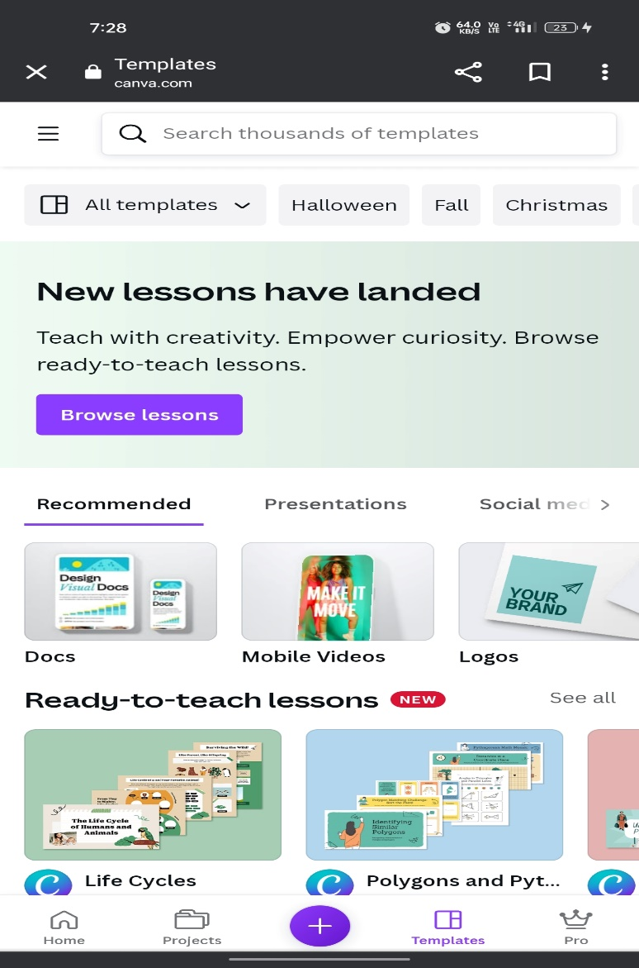

Step 4:

Search the logo for our brand .

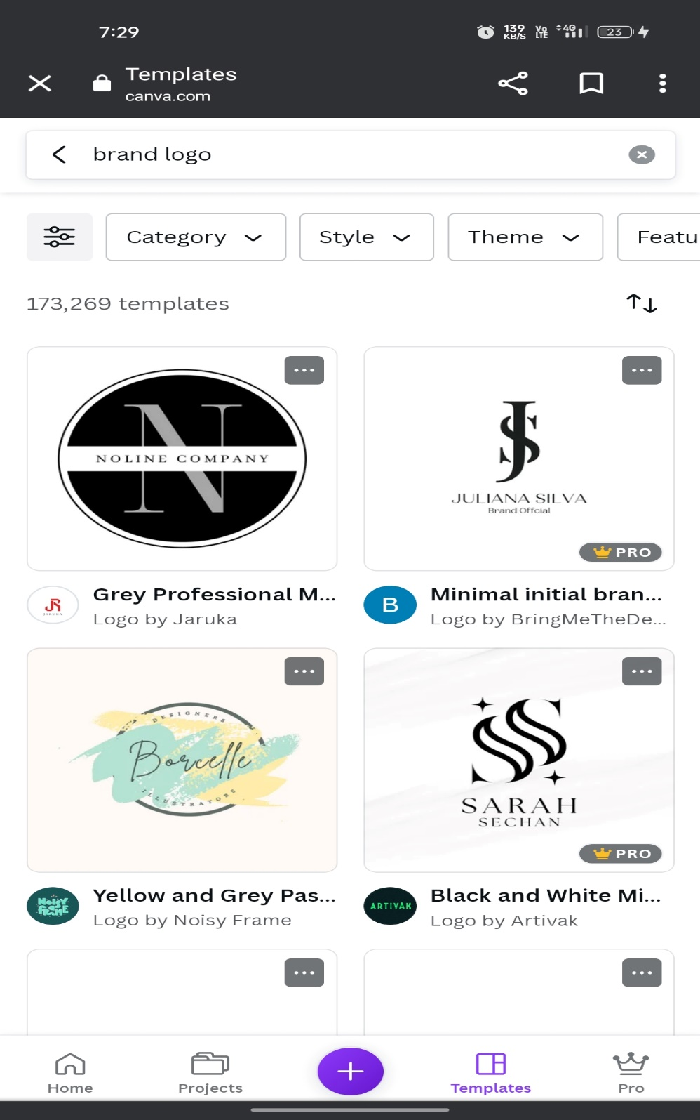

Step 5:

Select the logo .

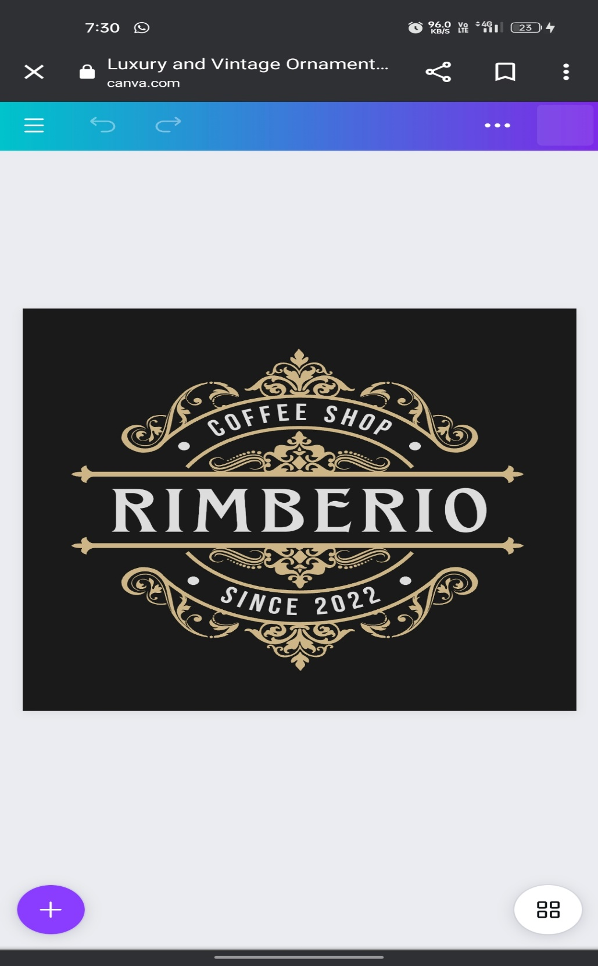

Step 6:

Finally edit the logo for our own brand .

