**CC-1**

**Q1**

package porm.test.demo;

import org.openqa.selenium.By;

import org.openqa.selenium.WebDriver;

import org.openqa.selenium.WebElement;

import org.openqa.selenium.chrome.ChromeDriver;

import org.openqa.selenium.chrome.ChromeOptions;

import io.github.bonigarcia.wdm.WebDriverManager;

public class ccq1 {

public static void main(String[] args) throws InterruptedException {

// TODO Auto-generated method stub

ChromeOptions co=new ChromeOptions();

co.addArguments ("--remote-allow-origins=*");

WebDriverManager.chromedriver().setup ();

WebDriver driver=new ChromeDriver(co);

driver.get ("https://www.saucedemo.com/");

driver.manage().window().maximize() ;

WebElement txtBoxl=driver.findElement(By.xpath("//*[@id=\"user-name\"]"));

txtBoxl.sendKeys("standard_user");

WebElement txtBox2=driver.findElement(By.xpath("//*[@id=\"password\"]"));

txtBox2.sendKeys("secret_sauce");

driver.findElement(By.xpath("//*[@id=\"login-button\"]")).click();

driver.findElement(By.xpath("//*[@id=\"add-to-cart-sauce-labs-backpack\"]")).click();

driver.findElement(By.xpath("//*[@id=\"shopping_cart_container\"]/a")).click();

driver.findElement(By.xpath("//*[@id=\"checkout\"]")).click();

WebElement txtBox3=driver.findElement(By.xpath("//*[@id=\"first-name\"]"));

txtBox3.sendKeys("kamalesh");

WebElement txtBox4=driver.findElement(By.xpath("//*[@id=\"last-name\"]"));

txtBox4.sendKeys("k");

WebElement txtBox5=driver.findElement(By.xpath("//*[@id=\"postal-code\"]"));

txtBox5.sendKeys("627754");

driver.findElement(By.xpath("//*[@id=\"continue\"]")).click();

String txt1=driver.findElement(By.xpath("//*[@id=\"item_4_title_link\"]/div")).getText();

System.out.println(txt1);

String txt2=driver.findElement(By.xpath("//*[@id=\"checkout_summary_container\"]/div/div[2]/div[8]")).getText();

System.out.println(txt2);

String currentTitle=driver.getTitle();

System.out.println(currentTitle);

String expectedTitle="Swag Labs";

if(currentTitle.equals(expectedTitle)) {

System.out.println("Title Matched");

}

else {

System.out.println("Title not Matched");

}

String currentUrl=driver.getCurrentUrl();

String expectedUrl="https://www.saucedemo.com/checkout-step-two.html";

if(currentUrl.equals(expectedUrl)) {

System.out.println("URL Matched");

}

else {

System.out.println("URL not Matched");

}

Thread.sleep(5000);

}

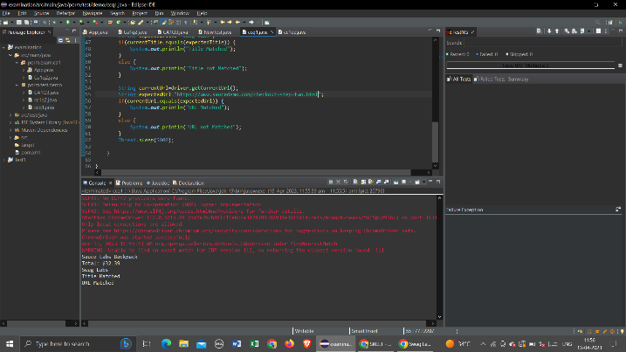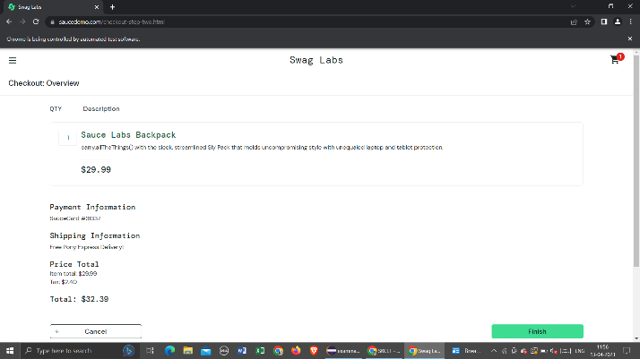}

**Output:**

**Q2**

package porm.test.demo;

import org.openqa.selenium.By;

import org.openqa.selenium.WebDriver;

import org.openqa.selenium.WebElement;

import org.openqa.selenium.chrome.ChromeDriver;

import org.openqa.selenium.chrome.ChromeOptions;

import io.github.bonigarcia.wdm.WebDriverManager;

public class cc1q2 {

public static void main(String[] args) throws InterruptedException {

// TODO Auto-generated method stub

ChromeOptions co=new ChromeOptions();

co.addArguments ("--remote-allow-origins=*");

WebDriverManager.chromedriver().setup ();

WebDriver driver=new ChromeDriver(co);

driver.get ("https://www.saucedemo.com/");

driver.manage().window().maximize() ;

WebElement txtBoxl=driver.findElement(By.xpath("//*[@id=\"user-name\"]"));

txtBoxl.sendKeys("standard_user");

WebElement txtBox2=driver.findElement(By.xpath("//*[@id=\"password\"]"));

txtBox2.sendKeys("secret_sauce");

driver.findElement(By.xpath("//*[@id=\"login-button\"]")).click();

String txt1=driver.findElement(By.xpath("//*[@id=\"item_4_title_link\"]/div")).getText();

System.out.println(txt1);

driver.findElement(By.xpath("//*[@id=\"header_container\"]/div[2]/div/span/select")).click();

driver.findElement(By.xpath("//*[@id=\"header_container\"]/div[2]/div/span/select/option[2]")).click();

String txt2=driver.findElement(By.xpath("//*[@id=\"item_3_title_link\"]/div")).getText();

System.out.println(txt2);

driver.findElement(By.xpath("//*[@id=\"header_container\"]/div[2]/div/span/select")).click();

driver.findElement(By.xpath("//*[@id=\"header_container\"]/div[2]/div/span/select/option[3]")).click();

String txt3=driver.findElement(By.xpath("//*[@id=\"item_2_title_link\"]/div")).getText();

System.out.println(txt3);

driver.findElement(By.xpath("//*[@id=\"header_container\"]/div[2]/div/span/select")).click();

driver.findElement(By.xpath("//*[@id=\"header_container\"]/div[2]/div/span/select/option[4]")).click();

String txt4=driver.findElement(By.xpath("//*[@id=\"item_5_title_link\"]/div")).getText();

System.out.println(txt4);

Thread.sleep(5000);

}

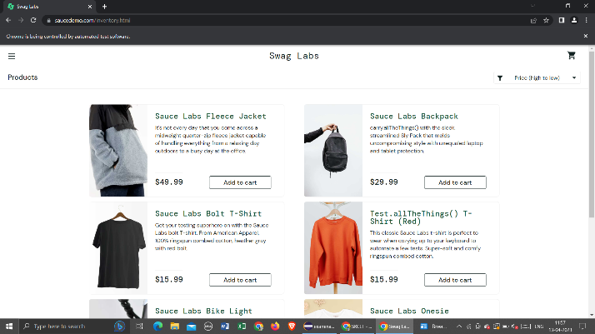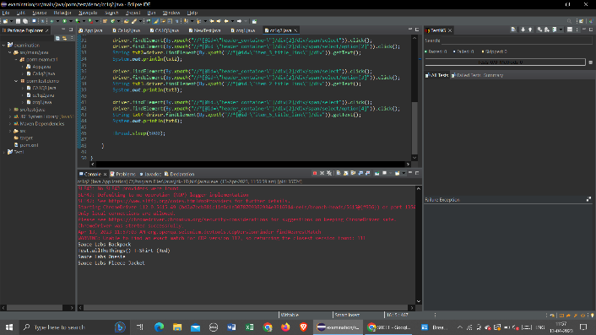}

**Output:**