**Q1:**

package porm.exam.ca1;

import org.openqa.selenium.By;

import org.openqa.selenium.JavascriptExecutor;

import org.openqa.selenium.WebDriver;

import org.openqa.selenium.WebElement;

import org.openqa.selenium.chrome.ChromeDriver;

import org.openqa.selenium.chrome.ChromeOptions;

import io.github.bonigarcia.wdm.WebDriverManager;

/**

* Hello world!

*

*/

public class App

{

public static void main( String[] args ) throws InterruptedException

{

ChromeOptions co=new ChromeOptions();

co.addArguments("--remote-allow-origins=*");

WebDriverManager.chromedriver().setup();

WebDriver d=new ChromeDriver(co);

// TODO Auto-generated method stub

ChromeOptions co1=new ChromeOptions();

co1.addArguments ("--remote-allow-origins=*");

WebDriverManager.chromedriver().setup ();

WebDriver driver=new ChromeDriver(co1);

driver.get ("https://www.amazon.in/Fire-Boltt-Bluetooth-Calling-Assistance-Resolution/dp/B0BF57RN3K/ref=sr_1_1?pd_rd_r=409b3030-7867-4121-a31d-a60d9451d0ca&pd_rd_w=lvK72&pd_rd_wg=vpblK&pf_rd_p=3a59b28c-4626-48f9-b66f-114571ee563d&pf_rd_r=722H7NPQ0Q655R1NJNXP&qid=1681290834&sr=8-1");

driver.manage().window().maximize() ;

String currentTitle=driver.getTitle();

System.out.println(currentTitle);

String expectedTitle="Fire-Boltt Ninja Call Pro Plus 1.83\" Smart Watch with Bluetooth Calling, AI Voice Assistance, 100 Sports Modes IP67 Rating, 240 * 280 Pixel High Resolution (Black) - Amazon.in";

if(currentTitle.equals(expectedTitle)) {

System.out.println("Title Matched");

}

else {

System.out.println("Title not Matched");

}

driver.findElement(By.xpath("//*[@id=\"add-to-cart-button\"]")).click();

driver.findElement(By.xpath("//*[@id=\"nav-cart\"]")).click();

driver.findElement(By.xpath("//*[@id=\"a-autoid-0-announce\"]")).click();

driver.findElement(By.xpath("//*[@id=\"quantity_4\"]")).click();

driver.findElement(By.xpath("//*[@id=\"sc-buy-box-ptc-button\"]/span/input")).click();

WebElement txtBoxl=driver.findElement(By.xpath("//*[@id=\"ap_email\"]"));

txtBoxl.sendKeys("7502840773");

WebElement txtBox2=driver.findElement(By.xpath("//*[@id=\"ap_email\"]"));

txtBox2.sendKeys("7502840773");

// driver.navigate().back();

Thread.sleep(5000);

// driver.findElement(By.xpath("//*[@id=\"Mod112\"]/div/div/ul/li[1]/h4/a")).click();

}}

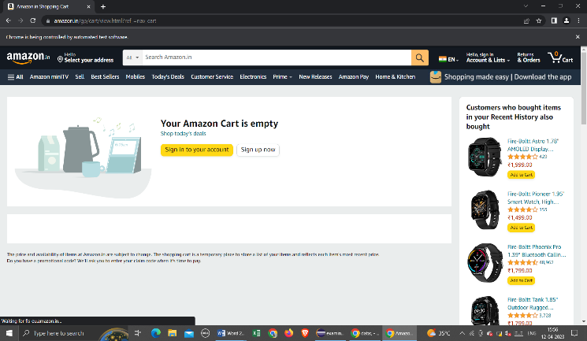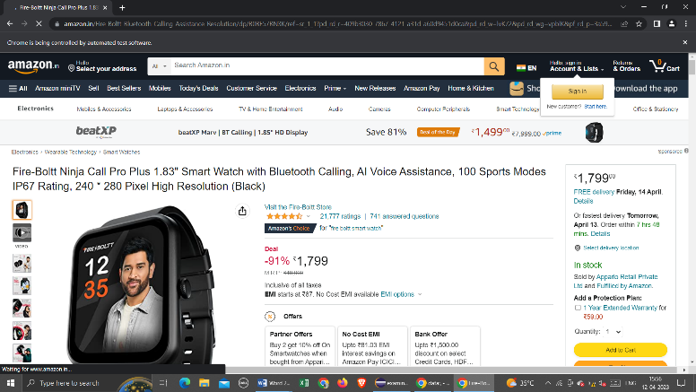

**Q2:**

package porm.exam.ca1;

import org.openqa.selenium.By;

import org.openqa.selenium.WebDriver;

import org.openqa.selenium.WebElement;

import org.openqa.selenium.chrome.ChromeDriver;

import org.openqa.selenium.chrome.ChromeOptions;

import io.github.bonigarcia.wdm.WebDriverManager;

public class Ca1q2 {

public static void main(String[] args) {

// TODO Auto-generated method stub

ChromeOptions co=new ChromeOptions();

co.addArguments ("--remote-allow-origins=*");

WebDriverManager.chromedriver().setup ();

WebDriver driver=new ChromeDriver(co);

driver.get ("https://www.amazon.in/");

driver.manage().window().maximize() ;

String currentTitle=driver.getTitle();

System.out.println(currentTitle);

String expectedTitle="Online Shopping site in India: Shop Online for Mobiles, Books, Watches, Shoes and More - Amazon.in";

if(currentTitle.equals(expectedTitle)) {

System.out.println("Title Matched");

}

else {

System.out.println("Title not Matched");

}

WebElement txtBoxl=driver.findElement(By.xpath("//*[@id=\"twotabsearchtextbox\"]"));

txtBoxl.sendKeys("macbook");

driver.findElement(By.xpath("//*[@id=\"nav-search-submit-button\"]")).click();

//displaying 5 products

String txt1=driver.findElement(By.xpath("//*[@id=\"search\"]/div[1]/div[1]/div/span[1]/div[1]/div[3]/div/div/div/div/div/div/div/div[2]/div/div/div[1]/h2/a/span")).getText();

System.out.println(txt1);

String txt2=driver.findElement(By.xpath("//*[@id=\"search\"]/div[1]/div[1]/div/span[1]/div[1]/div[4]/div/div/div/div/div/div/div/div[2]/div/div/div[1]/h2/a/span")).getText();

System.out.println(txt2);

String txt3=driver.findElement(By.xpath("//*[@id=\"search\"]/div[1]/div[1]/div/span[1]/div[1]/div[5]/div/div/div/div/div/div[2]/div/div/div[1]/h2/a/span")).getText();

System.out.println(txt3);

String txt4=driver.findElement(By.xpath("//*[@id=\"search\"]/div[1]/div[1]/div/span[1]/div[1]/div[6]/div/div/div/div/div/div[2]/div/div/div[1]/h2/a/span")).getText();

System.out.println(txt4);

String txt5=driver.findElement(By.xpath("//*[@id=\"search\"]/div[1]/div[1]/div/span[1]/div[1]/div[7]/div/div/div/div/div/div[2]/div/div/div[1]/h2/a/span")).getText();

System.out.println(txt5);

//filter

driver.findElement(By.xpath("//*[@id=\"p_36/7252032031\"]/span/a/span")).click();

driver.findElement(By.xpath("//*[@id=\"p_n_pattern_browse-bin/1464446031\"]/span/a/span")).click();

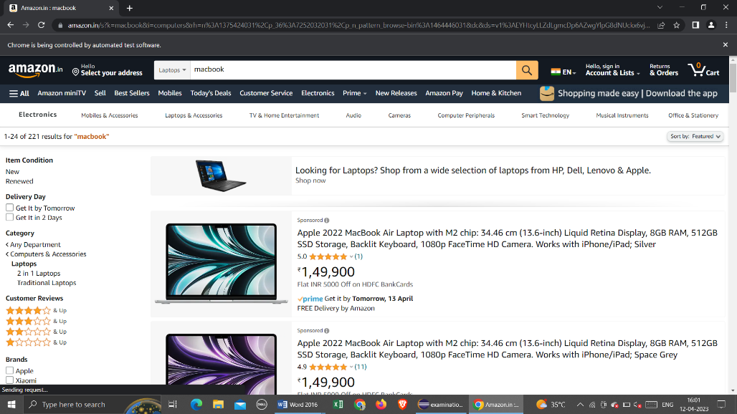

}}

**Q3:**

package porm.test.demo;

import org.openqa.selenium.By;

import org.openqa.selenium.WebDriver;

import org.openqa.selenium.WebElement;

import org.openqa.selenium.chrome.ChromeDriver;

import org.openqa.selenium.chrome.ChromeOptions;

import io.github.bonigarcia.wdm.WebDriverManager;

public class CA1Q3 {

public static void main(String[] args) {

// TODO Auto-generated method stub

ChromeOptions co=new ChromeOptions();

co.addArguments ("--remote-allow-origins=*");

WebDriverManager.chromedriver().setup ();

WebDriver driver=new ChromeDriver(co);

driver.get ("https://www.amazon.in/");

driver.manage().window().maximize() ;

String currentTitle=driver.getTitle();

System.out.println(currentTitle);

String expectedTitle="Online Shopping site in India: Shop Online for Mobiles, Books, Watches, Shoes and More - Amazon.in";

if(currentTitle.equals(expectedTitle)) {

System.out.println("Title Matched");

}

else {

System.out.println("Title not Matched");

}

driver.findElement(By.xpath("//*[@id=\"nav-link-accountList\"]")).click();

WebElement txtBoxl=driver.findElement(By.xpath("//*[@id=\"ap_email\"]"));

txtBoxl.sendKeys("9345611608");

driver.findElement(By.xpath("//*[@id=\"continue\"]")).click();

WebElement txtBox2=driver.findElement(By.xpath("//*[@id=\"ap_password\"]"));

txtBox2.sendKeys("kamalesh0617");

driver.findElement(By.xpath("//*[@id=\"signInSubmit\"]")).click();

driver.findElement(By.xpath("//*[@id=\"nav-link-accountList\"]")).click();

driver.findElement(By.xpath("//*[@id=\"a-page\"]/div[2]/div/div[2]/div[1]/a/div/div")).click();

driver.findElement(By.xpath("//*[@id=\"a-autoid-2-announce\"]")).click();

driver.findElement(By.xpath("//*[@id=\"ordersInPackage-container\"]/div/div/a[1]")).click();

