System Architecture Specification
Project: Intelligent Face Tracker with Auto-Registration and Visitor Counting
Hackathon: Katomaran Hackathon (https://katomaran.com)
Architecture Version: 1.0.0
Status: Verified against working implementation

1. End-to-End System Flow Diagram
The following Mermaid diagram maps the end-to-end execution flow from raw video ingress to analytics and audit persistence:
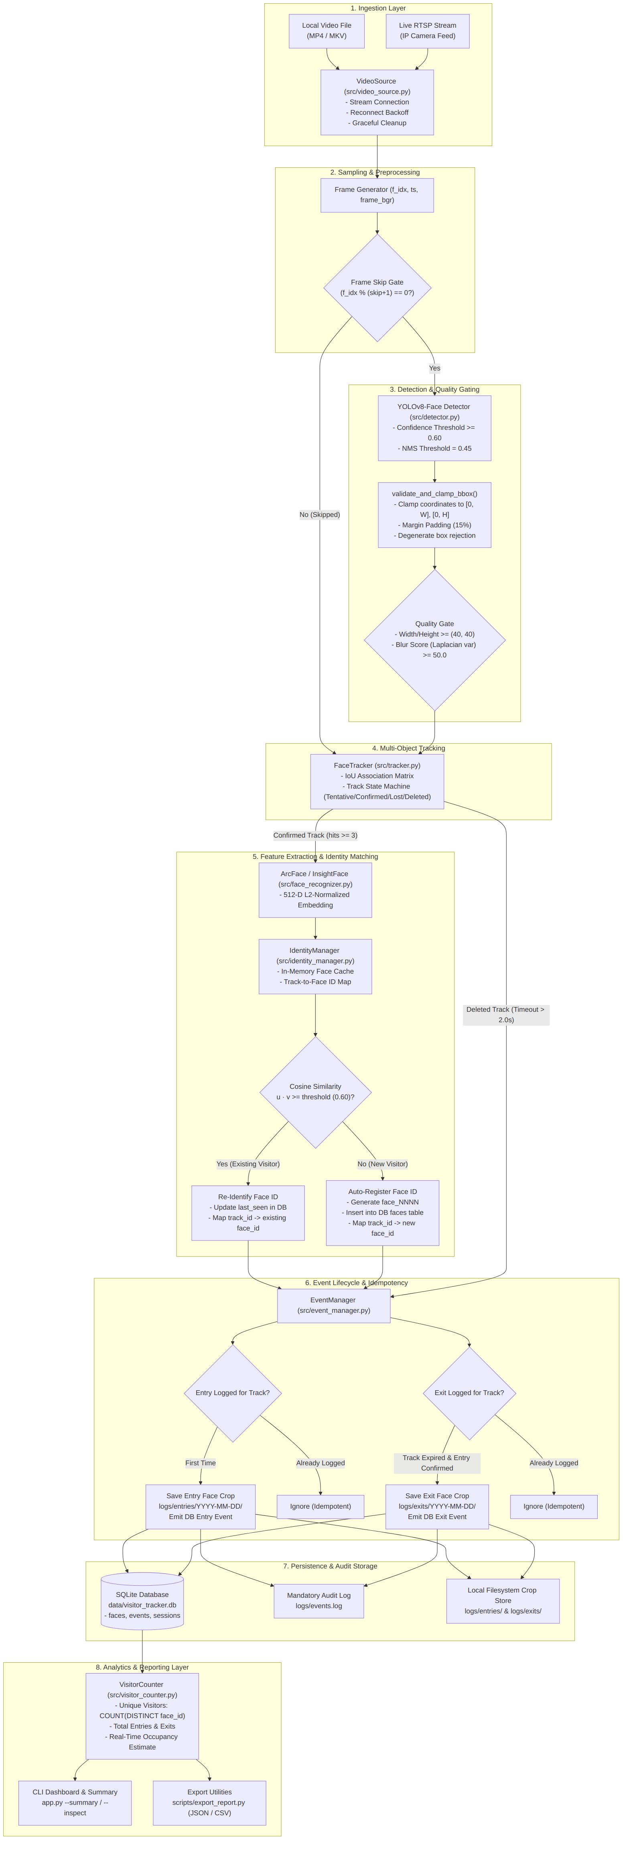
End-to-End System Flow

2. Component Architecture Diagram
The component view details the separation of concerns and interfaces across modules:
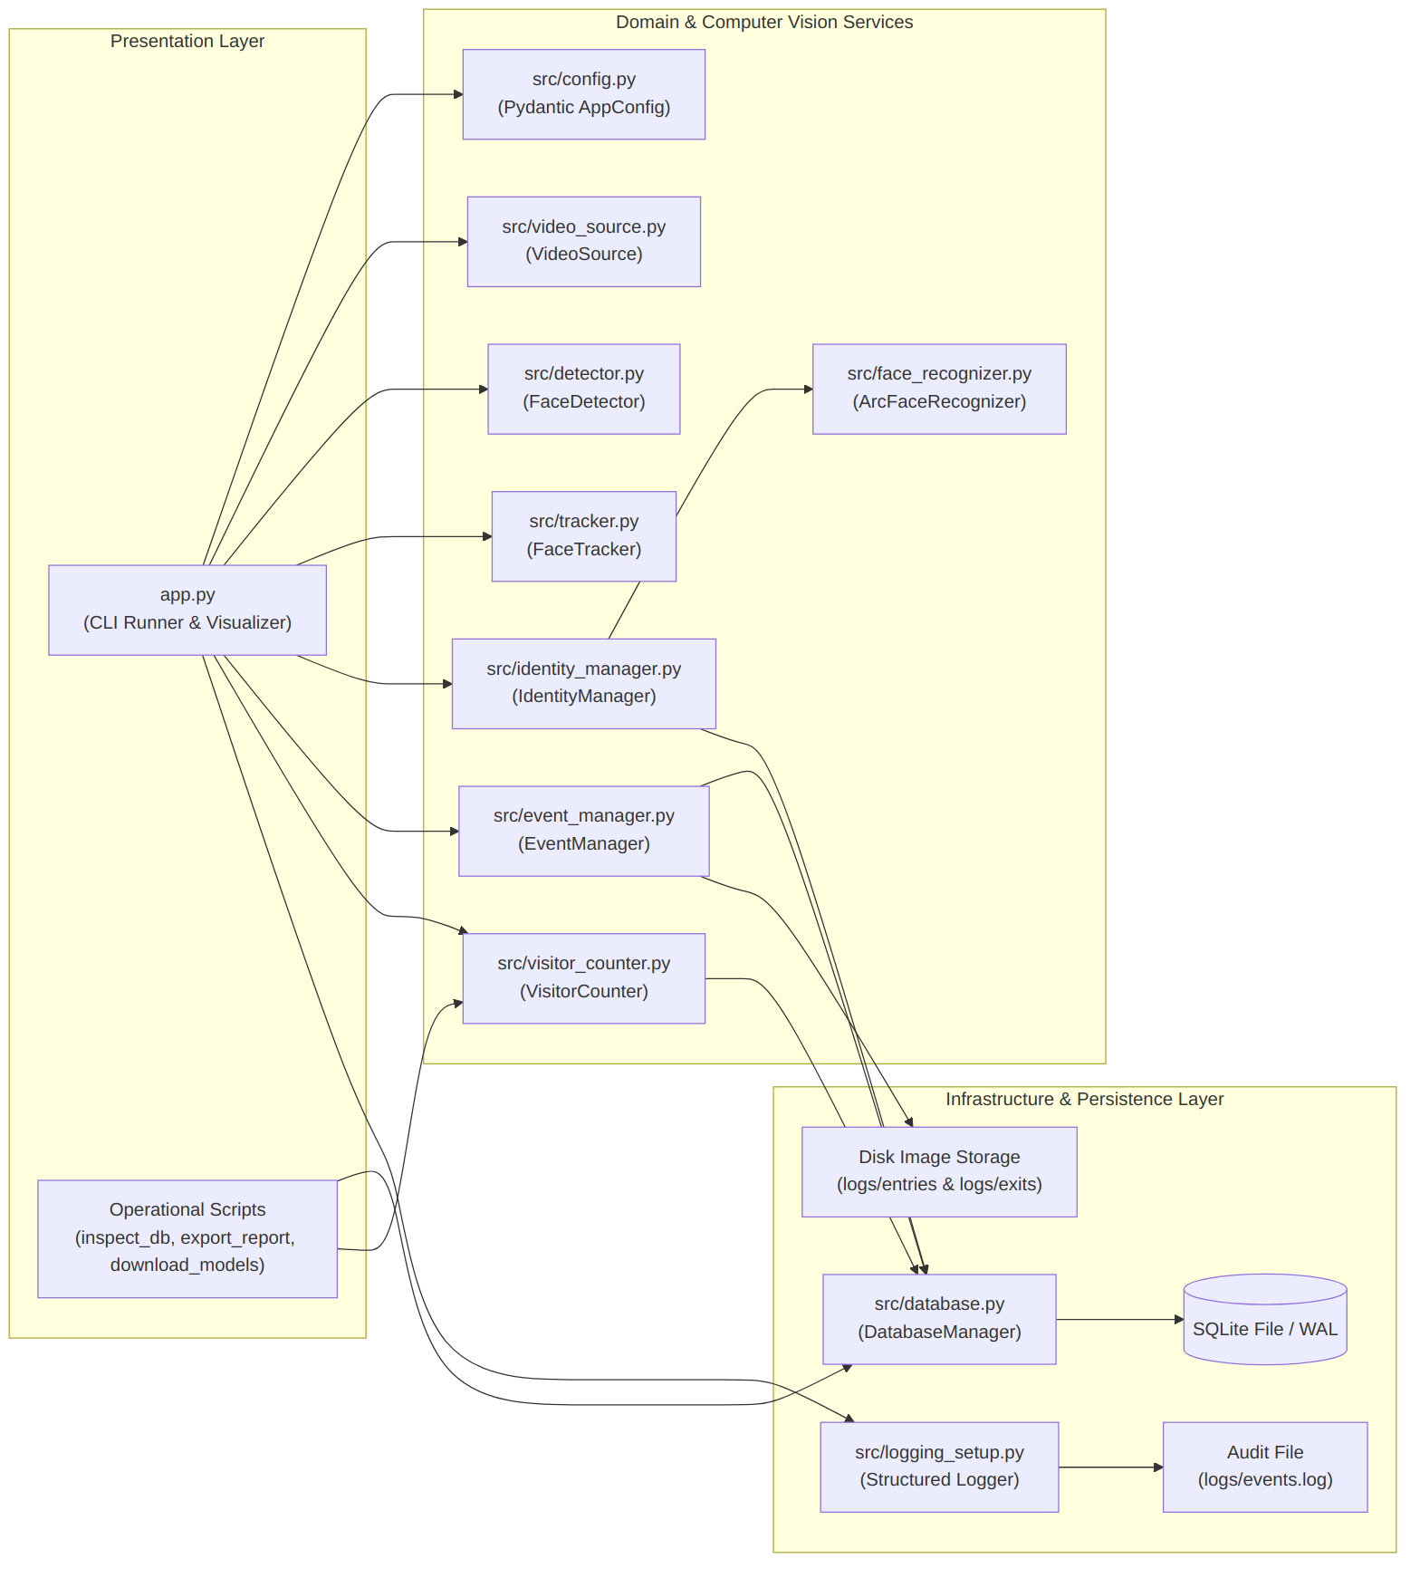
Component Architecture

3. Processing Sequence Diagram (Single Visitor Lifecycle)
This sequence diagram details interactions across a visitor entering, being tracked, registered, and exiting:
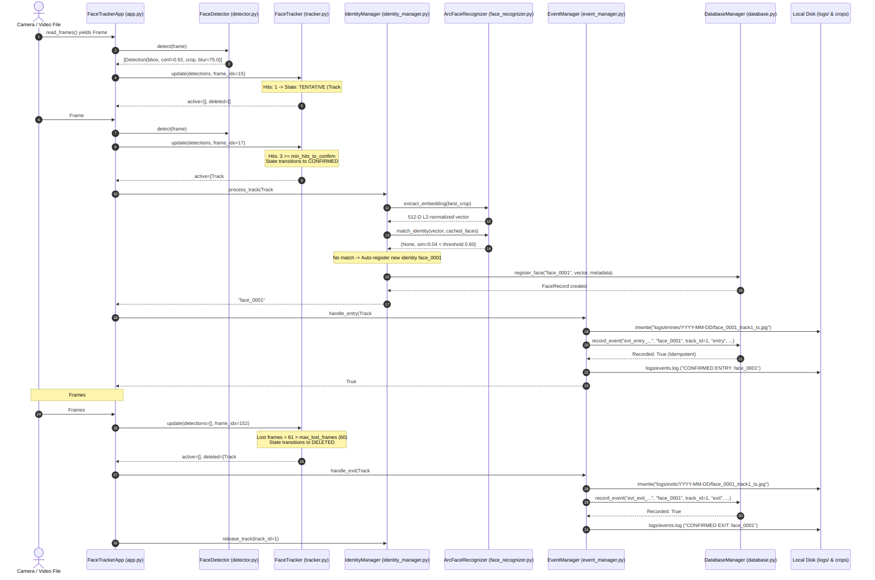
Single Visitor Lifecycle

4. Database Entity-Relationship (ER) Diagram
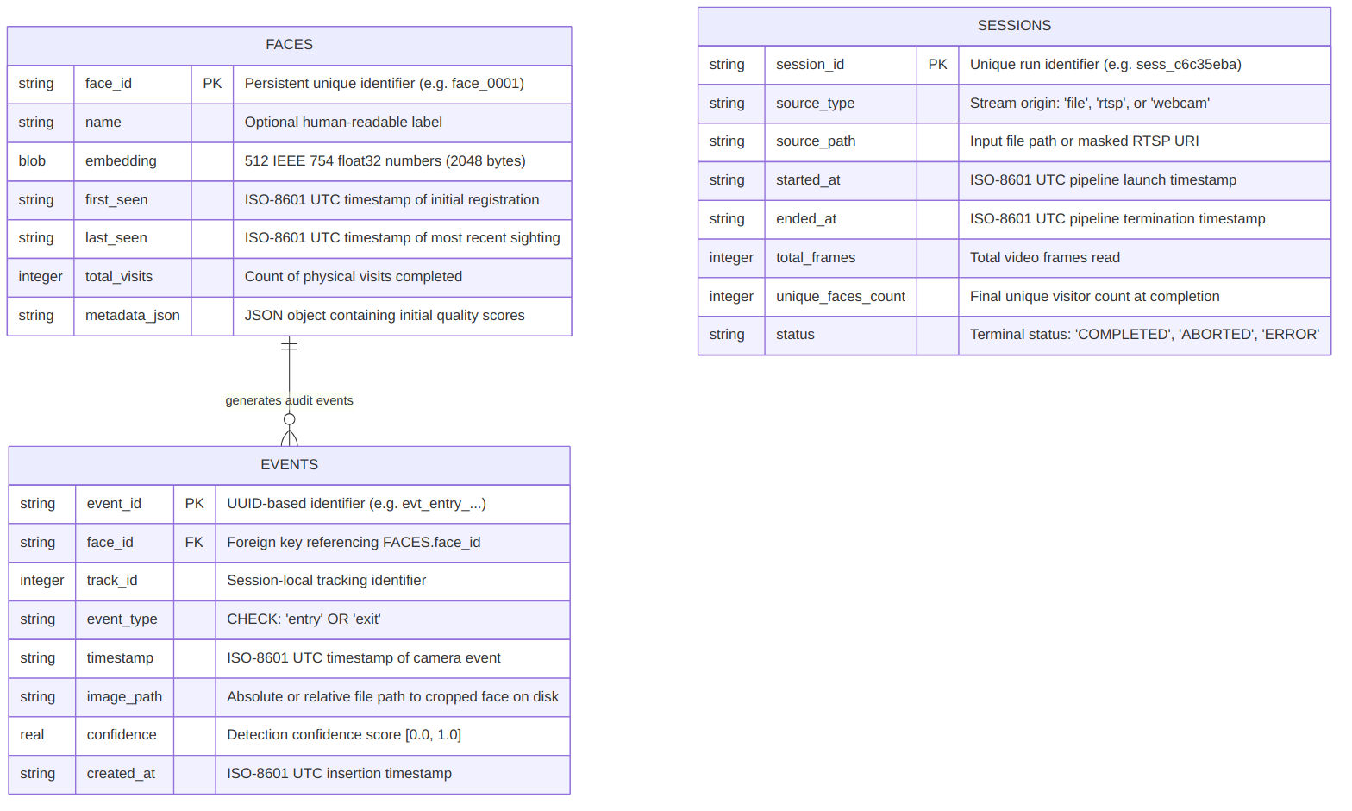
Database ER Diagram

Uniqueness & Integrity Constraints:
- FACES.face_id is the primary key.
- EVENTS.face_id references FACES.face_id with ON DELETE CASCADE.
- UNIQUE(track_id, event_type) in EVENTS guarantees that an active track can never insert more than one entry and one exit in the database, enforcing transactional idempotency.
- Indexes exist on events(face_id), events(event_type, timestamp), and faces(last_seen) for sub-millisecond query performance.

5. Detailed Component & Dataflow Descriptions
Component | Input | Internal Operation | Output
VideoSource | Video file path or RTSP URL | Wraps OpenCV VideoCapture; handles exponential reconnect backoff for network streams; yields timestamped BGR arrays. | Stream of (frame_idx, timestamp_iso, frame_bgr)
FaceDetector | BGR Frame array, thresholds | Runs YOLOv8n-face (or YuNet ONNX); clamps bounding boxes; checks minimum face size (40 × 40) and blur variance (σ² ≥ 50). | List of validated Detection objects
ArcFaceRecognizer | Cropped face image patch | Normalizes crop to 112 × 112 × 3; runs ONNX ArcFace model (or fallback zero-centered spatial moments); computes L2 normalization. | 512-dimensional float32 vector (‖v‖₂ = 1.0)
FaceTracker | List of Detections, frame index | Computes IoU overlap matrix against active tracks; updates Kalman/hit counters; manages Tentative → Confirmed → Lost → Deleted transitions. | (active_tracks, deleted_tracks)
IdentityManager | Confirmed Track, ArcFaceRecognizer | Checks in-memory track-to-face map; if unassigned, computes cosine similarity against cached face vectors; re-identifies or auto-registers new identity. | Persistent face_id (e.g. face_0001)
EventManager | Track, event type, timestamp | Saves highest quality face crop to logs/entries/YYYY-MM-DD/ or logs/exits/YYYY-MM-DD/; records event in SQLite; writes to logs/events.log. | Persisted event record & cropped image file
DatabaseManager | Structured records, queries | Thread-safe SQLite repository layer; enforces WAL mode, foreign keys, and idempotency constraints. | Queried analytics, inserted rows
VisitorCounter | Database connection | Queries COUNT(DISTINCT face_id), total entries, total exits, occupancy; formats ASCII and JSON reports. | Aggregated visitor metrics

