Execution Report
1. Objective
The purpose of this report is to execute the Login and Signup validation test cases for the Tichi Web Application and record the execution results.
2. Test Environment
- Windows 11
- Google Chrome (Latest)
- Python
- Selenium WebDriver
3. Test Execution Summary
The Login and Signup test cases were executed successfully using Selenium automation scripts. Different email formats and password validations were tested on both pages to check how the application responds to valid and invalid input.
4. Test Execution Steps
- Open the Sign In page and confirm the correct page URL loads.
- Enter valid and invalid email addresses in the Email field and submit the form.
- Record whether each email format is accepted or rejected.
- Open the Sign Up page and confirm the correct page URL loads with the email carried forward.
- Enter valid and invalid passwords, along with matching and mismatching confirm-password values.
- Submit the Sign Up form and record the validation messages shown.
5. Execution Results
Most invalid email formats, such as abc, abc@, @gmail.com, abc.com, and fsdg, were correctly rejected on the Sign In page during execution.
The email ab..cd@gmail.com navigated to the next page before any validation message was shown.
Password validation executed successfully, with valid passwords accepted and short or non-alphanumeric passwords correctly rejected.
Signup validation executed successfully, including checks for matching and mismatching confirm-password values.

6. Execution Evidence
The screenshots below show the automation scripts and their execution results, arranged in the order they were run.
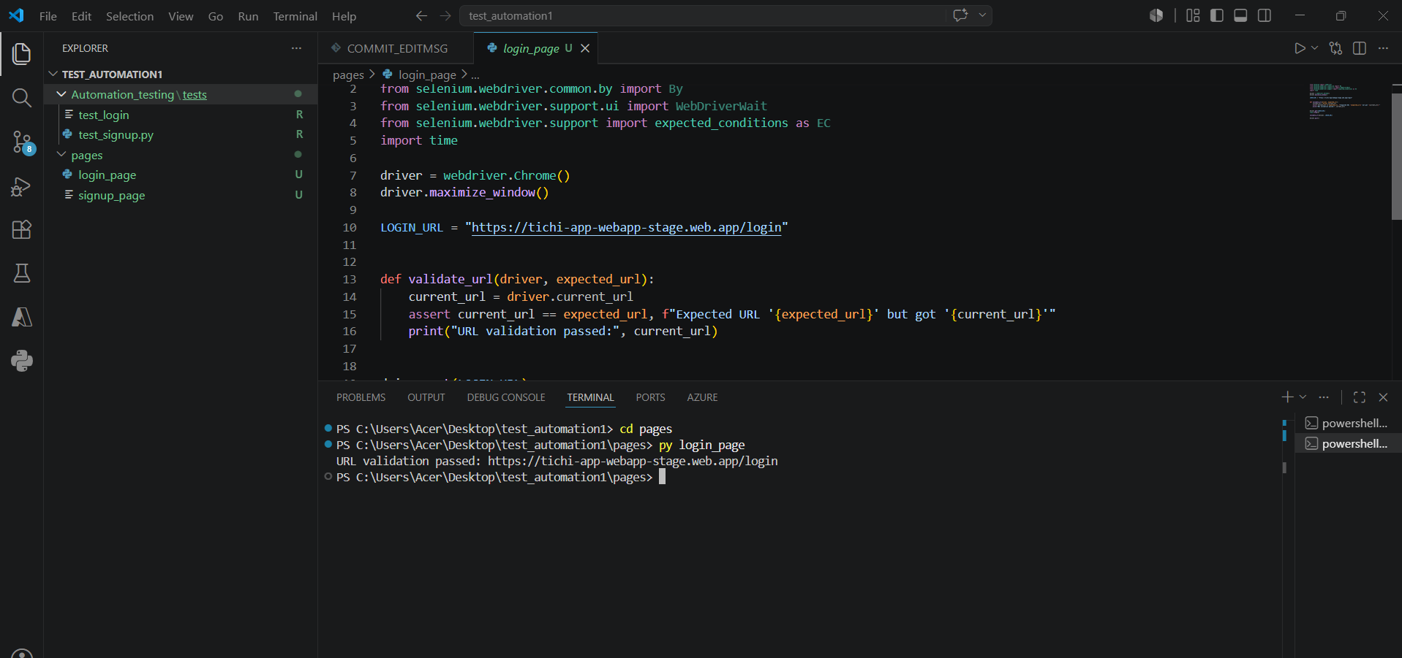
Figure 1: Overall view of the Sign In page before test execution.
This screenshot shows the login automation script confirming the Sign In page URL before any email is entered.
It marks the starting point of the Login test execution.

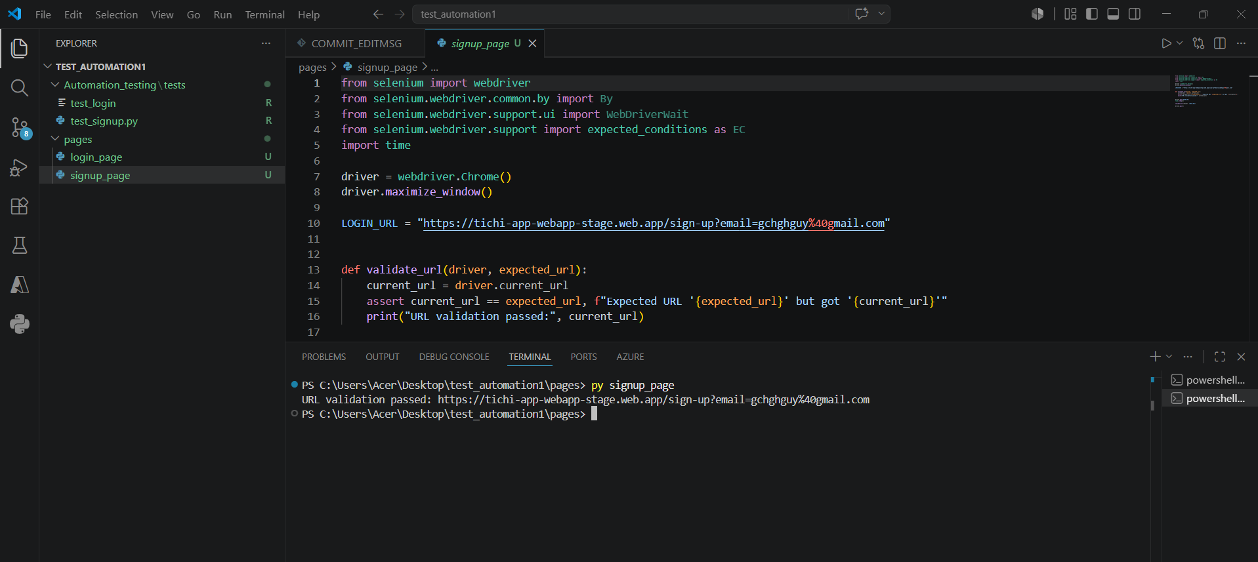
Figure 2: Navigation to the next page after entering ab..cd@gmail.com.
This screenshot shows the application moving to the Sign Up page with this email carried forward in the URL.
This email format proceeded to the next page while other tested invalid email formats were rejected on the initial page.

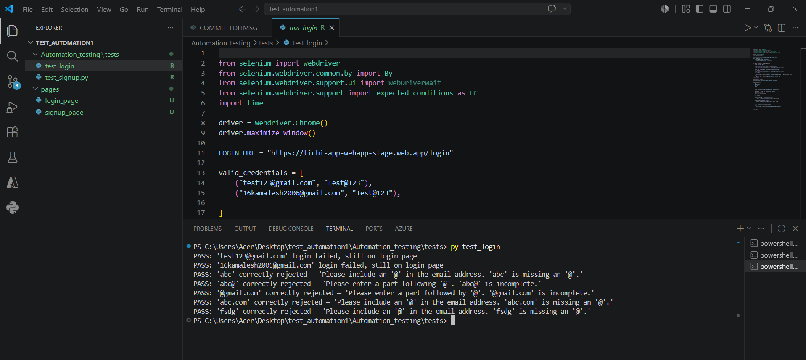
Figure 3: Execution output from Login automation.
This screenshot shows the terminal output of the Login test script, listing each email format tested and its result.
All listed invalid formats were marked as PASS for correct rejection.

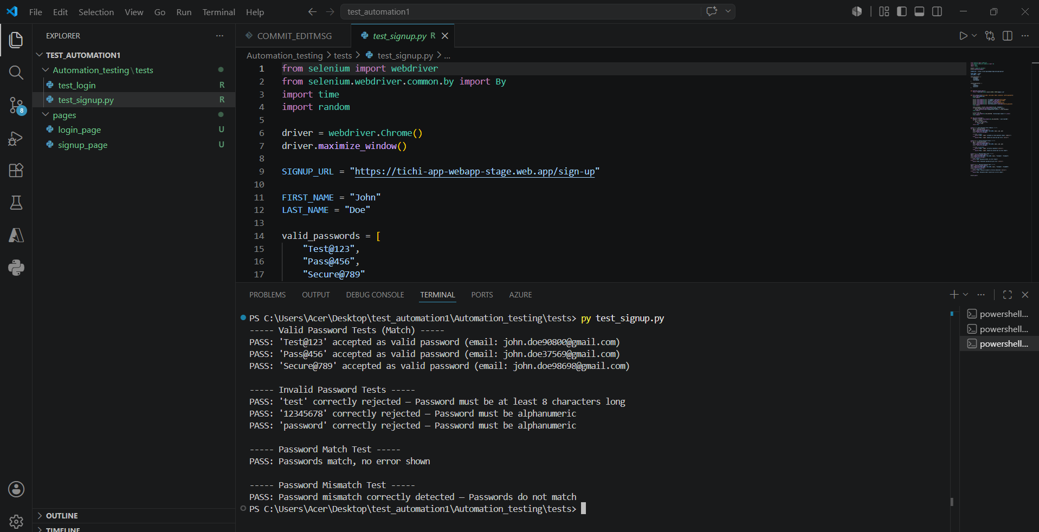
Figure 4: Execution output from Signup automation.
This screenshot shows the terminal output of the Signup test script, covering password and confirm-password checks.
All test cases in this run were marked as PASS.

7. Source Code Reference
email_field = driver.find_element(By.ID, "email")
email_field.clear()
email_field.send_keys(email)

driver.find_element(By.CSS_SELECTOR, "button[type='submit']").click()
time.sleep(1)

validation_message = driver.execute_script(
"return arguments[0].validationMessage;", email_field
)
is_valid = driver.execute_script(
"return arguments[0].checkValidity();", email_field
)

This code enters an email address into the Sign In field and clicks Continue. It then reads the browser's validation result and message for that field. This same pattern is repeated for each email format in the test list to record whether it was accepted or rejected.
8. Final Execution Summary
Login and Signup execution was completed successfully, and the execution results for all tested email formats and password scenarios were recorded.

