Defect Report
Application: Tichi Web Application (Stage)
Field | Details
Bug ID | BUG-001
Title | Invalid email format is accepted on the initial login screen before validation.
Module | Login / Email Validation
Environment | Windows 11, Google Chrome (Latest), Stage Environment
Severity | Medium
Priority | High
Status | Open
Reported By | QA Tester
Description | The application allows ab..cd@gmail.com to proceed to the next screen without validating the email format. Other invalid formats are rejected correctly, so this behaviour is inconsistent.
Preconditions | Application is running.  User is on the Sign In page.
Steps to Reproduce | 1. Open the application and enter ab..cd@gmail.com in the Email field.  2. Click Continue and observe the behaviour.  3. Repeat using abcgmail.com, abc@, and @gmail.com.  4. Compare the validation behaviour for each format.
Expected Result | All invalid email formats should be validated consistently on the Sign In page, with navigation blocked until a valid email is entered.
Actual Result | ab..cd@gmail.com was allowed to navigate to the next page, with validation shown only afterward. Other invalid formats were rejected correctly on the first page.
Impact | Inconsistent validation may confuse users, since some invalid formats are blocked immediately while others pass through unvalidated.
Recommendation | Apply the same email validation rules on the Sign In page for all invalid formats before allowing navigation.

Attachment
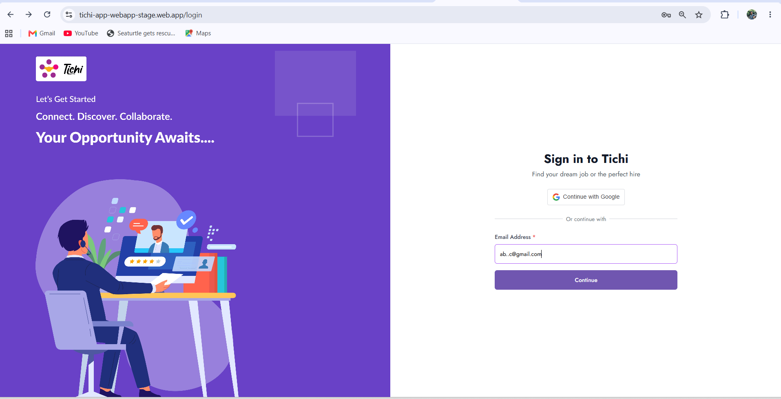
Figure 1: Initial Sign In page showing the email address entered before clicking the Continue button.
The Sign In page with ab..cd@gmail.com entered, before proceeding to the next screen.
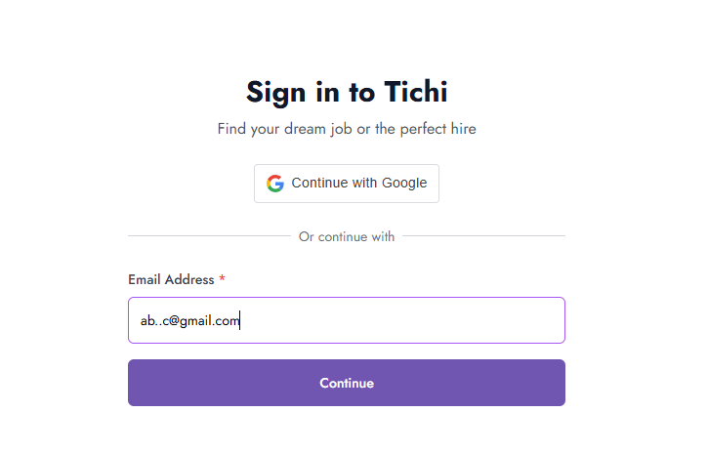
Figure 2: The application navigates to the next page after entering the email address ab..cd@gmail.com.
Navigation is allowed even though ab..cd@gmail.com is an invalid email format in this scenario.
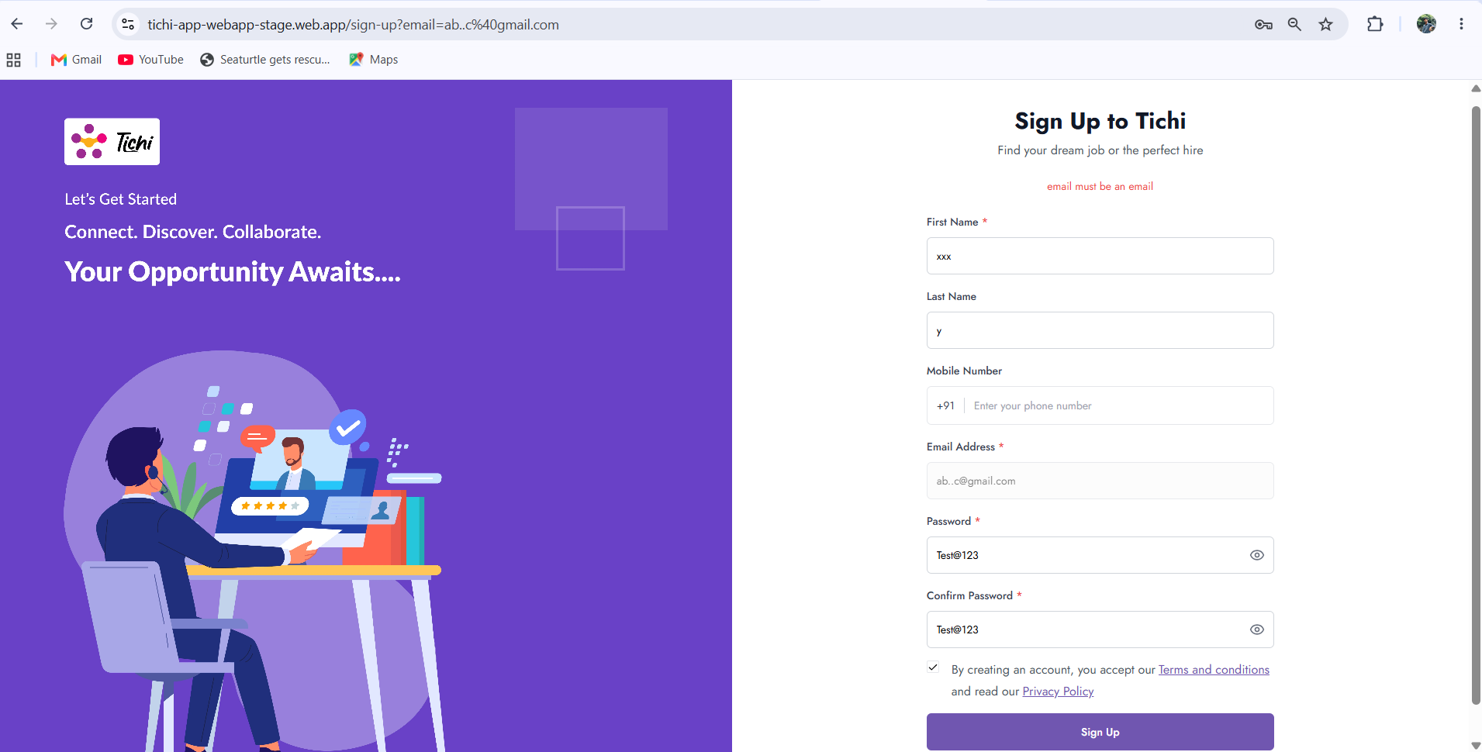
Figure 3: Validation message displayed on the Sign Up page after navigation.
The message "email must be an email" appears only after navigation, showing validation runs too late.
Other invalid formats tested:
- abcgmail.com
- abc@
- @gmail.com
These were rejected on the initial screen, but ab..cd@gmail.com was not — this inconsistency is the reported defect.

