AI-Based Farm Credit and Crop Yield Assessment System
V. Maneesh Kumar Reddy¹  Department of Computer Science and Engineering  KLH CSE Bowrampet Campus, KL (Deemed to be) University  Telangana, India  2420030246@klh.edu.in | K. Kumar Satya Sai²  Department of Computer Science and Engineering  KLH CSE Bowrampet Campus, KL (Deemed to be) University  Telangana, India  2420030202@klh.edu.in | B. Kamalesh³  Department of Computer Science and Engineering  KLH CSE Bowrampet Campus, KL (Deemed to be) University  Telangana, India  2420030156@klh.edu.in
Bonagani Prathusha⁴
Department of Computer Science and Engineering
Koneru Lakshmaiah Education Foundation,
Bowrampet, Hyderabad-500043, Telangana, India.
Email: prathushabonagani@gmail.com
Abstract—Farmers often have to plan crops and borrow money without a clear idea of how much their land will produce. This paper describes a web-based system that looks at yield and credit together. A user enters the crop, location, season, farm area, rainfall, temperature, soil type, irrigation, fertilizer and pesticide use, previous yield, farming experience, land ownership, banking and loan history, income and debt. From these the system estimates yield and total production with a rule-based engine, scores credit readiness out of 100 using five components, and works out soil health and agricultural viability. Results are shown on a dashboard with state and national comparisons, a confidence indicator, a breakdown of every score and a few recommendations. The front end is built with React and TypeScript, and Supabase is used to store assessments. The present version is a deterministic prototype. It does not train a machine-learning model, so we report no accuracy figures, and its credit rules have not been checked against real loan outcomes. Validated datasets, live weather data and trained models are left as future work.
Index Terms—Agricultural analytics, farm credit assessment, credit scoring, crop yield prediction, soil analysis, decision support system, data science, precision agriculture

I. Introduction
Farm decisions rely on many kinds of data: bank records, land details, soil condition, weather, crop history and the way the farm is managed. Most farmers still weigh these by experience. Studies on crop yield usually bring in weather, soil and past yield, and the methods tried most often are Random Forest, neural networks, support vector machines and gradient boosting [1], [2].
Lending to farmers raises a related problem. A farmer’s ability to repay depends on more than a credit history. It also depends on land holding, the crop chosen, irrigation, how productive the soil is, earlier loans and how much the farm is expected to produce. Some recent work has started to link land and yield capacity with loan appraisal [3], [4].
We built a browser-based platform that handles both questions. It collects farmer, banking, land, crop and soil details, turns them into scores that are easy to read, estimates yield, and gives a credit assessment with a loan-eligibility suggestion. We are not proposing a new machine-learning algorithm. The aim is a workflow that a farmer or a loan officer can follow and question.
II. Related Work
A. Yield and crop prediction
Jhajharia et al. compared Random Forest, SVM, gradient descent, LSTM and Lasso regression for yield estimation, and Random Forest did best on their Rajasthan data [1]. Elbasi et al. looked at crop prediction with machine learning and made use of sensor readings along with farm records [5]. A chapter in a Wiley-IEEE volume predicted yield and soil moisture from rainfall, temperature, humidity and soil moisture [2].
B. Farmer credit risk and loan appraisal
Chai et al. built a credit-risk framework on data from 8,624 farmers and found that machine learning picked out likely defaulters better than the usual econometric methods [3]. Their model is about money only and has no crop or soil information in it. Pushpalatha et al. proposed an AI-based loan appraisal system for farmers that takes land yield capacity into account [4].
C. Multivariate and explainable approaches
Kumar et al. predicted agricultural production from N, P, K, rainfall, temperature, humidity, soil quality and pH, and paid attention to explainability [6]. Snehalatha and Patil described AgriYieldAI, a decision-support system for yield prediction built around a model called YieldFusionNet [7]. Both point toward systems that explain themselves. Table I lists the studies.
TABLE I
Comparison of related studies
Work | Main task | Relevance here
Jhajharia [1] | Yield prediction, RF/SVM/LSTM | Multi-factor yield prediction
Wiley-IEEE [2] | Yield and soil moisture | Soil and weather features
Chai [3] | Farmer credit risk, 8,624 farmers | Data-driven farmer credit scoring
Pushpalatha [4] | Agricultural loan appraisal | Links land yield and lending
Elbasi [5] | Crop prediction with sensors | Data-driven farm decisions
Kumar [6] | Multivariate production prediction | Soil and climate inputs
Snehalatha [7] | Yield decision support | Explainable, multimodal direction
The gap we see is that yield studies rarely look at a farmer’s finances, and credit studies rarely look at the farm. Few systems join the two. Many are also hard to use for people with limited digital skills, and few say which factor is pulling an estimate up or down. Our system tries to cover this with one lightweight tool whose rules can be read. Because it uses rules, it works without the large labelled dataset that machine-learning models need.
III. Problem Statement and Objectives
Farmers seldom have a dependable way to estimate yield or to judge the health of a farm before they commit to a crop or a loan. Yield guesses based on habit lead to poor financial plans. Agronomic tools and financial tools are usually kept apart.
The system should:
- collect crop, location, season, area, weather, soil, irrigation, fertilizer, pesticide and previous-yield data;
- estimate yield and total production with transparent rules;
- assess credit readiness from banking, loan, farming, land, agricultural and market indicators;
- show predicted yield, production, a confidence indicator and state and national comparisons on a dashboard;
- show which factors matter and give recommendations on irrigation, soil, fertilizer and crop management;
- save assessments for later review and leave room for weather data, validated datasets and trained models.
IV. Proposed System
The application is a web app with a step-by-step flow. A farmer creates an account and enters personal and farm details. Banking and loan history come next, followed by crop plans, farming practices and land information. The soil step uses regional soil data and, where available, outside weather or soil data. The indicators from all steps go into the credit-scoring module, and the dashboard brings together the score, loan history, crop details, soil health and recommendations.
There are seven modules: (1) farmer registration and profile, (2) banking history and loan records, (3) crop planning and farming practices, (4) soil analysis and agricultural viability, (5) credit score and loan eligibility, (6) yield prediction and benchmark comparison, and (7) dashboard and saved assessments.
V. System Architecture
The app is organised in layers (Fig. 1). The interface is written in React and TypeScript, with one page for each step. Service modules deal with soil data, district information, authentication, saved data and external environmental data. Four rule-based engines do the calculations, and a Supabase client stores the results.
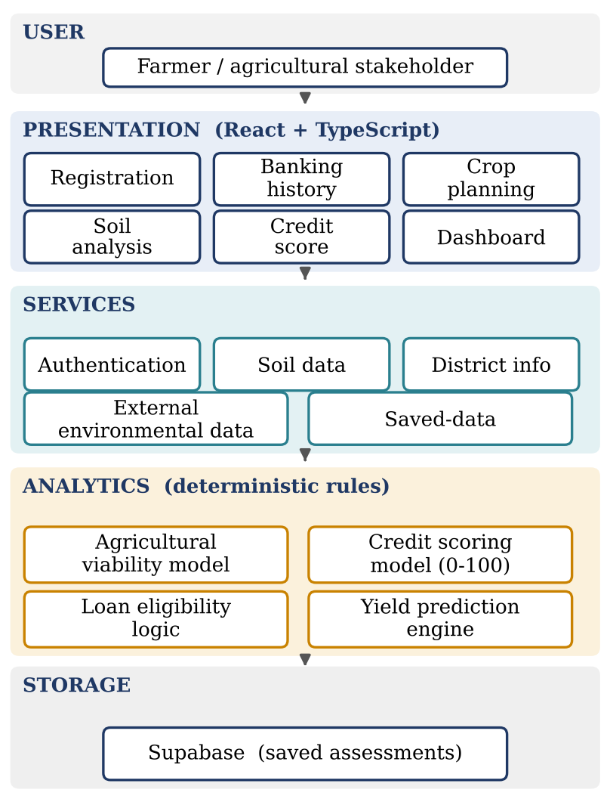
Fig. 1. Layers of the proposed system. This is a diagram drawn from the project description, not a screenshot.
Data moves through the system as follows. Personal and farm inputs build the farmer profile. Banking history and loan records give repayment and debt indicators. The crop plan gives crop, season, area and management indicators, and the location gives pH, organic carbon, nutrient, drainage and erosion values. Soil health and agricultural viability come from these. All indicators are then combined into the 100-point credit score. The score, the debt burden and any default history decide eligibility and the loan parameters. In parallel, the crop and weather inputs produce a yield estimate that is compared with the state and national baselines. Everything ends up on the dashboard and in the saved records.
VI. Methodology
A. Credit scoring
The credit model is a weighted score and not a trained classifier. The maximum is 100, split across five components (Fig. 2a): banking and credit history (30), farming experience and practices (20), land ownership and size (15), agricultural viability (20) and crop market viability (15). The overall score is
S = S_{B} + S_{F} + S_{L} + S_{A} + S_{M} (1)
where the terms are the banking, farming, land, agricultural and market scores. The banking score uses account age, previous loans, average repayment rate, monthly income, outstanding debt and default history. Debt burden is measured by the debt-to-income ratio
DTI = D / (12 × I_{m}) (2)
with D the outstanding debt and I_{m} the monthly income. A penalty is applied when DTI goes above 40%, 60% or 80%. The farming score looks at years of experience, use of irrigation, fertilizer and pesticide, and the number of crop plans. The land score depends on area and ownership. The market score depends on how varied the crop plan is and on whether an expected yield was given.
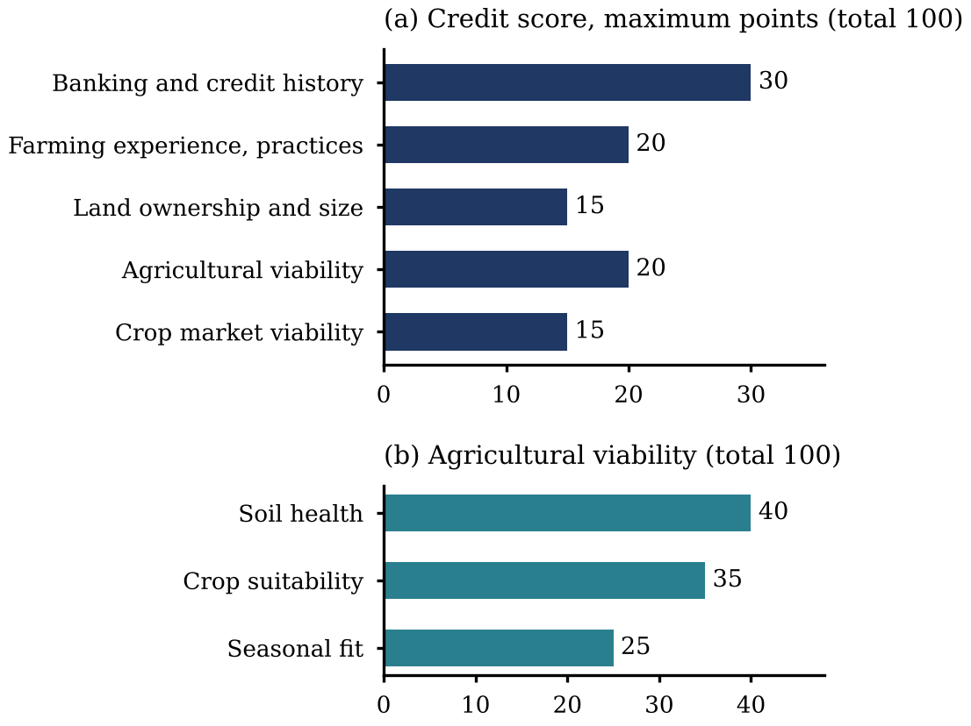
Fig. 2. Point allocation in (a) the credit score and (b) the agricultural viability score.
B. Agricultural viability
The viability score has three parts (Fig. 2b): soil health (40 points) from pH, organic carbon, drainage and erosion; crop suitability (35) from how well the crop, season and soil type match; and seasonal fit (25). The result is put on a 100-point scale and then scaled down to at most 20 points for the credit score.
C. Yield prediction
For each supported crop there is a baseline yield, which is multiplied by factors for state, soil, irrigation, rainfall, temperature, fertilizer and pest management:
Y_{c} = Y₀ · m_{state} · m_{soil} · m_{irr} · m_{rain} · m_{temp} · m_{fert} · m_{pest} (3)
If the farmer supplies the previous yield Y_{p}, the final estimate takes 70% from the calculated value and 30% from the previous one:
Y = 0.7 Y_{c} + 0.3 Y_{p} (4)
Total production is the yield multiplied by the farm area, and both are compared with a state and a national baseline. A confidence indicator is the average of six factor scores. It is an internal measure, not a calibrated probability.
D. Loan eligibility
Eligibility follows from the score range and is then adjusted. A score of 80 or more gives the top tier, and lower ranges reduce the suggested maximum or call for a review. A heavy debt burden can cut the maximum to 75%, 60% or 40% of the standard amount. A previous default can turn an approval into a conditional approval, a review or a rejection, depending on the score. These are rules we chose for the prototype. They are not bank lending criteria and cannot replace a bank’s own validated risk model.
VII. Implementation
The prototype uses React and TypeScript with separate page and service components, and reusable pieces for forms, cards, charts, dialogs, progress indicators, tables and navigation. The main pages are Farmer Registration, Banking History, Crop Planning, Soil Analysis, Credit Score and Dashboard.
The soil service holds regional entries for several Indian states. Each entry has soil type, texture, pH, organic carbon, nitrogen, phosphorus, potassium, sulphur, zinc, iron, drainage quality, erosion level and suitable crops. The soil page can also show weather and environmental values from an external service. The dashboard shows the credit-score components, loan history, crop details, expected yield, soil-health score and recommendations. We chose to show the parts of each result because we did not want the tool to return a single decision with no explanation.
VIII. Results and Discussion
The prototype produces three main outputs: an agricultural viability assessment, a 100-point credit assessment and a yield estimate for planning (Table II). The credit score is split into five visible categories, so a user can see where a low score comes from. The loan module also shows its debt-related adjustments and recommendation messages.
TABLE II
Analytical outputs of the prototype
Module | Inputs | Output
Credit assessment | Banking, loans, income, farming, land, agriculture, crops | Score out of 100, eligibility, loan amount, interest and tenure
Soil analysis | pH, organic carbon, nutrients, drainage, erosion, crop, season | Soil-health and viability scores
Yield prediction | Crop, state, soil, water, climate, fertilizer, pesticide, previous yield | Yield, production, benchmark comparison, grade, advice
Dashboard | Saved results | Charts, loan history, score breakdown, recommendations
The yield view gives the predicted yield, total production, state and national averages, a grade, factor scores, a monthly growth chart and recommendations. This fits the literature, which combines weather, soil and past yield for prediction [2], [6]. We do not report an accuracy figure because no model was trained or tested on a labelled dataset.
The main strength of the prototype is that each result can be traced back to inputs and rules. Machine-learning approaches in the literature may predict better, but they are harder to explain and to deploy [4], [7]. The price of our approach is that the system cannot estimate a real default probability or show that it generalises.
IX. Limitations
- The credit score is a hand-built heuristic. It has not been trained or calibrated on historical loan defaults.
- Yield uses fixed baselines and multipliers instead of a model trained on validated data.
- The regional soil data are a static, mock database and must be replaced with authoritative field-level data for real use.
- The confidence indicator is a heuristic and not a statistical confidence interval.
- Loan amounts, interest rates and tenures are prototype rules and not actual bank terms.
- A real deployment would need data governance, privacy protection, fairness testing, model validation, audit trails and verified financial and agricultural data.
X. Future Scope
The next step is to collect historical loan outcomes and farm production records and train supervised models for default probability, repayment and yield. Logistic regression, Random Forest, gradient boosting and calibrated ensembles are the first candidates. They should be compared on a proper train, validation and test split using ROC-AUC, precision, recall, F1-score, MAE, RMSE and R² where they apply [2].
Other additions are satellite and remote-sensing features, weather time series, field-level soil measurements, market prices and crop insurance data. Explainability methods such as SHAP, uncertainty estimates and a multilingual interface would also help. Recent work moves in the same direction [4], [7].
XI. Conclusion
This paper presented a web-based system that joins financial, farming, land, soil, crop and weather information in one workflow. It combines a 100-point credit score, a viability analysis, debt-burden adjustments and a rule-based yield engine, and it shows the parts of each result instead of one unexplained number.
The prototype shows that farm analytics and credit screening can sit in one tool. Its rules, however, were set by hand and not learned from lending data, so it should be treated as a decision-support prototype. Validated data, trained models, proper evaluation and testing with real financial data are needed before it is used for actual credit decisions.
Acknowledgment
We would like to thank Bonagani Prathusha, Department of Computer Science and Engineering, KLH CSE Bowrampet Campus, for her guidance and support.
References
[1] K. Jhajharia, P. Mathur, S. Jain, and S. Nijhawan, “Crop yield prediction using machine learning and deep learning techniques,” Procedia Comput. Sci., vol. 218, pp. 406–417, 2023, doi: 10.1016/j.procs.2023.01.023.
[2] “Crop yield and soil moisture prediction using machine learning algorithms,” in Machine Learning Applications: From Computer Vision to Robotics. Wiley-IEEE Press, 2024, pp. 183–194, doi: 10.1002/9781394173358.ch11.
[3] N. Chai, M. Z. Abedin, X. Wang, and B. Shi, “Growth potential of machine learning in credit risk predicting of farmers in the industry 4.0 era,” Int. J. Finance Econ., vol. 30, no. 3, pp. 2163–2185, 2025, doi: 10.1002/ijfe.3010.
[4] N. Pushpalatha, Nandhini, G. M. Santhiya, F. Khan, and A. Alkhayyat, “A farmer friendly AI powered smart agriculture loan appraisal system by considering their land yield capacity,” in Proc. 2nd Symp. Smart, Sustainable, and Secure Internet of Things (S4IoT 2025), Lecture Notes in Electrical Engineering, vol. 1513. Springer, 2026, pp. 217–228, doi: 10.1007/978-981-95-5136-1_21.
[5] E. Elbasi et al., “Crop prediction model using machine learning algorithms,” Appl. Sci., vol. 13, no. 16, Art. no. 9288, 2023, doi: 10.3390/app13169288.
[6] R. Kumar, P. K. Singh, and R. K. Tiwari, “Prediction of agricultural production based on multivariate data with feature aware machine learning models,” Discover Artif. Intell., vol. 6, Art. no. 796, 2026, doi: 10.1007/s44163-026-01987-6.
[7] M. Snehalatha and A. Patil, “AgriYieldAI an AI driven decision support system for crop yield prediction using YieldFusionNet,” Discover Comput., vol. 29, Art. no. 222, 2026, doi: 10.1007/s10791-026-10096-y.

