COMMUNITY CONNECT
Abdul Faizudeen M 23Z301
Amruth K 23Z305
Kaleeswar G 23Z331
Kamalesh G 23Z332
Sam Jeba Ashlin R 23Z364

23Z615 - AICTE ACTIVITY POINT PROGRAMME

report submitted in partial fulfillment of the requirement for the award of degree of

BACHELOR OF ENGINEERING

Branch: COMPUTER SCIENCE AND ENGINEERING
Of Anna University

March 2026
DEPARTMENT OF COMPUTER SCIENCE AND ENGINEERING
PSG COLLEGE OF TECHNOLOGY
(Autonomous Institution)
COIMBATORE – 641 004

PSG COLLEGE OF TECHNOLOGY
(Autonomous Institution)
COIMBATORE – 641 004

COMMUNITY CONNECT
Bona fide record of work done by
Abdul Faizudeen M 23Z301
Amruth K 23Z305
Kaleeswar G 23Z331
Kamalesh G 23Z332
Sam Jeba Ashlin R 23Z364

Dissertation submitted in partial fulfillment of the requirements for the degree of

BACHELOR OF ENGINEERING
Branch: COMPUTER SCIENCE AND ENGINEERING

of Anna University
March 2026

…....……………………..… …………..……………….
Dr. V. Santhi Dr. G. Sudha Sadasivam
Programme Coordinator Head of the Department

The candidate was examined in the review held on ………………….

……………………… …………………….... ………………………
Panel Member 1 Panel Member 2 Panel Member 3
Dr. V. Santhi Dr. N. Gopika Rani Dr. S. Sivaranjini
ACKNOWLEDGEMENT

The AICTE Activity Point Programme project work had paved the way for personal development and creativity as proud volunteers with a sense of achievement and ready to take up projects having a social impact and creating digital awareness. We feel privileged to be associated with such a curriculum in PSG College of Technology.
We are extremely grateful to our Principal Dr. K. Prakasan for facilitating and extending untiring support in successful completion of the project. We are extremely glad to extend our gratitude to the department Head Dr. G. Sudha Sadasivam and Programme Co-ordinator Dr. V. Santhi for offering us this opportunity which has made us to strengthen our soft skills, leadership qualities and team spirit. We extend our thanks to Department Placement Co-ordinator Dr. K. Sathiya Priya who has been the pillar of support.
We would like to take this opportunity to place my sincere thanks to our Tutor Dr.N.Gopika Rani for her guidance in our project work and would also like to thank our Panel members who has spent their valuable time to aid us for coming out with the good project.

CERTIFICATE

Certified that this report titled “COMMUNITY CONNECT ” for the AICTE ACTIVITY POINT PROGRAMME project work (23Z615) is a bonafide work of “Abdul Faizudeen M(23Z301),Amruth K(23Z305), Kaleeswar G(23Z331), Kamalesh G(23Z332), Sam Jeba Ashlin R(23Z364)” who have carried out the work for the partial fulfillment of the requirements for the award of the degree of Bachelor of Engineering in Computer Science and Engineering.

Place: Coimbatore
Date : 26.03.2026

Tutor Department Placement Coordinator
(Dr. N. GOPIKARANI) (Dr. K SATHIYAPRIYA)

COUNTERSIGNED

Dr. G. Sudha Sadasivam
HOD
Department of Computer Science and Engineering
PSG College of Technology, Coimbatore - 641004

CONTENTS
CHAPTER Page No.
Abstract................................................................................................................... 5
- INTRODUCTION 6
  - Introduction
  - Problem Statement
- ACTIVITY PLAN 7
  - Literature Survey
  - Proposed Plan
  - Estimated time

- SYSTEM DESIGN 11
  - System requirements
  - Module description
  - Analysis and Design
  - Architecture

- DISCUSSION 28
  - Discussion on the proposed activity

- IMPLEMENTATION 29
5.1 Implementation and Experimental results
- ACTIVITY LOG 38

ABSTRACT
Community Connect is a dynamic platform designed to empower local communities in their efforts to combat poverty. Through a user-friendly interface, volunteers can easily discover and connect with organizations dedicated to poverty alleviation within their vicinity. The platform facilitates seamless communication and collaboration, enabling volunteers to contribute their time, skills, and resources effectively. By bridging the gap between volunteers and organizations, Community Connect fosters a sense of unity and collective action, driving meaningful impact in the fight against poverty at the grassroots level.

At the heart of Community Connect lies its advanced matching algorithms, which play a pivotal role in facilitating efficient and impactful connections. These algorithms take into account various factors, such as geographical location, donation preferences, and the urgency of the needs. By considering these parameters, Community Connect ensures that volunteers are presented with personalised recommendations that align with their desired causes and have the potential to help organizations.

The platform simplifies the process of making donations by allowing users to create profiles as either volunteers or organization. One can specify their areas of interest, whether it be providing financial aid, donating food supplies, or offering mechanical items. Organisations, on the other hand, can describe their specific needs, such as trust funds. This detailed information helps streamline the matching process and ensures that volunteers can find suitable matches that resonate with their philanthropic goals.

CHAPTER 1
INTRODUCTION

1.1 Introduction
Community Connect acts as a bridge, connecting generous donors with working organizations through a community-driven platform. Users can create profiles allowing them to participate in the network of compassionate individuals. People have the opportunity to specify their areas of interest in donating. Organisations, on the other hand, can describe their specific needs. By enabling this level of customization and personalization, Community Connect ensures that poor and rich can establish meaningful connections by specific requirements.

1.2 Problem Statement
The current world faces several challenges that require effective connections between generous donors and organizations which help the poor. Individuals who are eager to contribute often struggle to find suitable organisations or individuals to donate to, resulting in a lack of supply. Likewise, seekers, such as trust funds, orphanages, or individuals requiring financial assistance, face difficulties in reaching potential volunteers and accessing the support they require.
This lack of a streamlined and efficient platform leads to a disconnect between donors and receivers, resulting in wasted resources and missed opportunities to make a positive impact.
The problem lies in the absence of facilitates with effective connections and enables seamless communication and coordination between donors and the needy. A need exists for a user-friendly mobile application that employs advanced matching algorithms, provides secure payment gateways, and fosters a sense of community to bridge the gap and ensure impactful contributions.

CHAPTER 2

ACTIVITY PLAN

2.1 Literature Survey
Several websites and projects have successfully implemented ideas similar to Community Connect, bridging donors and organizations through personalized and community-driven approaches. Here are some of them:
- GoFundMe
Overview: GoFundMe is one of the most well-known crowdfunding platforms that allows individuals and organizations to raise money for various causes, including medical expenses, community projects, and charitable initiatives. Users can create fundraising campaigns, and donors can easily contribute to causes they are passionate about.
Key Features:
  - Personalized campaign creation.
  - Donor matching through shared interests or social connections.
  - Transparency with updates and progress reports from fundraisers.
Advantages:
  - GoFundMe does not have any fees for using the platform and it is available to anyone in the world.
  - High ease of use with intuitive campaign setup.
  - Wide variety of supported causes, from personal needs to community projects.
Disadvantages.
1. The main downside of GoFundMe is that it is an all-or-nothing platform. This means that if you do not reach your fundraising goal, you will not receive any of the money that you have raised.

- JustGiving
Overview: JustGiving is another major platform for online giving, allowing individuals and organizations to create fundraising pages for charity. It focuses on personalized connections between donors and specific charitable causes, allowing users to select from a wide range of nonprofit organizations.
Key features:
- Customizable fundraising pages for causes and charities.
- Tools for social sharing to encourage wider donations.
- Allows users to donate to both specific organizations and individual fundraisers.
Advantages:
- Simple integration with social media platforms to boost visibility. • Advanced analytics for charities to assess campaign performance.
Disadvantages:
- JustGiving charges fees for its services, particularly for charities, which may reduce the net amount received by the cause. This includes transaction fees and platform fees for specific fundraising types, though these fees are less visible to donors.
- While it offers tools for creating campaign pages, smaller fundraisers or those outside registered charities may find fewer advanced customization options.

3. Charity Navigator
Overview: Charity Navigator is a prominent nonprofit organization that evaluates and rates the financial health, accountability, and transparency of charities. It aims to help donors make informed decisions by providing easy-to-understand ratings, which assess how effectively charities utilize their resources to achieve their missions.
Advantages:
- Offers detailed ratings on over 200,000 U.S.-based nonprofits, helping donors understand how their contributions are used.
- The platform provides intuitive search features, making it simple for donors to find charities aligned with their values.
Disadvantages.
- Smaller or newer organizations without extensive financial histories are often not rated, potentially excluding impactful but less established groups.
- While basic features are free, advanced features like more detailed charity analysis and saved searches are part of a paid Premium membership.

2.2 Proposed Plan
The development and implementation of the Community Connect website requires a systematic and well-organized activity plan. The proposed plan outlines the various steps and estimated time frames for each stage of the project.

Phase 1: Planning and Research
- Identify the needs and preferences of both donors and organizations. Understand existing platforms and gather insights on their successes and challenges.
- Analyse projects like GoFundMe, JustGiving, and others to understand the features they offer.
- Specify the core features of the platform, focusing on user experience and seamless matching between donors and organizations.
- Define the main features: profile creation, personalization options (donor interests, organization needs), secure donation handling and social sharing.
- Plan for user dashboards for both donors and organizations.
- Identify integration needs (e.g., payment gateways, social media).
Phase 2: Development
- Front-End Development:
  - Build the user-facing side of the platform.
  - Develop web pages for key sections: homepage, sign-up, profile creation (for donors and organizations), donation page, etc.
  - Ensure responsiveness across devices (desktops, tablets, smartphones).
  - Implement design elements and ensure a user-friendly interface.
- Back-End Development:
  - Build the server-side functionality of the platform.
  - Develop user authentication and profile management systems.
  - Create a matching algorithm that pairs donors with organizations based on shared interests and needs.
  - Implement donation handling and payment gateway integration (e.g., Stripe, PayPal).
- Security and Privacy Setup:
  - Ensure that the platform is secure, protecting user data and financial transactions.
  - Implement secure user authentication (e.g., two-factor authentication).
Phase 3: Testing and Quality Assurance
- Usability Testing:
  - Test the platform with real users to ensure it is easy to use and meets their expectations.
  - Recruit users from both the donor and organization side to test navigation, features, and design.
- Bug Testing:
  - Identify and fix any bugs or performance issues before launch.
  - Test the payment gateway to ensure seamless donation processing.
  - Optimize site speed and scalability, ensuring it can handle traffic spikes.
  - Conduct penetration testing to identify and fix any security flaws.

This plan outlines the activities needed to develop Community Connect, ensuring that the platform provides a seamless, secure, and user-friendly experience for both donors and organizations. By focusing on market research, user-centric design, strong security, and continuous feedback, the platform will be well-equipped to meet the needs of its users and drive meaningful connections between donors and causes.

2.3 Estimated time
The Community Connect project can be completed in approximately 10-14 weeks. This includes 1-2 weeks for planning and requirement analysis to define the project scope, 2-3 weeks for designing user-friendly and responsive interfaces, and 6-8 weeks for frontend and backend development using frameworks like React.js and Node.js. The frontend focuses on building dynamic pages for Login, Posting Needs, Browsing Needs, and Payment integration, while the backend manages user authentication, APIs, and database connections. After development, 2-3 weeks are allocated for thorough testing and debugging to ensure functionality, performance, and security. Finally, the project is deployed within a week on a hosting platform like AWS, followed by ongoing support to address feedback and maintenance.

CHAPTER 3

SYSTEM DESIGN

3.1 System requirements
- Hardware Requirements
  - Development
  - Processor : Intel i5 or AMD Ryzen 5 or above.
  - RAM : Minimum 8GB of RAM or above.
  - Storage : SSD with 256 GB minimum.
  - Graphics Card : Optional. Dedicated GPU is only necessary if working with heavy media editing and simulations.
  - OS : Windows 10/11 or Linux or macOS.

  - Server Requirements
  - Processor : Multi-core processors like Intel Xeon or AMD EPYC for handling high traffic and simultaneous requests.
  - RAM : At least 32 GB for medium-scale platforms; scalable up to 128 GB or more for larger user bases.
  - OS: Windows 10/11 ,Linux or macOS.

- Software Requirements
  - Development Tools
(i) Frontend Development
    - HTML, CSS, JavaScript for building website’s structure, styling and interactivity.
    - Frameworks like ReactJS to create dynamic interactive user interfaces.

- Backend Development
  - NodeJS Programming Language.
  - Postman API tool.
- Database
  - MongoDB for data storage.
- Payment integration
  - Use of test mode of Razorpay .
- Version Control
  - Use Git of with GitHub for collaborative development.

3.2 Module description
- Home Page:
Provides an overview of the platform's mission, features, and navigation to key sections like Login, Contact, and Payment pages. Includes highlights like success stories and call-to-action buttons for new users.
- Login Page:
Secure login for volunteers and organizations, with separate access options, third-party logins, and "Forgot Password" functionality.
A Page to select whether you are a volunteer or an organisation. For Volunteers: Register and create profiles with personal information and donation preferences (e.g., products, food, cash, etc.).
For Organizations: Register and create profiles with organisation details and specific needs. Upload credentials to verify legitimacy.

- Post a Need (Organization):
Enables organizations to post their specific needs with details such as title, description, category, urgency, and location, helping volunteers connect easily.
Track and manage feature to keep track of the status of donations.

- Browse Needs (Volunteer):
Allows volunteers to view, search, and filter organization posts based on interests or location, with options to bookmark or contact organizations.
Enables volunteers to choose the organization they prefer to donate. A search feature allowing users to browse organizations or causes by category, location, or need type.
Filter and sort options to simplify navigation for both donors and organizations.
Track and manage feature to keep track of the status of donations.
- Payment Page:
Facilitates secure donations via payment gateways, offering one-time or recurring options, with receipt generation and transparent fund tracking.

3.3 Analysis and Design

3.3.1 Activity Diagram

The activity diagram represents the workflow between Admin, Organisation, and Volunteers in a donation or support system. It begins with an organisation registering and posting requirements after admin verification. Volunteers log in, view requirements, and choose whether to donate or see other needs. Based on their action (donation or communication), the activity is recorded, and help received is tracked and logged by the organisation.
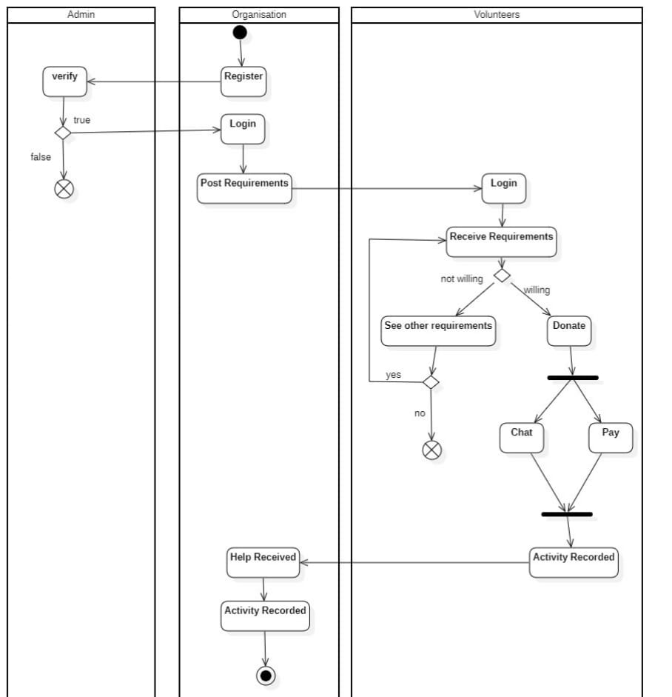

3.3.2 Use Case Diagram

The use case diagram illustrates the interactions between Volunteers, Organizations, and Admin within the "Community Connect" system. Volunteers can register, log in, browse and follow organizations, view requirements, donate, chat, and track activity history. Admins manage volunteers and verify organizations, while organizations can post requirements and view their followers.

Actors:
- Volunteer-
- Organisation-
- Admin-

Use Cases:
- Volunteer can:
- Login
- Register
- Browse Organizations
- View Followed Organizations
- View Organization’s Requirements
- Donate
Activity History
- Chat
- Organisation can:
- Login
- Register
- Activity History
- Chat
- Post Requirements
- View Followers

- Admin can:
      - Manage and Verify Organization
      - Manage Volunteers

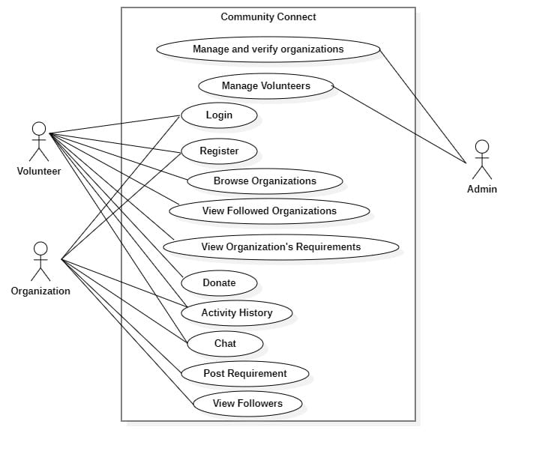

    - Class Diagram
The class diagram depicts the structure of a community support system involving Admins, Volunteers, and Organizations. It defines key entities like Requirement, Donation, Chat, and Activity, along with their attributes and methods. Relationships between classes represent how users interact—Admins verify and manage, Organizations post needs, and Volunteers donate or communicate—ensuring effective support and tracking.
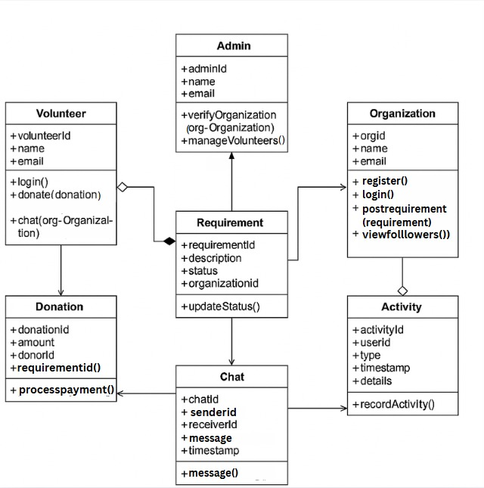

    - Data Flow Diagram

This Data Flow Diagram (DFD) depicts the "Community Connect" system at Level 0 and Level 1. At Level 0, it shows interactions between Volunteers, Organizations, and Admin through the central system. Level 1 breaks down the processes into five main functions: managing organizations, viewing requirements, posting requirements, donating and chatting, and recording donations and chats. Data stores such as Volunteer Data, Organization Data, Donation Records, and Chat Records support these operations.

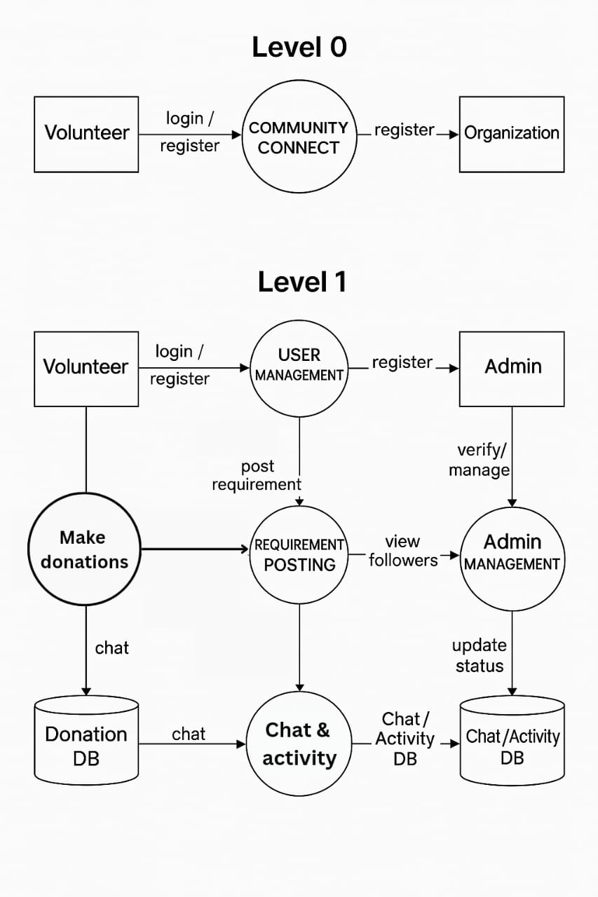

    - Collaboration Diagram

This Collaboration Diagram illustrates the structural relationships and communication pathways among the seven main objects: Admin, Volunteer, Organization, Requirement, Donation, Chat, and Activity. The Volunteer object is central, directly communicating with most other entities to perform actions like donating, viewing requirements, and chatting. The diagram highlights the dependencies and shows that Activity serves as the central logging object, receiving record messages from Donation, Organization, and Chat. It acts as a static map defining which objects call specific methods on others (e.g., donate(requirementId) or verifyOrganization()) across the system..

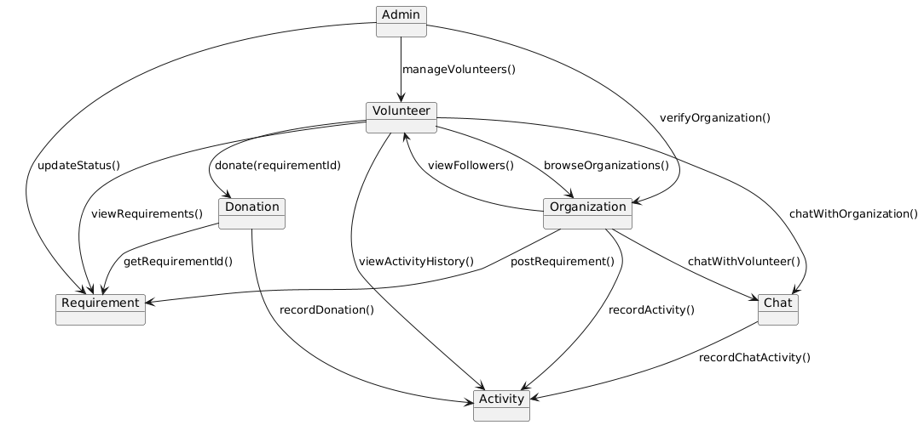

    - Component Diagram

This Component Diagram provides a high-level view of the system's architecture, decomposing it into seven major functional components, all contained within the CommunityConnect boundary. The core components are User Management, Admin Module, and the handling services for Donation, Requirement, Messaging, and Activity. All major handling components rely on the central Database for persistent storage and retrieval of their respective records. The diagram emphasizes the dependencies and data flow between these modules, showing how requests initiated by users (via User Management) flow to the specialized handlers, often under administrative control (Admin Module).

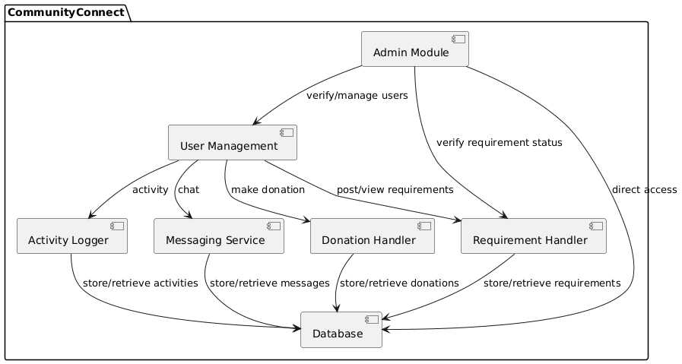

    - Deployment Diagram

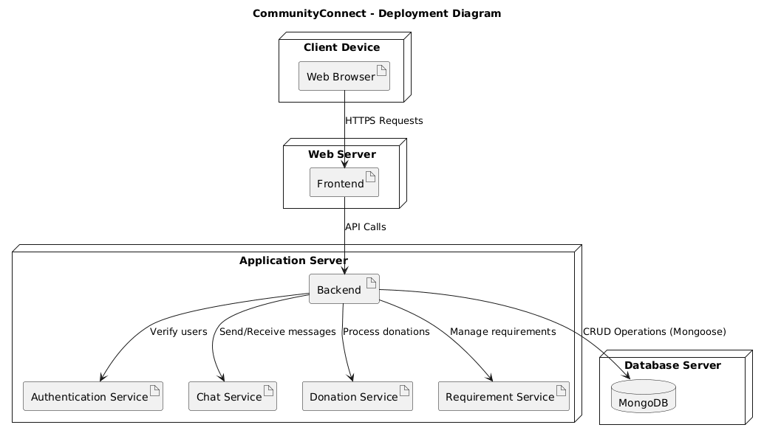
This Deployment Diagram illustrates the physical architecture of the Community Connect website, detailing how software components are mapped onto hardware nodes. The system uses a three-tier structure: a Client Device hosting the Web Browser, a Web Server hosting the Frontend, and an Application Server hosting the Backend and core microservices. The Backend serves as the central orchestration point, communicating with specialized services for Authentication, Chat, Donation, and Requirement handling. Persistent data is managed separately on a Database Server using MongoDB, which the Backend accesses via CRUD operations.

    - Package Diagram

This Package Diagram illustrates the high-level modular structure of the Community Connect system by grouping related classes into six functional packages. Key packages include User Management (handling core entities like Volunteer, Admin, and Organization) and Requirement Module (managing system needs). The diagram defines dependencies between these modules, showing that the Donation Module is dependent on the Requirement and Activity packages, and the Communication Module links user entities. This packaging simplifies the architecture by organizing the system's thousands of classes into manageable and cohesive functional units.
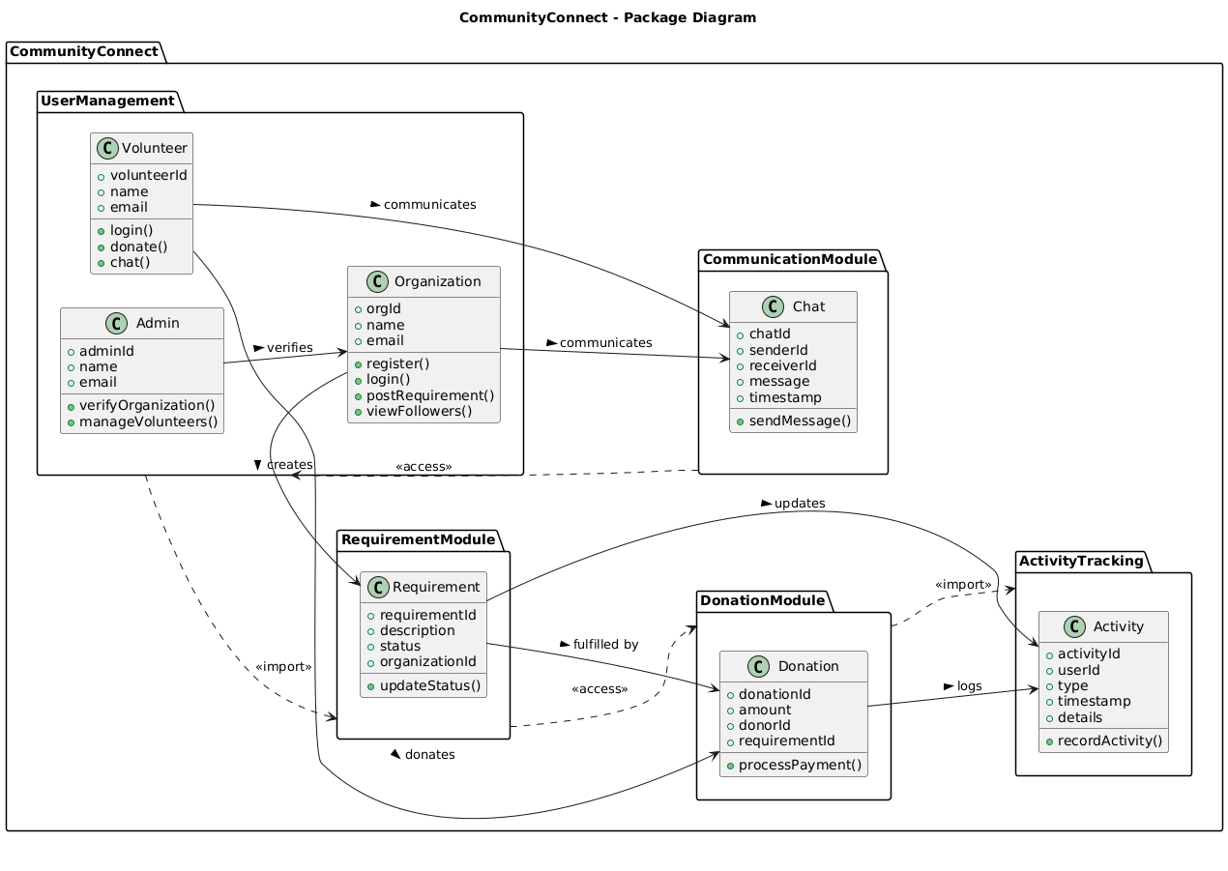

    - Sequence Diagram

This Sequence Diagram illustrates the time-ordered interaction between actors (Volunteer, Organization, Admin) and the system's core components (CommunityConnect, Requirement, Donation, Activity, Chat). It depicts several key use cases, including user Registration, Login, and Requirement Posting. The diagram's primary focus is the Donation process, showing the sequence where the CommunityConnect component delegates the request to the Donation service, which then independently communicates with the Requirement and Activity components to ensure status checks and logging are completed before sending a final confirmation.
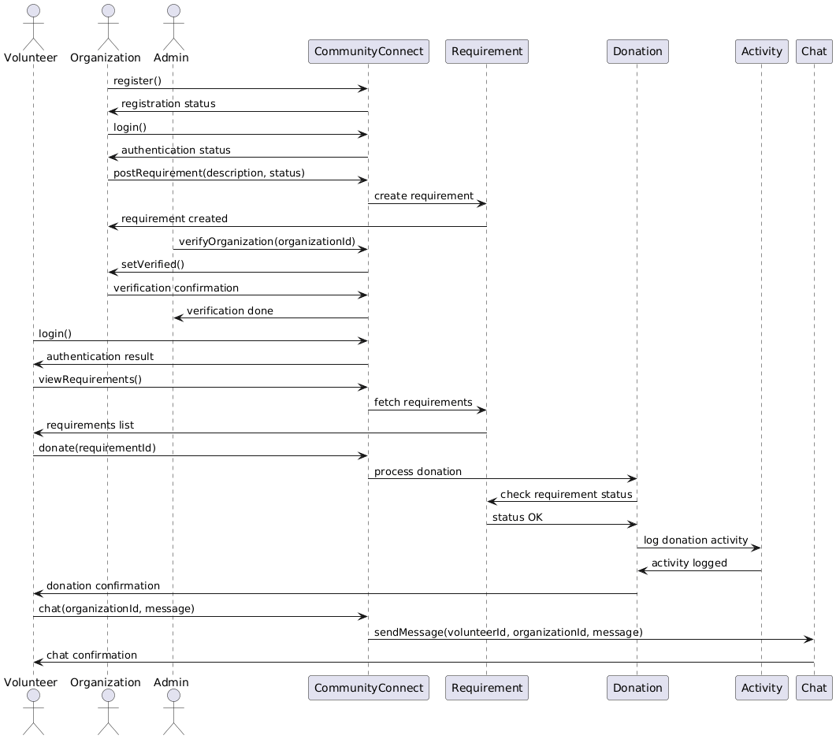

  - Architecthure
The Community Connect platform follows a three-tier architecture consisting of:
    - Frontend Layer (Client)
    - Backend Layer (Server)
    - Database Layer (Storage)
The system is designed using the MERN stack to ensure scalability, modularity, and maintainability. A single backend service handles requests from two separate frontend applications (Admin and User).

- Frontend Layer
The frontend is divided into two independent applications:
    - Admin Frontend
    - User Frontend (Volunteer + NGO)
Both are built using React with Vite for fast development.
Responsibilities:
  - User interface rendering
  - Routing and navigation
  - API communication using Axios
  - State management (authentication, user data)

- Backend Layer
The backend is built using Node.js and Express.js.
Responsibilities:
- REST API handling
- Authentication using JWT
- Business logic (requirements, donations, chat, notifications)
- Validation and middleware handling
- Payment integration (Razorpay)
The backend serves as a central API layer for all user roles.

- Database Layer
The database uses MongoDB with Mongoose.
Responsibilities:
- Store user data (Volunteer, NGO, Admin)
- Manage requirements, donations, chats, notifications
- Maintain relationships between entities

Data Flow
- User interacts with frontend (e.g., clicks “Donate”)
- Frontend sends request to backend API
- Backend processes logic and interacts with database
- Backend returns response to frontend
- Frontend updates UI accordingly

CHAPTER 4

DISCUSSION

4.1 Discussion on the proposed activity
The primary objective of this project is to combat poverty by establishing an efficient surplus commodity donation system that ensures funds are redirected to individuals and communities in need & facing poverty.
Community Connect is fully aligned with the United Nations Sustainable Development Goals (SDGs) and the All India Council for Technical Education (AICTE) themes, reflecting its commitment to social development and inclusivity.
Community Connect plays a crucial role in supporting several SDGs, such as eradicating poverty (SDG 1), Zero Hunger (SDG 2), ensuring quality education (SDG 4) and reducing inequalities (SDG 10).
This digital solution provides a streamlined interface where NGOs can post their initiatives and volunteer opportunities, and where individuals interested in contributing their time and skills can easily find and connect with these opportunities.
By creating a streamlined process for collecting, storing, and distributing funds, the project seeks to minimize waste and maximize the utilization of valuable resources.

CHAPTER 5

IMPLEMENTATION

5.1 Implementation and Experimental results:

HOME PAGE
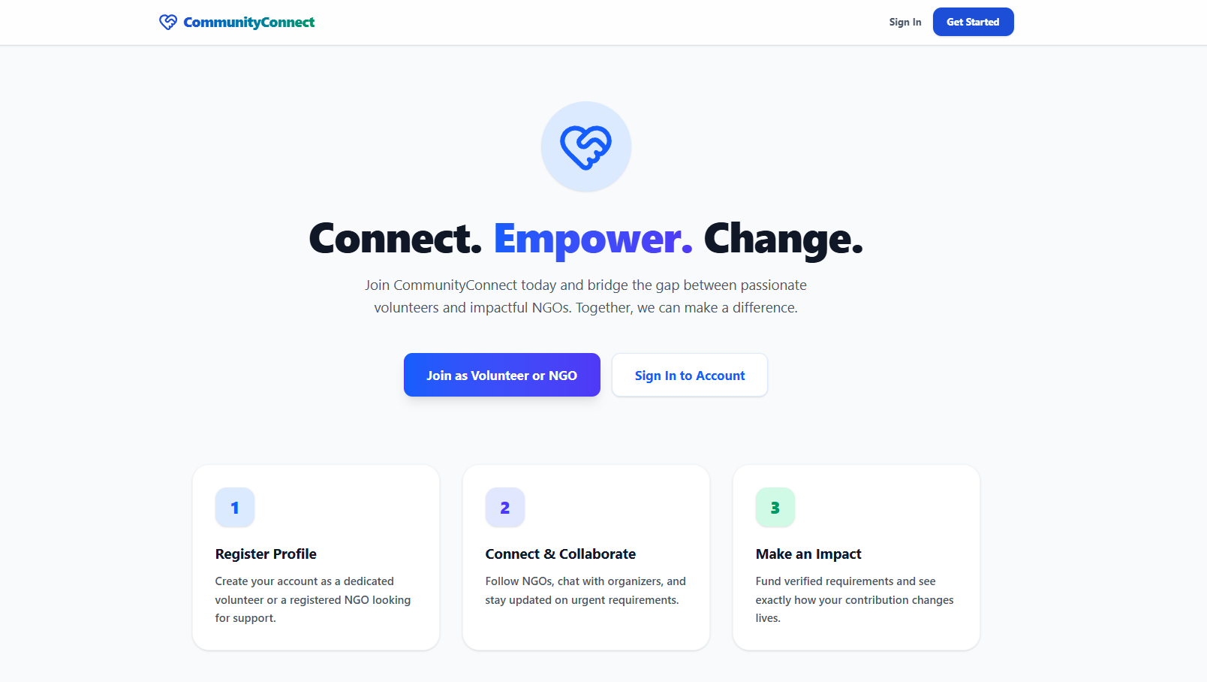

SIGN UP PAGE - VOLUNTEER
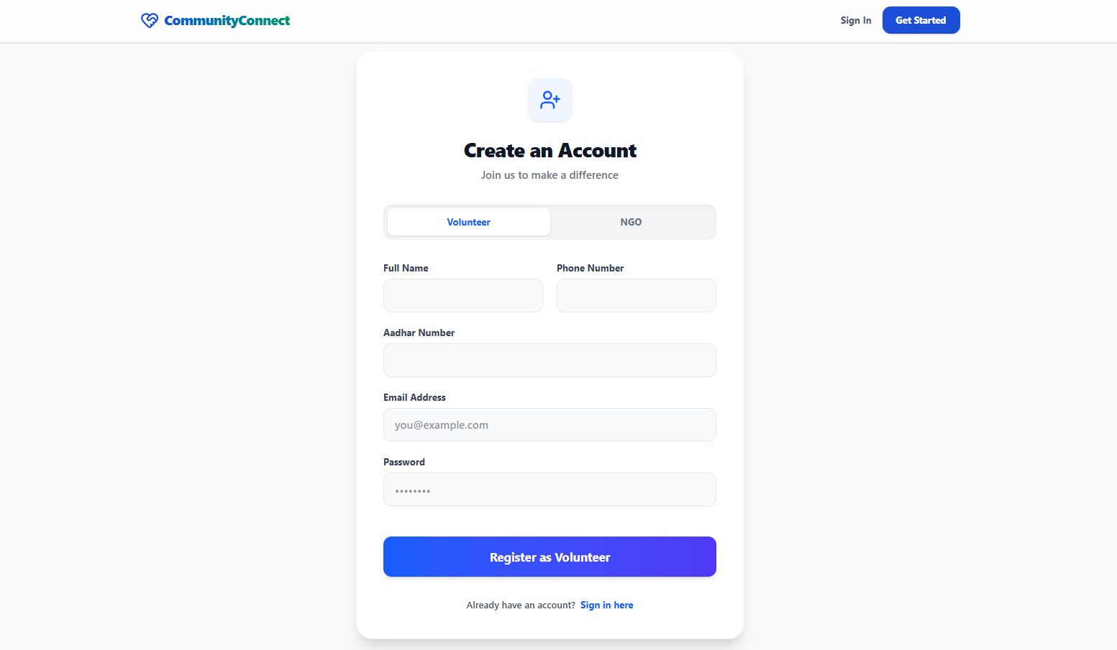
SIGN UP PAGE - NGO
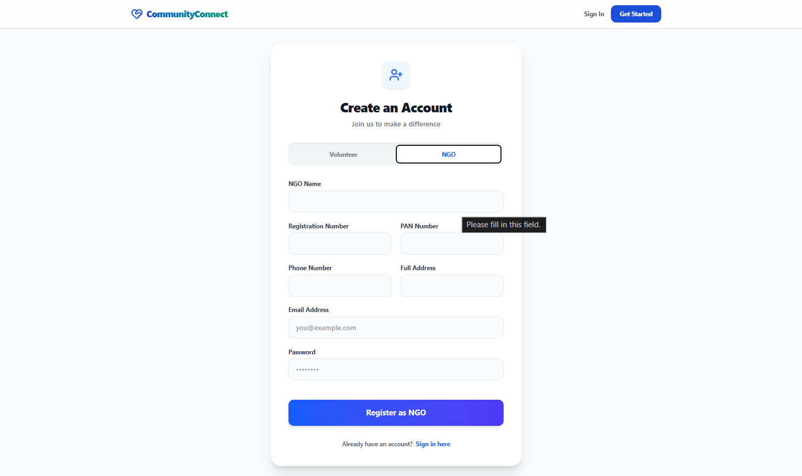

LOG IN PAGE
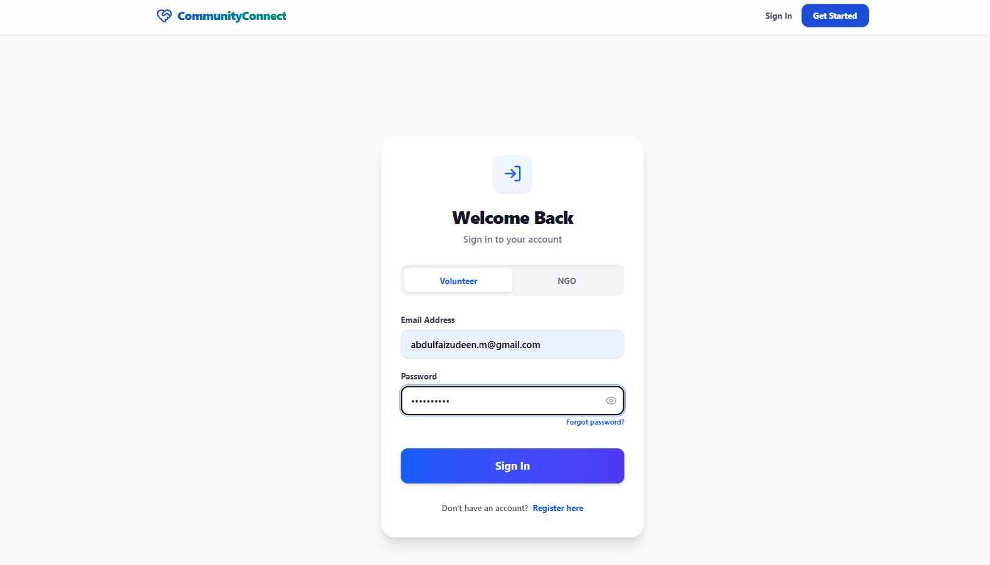

NGO DASHBOARD
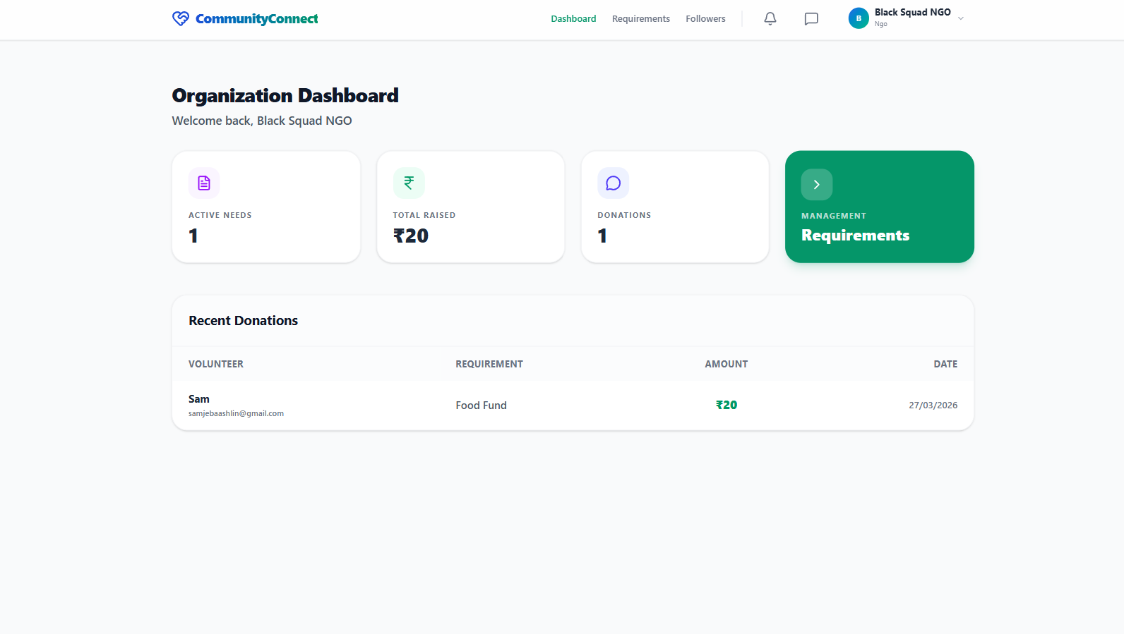

REQUIREMENTS PAGE
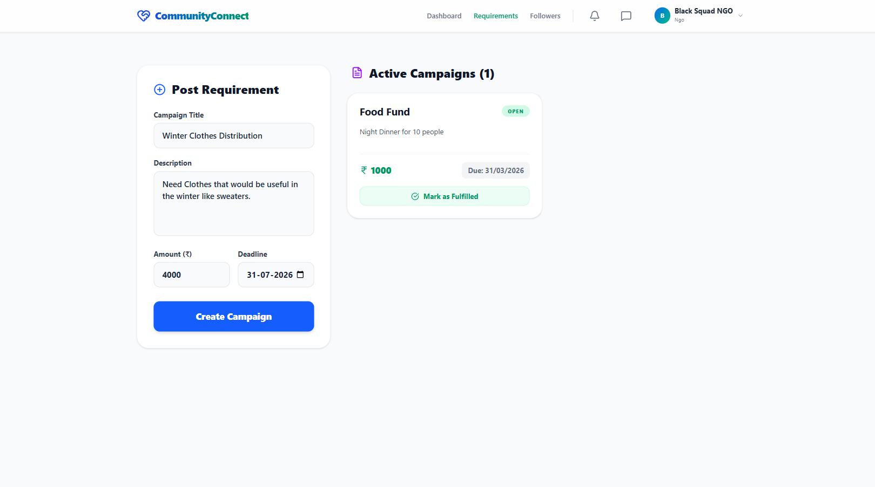

NGO FOLLOWERS 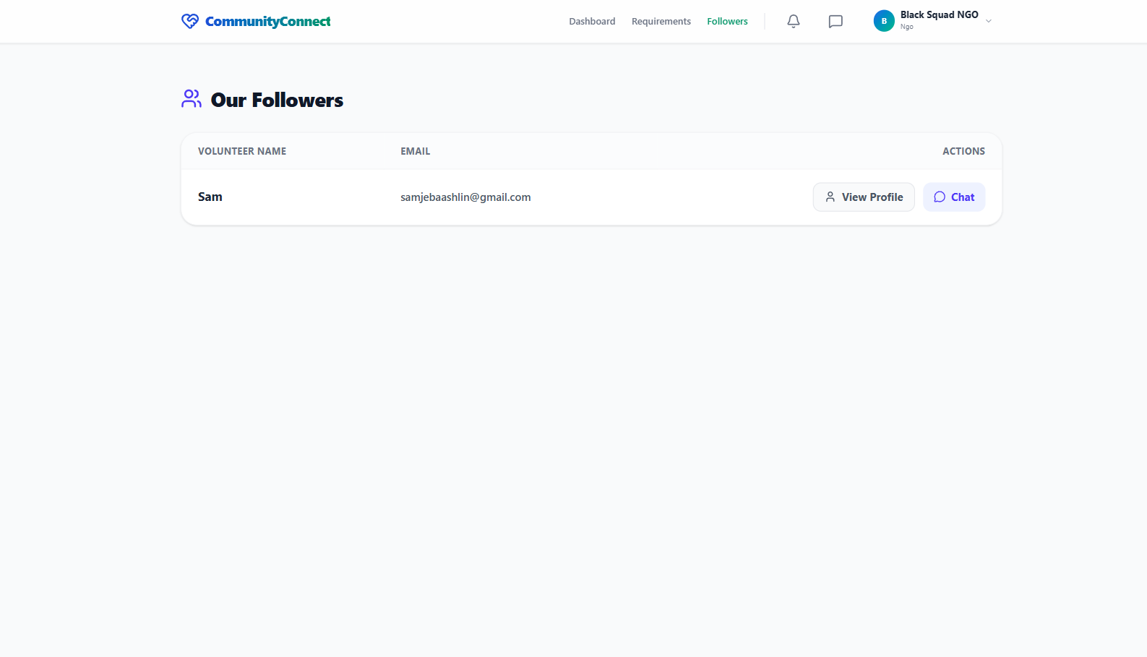

VOLUNTEER DASHBOARD
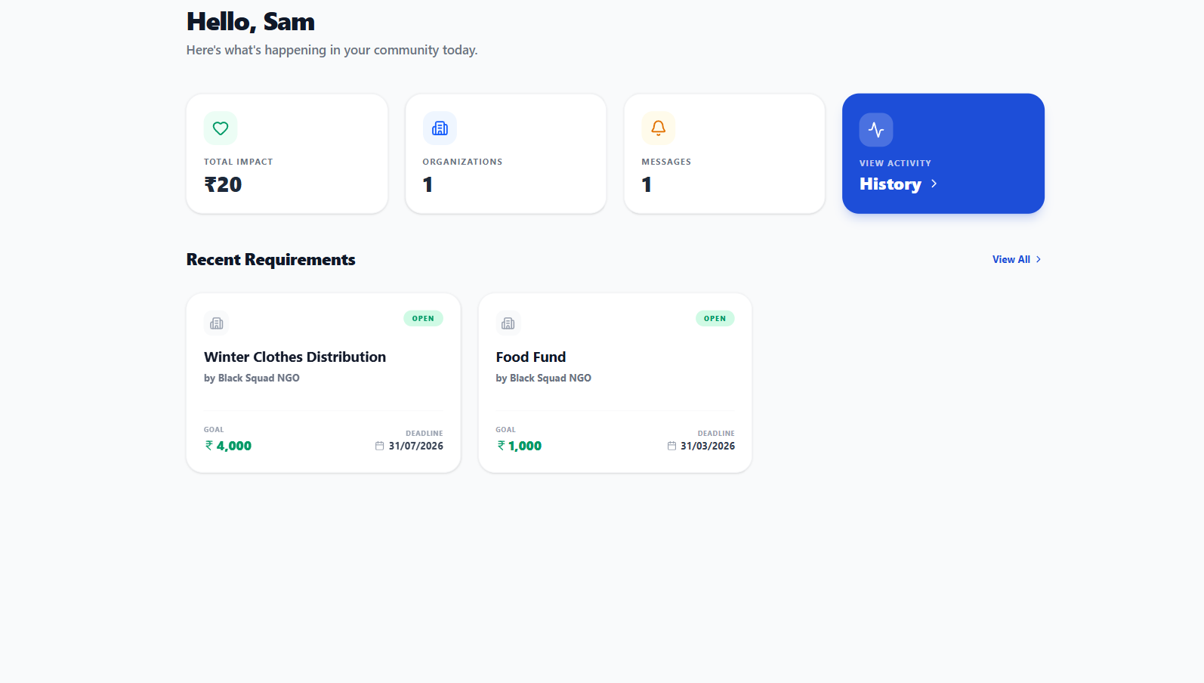

ORGANIZATIONS PAGE
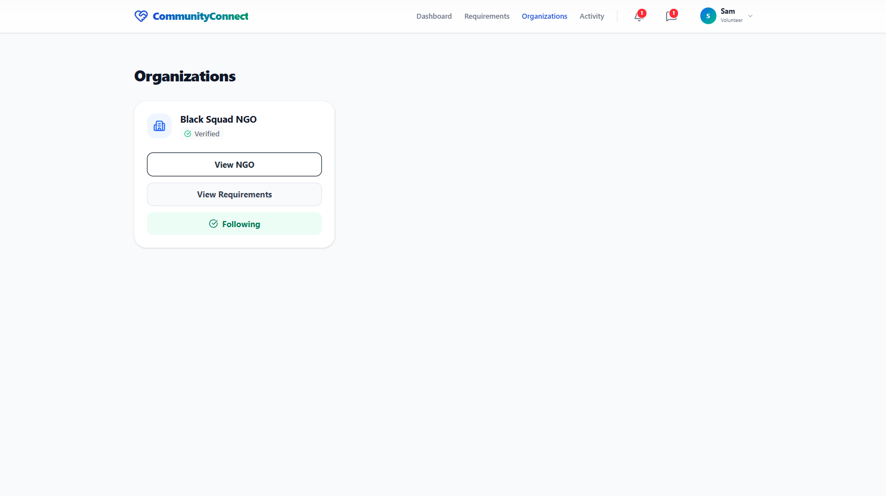

VIEWING REQUIREMENTS
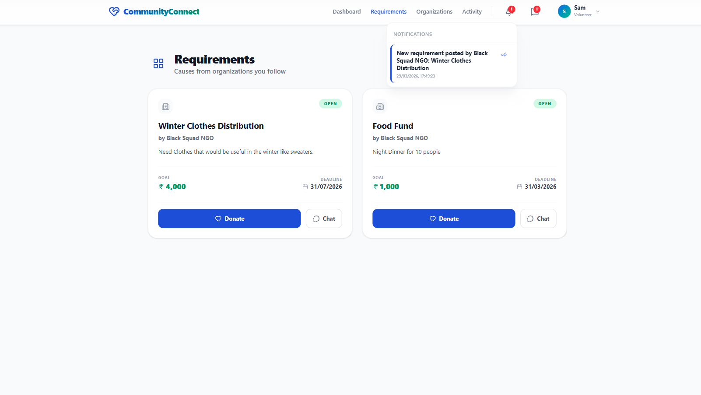

DONATION PAGE
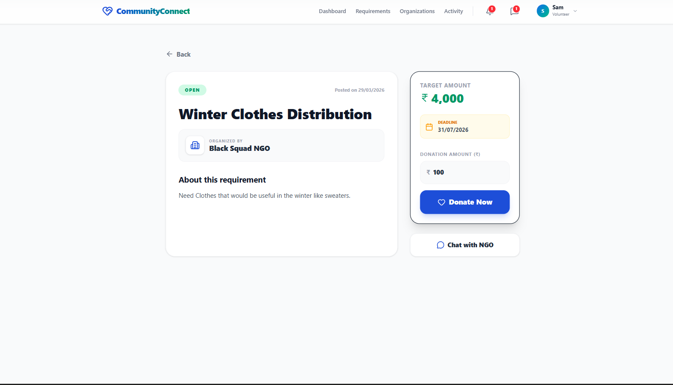

PAYMENT PROCESS
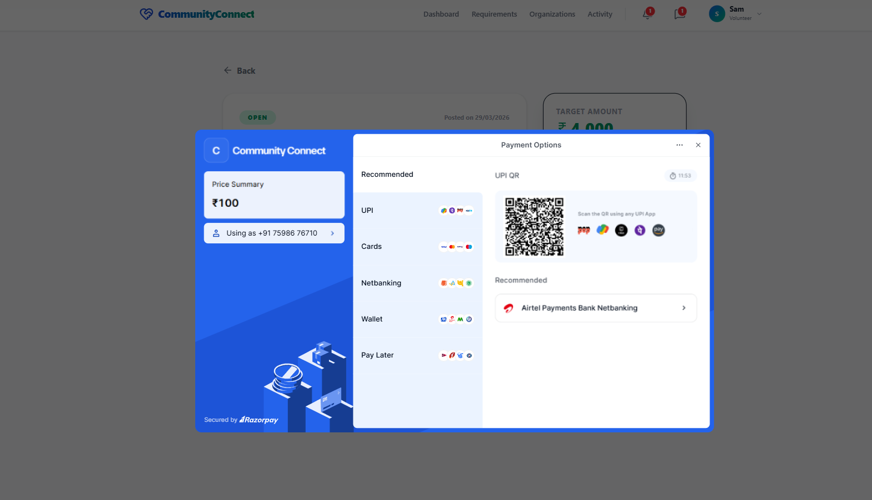

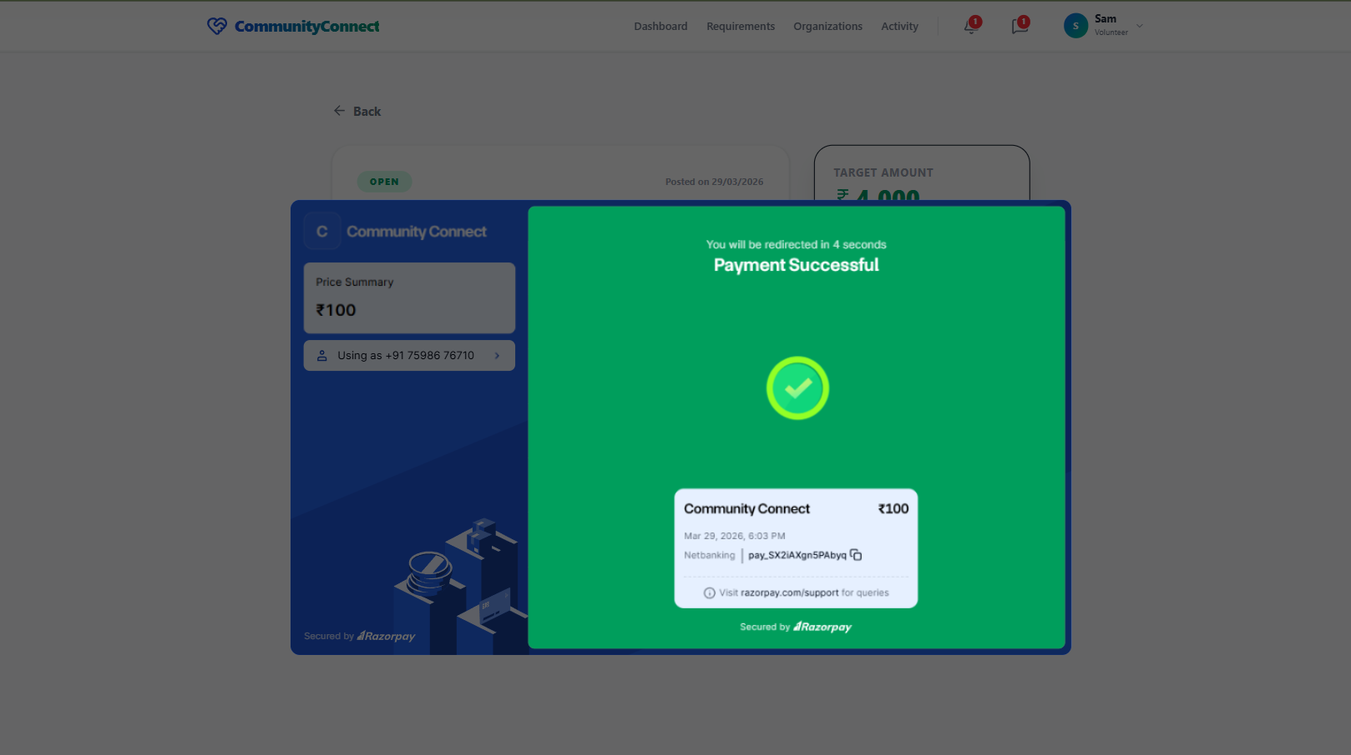

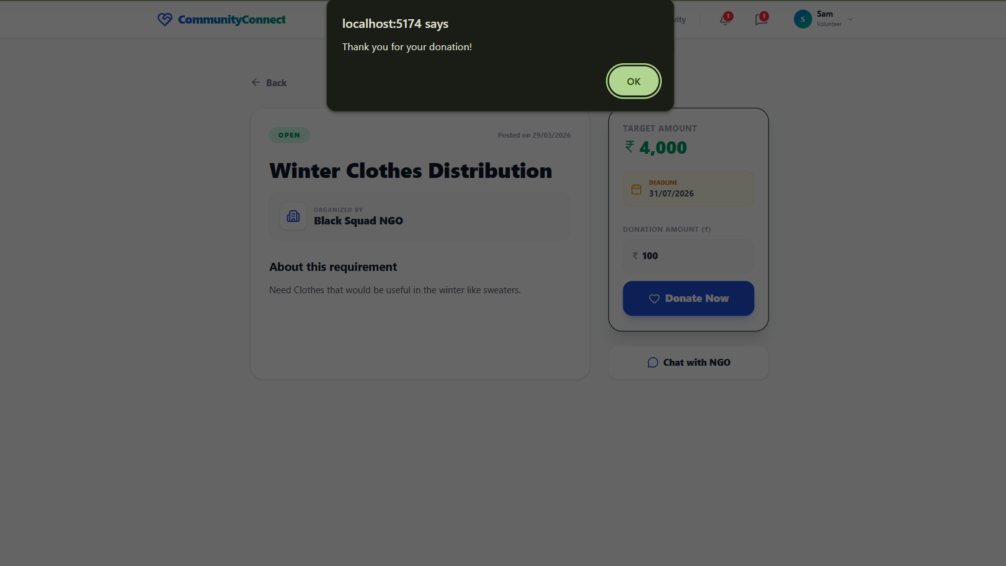

ACTIVTIES PAGE
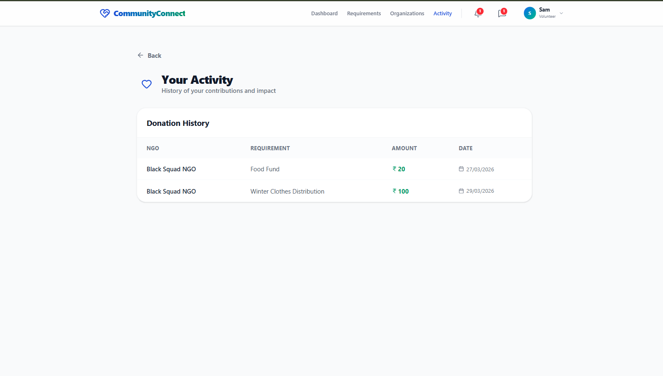

CHAT FEATURE
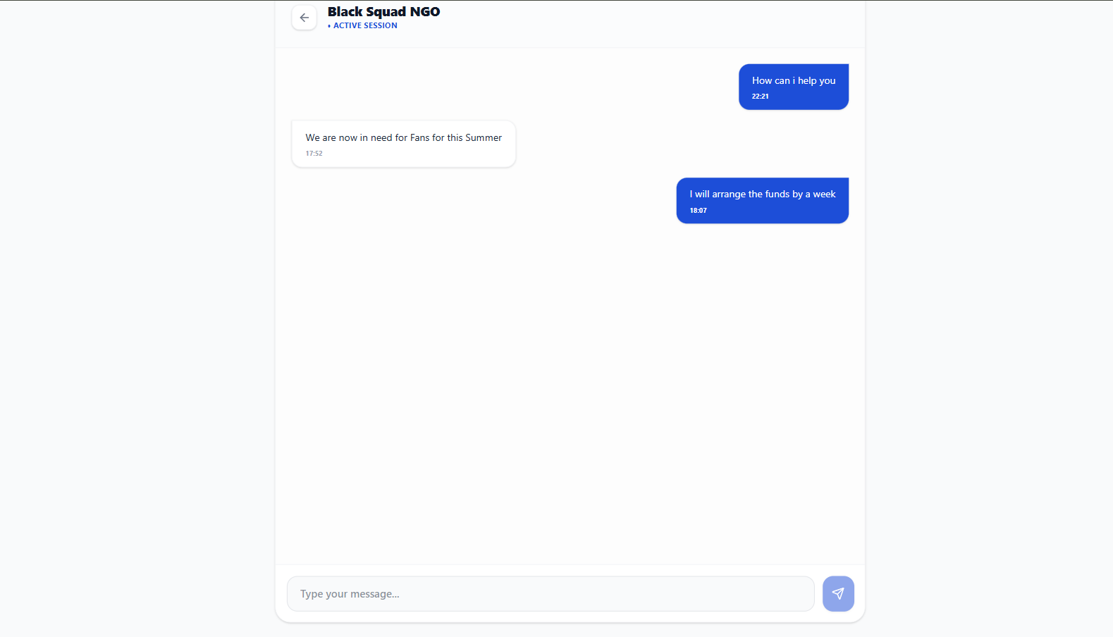

ADMIN DASHBOARD
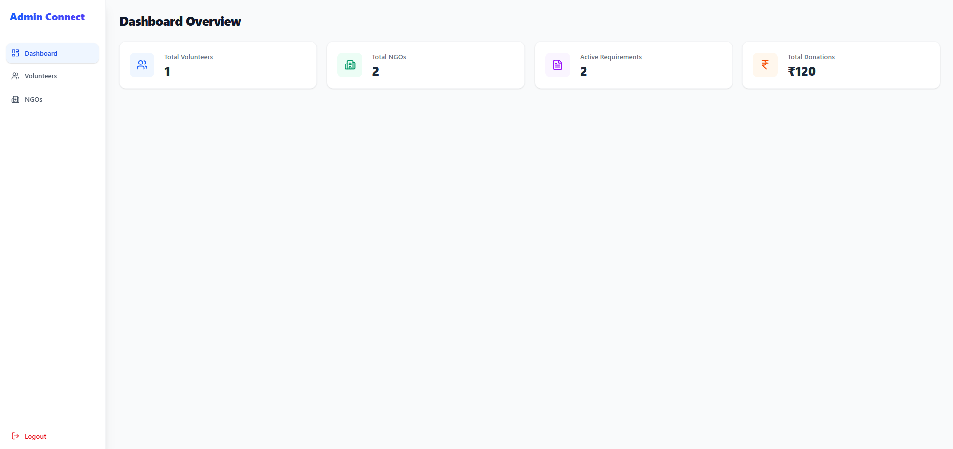

MANAGE NGOs
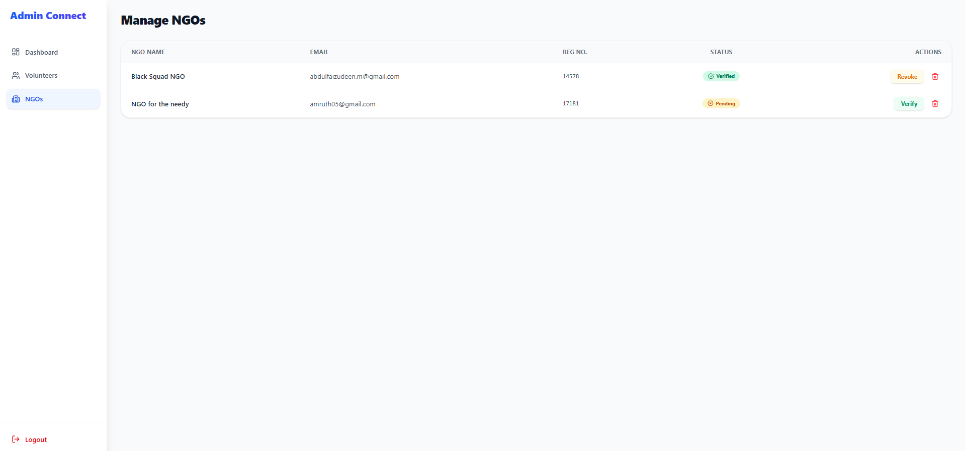

CHAPTER 6

ACTIVITY LOG
S. No | Activity list | Date/s of activity completed | No. of hours spent
1 | Study on AICTE and its scheme | 27/03/2024 | 4
2 | Project initiation and design | 01/04/2024 | 5
3 | Formulating the problem | 05/04/2024 | 6
4 | Collecting data about nearby organizations | 09/04/2024 &  16/04/2024 | 8
5 | Analysing other apps or websites related to charities | 25/04/2024 | 4
6 | Gathering necessary information to formulate solutions. | 28/04/2024 | 4
7 | Acquiring knowledge of several methodologies for the development of digital interfaces | 30/04/24  & 01/05/24 | 5
8 | Gathering data on external reference to help in build the app/website | 04/05/2024 | 8
9 | Preparation of UML Diagrams (Use Case, Class, DFD, Sequence) | 01/10/2024 – 04/10/2024 | 12
10 | Initial Setup & Basic Authentication (Login/Register – Phase 1) | 15/10/2024 | 8
11 | Testing of Basic Authentication | 20/10/2024 | 3
12 | Design of Profile & Requirement Modules | 10/11/2024 | 6
13 | Frontend UI Design (Login, Signup, Home Pages) | 05/12/2024 | 8
14 | Implementation of Authentication Module | 20/05/2025 | 16
15 | Implementation of Volunteer & Organization Profile Module | 05/06/2025 | 18
16 | Testing of Authentication & Profile Modules | 10/06/2025 | 6
17 | Implementation of Requirement Posting Module | 01/07/2025 | 20
18 | Implementation of Browsing & Filtering Module | 10/07/2025 | 16
19 | Testing of Requirement & Browsing Modules | 15/07/2025 | 6
20 | Implementation of Chat & Communication Module | 05/08/2025 | 20
21 | Testing of Chat Module | 15/08/2025 | 6
22 | Integration of Donation & Payment Gateway Module | 10/09/2025 | 18
23 | Implementation of Notification System | 25/09/2025 | 12
24 | Development of Admin Dashboard (Manage Users & NGOs) | 15/10/2025 | 16
25 | Activity Logging & Tracking Module Implementation | 01/11/2025 | 12
26 | Intermediate System Testing (All Modules) | 10/11/2025 | 8
27 | System Integration & Deployment Setup (Server + Hosting) | 05/12/2025 | 20
28 | Debugging & Performance Optimization | 20/12/2025 | 14
29 | Final System Testing & Validation (End-to-End Testing) | 25/01/2026 | 10
30 | Security Enhancements & Data Validation Module | 10/02/2026 | 12
31 | Documentation Update & Report Drafting | 01/03/2026 | 10
32 | Final Report Submission, Review & Presentation Preparation | 27/03/2026 | 10

