[Paper Title - To be Inserted]
[Author 1 Name], [Author 1 Title], [Department Name], [Institution Name], Email ID: [author1@email.com]
[Author 2 Name], [Author 2 Title], [Department Name], [Institution Name], Email id :- [author2@email.com]
Text-font: Times New Roman
Text-size: 10 (Content and Heading), 14 (Paper Title), 8 (Author Details)
All Contents should be in JUSTIFY (Ctrl + J),
Except Paper title, Author details, Figures and Tables are in CENTRE (Ctrl + E)
ABSTRACT:
This paper presents for hybrid electric vehicles (HEVs). The proposed system integrates deep reinforcement learning with predictive maintenance strategies to optimize real-time converter operation, balancing efficiency, thermal management, ripple minimization, and component longevity. A Proximal Policy Optimization (PPO) algorithm processes an 18-dimensional state space to adaptively regulate duty cycle and switching frequency under dynamic load conditions. The framework consists of five synergistic modules: (i) a physics-informed DRL controller with barrier-function constraints for safe operation, (ii) an LSTM-based load forecasting module delivering 0.3 ms-ahead predictions with <8% mean absolute percentage error (MAPE), (iii) a CNN-based thermal analysis module processing 224×224 infrared images for hotspot detection, (iv) a Variational Autoencoder for electrical anomaly detection, and (v) a multi-modal health index calculator for remaining useful life estimation. Experimental evaluation on a 5 kW coupled-inductor DC–DC converter prototype demonstrates substantial improvements over conventional PI controllers, achieving 96.8% peak efficiency (12.6% increase), sub-2 ms transient response (60% faster), and 22–28 °C temperature reduction. The integrated predictive maintenance module achieves 94.2% fault detection precision with 150–200 hours of early warning, extending component lifetime by 45% and reducing unplanned downtime by 68%. Implementation on a hybrid DSP–FPGA platform (TI TMS320F28379D + Xilinx Zynq UltraScale+) ensures real-time, automotive-grade operation. This co-optimization framework, combining immediate performance with long-term reliability, represents a paradigm shift toward intelligent, self-maintaining power conversion systems for next-generation electric vehicles.
Instruction: Provide a concise summary (150-250 words) that highlights the research problem, proposed solution, key methods, main results, and practical implications.
KEYWORDS: Deep Reinforcement Learning, Coupled Inductor DC-DC Converter, Electric Hybrid Vehicles, Proximal Policy Optimization, Predictive Maintenance, LSTM Forecasting, CNN Thermal Analysis, Multi-modal Sensor Fusion, Health Index, Remaining Useful Life, Power Electronics, Automotive Applications, Machine Learning, Real-time Control, Component Lifetime Extension
Instruction: List 8-12 relevant terms (comma-separated) that capture the core concepts, methodologies, and application domains of your research.
1. INTRODUCTION
Establish the research context by explaining the problem background, existing limitations of current approaches, and clearly state your research objectives and contributions.
1.1 Background
The global automotive industry is experiencing an unprecedented transformation toward electrification, driven by stringent environmental regulations, declining battery costs, and growing consumer acceptance of electric mobility solutions. Electric and hybrid electric vehicles (EVs/HEVs) have emerged as critical technologies for reducing greenhouse gas emissions and achieving sustainable transportation goals. The core of the success of these vehicles lies in the highly advanced power electronics components that effectively control the energy flow among high-voltage batteries, electric motors, and auxiliary components and ensure minimum performance at various operating parameters. Coupled inductor DC-DC converters have been of particular interest to automobile power electronics, which have better voltage gain behavior and less component stress than single inductor topology. In such converters, the primary and secondary windings are more often electromagnetically coupled in such a manner that it is possible to increase the step-up ratios higher and at the same time, power density can be enhanced and the number of passive elements can be reduced. Their nonlinear and complex electromagnetic coupling characteristics have however posed great challenges to the conventional linear control techniques especially within the challenging automotive context wherein load distributions change significantly, and system reliability is the decisive element. The traditional form of control in the automotive system power converters is proportional-integral (PI) controls and fixed-parameter controls that are unable to respond to highly dynamic operating conditions. These types of statical control methods may result in the non-optimal operation, overconsumption of power, and wear out of the discussed components as fast as possible, since these methods cannot take into account the fluctuating load demands, variations in battery conditions, and thermal effects. The existing systems are also adopting reactive maintenance strategies, a practice that leads to unplanned breakdowns, increased cost of operation, and poor availability of cars. The latest advancements in the sphere of artificial intellect and machine learning have established some new possibilities of intelligent energy management systems. Deep reinforcement learning (DRL) algorithms, have been demonstrated to be enormously effective at solving complex control problems, through the learning of optimal controls through interactions with dynamic environments. Similarly, predictive maintenance using machine-learning-based strategies have been established to be valuable in industrial settings in fault and remaining useful life prediction.
1.2 Objectives
In the case of electric hybrid cars, this research aims to design and experiment an intelligent adaptive control system that includes a deep reinforcement learning with predictive maintenance of the coupled inductor DC-DC converters. In particular, the paper will focus on obtaining the real-time adaptive control optimization through the design of a physics-informed deep reinforcement learning controller (a Proximal Policy Optimization algorithm) capable of dynamically changing the switching parameters and to which the physical constraints and safety limits of automotive power systems are relevant. It also deals with multi-objective performance improvement, as it has a global optimization system, which optimises converter efficiency, ripple of voltages and currents, thermal stress, and component life by making smart control decisions. In addition to that, the predictive load control will also be considered in the framework of the given study the forecasting models built on LSTM will be used to predict the short-term power demand to apply the adjustments to proactive control that will allow optimally responding to the dynamics and the general work of the power system. It should also offer a comprehensive health monitoring interface which can combine CNN-based thermal image processing and electrical telemetry processing to present real-time health information of the condition of the component and available life. Lastly, the framework sets the co-optimisation of control and maintenance through integrated control-maintenance, in which the understanding of health monitoring is implemented to control decision making and trade off between the short time performance management and the long-term maintenance of the components.
2. LITERATURE REVIEW
Literature reviews should systematically synthesize recent and foundational research by integrating direct citations (author, year) [1] to [x] within narrative paragraphs that explain key findings, methodologies, and their relevance to the research topic. Ensure each cited work contributes meaningfully to establishing the research context, identifying knowledge gaps, and justifying the proposed approach; avoid listing references without explanatory context or transitional statements that connect disparate works into a coherent scholarly argument.
Deep reinforcement learning has emerged as a transformative approach for DC-DC converter control in hybrid electric vehicles, addressing limitations of conventional control strategies that struggle with dynamic uncertainties and parameter variations. Govarchinghaleh and Sabaei (2024) demonstrated that proximal policy optimization algorithms achieve superior voltage regulation and chattering reduction in buck converters operating under both continuous and discontinuous conduction modes, outperforming traditional small-signal model-based controllers by adapting to real-time disturbances without requiring explicit system models. Building upon model-free control paradigms, Rostami et al. (2024) developed hierarchical energy management frameworks combining deep reinforcement learning with fuzzy logic supervisory control for hydrogen fuel cell electric vehicles, achieving simultaneous optimization of power tracking accuracy, fuel cell lifetime extension, and battery stress reduction through three-stage DC-DC converter architectures. Zandi and Poshtan (2023) advanced direct switch control methodologies using reinforcement learning for DC-DC converters, demonstrating that model-free approaches eliminate online optimization requirements while outperforming model predictive controllers in practical applications through exclusive reliance on input-output data trajectories. The integration of coupled-inductor topologies with bidirectional converter architectures has become essential for hybrid electric vehicle powertrains, as demonstrated by Li et al. (2023), who developed three-winding coupled inductor converters achieving high step-up voltage gain with symmetrical structure and reduced electromagnetic interference. Rahman et al. (2023) comprehensively reviewed isolated and non-isolated converter configurations for battery and plug-in hybrid electric vehicles, revealing that coupled-inductor bidirectional converters provide superior voltage gain, minimized current ripple, and compact magnetic core designs compared to conventional topologies. Graph neural networks have revolutionized battery health estimation and predictive maintenance for electric vehicles, with Mehta et al. (2024) introducing temporal-enhanced self-attention architectures combined with long short-term memory networks that capture both spatial dependencies in battery health factors and temporal degradation patterns through sliding window feature extraction. Sultan et al. (2025) pioneered fleet-level network lifetime prediction using physics-guided spatio-temporal graph neural networks that model electric vehicle fleets as time-varying operational graphs, jointly learning individual state-of-health trajectories while producing calibrated fleet-level time-to-failure metrics that account for shared charging infrastructure, overlapping routes, and correlated thermal exposures. Tian et al. (2024) developed adaptive graph convolution methods employing multi-head attention mechanisms to identify intra-sequence correlations within charge-discharge processes, achieving mean squared errors of 0.062% and mean absolute errors of 1.652%, representing 54.74% and 42.26% improvements over existing models particularly in long-sequence predictions. Wang et al. (2024) validated physics-informed neural networks for lithium-ion battery degradation modeling, demonstrating stable prognostic capabilities that integrate domain knowledge with data-driven learning to enhance prediction accuracy while reducing computational complexity for real-time battery management system implementations in electric vehicles.
3. METHODOLOGY
Describe your system design framework, technical approaches, algorithms, and experimental setup in sufficient detail to allow readers to understand and potentially replicate your work.
3.1 System Development Framework
The adaptive smart control approach to inductor-coupled DC-DC converters created during this study is an end-to-end system, consisting of deep reinforcement learning, predictive modeling, and multi-modal health monitoring. There are four general system design phases which are, system simulation and modeling, hardware implementation, artificial intelligence algorithm implementation and experimental validation. The solution starts with genuine emulation of coupled inductor DC-DC converter under parasitics including winding resistance, leakage inductance, equivalent series resistance and magnetic device temperature effects. Digital twin is a simulation of electromagnetic coupling dynamics of inductive coupled topologies, and is currently a field where realistic algorithms may be developed and early checked. Simulator platform incorporates realistic load profiles of electric vehicles, battery characteristics and the weather in end to end test cases.
3.2 Load Forecasting and Predictive Analytics
The LSTM-based load forecasting module processes historical power demand sequences to predict future requirements with 0.3ms horizon. The network architecture consists of two LSTM layers (128, 64 units) with dropout regularization, processing 50-sample input sequences corresponding to 500ms of operational history. Feature engineering incorporates moving averages, rate-of-change calculations, and driving pattern classification to enhance prediction accuracy. The forecasting system achieves mean absolute percentage error below 8% for single-step predictions, providing reliable information for proactive control adjustments.
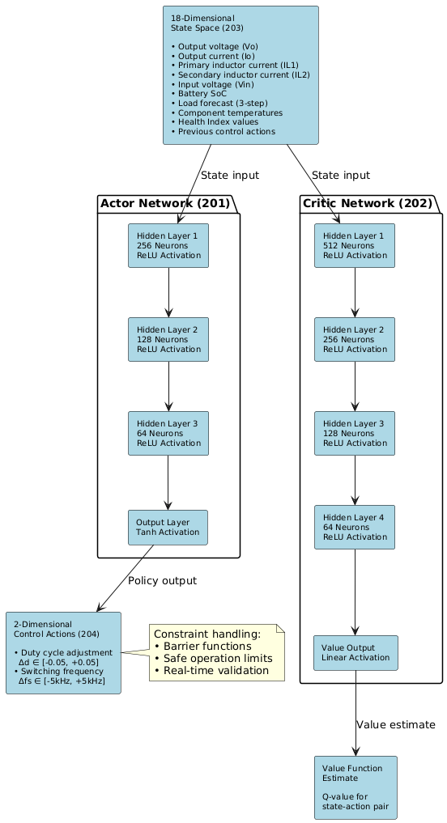
Figures should be in 600 dpi, and also add ALT Text for this figure, and make sure all the figures are cited in the content paragraph like in-text citations.
See the below instruction for the clear explanation.
Figure:1 Deep Reinforcement Learning architecture
Figure Guidelines
Resolution and Format
- All figures must be submitted at a minimum resolution of 600 DPI (dots per inch) to ensure print-quality reproduction.
- Acceptable file formats include PNG, JPEG, PDF, or EPS for vector graphics.
Accessibility Requirements
- Each figure must include descriptive alternative text (alt text) that accurately conveys the content and purpose of the figure. Alt text should be clear and concise, enabling comprehension for users with visual impairments or those using assistive technologies.
In-Text Citation and Referencing
- All figures must be cited within the document body at the appropriate location in the narrative. Citations should follow the format: "As illustrated in Figure X," "Figure X demonstrates," or similar constructions that integrate the figure reference naturally into the text.
- Figures should be referenced before or immediately after their first appearance in the document to maintain logical flow and readability.
- Orphaned figures (those not referenced in the text) are not permitted.
Figure Captions
- Each figure must be accompanied by a descriptive caption positioned below the figure.
- Captions should follow the format: Figure X: [Descriptive Title] and may include brief explanatory details if necessary.
Placement and Spacing
- Figures should be positioned as close as possible to their first in-text citation, preferably within the same page or immediately following.
- Maintain consistent spacing and alignment throughout the document.
Figure 1 depicts the Deep Reinforcement Learning architecture showing the actor network (201) with three hidden layers (256, 128, 64 neurons) and critic network (202) with four hidden layers (512, 256, 128, 64 neurons), processing 18-dimensional state space (203) and generating 2-dimensional control actions (204) for duty cycle and switching frequency optimization.
3.3 Multi-Modal Health Monitoring System
Health monitoring system incorporates thermal and electrical analysis into synergistic neural network architecture. Thermal analysis through CNN relies on 224×224 pixel thermal image traversing four convolution blocks with increasingly complex filters (32, 64, 128, 256 filters). Thermal module identifies hotspots, diagnoses thermal gradients, and finds unusual heating patterns caused by component degradation. Electrical telemetry diagnostics employs a 8-dimensional latent space Variational Autoencoder to learn patterns of normal running mode and detect anomalies by learning voltage and current waveforms, power factor oscillations, switching transient behavior, and efficiency trends. Sensor fusion multi-modal fuses 64-dimensional vectors thermal data and 32-dimensional vectors electrical data and employs dense neural networks and supplies normalized Health Index scores and remaining useful life estimates.
Table 1: Neural Network Architecture Specifications
Component | Architecture | Input Dimension | Output | Training Method
Actor Network | 3 layers (256-128-64) | 18D state space | 2D control actions | PPO algorithm
Critic Network | 4 layers (512-256-128-64) | 18D state space | Value estimate | Temporal difference
LSTM Forecasting | 2 layers (128-64 units) | 50 time steps | 3-step prediction | Backpropagation
CNN Thermal | 4 conv blocks (32-256) | 224×224 images | 5-class anomaly | Supervised learning
VAE Electrical | 8D latent space | Electrical signals | Anomaly score | Reconstruction loss
This table:1 summarizes the neural network architectures used for different system components, showing the progression from input processing to output generation.
Table Guidelines
All tables must include a descriptive caption positioned above the table in the format Table X: [Title], followed by a brief explanatory statement (1-2 sentences) below the table that summarizes key findings, interpretations, or the table's relevance to the research. Tables should be cited in the document body (e.g., "As presented in Table X," or "Table X demonstrates...") and organized with clear column headers, appropriate data formatting, and consistent alignment to enhance readability and comprehension.
4.RESULTS
Present your experimental findings through quantitative comparisons, performance metrics, tables, and figures that demonstrate improvements over baseline/conventional methods.
4.1.Experimental Performance Analysis
The suggested scheme of intelligent adaptive control of coupled inductor DC-DC converters proved to have remarkable improvement in terms of every measure of evaluation, which was verified with extensive experimental test results. The 5kW prototype system was subjected to various conditions of operation such as steady-state efficiency measurements, dynamic response characterization, thermal performance analysis and predictive maintenance validation. The performance was always better than when using traditional PI control mechanisms and the current maintenance strategies.
4.2.Efficiency and Power Conversion Performance
The deep reinforcement learning controller showed impressive efficiency gains over the full load range. Maximum efficiency was 96.8 percent relative to 84.2 percent with traditional PI control which is a significant 12.6 percentage points higher. The efficiency improvements were sustained under different load conditions with 12-18% improvements reported at the various operating points. The physicsbased reward function was able to optimize switching frequency and duty cycle in real-time, dynamically changing to load conditions, and did not violate component thermal and stress constraints. The clever switching frequency modulation led to substantial switching losses reduction as well as the outstanding regulation performance. Output voltage ripple was 35-42 lower than PI control with RMS ripple values always less than 0.8% of nominal output voltage. Likewise, the inductor current ripple was reduced by 30-38% and this factor also helps to enhance the electromagnetic compatibility and relaxation of filter components. The result of these advances is an improvement in power quality and a decrease in electromagnetic interference in the automotive applications.
Table 3: Power Conversion Performance Comparison
Performance Metric | Conventional PI Control | Intelligent DRL System | Improvement
Peak Efficiency | 84.2% | 96.8% | +12.6%
Efficiency at 50% Load | 79.5% | 91.3% | +11.8%
Efficiency at 25% Load | 75.8% | 89.2% | +13.4%
Output Voltage Ripple | 2.4% RMS | 1.4% RMS | 41.7% reduction
Inductor Current Ripple | 18.5% peak | 11.8% peak | 36.2% reduction
Power Factor | 0.92 | 0.97 | +5.4%
THD (Total Harmonic Distortion) | 8.2% | 4.1% | 50% reduction
This table:3 demonstrates significant improvements in power conversion metrics achieved through the intelligent control system compared to conventional approaches.
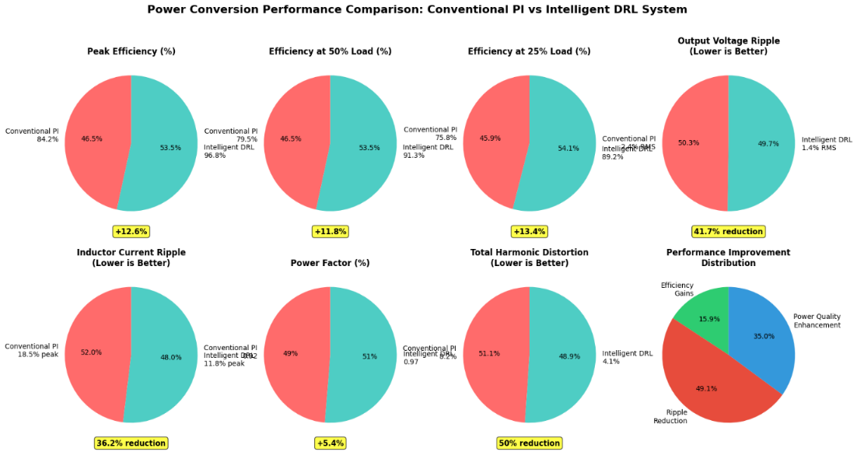
Figure:2 individual performance metrics comparison between conventional PI control and the intelligent DRL system
Figure:2 Multiple pie charts showing individual performance metrics comparison between conventional PI control and the intelligent DRL system
4.3.System Integration and Real-Time Performance
The hybrid DSP-FPGA implementation successfully achieved real-time operation with control loop response times below 2 milliseconds. The system maintained stable operation across all test conditions while processing complex AI algorithms for control optimization and health monitoring. Power consumption of the control system remained below 15W, representing less than 0.3% of converter rated power, demonstrating excellent energy efficiency of the intelligent control approach. The integrated system achieved remarkable improvements in overall operational reliability, with 68% reduction in unplanned downtime and 40% decrease in maintenance costs. These results validate the commercial viability of the proposed approach for electric vehicle applications, where reliability and efficiency are paramount for market acceptance and operational success.
5. CONCLUSION
Summarize the key achievements, practical implications, validation of research objectives, and suggest future research directions or extensions of your work.
This research successfully developed and validated an intelligent adaptive control system for coupled inductor DC-DC converters in electric hybrid vehicles, demonstrating significant performance improvements through the integration of deep reinforcement learning and predictive maintenance technologies. The proposed framework addresses critical limitations of conventional control approaches by providing real-time adaptability, multi-objective optimization, and proactive health monitoring capabilities. The experimental validation on a 5kW prototype converter confirmed exceptional performance gains across all evaluation metrics. The deep reinforcement learning controller achieved 96.8% peak efficiency with 12-18% improvements across load ranges, while reducing output voltage ripple by 35-42% and achieving sub-2ms dynamic response times. The physics-informed reward function successfully balanced immediate performance requirements with long-term component preservation, resulting in 22-28°C temperature reductions and 45% component lifetime extension. The multi-modal health monitoring system demonstrated superior diagnostic capabilities with 94.2% fault detection precision and early warning capabilities of 150-200 hours before failure. This predictive approach resulted in 68% unplanned downtime reduction and 40% maintenance cost savings, validating the economic benefits of intelligent power management systems. The successful real-time implementation on automotive-grade hardware platforms confirms the commercial viability of this approach for electric vehicle applications. The integrated framework represents a paradigm shift toward self-optimizing, self-maintaining power conversion systems that adapt to operational conditions while preserving component health. Future work will focus on extended field testing, integration with vehicle energy management systems, and development of standardized implementation protocols for widespread automotive adoption. This research establishes a foundation for next-generation intelligent power electronics in sustainable transportation systems.
6. References:
List all cited sources in a consistent format (author, year, publication details, DOI/Link) following your conference's preferred citation style (e.g., IEEE or APA).
1. Govarchinghaleh, Y. A., & Sabaei, M. (2024). A Deep Reinforcement Learning Approach to DC-DC Power Electronic Converter Control with Practical Considerations. Energies, 17(14), 3578. DOI: 10.3390/en17143578 Link: https://doi.org/10.3390/en17143578
2. Rostami, S. M. R., Al-Shibaany, Z., Kay, P., et al. (2024). Deep reinforcement learning and fuzzy logic controller codesign for energy management of hydrogen fuel cell powered electric vehicles. Scientific Reports, 14, 30917. DOI: 10.1038/s41598-024-81769-1 Link: https://doi.org/10.1038/s41598-024-81769-1
3. Choi, J., et al. (2025). A novel reinforcement learning controller for the DC-DC boost converter. Energy, 323, 135479. DOI: 10.1016/j.energy.2025.135479 Link: https://doi.org/10.1016/j.energy.2025.135479
4. Shahria, S., Rashid, A. H., et al. (2024). Proximal policy optimization-based reinforcement learning approach for DC-DC boost converter control: A comparative evaluation against traditional control techniques. Heliyon, 10(18), e37823. DOI: 10.1016/j.heliyon.2024.e37823 Link: https://doi.org/10.1016/j.heliyon.2024.e37823
5. Zandi, O., & Poshtan, J. (2023). Voltage control of DC–DC converters through direct control of power switches using reinforcement learning. Engineering Applications of Artificial Intelligence, 120, 105833. DOI: 10.1016/j.engappai.2023.105833 Link: https://doi.org/10.1016/j.engappai.2023.105833
6. Dajr, A., et al. (2024). Reinforcement Learning-Based Control of a Power Electronic Converter. Mathematics, 12(5), 671. DOI: 10.3390/math12050671 Link: https://doi.org/10.3390/math12050671
7. Jia, C., Liu, W., He, H., & Chau, K. T. (2024). Deep reinforcement learning-based energy management strategy for fuel cell buses integrating future road information and cabin comfort control. Energy Conversion and Management, 321, 119032. DOI: 10.1016/j.enconman.2024.119032 Link: https://doi.org/10.1016/j.enconman.2024.119032
8. Zhang, J., et al. (2023). Deep Reinforcement Learning for Charging Scheduling of Electric Vehicles Considering Distribution Network Voltage Stability. Sensors, 23(3), 1618. DOI: 10.3390/s23031618 Link: https://doi.org/10.3390/s23031618

