Day : Conditional Statements (4-8-2025)

1. Write a program to check if a number is positive, negative, or zero.

#include <stdio.h>

void main()

int main()

{

int number;

scanf("%d", &number);

if (number > 0)

{

printf("The number is positive.\n");

} else if (number < 0)

{

printf("The number is negative.\n");

} else

{

printf("The number is zero.\n");

}

}

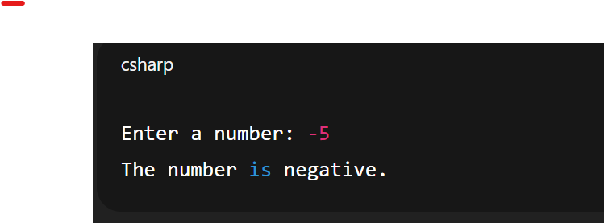

1. Write a program to find the largest among three numbers.

#include <stdio.h>

void main

{

int num1, num2, num3;

scanf("%d", &num1);

printf("Enter second number: ");

scanf("%d", &num2);

printf("Enter third number: ");

scanf("%d", &num3);

if (num1 >= num2 && num1 >= num3)

{

printf("The largest number is: %d\n", num1);

}

else if (num2 >= num1 && num2 >= num3)

{

printf("The largest number is: %d\n", num2);

}

else

{

printf("The largest number is: %d\n", num3);

}

}

Output:

Enter first number: 10

Enter second number: 25

Enter third number: 15

The largest number is: 25

1. Write a program to check if a year is a leap year.

#include <stdio.h>

void main

{

int year;

scanf("%d", &year);

if (year % 4 == 0)

{

printf("%d is a leap year.\n", year);

}

else

{

printf("%d is not a leap year.\n", year);

}

}

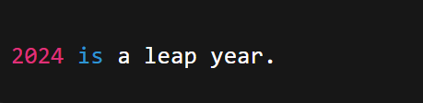

1. Write a program to check whether a character is a vowel or consonant.

#include <stdio.h>

void main()

{

char c;

scanf("%c", &c);

if (c == 'a' || c == 'e' || c == 'i' || c == 'o' || c == 'u' ||

c == 'A' || c == 'E' || c == 'I' || c == 'O' || c == 'U')

{

printf("%c is a vowel.\n", c);

}

else

{

printf("%c is a consonant.\n", c);

}

}

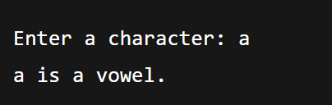

✅

1. Write a program to assign grades based on marks.

#include <stdio.h>

void main()

{

int marks;

printf("Enter your marks (0-100): ");

scanf("%d", &marks);

if (marks >= 90)

{

printf("Grade: A\n");

}

else if (marks >= 80)

{

printf("Grade: B\n");

}

else if (marks >= 70)

{

printf("Grade: C\n");

}

else if (marks >= 60)

{

printf("Grade: D\n");

}

else

{

printf("Grade: F\n");

}

}

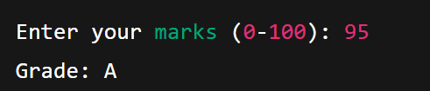

1. Write a program to check whether a number is divisible by 5 and 11.

#include <stdio.h>

void main()

{

int num;

printf("Enter a number: ");

scanf("%d", &num);

if (num % 5 == 0 && num % 11 == 0)

{

printf("%d is divisible by both 5 and 11.\n", num);

}

else

{

printf("%d is not divisible by both 5 and 11.\n", num);

}

}

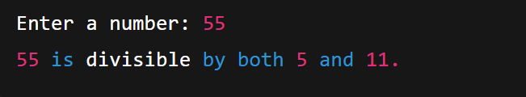

1. Write a program to find the absolute value of a number.

#include <stdio.h>

void main()

{

int num, absValue;

printf("Enter a number: ");

scanf("%d", &num);

if (num < 0)

{

absValue = -num;

}

else

{

absValue = num;

}

printf("The absolute value of %d is %d.\n", num, absValue);

}

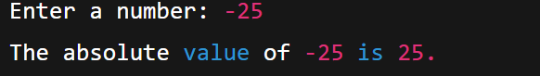

1. Write a menu-driven program to perform +, -, \*, / operations.

#include <stdio.h>

void main()

{

int choice;

float num1, num2, result;

printf("Simple Calculator Menu:\n");

printf("1. Addition (+)\n");

printf("2. Subtraction (-)\n");

printf("3. Multiplication (\*)\n");

printf("4. Division (/)\n");

printf("Enter your choice (1-4): ");

scanf("%d", &choice);

printf("Enter first number: ");

scanf("%f", &num1);

printf("Enter second number: ");

scanf("%f", &num2);

if (choice == 1)

{

result = num1 + num2;

printf("Result: %.2f + %.2f = %.2f\n", num1, num2, result);

}

else if (choice == 2)

{

result = num1 - num2;

printf("Result: %.2f - %.2f = %.2f\n", num1, num2, result);

}

else if (choice == 3)

{

result = num1 \* num2;

printf("Result: %.2f \* %.2f = %.2f\n", num1, num2, result);

}

else if (choice == 4)

{

if (num2 != 0)

{

result = num1 / num2;

printf("Result: %.2f / %.2f = %.2f\n", num1, num2, result);

}

else

{

printf("Error: Division by zero is not allowed.\n");

}

}

else

{

printf("Invalid choice! Please enter 1, 2, 3, or 4.\n");

}

}

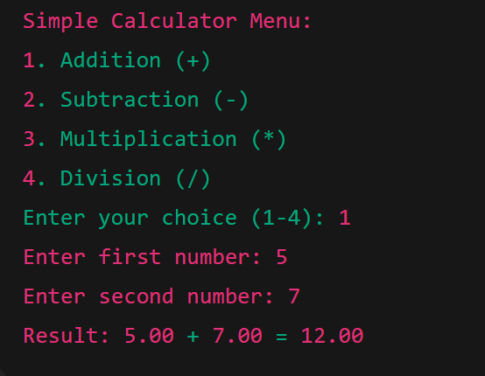

1. Write a program to find roots of a quadratic equation.

#include <stdio.h>

#include <math.h>

void main()

{

float a, b, c;

float discriminant, root1, root2, realPart, imagPart;

printf("Enter coefficients a, b, and c: ");

scanf("%f%f%f", &a, &b, &c);

discriminant = b \* b - 4 \* a \* c;

if (discriminant > 0)

{

root1 = (-b + sqrt(discriminant)) / (2 \* a);

root2 = (-b - sqrt(discriminant)) / (2 \* a);

printf("Roots are real and different.\n");

printf("Root 1 = %.2f\n", root1);

printf("Root 2 = %.2f\n", root2);

}

else if (discriminant == 0)

{

root1 = -b / (2 \* a);

printf("Roots are real and equal.\n");

printf("Root = %.2f\n", root1);

}

else

{

realPart = -b / (2 \* a);

imagPart = sqrt(-discriminant) / (2 \* a);

printf("Roots are complex and different.\n");

printf("Root 1 = %.2f + %.2fi\n", realPart, imagPart);

printf("Root 2 = %.2f - %.2fi\n", realPart, imagPart);

}

}

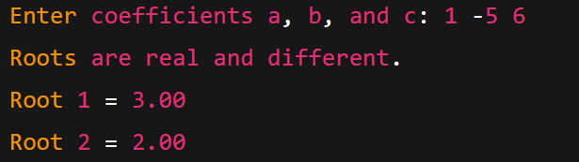

1. Write a program to find the number of digits in a number.

#include <stdio.h>

void main()

{

int num, count = 0;

printf("Enter a number: ");

scanf("%d", &num);

// If the number is 0, it has 1 digit

if (num == 0)

{

count = 1;

}

else

{

// Make number positive if it's negative

if (num < 0)

{

num = -num;

}

while (num != 0)

{

num = num / 10; // Remove last digit

count++;

}

}

printf("Number of digits: %d\n", count);

}

