Table of Contents

LockedMe.com - Screenshots 2

Home 2

Show files 2

Business Operations 2

Add file 3

Delete file 3

Search files 3

Exit Application 4

# LockedMe.com - Screenshots

## Home

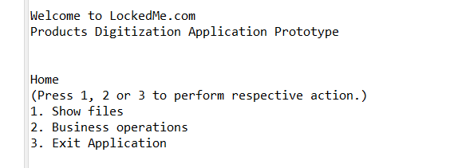

## Show files

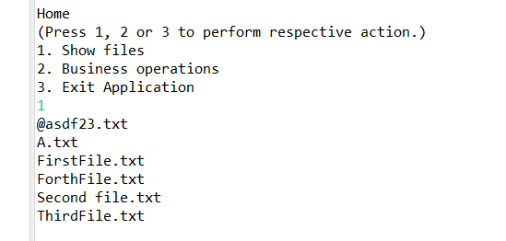

## Business Operations

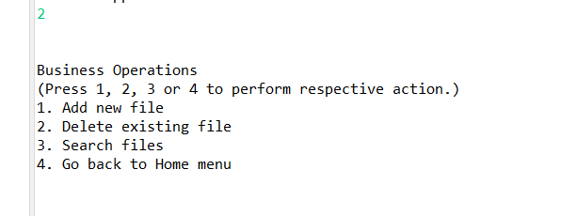

## Add file

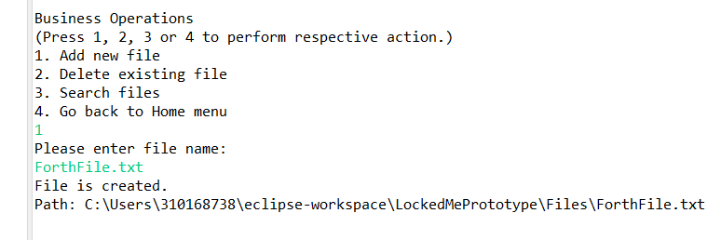

## Delete file

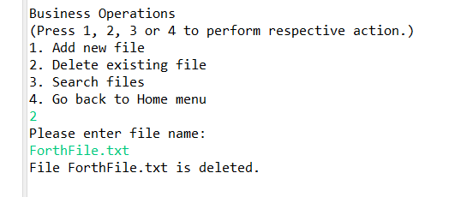

## Search files

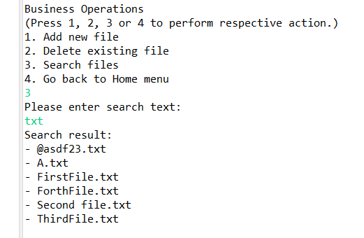

## Exit Application

