S.ARUN PRAKASH, 22PD28
KAMALESH PANTRA, 22PD15

ABOUT
The Collection Frameworks in Java represent a fundamental pillar of the Java programming language, providing developers with a powerful arsenal of data structures and algorithms for efficient data manipulation and storage. This abstract explores the essential concepts and components that constitute Java's Collection Frameworks, shedding light on their significance in modern software development.

It has a comprehensive set of classes and interfaces that makes it easay organization and manipulation of data. It is one among the versatile frameworks of Java.
Below is the inheritance hierarchy of Collection frameworks.
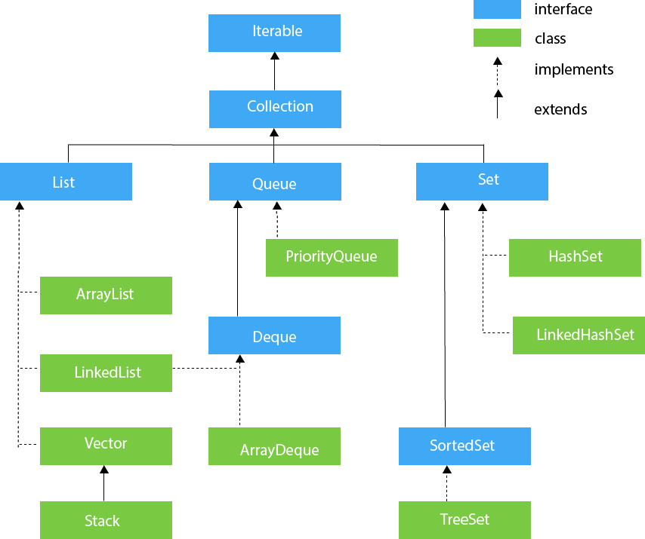
All these in-built data structures available in our frameworks are applied many for our daily applications.

ARRAYLISTS
ArrayList is a dynamic array-like data structure provided by the Java Collections Framework. Unlike traditional arrays, ArrayLists can grow or shrink in size dynamically, making them a versatile choice for managing collections of objects. Here, we'll explore ArrayLists in Java and their applications:

Applications of ArrayList in Java:
- List Management: ArrayLists are commonly used for managing lists of items, such as user records, product listings, or customer orders.
- Data Processing: They are used in data processing tasks where the number of data points is not known in advance. For example, reading data from a file and storing it in an ArrayList.
- Stacks and Queues: ArrayLists can be used to implement stack or queue data structures with the help of specific methods like add, remove, and get.
- Dynamic Collections: When the size of a collection needs to change dynamically, ArrayLists provide a convenient way to add or remove elements as needed.
- Search and Sort Operations: ArrayLists are suitable for searching and sorting operations, where the order or location of items needs to be modified.
- User Interfaces: ArrayLists are used in graphical user interfaces (GUIs) to manage lists of items, such as menu options or items in a shopping cart.
- Database Operations: ArrayLists can be used to store data retrieved from a database before processing or displaying it.
- Caching: They are used in caching mechanisms where frequently accessed data is stored in an ArrayList to reduce database or network calls.
- Serialization: ArrayLists can be serialized to save and restore the state of an object, which is useful for data storage and transfer.
- Data Analysis: In data analysis and scientific computing, ArrayLists can be used to store and manipulate datasets or results.
- Custom Data Structures: ArrayLists can be used as building blocks to create custom data structures like linked lists, hash tables, and more.
- Collections Framework: ArrayLists are part of the Java Collections Framework, which provides a unified and consistent way to work with collections in Java. They can be easily integrated with other collection types, such as HashMaps and Sets.
ArrayLists in Java are versatile and widely used in various Java applications due to their flexibility, ease of use, and dynamic sizing capabilities.
LINKED LISTS
LinkedList implements the Collection interface. It uses a doubly linked list internally to store the elements. It can store the duplicate elements. It maintains the insertion order and is not synchronized. In LinkedList, the manipulation is fast because no shifting is required.

Implementing Doubly Linked List Data Structure in Real-Life
- Undo/Redo Functionality
- Text Editors and Word Processors
- Navigation Systems
- Music Playlist Management
- Browser History
- Cache Management (e.g., LRU)
- Image Processing
- Task Management
- Database Systems
- Symbol Tables
- Deque (Double-Ended Queue)
STACK
The stack is the subclass of Vector. It implements the last-in-first-out data structure, i.e., Stack. The stack contains all of the methods of Vector class and also provides its methods like boolean push(), boolean peek(), boolean push(object o), which defines its properties.

Expression Evaluation
- Function Call Management
- Undo Functionality
- Backtracking Algorithms
- Memory Management
- Syntax Parsing
- Expression Conversion
- Task Scheduling
- Browser History
- Text Editors
- Function Call Stack Trace
- Evaluation of Postfix Expressions
- Task Management
- Parenthesis Matching
- Algorithm Implementations
- Simulation and Modeling
- Undo/Redo in Graphics Applications
- Compiler Intermediate Code Generation
- Maze Solving
- Transaction Management in Databases

PRIORITY QUEUE
The PriorityQueue class implements the Queue interface. It holds the elements or objects which are to be processed by their priorities. PriorityQueue doesn't allow null values to be stored in the queue.

APPLICATIONS:
Task Scheduling
- Dijkstra's Shortest Path Algorithm
- Huffman Coding for Data Compression
- Minimum Spanning Tree Algorithms
- A* Search Algorithm
- Job Scheduling in Operating Systems
- Resource Allocation in Real-Time Systems
- Network Routing
- Load Balancing
- Best-First Search Algorithms
- Event-driven Simulation
- Task Prioritization in Multithreaded Applications
- Data Stream Processing
- Emergency Room Patient Triage
- Disk Scheduling in Operating Systems
- Order Processing in E-commerce
- Traffic Light Control in Smart Cities
- Graph Traversals with Heuristic Values
- Elevator Control Systems
- Genetic Algorithms
HASHSET
HashSet class implements Set Interface. It represents the collection that uses a hash table for storage. Hashing is used to store the elements in the HashSet. It contains unique items.

APPLICATIONS:
Data Caching and Memoization
- Fast Data Retrieval and Lookup
- Counting Frequency of Elements
- Implementing Symbol Tables
- Storing and Retrieving Configuration Settings
- Efficient Implementation of Dictionaries
- Tracking Word Frequencies in Text
- Caching Database Query Results
- Implementing Caches in Web Applications
- Grouping and Aggregating Data
- Implementing Key-Value Stores in Databases
- Implementing Hash-Based Sets
- Efficient Handling of Large Data Sets
- Storing and Retrieving User Session Data
- Indexing in Search Engines
- Implementing Memoization in Dynamic Programming
- Implementing LRU (Least Recently Used) Caches
- Solving Problems in Graph Algorithms
- Implementing Efficient Counting Algorithms
- Implementing Custom Data Structures
LinkedHashSet is also a similar data structure implementing from Set interface.

TREE SET
TreeSet class implements the Set interface that uses a tree for storage. Like HashSet, TreeSet also contains unique elements. However, the access and retrieval time of TreeSet is quite fast. The elements in TreeSet stored in ascending order.
APPLICATIONS:
Binary Search Trees (BST)
- Balanced Binary Trees (AVL, Red-Black Trees)
- B-Trees and B+ Trees
- Trie (Prefix Tree)
- Heap (Binary Heap, Fibonacci Heap)
- Expression Trees
- Parse Trees and Abstract Syntax Trees (AST)
- Decision Trees
- Threaded Trees (Inorder, Preorder, Postorder)
- Suffix Trees and Suffix Arrays
- Binary Indexed Tree (Fenwick Tree)
- Ternary Search Trees
- KD-Trees
- Segment Trees
- Game Trees (Minimax Trees)
- Multiway Trees (Ternary Trees, Quad Trees, Oct Trees)
- Hierarchical Structures

