PROGRAM:

import csv
# Read CSV file
with open("job_data.csv") as file:
data = list(csv.reader(file))
# Separate header and training data
header = data[0]
training_data = data[1:]
print("Header:", header)
print("\nTraining Data:")
for row in training_data:
print(row)
# Initialize Specific Boundary (S)
S = training_data[0][:-1]
# Initialize General Boundary (G)
G = [["?" for i in range(len(S))] for i in range(len(S))]
# Candidate Elimination Algorithm
for i, example in enumerate(training_data):
if example[-1] == "Yes": # Positive Example
for j in range(len(S)):
if example[j] != S[j]:
S[j] = "?"
G[j][j] = "?"
elif example[-1] == "No": # Negative Example
for j in range(len(S)):
if example[j] != S[j]:
G[j][j] = S[j]
else:
G[j][j] = "?"
print("\nStep", i + 1)
print("S =", S)
print("G =", G)
print("\nFinal Output")
print("Specific Boundary (S):", S)
print("General Boundary (G):", G)

OUTPUT:
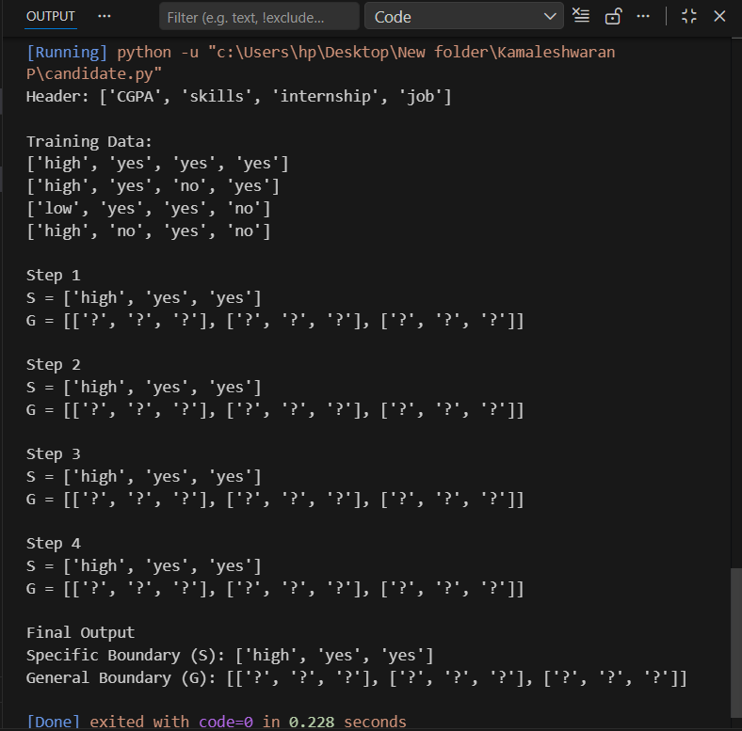
PROGRAM:
import csv
import math
def read_csv(file):
with open(file, newline='') as f:
reader = csv.reader(f)
header = next(reader)
data = [row for row in reader]
return header, data
def entropy(col):
counts = {}
for val in col:
counts[val] = counts.get(val, 0) + 1
ent = 0
for count in counts.values():
p = count / len(col)
ent -= p * math.log2(p)
return ent
def gain_ratio(data, col_idx):
target_col = [row[-1] for row in data] # Always last column
total_entropy = entropy(target_col)
vals = set(row[col_idx] for row in data)
weighted_entropy = 0
split_info = 0
for v in vals:
subset = [row for row in data if row[col_idx] == v]
ratio = len(subset) / len(data)
subset_target = [row[-1] for row in subset]
weighted_entropy += ratio * entropy(subset_target)
split_info -= ratio * math.log2(ratio)
if split_info == 0:
return 0
info_gain = total_entropy - weighted_entropy
return info_gain / split_info
def build_tree(data, attributes):
target_col = [row[-1] for row in data]
if target_col.count(target_col[0]) == len(target_col):
return target_col[0]
if not attributes:
return max(set(target_col), key=target_col.count)
gains = [gain_ratio(data, i) for i in range(len(attributes))]
best_idx = gains.index(max(gains))
best_attr = attributes[best_idx]
tree = {best_attr: {}}
values = set(row[best_idx] for row in data)
for v in values:
subset = []
for row in data:
if row[best_idx] == v:
# Remove best attribute column
new_row = row[:best_idx] + row[best_idx+1:]
subset.append(new_row)
new_attributes = attributes[:best_idx] + attributes[best_idx+1:]
if not subset:
tree[best_attr][v] = max(set(target_col), key=target_col.count)
else:
tree[best_attr][v] = build_tree(subset, new_attributes)
return tree
def print_tree(tree, indent=""):
if isinstance(tree, dict):
for key in tree:
print(indent + str(key))
for value in tree[key]:
print(indent + " ->", value)
print_tree(tree[key][value], indent + " ")
else:
print(indent + "Answer:", tree)
filename = "tennis.csv"
attributes, data = read_csv(filename)
tree_c45 = build_tree(data, attributes[:-1])
print("\n--- C4.5 Decision Tree ---")
print_tree(tree_c45)

OUTPUT:
