**Generate Dockerfile under project folder of your app**

**Modify FORM statement to use tomcat as base image**

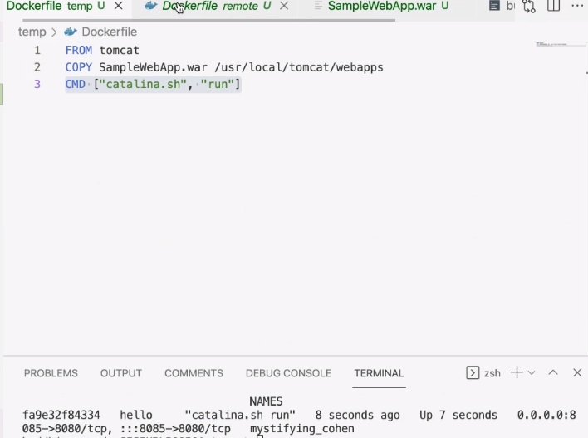

**Test the Dockerfile by running Docker build and create a container**

