**Modify Project index.jsp, Commit and Push to remote repo**

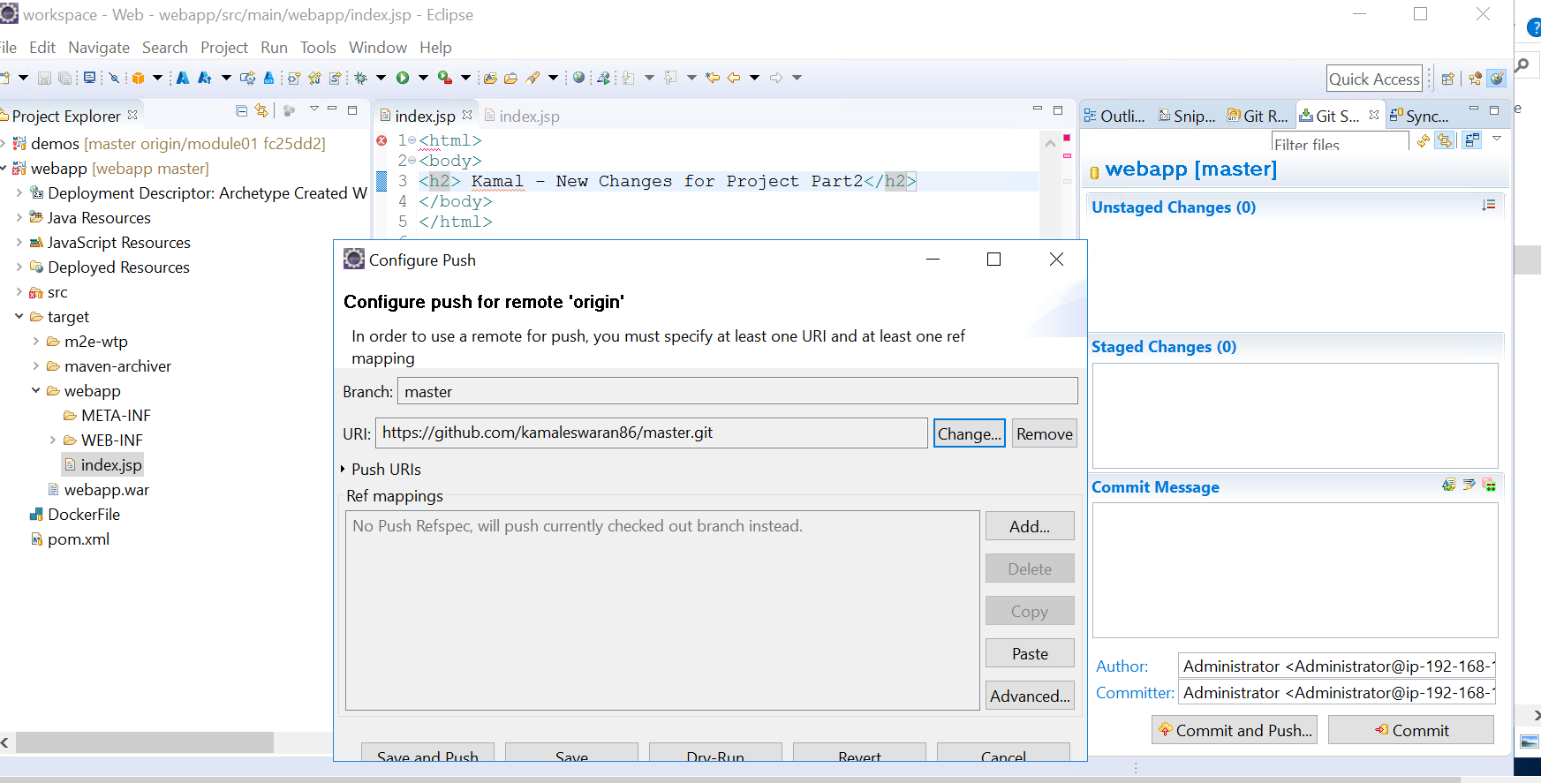

**Check for the change in remote Repo**

