**Push playbook1,playbook2 and shell scrip to Remote Git repo created in Phase3**

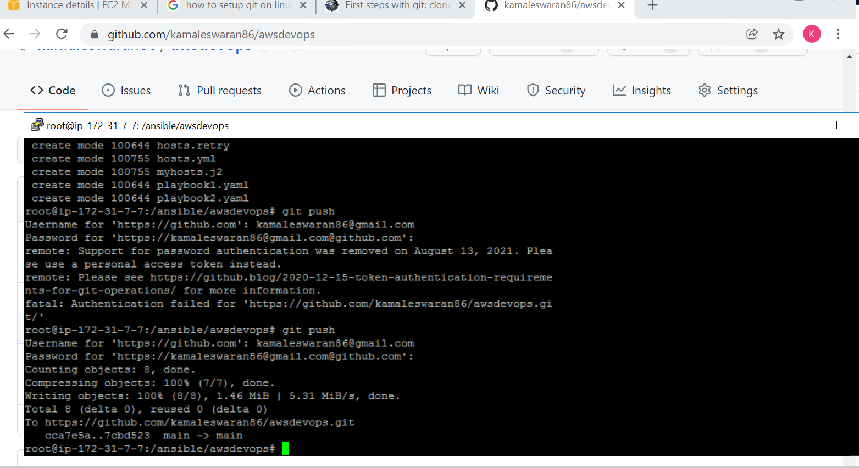

**Check for the change in remote Repo**

