**From Build server run the playbook1,playbook2 and shell script to test for the required result**

**Playbook1 – eventhough pip, boto installed and imported to python still facing boto error**

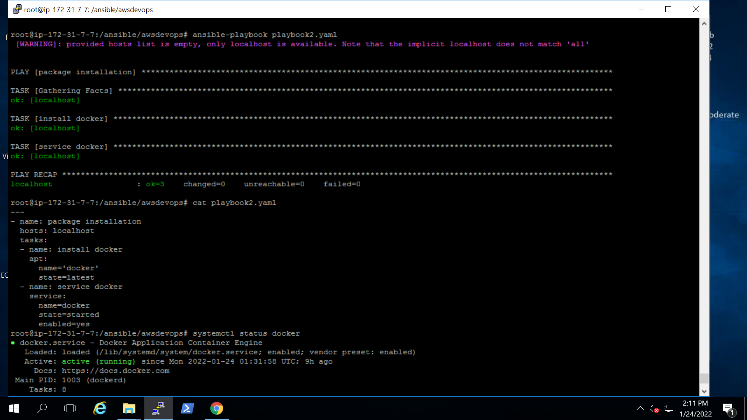

Playbook2 – Docker install

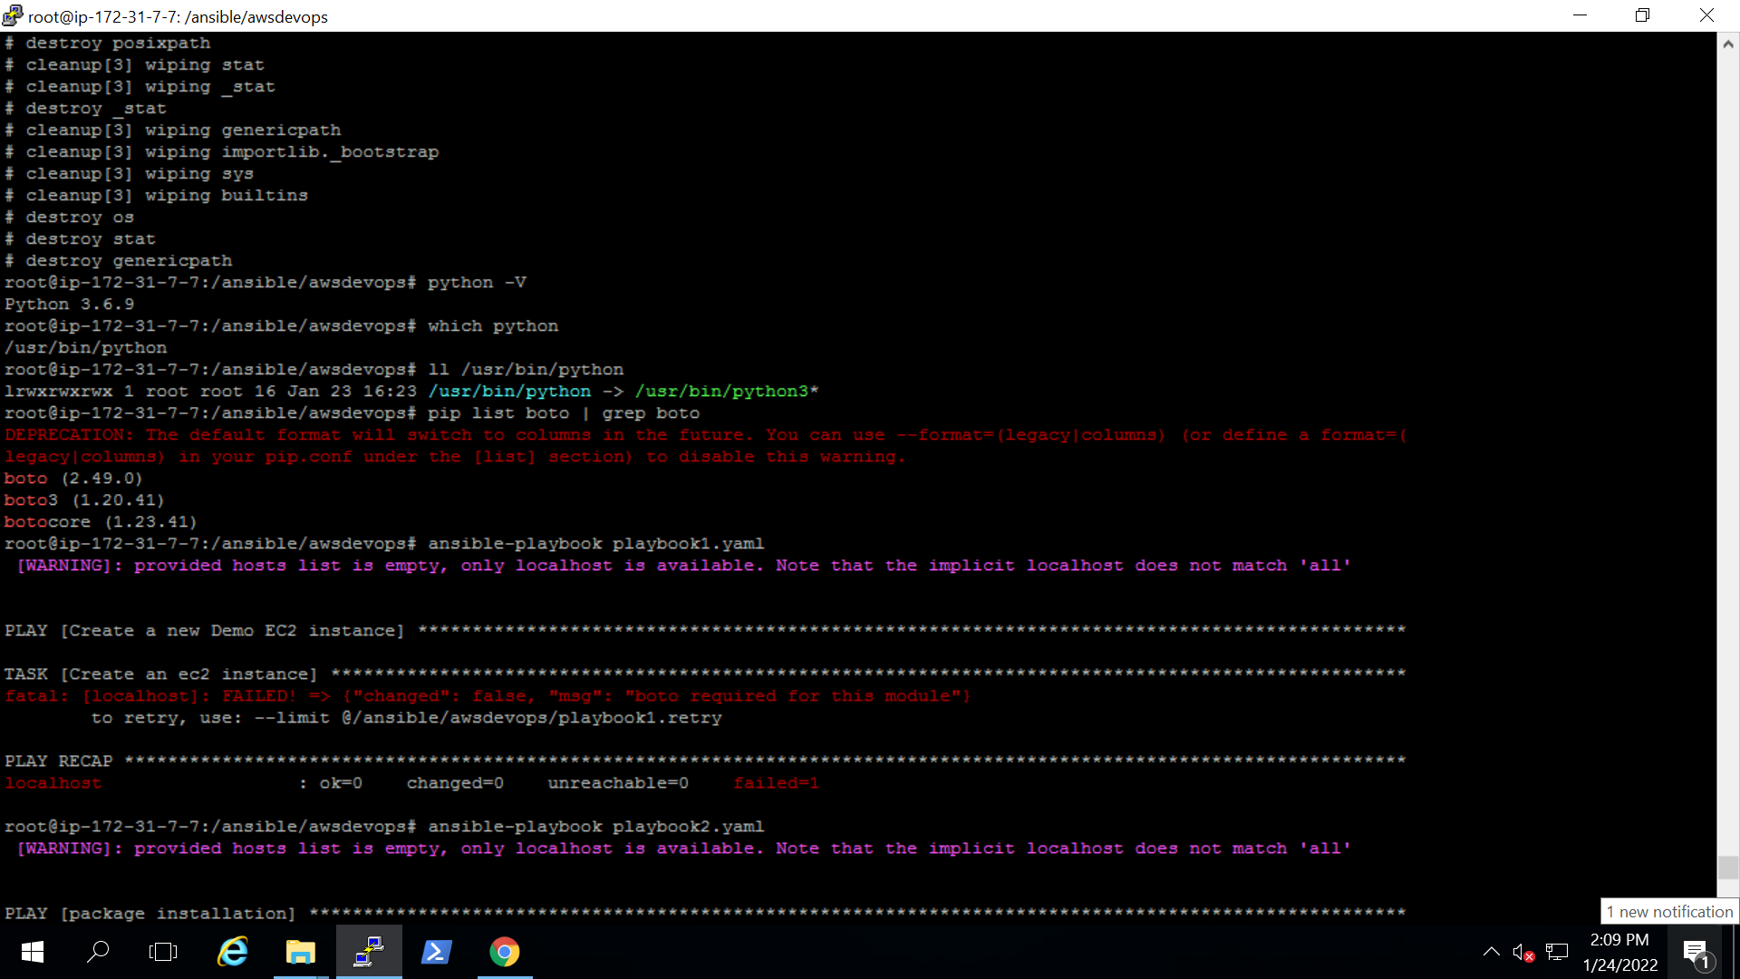

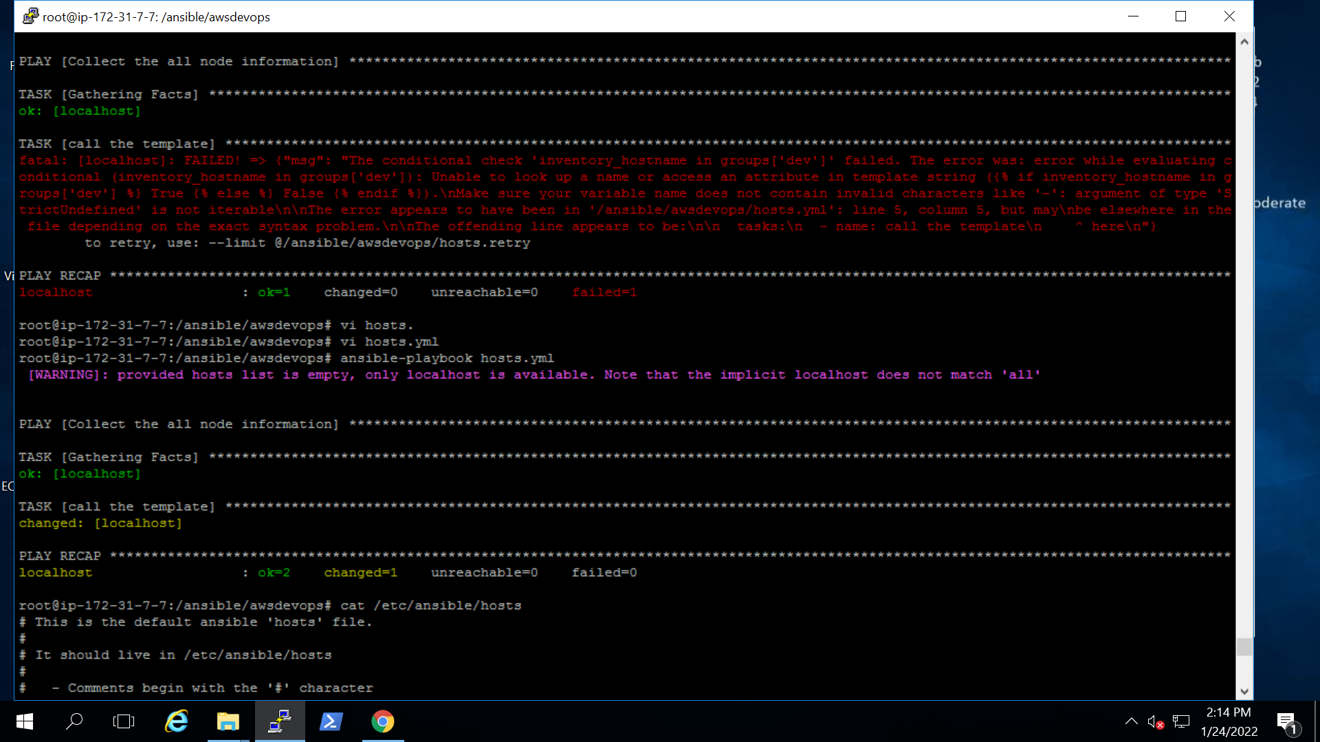s