1. **http://www.gr8ambitionz.com/2015/08/complete-list-of-schemes-launched-by-modi-government-with-details.htmlPRADHAN MANTRI SURAKSHA BIMA YOJANA:**

It is a personal accident policy which gives you the surety to protect not only your family but also your loss of income due to any disability.

Eligibility:

Age should be 18 to 70

Bank account is necessary

Features of this scheme:

Claim of 2 lakhs will be given by this policy if a person dies in an accident or suffers from a permanent disability due to an accident.

Policy will be valid to age of 70

Here claims given by this policy in permanent disability, what kind of permanent disability?

Loss of both eyes or loss of both hands and feet or loss of sight of one eye and loss of one hand or one foot. The policy does not cover temporary disabilities. 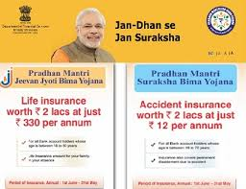

1. **PRADHAN MANTRI JEEVAN JYOTI BIMA YOJANA:**

It is a pure term plan that does not pay you anything back when the policy matures. If the insured dies it pays the sum insured to the family. Launched by by PM Narendra Modi on 9th May 2015.

Eligibility:

Age should 18 to 50 years.

Anyone with a bank account can buy the policy.

Features:

This is the policy which provides risk cover in case of an untoward incident pays Rs 2 lakh to the family as claim money. The policy is valid for one year (from June 1, 2015 to May 31, 2016), after which you need to pay premium to renew the policy. 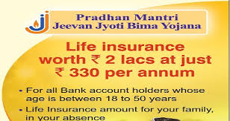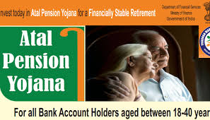

1. **ATAL PENSION YOJANA:**

Scheme provides pension plans to people to make their life well in their old age. These kind of schemes help people at the time they are not able to work or earn for their living.

Eligibility:

The scheme is available to all bank account holders between 18 and 40 years of age. You need to contribute for 20 years or more under the scheme.

Features:

According to this scheme you will be able to get pension of Rs 1,000 to Rs 5,000 per month, at the age of 60 years. Which varies on the age of joining the APY? Government provides the benefits of the scheme on the basis of current age. For example, a 35-year-old needs to pay Rs 902 a month for a pension of Rs 5,000.

Government also contributes 50% of your contribution.

But many of our people are still not aware or have information about these schemes due to lack of sources or communication by the government officials. Although we can get this information anytime from government websites or can get the information when it is available on newspaper or tv but due to lack of resources many places are still not aware about these government scheme. 

1. **Clean India–Attitude change is more important than the movement**.

Swachh Bharat Abhiyan is a national campaign by government of India aims to accomplish the vision of clean India by 2nd October 2019.

Launched by by PM Narendra Modi on 2nd October 2014.

A performance ranking on Swachh Bharat Abhiyan of 476 cities in the country, based on the extent of open defecation and solid waste management practices, released by the Ministry of Urban Development recently.

Top 10 cities are : Mysore, Tiruchirapalli, Navi Mumbai, Kochi, Hassan, Mandhya, Bengaluru, Thiruvanathapuram, Halisahar, Gangtok.

It is important to understand what Swachh actually means. Building toilets is an important part of it, as even after several years of Independence only a 30% of rural households have access to toilets. But along with this we have two equally important tasks: one is hygiene and other one is how to handle and deal with garbage. Each department has to join with the government at their level, as we have to move from step one.

A lot has been done to make people aware of cleanliness and hygiene, now it’s time for citizen of India to learn the facts and apply them into actions. Swachh Bharat Campaign requires comprehensive and coordinated efforts to create the back-end infrastructure to deal with solutions to segregate at source, create dry waste collection centers, compost the wet waste to make it reusable as soil, etc. Most of all it will require a massive behavioral change and significant investment in creating a garbage management system that uses science, technology and logistics that convert garbage to something of value. It should be a combined effort of government and people. There is no doubt about the fact that change begins at home. Every citizen of the country should take it upon himself to make this campaign a success rather than waiting for the government to do because until and unless people change their mindset no movement can be a success. 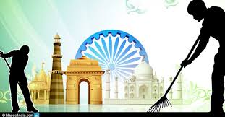

1. **Sukanya Dev Yojna – Benefits, Where & How to Open Account under Sukanya Samriddhi Yojna**

Modi Government is putting best efforts to promote Girl Child. Sukanya Dev Yojna is an extension of Government’s Beti Bachao Beti Padhao Campaign. The scheme is also known as Sukanya Samriddhi Yojna.

WHAT IS SUKANYA DEV YOJNA?

Sukanya Dev Yojna has been started in Post Offices by Haryana Government. This scheme will benefit girl child of age 1 Year to 10 Years. Parents will have to deposit Rs 1000 per month for next 14 Years, totaling Rs 1,68,000. Girl will get Rs 6,00,000 when she will become 21 Year Old. The best benefit is that it is not mandatory to deposit this amount every month. You can deposit it whenever you have, either 1000 per month or as per your convenience. But you have to deposit the amount in average of Rs 1000 per month and total Rs 1,68,000 in 14 Years.

Age Limit

The age limit for opening an account in this scheme is 10Years, and there is buffer period of 1 Year. Means the girl child who has attained the age of 10 years 1 year prior to the announcement i.e. December 2013 to December 2014, is also eligible to open account under Sukanya Samriddhi Scheme.

The objective behind this initiative is to address the gender imbalance & create positive environment in favor of girl child. It is the part of “Beti Bachao-Beti Padhao”.

Benefits of the scheme are

Highest interest rate of9.2%

Exempted from Tax u/s 80c

The maturity of account is 21 years from date of opening account or marriage of girl child whichever is earlier.

Initial deposit of Rs.1000 and thereafter any amount in multiple of Rs.100 can be deposited to maximum of 1.5lakhs

. 

1. **Preparation of major changes in land acquisition bill:**

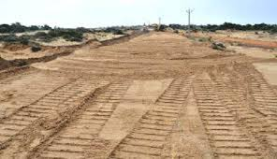

Amidst the uproar frenzy over Land Acquisition Bill, Finance Minister Arun Jaitley said the BJP-led NDA government in 2013, the Land Acquisition Bill “fundamental shift” has to consider economic activity, particularly in rural areas, to ensure can be.

Speaking at Columbia University’s students and teachers Jaitley said, “for any government to change the law is quite challenging. The common belief is that you do not approve of land. ”

It arrived on a private visit, Jaitley said that the development of rural roads, irrigation, electrification, livable home for the poor and protect the land required for the projects. However, under the provisions of existing law, no land cannot be acquired until then had not visit some of the terms.

Activities in this field have stopped completely. Even the defense is able to find a place for the projects. It is a daunting task.

You cannot change the method of compensation, but national security, rural infrastructure and some discounts for homes worth living is important. We are now facing the challenge and see how it can be dealt with in Parliament. “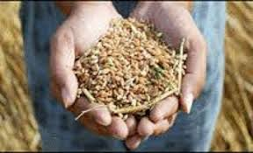

1. **LPG subsidy scheme to be transferred directly into a bank account: Has become the biggest plan.**

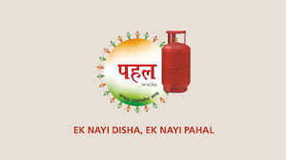

LPG subsidy scheme to be transferred directly into the bank account cash transfer initiatives around the world has become the biggest plan.

Prime Minister Narendra Modi on the achievement, saying that this love will prevent black marketing of LPG subsidies will only needy.

Subsidized LPG in the country’s total number of subscribers is 15.34 million. Of these, more than 10 million customers connected to the gas customer has a bank account number.

Scheme was introduced in 54 districts.

November 15, 2014, the scheme was introduced in the 54 districts, one in January 2015, which has been implemented in the country. 4299 crore through yet been transferred and so far has 11.33 million transactions.

According to a senior official of the Ministry of Petroleum of the scheme awareness campaign among the people who have been showing a positive effect. 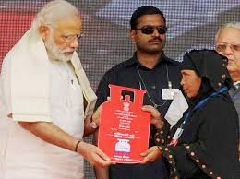

1. **Make in India or Made in India:**

Make in India’ is a concept proposed by our Prime Minister Shri Narendra Modi on 25th September 2014 for attracting investments from business around the world, and thus in a way strengthening India’s manufacturing industry. The main objective of ‘Make in India’ program is to make India a manufacturing hub, to create jobs for our educated youth and thus making India a self-reliant country. It will enforce the inflow of FDI. It will not only bring the economic transformation in India but will also let the government to utilize the human resource in a better way. The idea of ‘Make in India’ sounds very innovative but as we know every good side has a bad too, so same is the case with this program. This topic has become a brain storming for people as it should be ‘Make in India or Made in India’. Objective of Make in India initiative is

To promote India a manufacturing hub.

Economic transformation in India

To eliminate unnecessary law and regulation.

25 sectors have been included in Make in India scheme. Some of sectors are automobiles, chemicals, IT, pharmaceuticals, textiles, leather, tourism and hospitality, design manufacturing, renewable energy, mining and electronics. 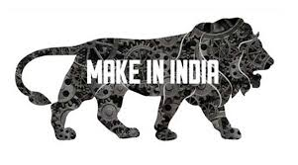

1. **PRADHAN MANTRI JAN DHAN YOJANA :**

Objective of "Pradhan Mantri Jan-Dhan Yojana (PMJDY)" is ensuring access to various financial services like availability of basic savings bank account, access to need based credit, remittances facility, insurance and pension to the excluded sections i.e. weaker sections & low income groups. Benefits of schemes are

Interest on deposit.

Accidental insurance cover of Rs.1Lakh

No minimum balance required

Life insurance cover of Rs.30,000

Overdraft facility after 6 months.

Access to Pension, insurance products.

RuPay Debit Card.

Overdraft facility upto Rs.5000/- is available in only one account per household.

Launched by PM Narendra Modi on 28th August 2014 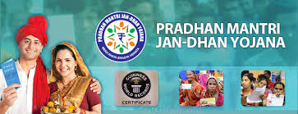

1. **MUDRA BANK YOJANA :**

(MUDRA Bank - Micro Unit Development and Refinance Agency Bank)

MUDRA will provide credit up to Rs.10 lakh to small entrepreneurs & act as regulator of Micro finance institutions.

Objective of the scheme are to encourage entrepreneurs and small business units to expand their capabilities and to reduce over indebtedness.

Schemes offered by MUDRA bank are:

Shishu - the starters-covers loan up to Rs.50,000

Kishor - the mid stage finance seekers-covers loan above Rs.50,000 and up to Rs.5,00,000.

Tarun - growth seekers- covers loan above Rs.5,00,000 and up to Rs. 10,00,000

Launched by PM Narendra Modi on 8th April 2015. 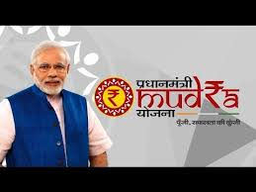

1. **KISAN VIKAS PATRA:**

Kisan Vikas Patra is a saving certificate scheme which was first launched in 1988 by India Post and it was relaunched in 2014.

The denomination available in Rs. 1000, 5000, 10000 & Rs.50000

The amount invested will double in 100 months.

Certificate is issued in single or in joint names.

It can be pledged as security to get loans.

Interest rate - 8.7%

Launched by by Finance Minister Arun jaitley on 18th November 2014. 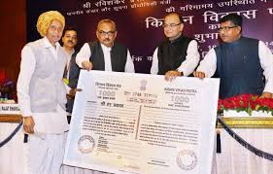

1. **KRISHI AMBANI BIMA YOJANA:**

Objective of the scheme is to give impetus dying to agriculture practice.

If farmers bear any financial burden due to unexpected weather, then Krishi Ambani Bima Yojana will help them

. 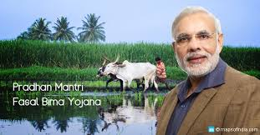

1. **PRADHAN MANTRI GRAM SINCHAI YOJANA:**

The motive of Pradhan Mantri Gram Sinchai Yojana will be to take irrigation water to each and every agricultural field in the country.

Launched by by Rajnath Singh.

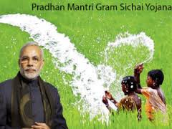

1. **PRADHAN MANTRI SANSAD ADARSH GRAM YOJANA:**

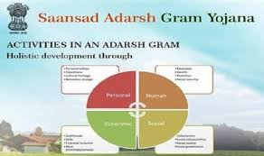

Under this scheme, Mps will be responsible for developing the socio-economic and physical infrastructure of three villages each by 2019. Total of eight villages by 2024.

The first Adarsh gram must be developed by 2016 and more by 2019.

Total of 6433 Adarsh Grams of 265000 gram Panchayat will be created by 2024.

Launched by by PM Narendra Modi on 11th October 2014.

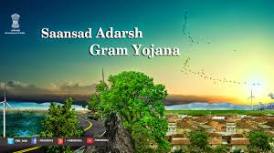

1. **SOIL HEALTH CARD SCHEME:**

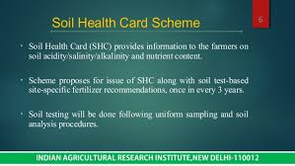

Govt has launched this scheme to provide every farmers a soil health. The card will carry crop wise recommendations of nutrients/ fertilizers required for farmers to improve productivity.

Budget allotted Rs.100 crore for issuing cards.

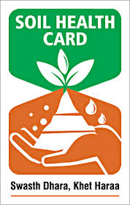

1. **DIGITAL INDIA:**

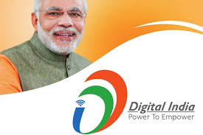

The Government of India has launched the Digital India programme with the vision to transform India into a digitally empowered society and knowledge economy.

Digital India is keyed on three key areas –

Digital Infrastructure as a Utility to Every Citizen

Governance & Services on Demand

Digital Empowerment of Citizens

Pillars of Digital India –

Broadband Highways

Universal Access to Phones

Public Internet Access Programme

e-Governance – Reforming government through Technology

e-Kranti – Electronic delivery of services

Information for All

Electronics Manufacturing – Target NET ZERO Imports

IT for Jobs

Early Harvest Programmes

Launched by by PM Narendra Modi on 1st july 2015.

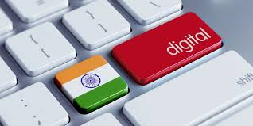

1. **SKILL INDIA:**

Skill India focuses on creating jobs for youth, the govt has decided to revamp the antiquated industrial training centres that will skill over 20 lakh youth annually.and creating 500million jobs by 2020.Launched by by PM Narendra Modi on 15th July 2015 (on occasion of world youth skills day)

. 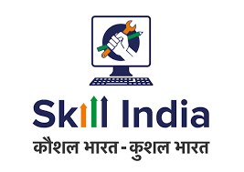

1. **HRIDAY (National Heritage City Development and Augmentation Yojana):**

The Ministry of Urban Development, Government of India, launched the (HRIDAY) scheme on 21st January, 2015, with a focus on holistic development of heritage cities.

With a duration of 27 months (completing in March 2017) and a total outlay of Rs.500 Crores, the Scheme is being implemented in 12 identified Cities namely, Ajmer, Amaravati, Amritsar, Badami, Dwarka, Gaya, Kanchipuram, Mathura, Puri, Varanasi, Velankanni and Warangal.

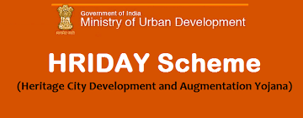

1. **BETI BACHAO, BETI PADHAO YOJANA:** 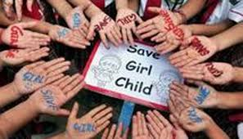

Beti Bachao, Beti Padhao (Save girl child, educate girl child) is a Government of India scheme that aims to generate awareness and improving the efficiency of welfare services meant for women. The scheme was initiated with an initial corpus of Rs 100 crore

Launched by by PM Narendra Modi on 22nd January 2015

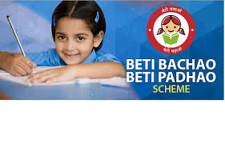

1. **INDRADANUSH:**

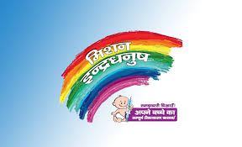

Mission Indradhanush was launched by the Ministry of Health and Family Welfare, Government of India on December 25, 2014.

The Mission Indradhanush, depicting seven colours of the rainbow, aims to cover all those children by 2020 who are either unvaccinated, or are partially vaccinated against seven vaccine preventable diseases which include diphtheria, whooping cough, tetanus, polio, tuberculosis, measles and hepatitis B.Mission Indradhanush was launched to speed up the process of immunization. It aims to immunize all children against seven vaccine preventable diseases namely diphtheria, whooping cough (Pertussis), tetanus, polio, tuberculosis, measles and hepatitis B by 2020. The target of full coverage is set to be achieved by the year 2020.Launched by by Union Health Minister J.P.Nadda on 25th december 2014

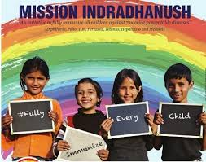

1. **Deen Dayal Upadhyaya Gram Jyoti Yojana:**

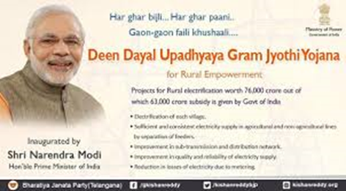

DDUGJY is a Government of India scheme aimed to provide continuous power supply to rural India.

It is one of the key initiatives of Modi Government and it aims to supply 24x7 uninterrupted power supplies to all homes.

The government plans to invest Rs 75,600 crore for rural electrification under this scheme. The scheme will replace the existing Rajiv Gandhi Grameen Vidyutikaran Yojana. 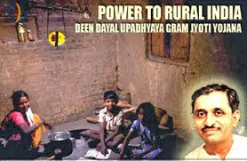

1. **Deen Dayal Upadhyaya Grameen Kaushalya Yojana :**

DDU-GKY is a Government of India youth employment scheme.

It was launched by on 25 September 2014 by Union Minsters Nitin Gadkari and Venkaiah Naidu on the occasion of 98th birth anniversary of Pandit Deendayal Upadhyay. It aims to target youth, under the age group of 18–35 years. 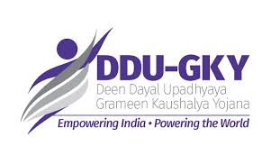

1. **PANDIT DEENDAYAL UPADHYAY SHRAMEV YOJANA:**

A dedicated Shram Suvidha Portal: That would allot Labour Identification Number (LIN) to nearly 6 lakhs units and allow them to file online compliance for 16 out of 44 labour laws

An all-new Random Inspection Scheme: Utilizing technology to eliminate human discretion in selection of units for Inspection, and uploading of Inspection Reports within 72 hours of inspection mandatory

Universal Account Number: Enables 4.17 crore employees to have their Provident Fund account portable, hassle-free and universally accessible

Apprentice Protsahan Yojana: Will support manufacturing units mainly and other establishments by reimbursing 50% of the stipend paid to apprentices during first two years of their training

Revamped Rashtriya Swasthya Bima Yojana: Introducing a Smart Card for the workers in the unorganized sector seeded with details of two more social securityschemes

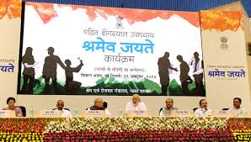

1. **AMRUT - ATAL MISSION FOR REJUVENATION AND URBAN DEVELPOMENT:**

The AMRUT scheme would focus on water supply, sewerage facilities and management, storm water drains to reduce flooding, strengthening of public transport facilities and creating public amenities like parks and recreation clubs.

AMRUT- Upgraded version of JNNURM (Jawaharlal Nehru National Urban Renewal Mission)’

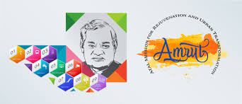

1. **SWADESH DARSHAN:**

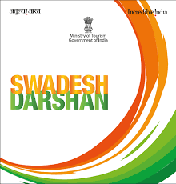

Under Swadesh Darshan, integrated development of theme based circuits has been taken up for holistic and inclusive development which can provide engaging and complete tourism experience to both domestic including low budget tourists and foreign tourists. The Scheme envisages enhancement of tourist attractiveness in a sustainable manner by developing world class infrastructure in the circuit destination. Launched by Ministry of Tourism.

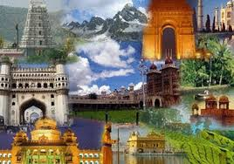

1. **PRASAD (Pilgrimage Rejuvenation and Spiritual Augmentation Drive)**

PRASAD to beautify and improve the amenities and infrastructure at pilgrimage centres of all faiths.

Under PRASAD, initially twelve cities have been identified namely Ajmer, Amritsar, Amravati, Dwarka, Gaya, Kedarnath, Kamakhaya, Kanchipuram, Mathura, Puri, Varanasi and Velankanni.

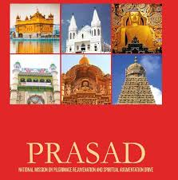

Launched by Ministry of Tourism.

1. **Mahatma Gandhi Pravasi Suraksha Yojana-MGPSY:**

Mahatma Gandhi Pravasi Suraksha Yojana is a special social security scheme which includes Pension and Life Insurance, introduced by Ministry of Overseas Indian Affairs for the overseas Indian workers in possession of Emigration Check Required (ECR) passports. It is a voluntary scheme designed to help workers to meet their three financial needs: saving for retirement, saving for their return and resettlement, and providing free life insurance offering coverage for death from natural causes.

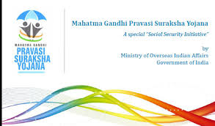

1. **UDAAN PROJECT:**

The Special Industry Initiative J&K ‘Udaan’ Scheme is to provide skills and enhance employability of 40,000 youth over a period of five years in key high growth sectors. The scheme is being implemented by the National Skill Development Council (NSDC) and the corporate sector in PPP mode.

Udaan also aims to provide a platform that empowers girl students and provides them with better learning opportunities. Human resource development (HRD) ministry programme is designed to provide a comprehensive platform to deserving girl students aspiring to pursue higher education in engineering and assist them to prepare for the IIT-JEE while studying in Classes 11 and 12. 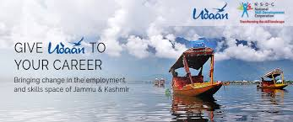

1. **BAL SWACHH ABHIYAN:** **http://www.studydhaba.com/indian-government-schemes-pdf-20152016-indian/**

**Launched on 14th November 2014)**

**Awareness about the cleanliness of the children**

**Bal Swachhta Mission Was Launched on 14 November 2014 on The Birth Anniversary of Late Pandit Jawahar Lal Nehru .**

**On this Day We celebrate – National Bal Diwas**

**The six main themes chosen for the Bal Swachhta Mission are,**

**Clean school and anganwadis**

**Clean surroundings like playgrounds**

**Clean self (personal hygiene/ child health)**

**Clean food**

**Clean drinking water**

**Clean toilets.**

