PROJECT REPORT
HOSPITAL MANAGEMENT SYSTEM
A Full-Stack CRUD Web Application
Submitted as a Project Report
Technologies: React, Vite, CSS, Django, Django REST Framework and SQLite

Prepared by: Kamali R
Register No.: 922525148047
Department: B.E-CSE AIML
Institution: VSB ENGINEERING COLLEGE

ABSTRACT

The Hospital Management System is a full-stack web application developed to simplify the management of patient records. The application provides a user-friendly interface for adding, viewing, searching, filtering, updating and deleting patient information. The frontend is implemented using React with Vite and CSS, while the backend is developed using Django and Django REST Framework. SQLite is used as the database. Communication between the frontend and backend is handled through REST API endpoints. The system also includes client-side and server-side validation to improve data quality and prevent invalid patient records. The application demonstrates the practical implementation of CRUD operations in a modern full-stack web development environment.

INTRODUCTION

Managing patient information is an important activity in a hospital environment. Patient details such as name, age, gender, contact information, blood group, disease or problem, and admission date need to be stored and accessed accurately. A web-based system can make this process faster and more organized than maintaining records manually.
This project implements a Hospital Management System focused on patient-record management. It uses a React frontend, a Django REST backend and an SQLite database. The application follows a client-server architecture in which the frontend sends HTTP requests to the backend API and the backend performs database operations.

PROBLEM STATEMENT

Manual or poorly organized patient record management can make it difficult to add, locate, modify and remove records efficiently. It can also increase the possibility of inconsistent or invalid data. Therefore, there is a need for a simple web-based application that provides centralized patient-record management with validation and CRUD functionality.

OBJECTIVES

- Develop a full-stack web application for managing patient records.
- Implement Create, Read, Update and Delete (CRUD) operations.
- Store patient data in an SQLite database through Django ORM.
- Provide REST API endpoints using Django REST Framework.
- Provide a responsive and user-friendly React interface.
- Implement client-side and server-side validation.
- Provide search and gender-filter functionality for patient records.

SCOPE OF THE PROJECT

The current version focuses on patient record management. It supports patient registration, record viewing, searching, filtering, editing and deletion. The project is designed as a working CRUD application and can be extended later with additional hospital modules.
- Patient record management
- REST API based communication
- Validation of patient information
- Search and filter support
- Responsive frontend interface
- SQLite-based data storage

TECHNOLOGY STACK

Technology | Purpose
React | Builds the interactive frontend user interface.
Vite | Provides the frontend development and build environment.
CSS | Provides layout, styling and responsive design.
Django | Provides the backend web framework.
Django REST Framework | Creates REST API endpoints for patient operations.
SQLite | Stores patient records in a relational database.
Django ORM | Connects backend models with the database.
Postman | Optional tool for testing REST API requests.
Git / GitHub | Version control and project hosting.

SYSTEM ARCHITECTURE

The system follows a simple three-layer flow: the user interacts with the React frontend; the frontend communicates with the Django REST API; and the Django backend uses Django ORM to read and modify data stored in SQLite.
USER
↓
REACT + VITE FRONTEND
↓
REST API / HTTP REQUEST
↓
DJANGO REST FRAMEWORK
↓
DJANGO ORM
↓
SQLITE DATABASE

Request Flow

- The user enters or modifies patient information in the React form.
- The frontend validates mandatory fields and basic input rules.
- The frontend sends a POST, GET, PUT or DELETE request to the REST API.
- Django REST Framework receives and processes the request.
- The serializer validates incoming data and converts it to or from API representations.
- Django ORM performs the corresponding database operation.
- The API returns the result to the React frontend.
- The frontend refreshes the displayed patient records and shows a success or error message.

MODULES

Module | Description
Patient Entry Module | Provides a form to enter full name, age, gender, email, phone, blood group, disease/problem and admission date.
Patient Listing Module | Displays patient records in a table and shows the total number of patients.
Search and Filter Module | Allows searching by patient name, email, phone, disease or blood group and filtering by gender.
Update Module | Loads an existing patient's information into the form and sends an update request.
Delete Module | Deletes a patient record after user confirmation.
Validation Module | Performs frontend and backend validation for important patient fields.
REST API Module | Provides API endpoints for create, read, update and delete operations.

DATABASE DESIGN

The application uses a Patient model. Each patient record contains an automatically generated ID and the fields required for basic patient information.
Field | Type | Description
id | Auto ID | Unique identifier for each patient.
full_name | Character | Patient's full name.
age | Positive Integer | Patient age; validated from 1 to 120.
gender | Choice | Male, Female or Other.
email | Email | Patient email; unique in the database.
phone | Character | Patient contact number.
blood_group | Choice | A+, A-, B+, B-, AB+, AB-, O+, O-.
disease | Character | Disease or health problem entered for the record.
admission_date | Date | Date of hospital admission.
created_at | DateTime | Automatically records record creation time.

9. CRUD OPERATIONS

9.1 Create
A new patient is added by submitting the patient form. The frontend sends a POST request to the patient API. The backend validates the data and stores the new record in SQLite.

9.2 Read
The application retrieves patient records through GET requests. Records are displayed in a table and can be searched or filtered.

9.3 Update
When the user selects an edit action, the selected patient's data is loaded into the form. After modification, the frontend sends a PUT request to update the record.

9.4 Delete
The delete action asks for confirmation and then sends a DELETE request to remove the selected patient record.
Operation | HTTP Method | Endpoint
Create | POST | /api/patients/
Read All | GET | /api/patients/
Read One | GET | /api/patients/{id}/
Update | PUT / PATCH | /api/patients/{id}/
Delete | DELETE | /api/patients/{id}/

10. VALIDATION AND ERROR HANDLING
Validation is implemented on both the frontend and backend. This provides immediate feedback to the user while also protecting the backend from invalid input.
- Mandatory fields must be completed.
- Age must be between 1 and 120.
- Email must follow a valid email format.
- Phone numbers must contain an appropriate number of digits.
- Full name must contain at least three characters after trimming spaces.
- Email is configured as a unique field in the database.
- Gender and blood group must be selected.
- The frontend displays success and error messages after API operations.

11. FRONTEND IMPLEMENTATION
The React frontend uses component state to store patient records, form values, editing state, search text, gender filter, loading state and user messages. API helper functions are maintained in a separate api.js file. CSS provides the layout, cards, forms, buttons, tables and responsive behavior for smaller screens.
- React hooks such as useState, useEffect and useMemo are used.
- The form supports both adding and updating a patient.
- The patient table displays the stored records.
- Search is performed against name, email, phone, disease and blood group.
- Gender filtering is available.
- The interface includes responsive layouts for smaller screens.

12. BACKEND IMPLEMENTATION
The backend is built with Django and Django REST Framework. A Patient model defines the database structure. PatientSerializer handles conversion and validation. PatientViewSet provides model-based CRUD operations, while a router creates the API routes.
- Django model: Patient
- Serializer: PatientSerializer
- View layer: PatientViewSet using ModelViewSet
- Search support through DRF SearchFilter
- Router-based API URL configuration
- SQLite database through Django ORM

13. PROJECT STRUCTURE
hospital_management_system/
├── backend/
│ ├── hospital_backend/
│ ├── patients/
│ ├── manage.py
│ └── requirements.txt
├── frontend/
│ ├── src/
│ │ ├── App.jsx
│ │ ├── api.js
│ │ ├── main.jsx
│ │ └── style.css
│ ├── index.html
│ └── package.json
└── docs/
├── PROJECT_REPORT_TEMPLATE.md
└── postman_sample.json

14. SETUP AND EXECUTION

14.1 Backend Setup
- Open the backend folder in a terminal.
- Create and activate a Python virtual environment.
- Install the packages listed in requirements.txt.
- Run Django migrations using python manage.py makemigrations and python manage.py migrate.
- Start the server using python manage.py runserver.
- The backend is configured to run at http://127.0.0.1:8000.

14.2 Frontend Setup
- Open a second terminal and move to the frontend folder.
- Run npm install to install the frontend dependencies.
- Run npm run dev to start the Vite development server.
- Open the local URL displayed by Vite, normally http://localhost:5173.

15. TESTING
Testing verifies that the frontend, API and database operations work together correctly. The following functional test cases are recommended for this project.
Test Case | Input / Action | Expected Result
Add patient | Enter valid patient data and submit. | Patient is created and success message is displayed.
Required validation | Leave mandatory fields empty. | Validation message is displayed.
Age validation | Enter age below 1 or above 120. | Age validation error is displayed.
Email validation | Enter an invalid email. | Invalid email message is displayed.
Duplicate email | Use an email already stored. | Backend validation prevents duplicate record.
View patients | Open the application. | Stored patient records are displayed.
Search | Enter a name, disease or email in search. | Matching records are displayed.
Gender filter | Select a gender. | Records for the selected gender are displayed.
Update patient | Edit an existing patient and submit. | Patient details are updated.
Delete patient | Click delete and confirm. | Selected patient record is removed.

16. ADVANTAGES
- Simple and user-friendly patient record interface.
- Supports complete CRUD operations.
- REST API separates frontend and backend responsibilities.
- Validation improves data consistency.
- Search and filtering make records easier to locate.
- SQLite provides a lightweight database for the project.
- Responsive CSS supports different screen sizes.
- The architecture can be extended with additional hospital modules.

17. LIMITATIONS
- The current version focuses mainly on patient records.
- Authentication and role-based access control are not included in the current implementation.
- Doctor, appointment and billing modules are not currently implemented.
- The project is configured for development use and would require production security configuration before deployment.

18. FUTURE ENHANCEMENTS
- User authentication and secure login.
- Role-based access for administrators, doctors and staff.
- Doctor management module.
- Appointment scheduling module.
- Billing and payment management.
- Patient medical-history module.
- Reports and dashboard charts.
- Cloud or production-grade database deployment.
- Audit logs and improved security controls.

19. CONCLUSION
The Hospital Management System demonstrates the development of a complete CRUD-based full-stack web application. The React frontend provides an interactive interface, while Django REST Framework provides the backend API and SQLite stores the patient records. The project combines frontend validation, backend validation, REST communication and database operations in a single workflow. The current implementation provides a practical foundation that can be expanded into a larger hospital information system by adding authentication, appointments, doctors, billing and reporting.

20. REFERENCES
- Django Documentation
- Django REST Framework Documentation
- React Documentation
- Vite Documentation
- SQLite Documentation
- Python Documentation
- MDN Web Docs – HTML, CSS and JavaScript references

APPENDIX A – SAMPLE API USAGE
Sample patient JSON structure:
{
"full_name": "Sample Patient",
"age": 35,
"gender": "Male",
"email": "sample@example.com",
"phone": "9876543210",
"blood_group": "O+",
"disease": "General Checkup",
"admission_date": "2026-09-17"
}

APPENDIX B – REPORT PREPARATION NOTE
Screenshots of the running application can be inserted in the appropriate sections before final submission. Recommended screenshots include the patient entry form, patient records table, search/filter view, update form, successful add/update message, and delete confirmation/result.

21. APPLICATION SCREENSHOTS

The following screenshots are UI previews generated from the supplied React source code. They are included to illustrate the implemented interface and can be replaced with actual runtime screenshots before final submission if required by the institution.

Figure 1: Hospital Management System – Main Dashboard

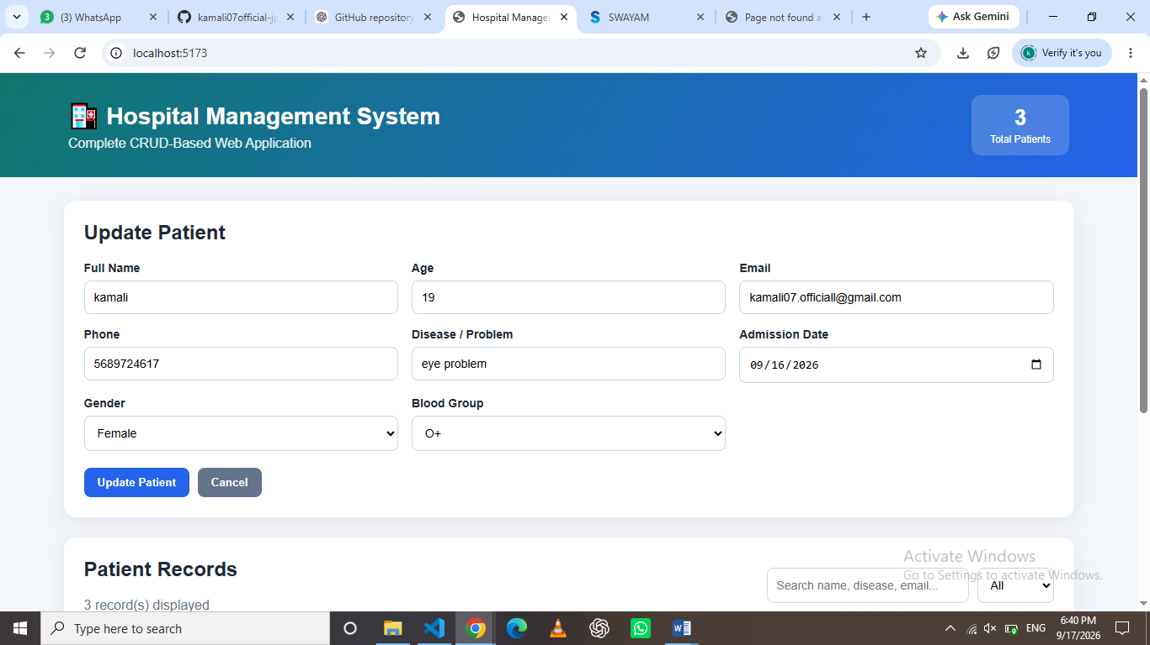
Patient entry form and patient records table with CRUD actions.

Figure 2: Update Patient Interface
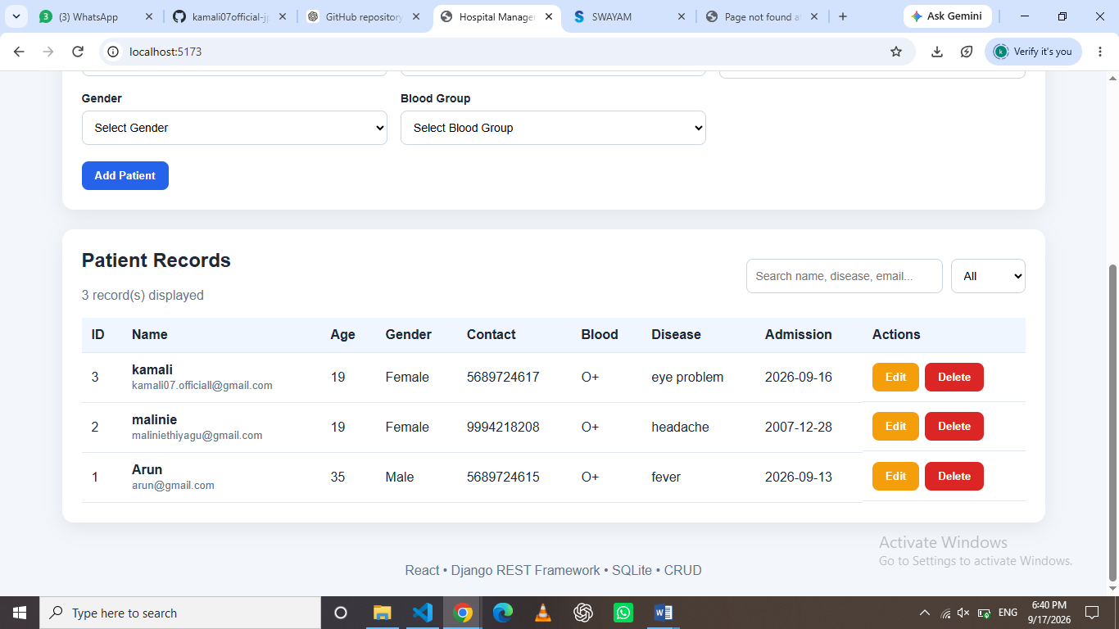
The edit/update mode supported by the React application.

Figure 3: Search and Filter Interface

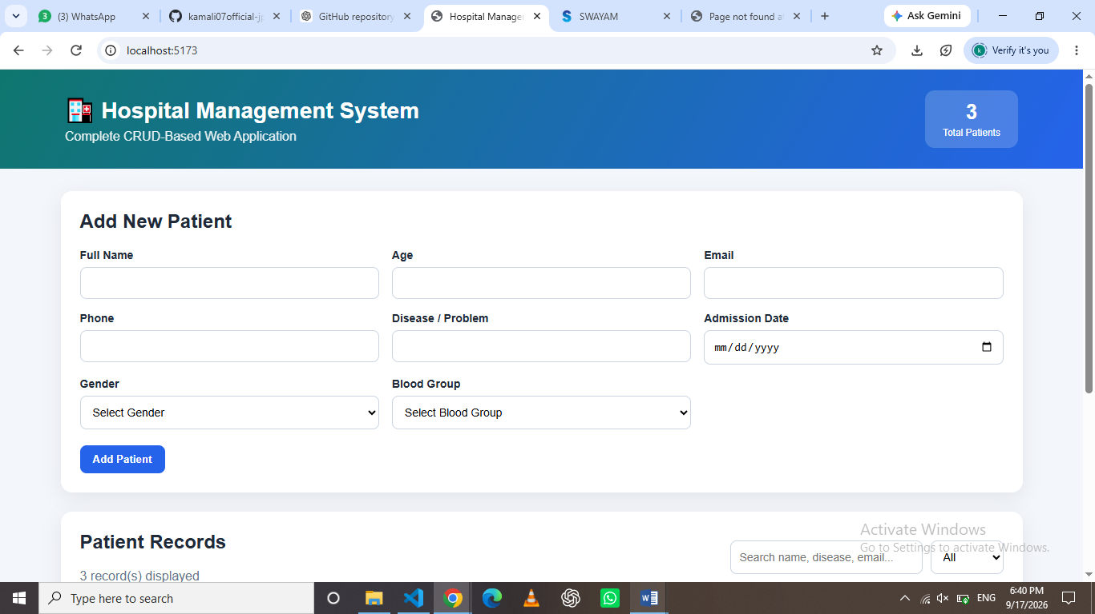
Search and gender-filter controls used to locate patient records.

