Data Domain Governance Portal — Production-Ready Semantic Model & Report Redesign
Prepared for: Balasubramaniam, Durga, Data Architecture Manager, EQ Data Office Grounded in: kpi_dashboard_data_domain_governance_portal_20260820_165036 - Copy.docx, the current governance_bootstrap_kpi_lineage_latest notebook (multi-model discovery version) and the existing 8-page redesign draft Target platform: Microsoft Fabric + Power BI (Direct Lake) + Purview
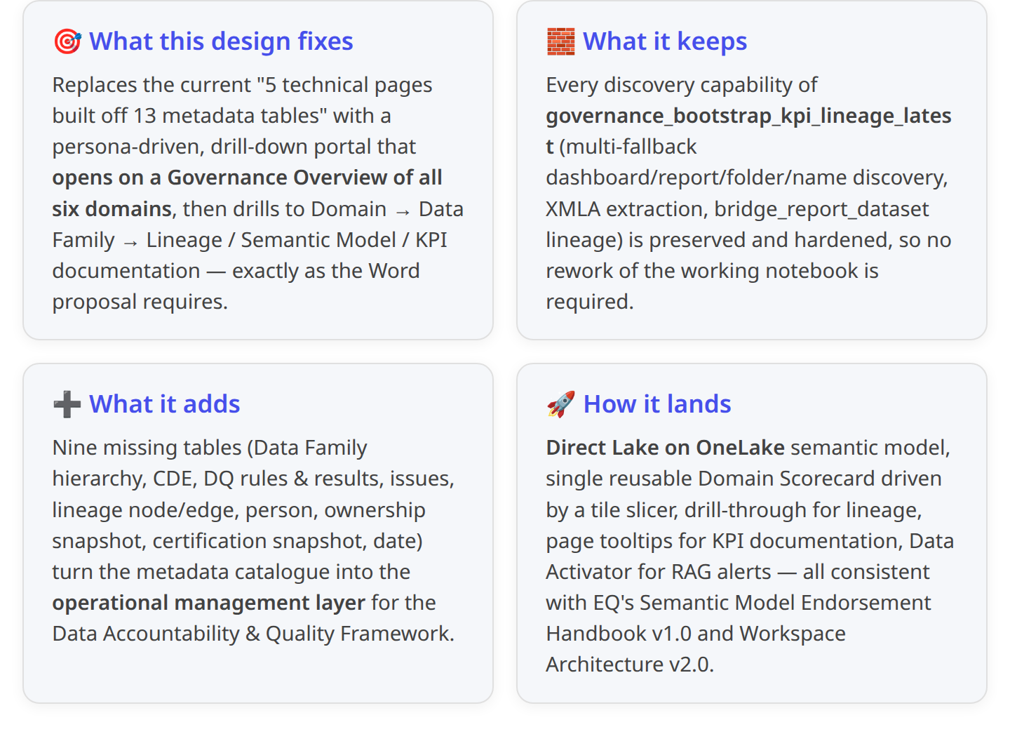 9 4 1 3 2

1. Current-state assessment — governance_bootstrap_kpi_lineage_latest

1.1 What the notebook produces today
The current notebook is the multi-model discovery amendment built on top of the original single-model bootstrap. It resolves the KPI Dashboard container (dashboard / report / folder / name-pattern), enumerates every semantic model behind it, and extracts metadata for all of them into 13 Delta tables in DataGovernance_metadata_LH.governance.9 4
Discovery mechanics that must be retained:
- Four fallback strategies: DISCOVER_AS_DASHBOARD → DISCOVER_AS_REPORT → DISCOVER_AS_FOLDER → DISCOVER_BY_NAME, unified and de-duplicated into datasets_in_scope.9
- OVERRIDE_MODELS_ONLY bypass with the nine known models (salesforce_gold, dashboard_sundries, Product_Static, Consolidated Sales Report, EQ-UK DAILY MTD MARGIN INCOME REPORT, top_100_client_revenue, EQ US Fiduciary Margin Income, EQ+NOTIFIED CORPORATE CASH BALANCE BY BUSINESS UNIT AND BANK, finance_cy_mtd_sql).10
- Loop over every DatasetId extracting Tables → Columns → Measures → Relationships → Hierarchies → KPIs → Refresh History → Reports.9
- bridge_report_dataset captures container→dataset lineage with DiscoverySource ∈ {dashboard_tile, report_binding, folder_item, name_match, composite_model} — the payoff of multi-model discovery.8
- Idempotent audit trail in audit_run_log; safe to re-run at any cadence.4
The 13 tables in DataGovernance_metadata_LH.governance:
Category | Tables | Grain / business key
Governance dims | dim_domain, dim_kpi | DomainCode / KpiKey
Model & catalog dims | dim_semantic_model, dim_table, dim_column, dim_measure, dim_relationship, dim_hierarchy | DatasetId (+ child composite keys)
Bridges | bridge_domain_kpi, bridge_report_dataset | Domain↔KPI, container↔dataset
Facts | fact_refresh_history, fact_report_consumption | DatasetId+RefreshRequestId, ReportId
Audit | audit_run_log | RunId
4

1.2 Gap against the target design
The chart below summarises the gap between what the notebook currently captures and what the Word proposal requires the portal to answer. Nine metadata surfaces are needed to serve the Executive Governance → Domain → Data Family → Lineage / Semantic Model / KPI drill journey; the current notebook covers only four strongly and two partially.
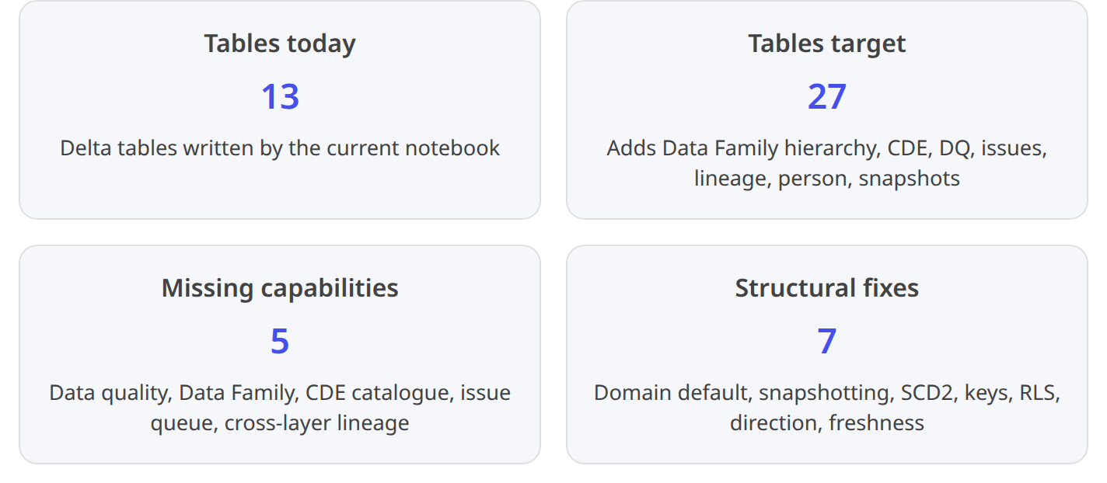 4
Concrete gaps mapped to Word-doc sections:
Word doc requirement | Where in doc | Notebook today | Gap type
Data Family / Data Concept / Data Element hierarchy under each domain | §6.1, §6.31 | Not represented | Missing dim — dim_data_family, dim_data_concept, dim_data_element
CDE (Critical Data Element) catalogue | §81 | Not represented | Missing dim — dim_cde + tag on dim_data_element
Data quality — 6 numerical + 5 categorical dimensions per Family | §131 | Not represented | Missing dim/fact — dim_dq_rule, fact_dq_result
High-severity issues open vs resolved; remediation SLA | §151 | Not represented | Missing fact — fact_issue
Ownership registry (Owner, Area Owner, Steward, Custodian, Sponsor, Council rep) | §4.11 | dim_domain has 3 columns (Owner/Steward/Custodian) as strings only | Redundancy + gap — refactor to dim_person + bridge_domain_role
End-to-end lineage: source → bronze → silver → gold → semantic model → report | §7.1, §10.11 | Only container → dataset (bridge_report_dataset) | Missing — dim_lineage_node, bridge_lineage_edge
KPI documentation template (formula, thresholds, targets, refresh, expiry, business interpretation) | §9.11 | dim_kpi has KPIName only; no formula/threshold/target/expiry | Missing columns on dim_kpi
CSM-Gold adoption / consumption trend | §11.11 | fact_report_consumption grain unclear; no Views, DistinctUsers verified | Verify columns — FUAM enrichment required
Certification history — Promoted → Certified → expiry every 12 months | §9.3, Gold Rubric1 | dim_semantic_model.Certification is current-state only | Missing — fact_certification_snapshot (SCD2 pattern)
Domain heat map / trend (Ownership, Mapping, Certification, Documentation, Reliability) | §11.11 | No history / snapshot | Missing — fact_ownership_snapshot, fact_documentation_snapshot, or a unified fact_domain_health
Domain default mapping fallback = DSD | Cell 14 of notebook4 | Every unclassified model lands as DSD, misreporting Ownership page | Fix logic — explicit mapping table + validation gate
Multiple people per role per domain | Framework "1-3 Stewards"1 | dim_domain allows only one string per role | Refactor — bridge many-to-many

1.3 Structural issues to fix in the notebook
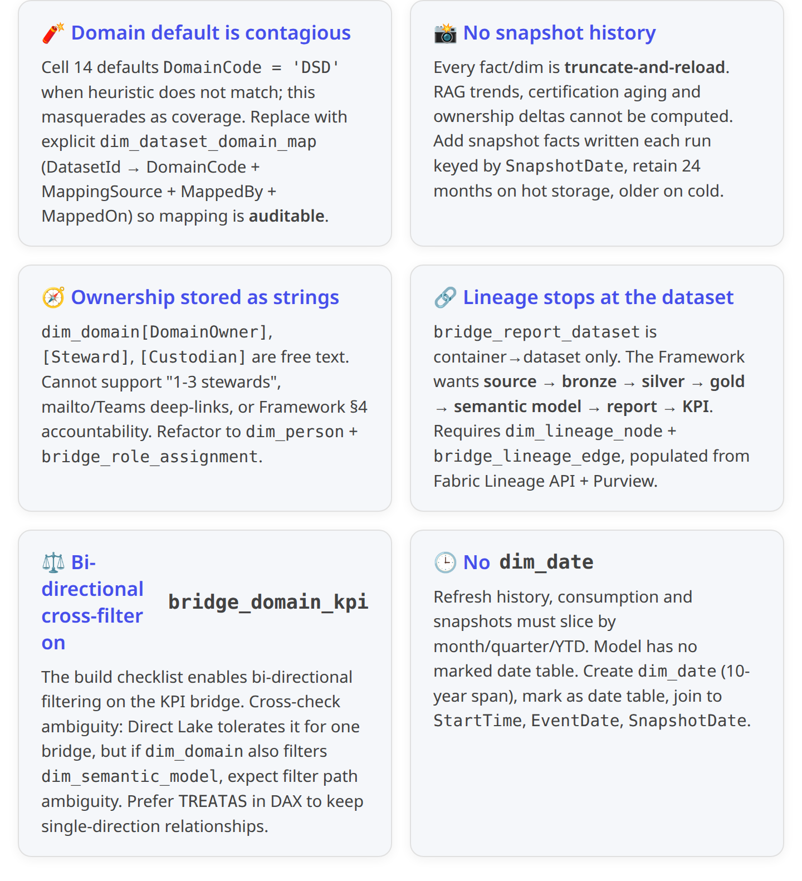 4 1

1.4 Recommendations for the notebook
The recommendations below are additive — the discovery loop, extraction cells and audit log are all retained.
# | Recommendation | Notebook change
N1 | Introduce dim_dataset_domain_map table with DatasetId, DomainCode, MappingSource, MappedBy, MappedOn, Confidence (enum: Manual, NamePattern, Folder, LineagePurview, Default). Fail the run if Confidence = 'Default' for > x% of datasets. | New Cell 14a; validation gate in Cell 19
N2 | Model dim_person — one row per named individual, keyed by AAD UserPrincipalName; populate from workspace list_users, dataset ConfiguredBy, Fabric domain roles API. Add columns DisplayName, EmailAddress, TeamsDeepLink, JobTitle. | New Cell 8a
N3 | Replace dim_domain free-text role columns with bridge_role_assignment(DomainCode, DataAreaCode, PersonKey, RoleType, ValidFrom, ValidTo). RoleType ∈ {DomainOwner, DataAreaOwner, Steward, Custodian, Sponsor, CouncilRep}. | Refactor Cell B3 (DOMAINS seed) into two tables
N4 | Add Data Family hierarchy tables — dim_data_family(FamilyKey, DomainCode, FamilyName, Description, DataAreaOwnerPersonKey); dim_data_concept(ConceptKey, FamilyKey, ConceptName, ApprovedDefinition, ApprovedBy, ApprovedOn, Sensitivity); dim_data_element(ElementKey, ConceptKey, PhysicalTable, PhysicalColumn, SourceSystem, IsCDE). Seed from Word-doc §6.3 table + business workshops. | New Cells B4, B5, B6
N5 | Extend dim_kpi with BusinessDefinition, DAXFormula, BusinessOwnerPersonKey, StewardPersonKey, RefreshFrequency, GreenThreshold, AmberThreshold, RedThreshold, TargetValue, CertificationStatus, CertificationExpiryDate, LastReviewDate, BusinessInterpretation, KnownExceptions. Extract measure DAX from dim_measure where measure name matches KPI naming pattern; leave documentation columns blank for manual population by Stewards. | Extend Cell 7F
N6 | Landing tables for Data Quality — dim_dq_rule(RuleKey, RuleName, RuleType ∈ {Completeness, Accuracy, Validity, Consistency, Timeliness, Uniqueness, RefDataCompliance, DomainConformity, MasterDataAlign, PolicyAdherence}, TableKey, ColumnKey, Threshold, Owner); fact_dq_result(ResultKey, RuleKey, RunTs, PassCount, FailCount, PassRate, SeverityBand ∈ {Green, Amber, Red}). Populated from Soda/Great Expectations runners.1 | New Cells DQ1, DQ2
N7 | Issue queue — fact_issue(IssueKey, DomainCode, FamilyKey, KpiKey, RuleKey, Severity ∈ {P0..P3}, Status ∈ {Open, InRemediation, Closed}, OpenedOn, AssignedTo, DueDate, ClosedOn, Description). | New Cell ISS1
N8 | Lineage node/edge — dim_lineage_node(NodeKey, NodeType ∈ {SourceSystem, BronzeTable, SilverTable, GoldTable, SemanticModel, Report, KPI}, DisplayName, Workspace, ItemGuid, DomainCode, FamilyKey, Sensitivity); bridge_lineage_edge(EdgeKey, FromNodeKey, ToNodeKey, EdgeType ∈ {Ingest, Transform, Consume}, Confidence, DiscoveredOn). Populate from Fabric Lineage API (/lineages endpoint) + Purview /atlas/v2/lineage; fall back to existing bridge_report_dataset for the Dataset→Report edge. | New Cell L1
N9 | Snapshot facts — Wrap the dimension rows into daily snapshots so RAG can trend: fact_ownership_snapshot(SnapshotDate, DomainCode, HasOwner, HasSteward, HasCustodian), fact_certification_snapshot(SnapshotDate, DatasetId, Endorsement, Certification, CertificationExpiryDate), fact_documentation_snapshot(SnapshotDate, DatasetId, TablesDescribedPct, ColumnsDescribedPct, MeasuresDescribedPct). Written at end of every notebook run. | New Cell SN1
N10 | Marked date table — dim_date(DateKey, Date, Year, Quarter, Month, MonthName, Week, DayOfWeek, IsWeekend, IsMonthEnd) 2020-01-01 → 2030-12-31. Marked as date table; joined to fact_refresh_history[StartTime].date, fact_report_consumption[EventDate], all SnapshotDate columns. | New Cell D1
N11 | fact_report_consumption enrichment — Ensure ReportId, EventDate, DistinctUsers, Views, WorkspaceId are present. Source from Fabric FUAM (Feature Usage and Adoption) via composite model, per your existing FUAM daily pipeline pattern.7 | Extend Cell 8
N12 | Freshness derived columns — Cell 8a computes LastSuccessRefreshTs, HoursSinceLastSuccess, IsStale per DatasetId (Stale = > SLA hours since last success). Persists to dim_semantic_model_freshness for Direct Lake performance. | New Cell 8a
N13 | audit_run_log extension — Add RowsExtracted, TablesTouched, Warnings JSON, MappingCoverage%, SnapshotWritten Bool. RAG-signal the run itself. | Extend Cell 19
N14 | Sensitivity labels + Purview push-through — On every metadata write, tag the Delta table with the Purview classification Internal; use PurviewClient to POST dim_semantic_model and dim_lineage_node as Purview data assets so lineage is visible in OneLake Catalog / Purview Data Map.5 | New Cell PV1
N15 | Idempotency + delta merges — Replace truncate-and-reload with MERGE INTO on business keys for dimensions; append-only for facts (snapshots and events). Guarantees safe concurrent execution and history preservation. | Wrap create_delta_if_absent helper into an upsert_delta helper
N16 | Domain default validation gate — If MappingCoverage% < 90, write a WARN row to audit_run_log, keep the run green but flag the ownership page in Power BI (existing "% of models with a mapped non-DSD-default DomainCode" measure already anticipates this).4 | New Cell 19a

2. Target semantic model — production design
The target semantic model is a single Direct Lake on OneLake model called Governance_Portal_Model, published in the data_governance_lh workspace. Direct Lake is preferred because (a) OneLake security supports fine-grained sensitivity on ownership metadata; (b) fallback-free DirectLakeOnly mode gives predictable performance; (c) no refresh schedule needs to be maintained — the semantic model is the lakehouse.6

2.1 Architecture — from lakehouse tables to executive report
The diagram below shows the three layers as they will land in production. Governance-hierarchy dimensions (blue) feed the person/asset dimensions (teal) and the bridge tables (amber), which in turn drive the snapshot and event facts (green). Together they build the Direct Lake star schema that powers the Data Domain Governance Portal Power BI report, whose entry page is the Executive Governance Overview with one tile per business domain.
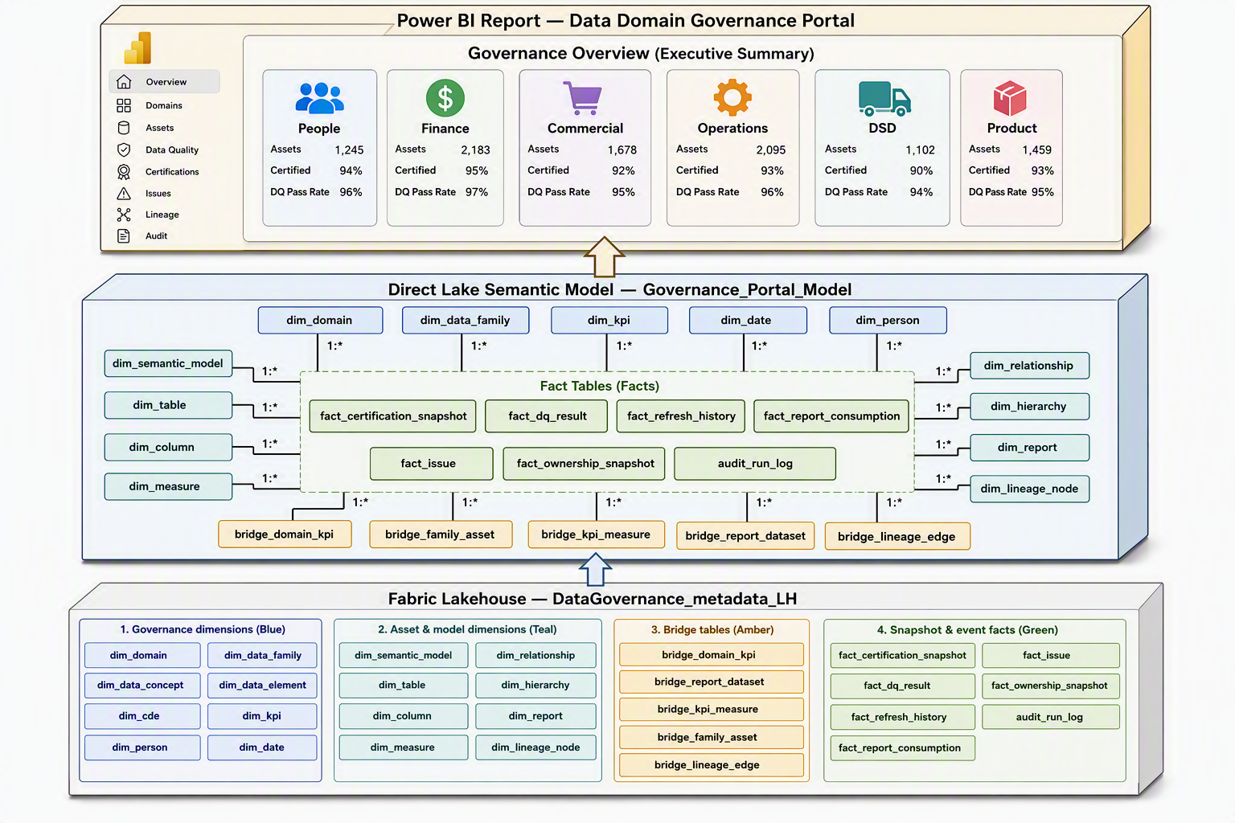 Figure 1: Target-state architecture — governance metadata Delta tables in DataGovernance_metadata_LH grouped by function, feeding the Direct Lake Governance_Portal_Model and the Power BI Data Domain Governance Portal whose landing page is a six-domain executive overview.

2.2 Complete schema — table by table
Twenty-seven tables in total. Every dimension has a surrogate key (*Key BIGINT IDENTITY) plus a business key (natural key from the source). Every fact keys off surrogate keys; every business key is preserved as a hidden column for audit.

2.2.1 Governance-hierarchy dimensions (blue)
Table | Grain | Business key | Key columns | Source
dim_domain | 1 row per business domain | DomainCode | DomainCode, DomainName, DomainDescription, BusinessSponsorPersonKey, DomainOwnerPersonKey, DataGovernanceCouncilRepPersonKey, Status ∈ {Active, Draft, Retired}, LastReviewDate | Seeded from Word-doc §5 (People, Finance, Commercial, Operations, DSD, Product)1
dim_data_family | 1 row per Data Family (Data Area) within a domain | FamilyCode | FamilyCode, DomainCode, FamilyName, FamilyDescription, DataAreaOwnerPersonKey, PrimarySourceSystem, Status | Seeded from Word-doc §6.3 table1
dim_data_concept | 1 row per governed business term | ConceptCode | ConceptCode, FamilyCode, ConceptName, ApprovedDefinition, ApprovedByPersonKey, ApprovedOn, DataConceptSensitivity ∈ {Public, Internal, Sensitive, PII}, IsCDE, GlossaryLinkPurviewId | Manual — populated at Framework workshops
dim_data_element | 1 row per physical column mapped to a Data Concept | ElementCode = SHA-1(SourceSystem + Table + Column) | ElementCode, ConceptCode, SourceSystem, SchemaName, TableName, ColumnName, DataType, Nullable, PII, RetentionYears | Automated from Silver/Gold catalog + Fabric SQL endpoint metadata
dim_cde | 1 row per Critical Data Element | CDECode | CDECode, ConceptCode, Rationale, MaterialityBand ∈ {High, Medium, Low}, RegulatoryDriver, ApprovedByPersonKey, ApprovedOn | Manual — per Framework §8 CDE catalogue1
dim_kpi | 1 row per KPI (target 36 = 6 domains × 6 KPIs) | KpiKey | KpiKey, KPIName, BusinessName, BusinessPurpose, BusinessOwnerPersonKey, StewardPersonKey, HomeModelDatasetId, DAXFormula, RefreshFrequency, GreenThreshold, AmberThreshold, RedThreshold, TargetValue, CertificationStatus ∈ {NotCertified, Promoted, Certified}, CertificationExpiryDate, LastReviewDate, BusinessInterpretation, KnownExceptions | Existing dim_kpi extended per §1.4 N5
dim_person | 1 row per named individual | UserPrincipalName | PersonKey, UserPrincipalName, DisplayName, EmailAddress, JobTitle, TeamsDeepLink, HRDivision | AAD via Fabric identity + workspace member API
dim_date | 1 row per calendar date, 2020-01-01 → 2030-12-31 | DateKey (int, YYYYMMDD) | Date, Year, Quarter, Month, MonthName, MonthKey, Week, DayOfWeek, IsWeekend, IsMonthEnd, IsFiscalYearStart | Generated in notebook Cell D1; marked as date table

2.2.2 Asset & model dimensions (teal)
Table | Grain | Business key | Key columns | Source
dim_semantic_model | 1 row per semantic model in scope | DatasetId (GUID) | DatasetSK, DatasetId, DatasetName, WorkspaceName, WorkspaceId, ConfiguredByPersonKey, ContentProviderType, CreatedDate, IsRefreshable, Endorsement, Certification, CertifiedByPersonKey, CertifiedOn, DomainCode, PrimaryFamilyCode, SensitivityLabel, StorageMode ∈ {DirectLake, Import, Composite} | Existing — extended with SK, PersonKey, PrimaryFamilyCode
dim_table | 1 row per table inside a semantic model | DatasetId + TableName | TableSK, DatasetSK, TableName, Description, IsHidden, IsFactTable, IsDimensionTable, RowCount, TableDescriptionPresent | Existing
dim_column | 1 row per column | DatasetId + TableName + ColumnName | ColumnSK, TableSK, ColumnName, DataType, IsHidden, IsKey, Description, ColumnDescriptionPresent, MappedElementCode (FK to dim_data_element) | Existing — plus new MappedElementCode
dim_measure | 1 row per DAX measure | DatasetId + MeasureName | MeasureSK, DatasetSK, HomeTable, MeasureName, Expression, Description, FormatString, DisplayFolder, MeasureDescriptionPresent | Existing
dim_relationship | 1 row per model relationship | DatasetId + FromTable + FromColumn + ToTable + ToColumn | RelSK, DatasetSK, FromTable, FromColumn, ToTable, ToColumn, Cardinality, CrossFilterDirection, IsActive | Existing
dim_hierarchy | 1 row per hierarchy | DatasetId + TableName + HierarchyName | HierSK, TableSK, HierarchyName, Levels, Description | Existing
dim_report | 1 row per Power BI report consuming any tracked model | ReportId (GUID) | ReportSK, ReportId, ReportName, WorkspaceId, WorkspaceName, ConfiguredByPersonKey, IsProduction, SensitivityLabel, LastModifiedOn | New — Fabric /reports API
dim_lineage_node | 1 row per lineage node | NodeKey (SHA-1 of NodeType + SystemName + ObjectPath) | NodeSK, NodeKey, NodeType ∈ {SourceSystem, BronzeTable, SilverTable, GoldTable, SemanticModel, Report, KPI}, DisplayName, WorkspaceName, ItemGuid, DomainCode, FamilyCode, Sensitivity | Fabric Lineage API + Purview + existing metadata

2.2.3 Bridge tables (amber)
Table | Grain | Notes
bridge_domain_kpi | Domain ↔ KPI | Existing. Add MappingSource ∈ {Manual, NamePattern, LineagePurview, Default} — the missing column the redesign already flags 4
bridge_report_dataset | Container ↔ Dataset | Existing — capturing DiscoverySource (multi-fallback provenance)4
bridge_family_asset | Data Family ↔ (Dataset, Table) | New — enables Data Family drill to underlying tables
bridge_kpi_measure | KPI ↔ (Dataset, Measure) | New — enables KPI → DAX definition drill on P5
bridge_role_assignment | (Domain, Family) ↔ Person ↔ Role | New — replaces free-text role columns on dim_domain. RoleType ∈ {DomainOwner, DataAreaOwner, Steward, Custodian, Sponsor, CouncilRep}, with ValidFrom / ValidTo for SCD2
bridge_lineage_edge | From-node ↔ To-node | New — the graph edge table for lineage discovery, EdgeType ∈ {Ingest, Transform, Consume}
bridge_dataset_domain_map | Dataset ↔ Domain | New — replaces dim_semantic_model.DomainCode hard-coded default with auditable mapping (see N1)

2.2.4 Snapshot & event facts (green)
Table | Grain | Key columns
fact_refresh_history | 1 row per refresh event per dataset | DatasetSK, RefreshRequestId, StartTime, EndTime, Status, DurationSec, FailureMessage. Direct Lake note: partition Delta by date_trunc('month', StartTime) to reduce Direct Lake column re-encoding cost.6
fact_report_consumption | 1 row per report view aggregate per day | ReportSK, EventDate, DistinctUsers, Views, UniqueSessions, WorkspaceSK — sourced from FUAM composite model (SM_COMP_feature_usage pattern already implemented)7
fact_dq_result | 1 row per DQ rule execution | RuleSK, RunTs, PassCount, FailCount, PassRate, SeverityBand, RunSource ∈ {Soda, GreatExpectations, Native}
fact_issue | 1 row per issue event (state change) | IssueKey, EventTs, DomainCode, FamilyCode, KpiKey, RuleSK, Severity ∈ {P0..P3}, Status ∈ {Open, InRemediation, Closed}, AssignedToPersonKey, DueDate, DaysOpen, DaysToDue — SCD-like: latest row per IssueKey is current state; historical rows enable aging
fact_ownership_snapshot | 1 row per (SnapshotDate × Domain) | SnapshotDate, DomainCode, HasOwner, HasSteward, HasCustodian, StewardCount, CustodianCount, DaysSinceLastReview, OwnershipCompleteness
fact_certification_snapshot | 1 row per (SnapshotDate × Dataset) | SnapshotDate, DatasetSK, Endorsement, Certification, IsExpired, DaysToExpiry
fact_documentation_snapshot | 1 row per (SnapshotDate × Dataset) | SnapshotDate, DatasetSK, TablesDescribedPct, ColumnsDescribedPct, MeasuresDescribedPct
audit_run_log | 1 row per notebook run | RunId, RunTs, Status, DurationSec, RowsExtracted, TablesTouched, MappingCoverage, WarningsJSON, SnapshotWritten
Grand total: 27 tables (8 governance dims + 8 asset dims + 7 bridges + 4 event facts + 3 snapshot facts + 1 audit table — 27 including dim_date).

2.3 Relationships and cardinalities
All relationships are single-direction unless explicitly annotated, honouring the ambiguity fix identified in the redesign draft.4 Bi-direction is limited to bridges where it is unavoidable.
From (1) | To (*) | Cardinality | Filter direction | Active
dim_domain[DomainCode] | dim_data_family[DomainCode] | 1:* | Single | ✔
dim_data_family[FamilyCode] | dim_data_concept[FamilyCode] | 1:* | Single | ✔
dim_data_concept[ConceptCode] | dim_data_element[ConceptCode] | 1:* | Single | ✔
dim_data_concept[ConceptCode] | dim_cde[ConceptCode] | 1:1 | Single | ✔
dim_domain[DomainCode] | bridge_dataset_domain_map[DomainCode] | 1:* | Single | ✔
dim_semantic_model[DatasetSK] | bridge_dataset_domain_map[DatasetSK] | 1:* | Single | ✔
dim_semantic_model[DatasetSK] | dim_table[DatasetSK] | 1:* | Single | ✔
dim_table[TableSK] | dim_column[TableSK] / dim_measure[HomeTableSK] / dim_hierarchy[TableSK] | 1:* | Single | ✔
dim_semantic_model[DatasetSK] | dim_relationship[DatasetSK] | 1:* | Single | ✔
dim_data_element[ElementCode] | dim_column[MappedElementCode] | 1:* | Single | ✔
dim_domain[DomainCode] ↔ dim_kpi[KpiKey] (via bridge_domain_kpi) | m:m | Both (on bridge only) | ✔ | —
dim_kpi[KpiKey] ↔ dim_measure[MeasureSK] (via bridge_kpi_measure) | m:m | Both (on bridge only) | ✔ | —
dim_data_family[FamilyCode] ↔ dim_table[TableSK] (via bridge_family_asset) | m:m | Both (on bridge only) | ✔ | —
dim_domain[DomainCode] + dim_person[PersonKey] ↔ bridge_role_assignment | m:m | Both (on bridge only) | ✔ | —
dim_semantic_model[DatasetSK] | bridge_report_dataset[DatasetSK] | 1:* | Single | ✔
bridge_report_dataset[ReportId] | dim_report[ReportId] | *:1 | Single | ✔
dim_report[ReportSK] | fact_report_consumption[ReportSK] | 1:* | Single | ✔
dim_semantic_model[DatasetSK] | fact_refresh_history[DatasetSK] | 1:* | Single | ✔
dim_lineage_node[NodeSK] | bridge_lineage_edge[FromNodeSK] | 1:* | Single | ✔
dim_lineage_node[NodeSK] | bridge_lineage_edge[ToNodeSK] | 1:* | Single | inactive — use USERELATIONSHIP for the reverse edge
dim_date[DateKey] | fact_refresh_history[StartDateKey] | 1:* | Single | ✔
dim_date[DateKey] | fact_report_consumption[EventDateKey] | 1:* | Single | ✔
dim_date[DateKey] | fact_*_snapshot[SnapshotDateKey] (each snapshot fact) | 1:* | Single | ✔
dim_domain[DomainCode] | fact_ownership_snapshot[DomainCode] | 1:* | Single | ✔
dim_semantic_model[DatasetSK] | fact_certification_snapshot[DatasetSK] / fact_documentation_snapshot[DatasetSK] | 1:* | Single | ✔
dim_kpi[KpiKey] | fact_issue[KpiKey] | 1:* | Single | ✔
audit_run_log | (standalone — hidden from report field list) | — | — | —

2.4 How the notebook writes to these tables
The bootstrap notebook lands data into DataGovernance_metadata_LH.governance in this sequence:
- Config + validation (existing Cells 1-3 + new Cell 3a): read overrides, validate lakehouse.
- DDL (existing Cell 5, extended): create_delta_if_absent for all 27 tables with the schemas above.
- Person + registry seed (new Cells B0-B6): person, domain, family, concept, element, CDE, role assignments.
- Multi-fallback discovery (existing Cell 6b): resolves datasets_in_scope.
- Loop over datasets (existing Cell 7 rewrap): extracts tables, columns, measures, relationships, hierarchies, KPIs, refresh, reports — writes to child dims.
- Report consumption enrichment (existing Cell 8 + new 8a): joins FUAM composite model for Views and DistinctUsers.
- Lineage extraction (new Cell L1): calls Fabric Lineage API (GET /workspaces/{ws}/lineages), pushes to dim_lineage_node and bridge_lineage_edge; supplements with Purview /atlas/v2/lineage.
- Domain mapping (existing Cell 14, rewritten): consumes bridge_dataset_domain_map — never defaults silently to DSD; writes MappingCoverage% to audit_run_log.
- Snapshots (new Cell SN1): writes fact_ownership_snapshot, fact_certification_snapshot, fact_documentation_snapshot with SnapshotDate = current_date().
- Purview push (new Cell PV1): registers dim_semantic_model and dim_lineage_node as Purview data assets.
- Audit finalisation (existing Cell 19, extended): writes audit_run_log with MappingCoverage, RowsExtracted, WarningsJSON.
Retention: dimensions upserted (MERGE); event facts appended; snapshot facts appended with SnapshotDate partitioning; audit_run_log appended.

3. DAX measure catalogue
The catalogue is 62 measures grouped into 10 display folders. Every % measure uses DIVIDE (safe divisor). Every domain-scoped measure works with the single-direction star; bridges use TREATAS where needed. Reference denominators (Domains Governed, Tables Governed, Columns Catalogued, Semantic Models, KPI Count) are the base of every percentage so filtering by domain/family produces trustworthy roll-ups.

3.1 Folder 01 — Portfolio counts (base denominators)
1 Semantic Models = DISTINCTCOUNT ( dim_semantic_model[DatasetId] )
2
3 Tables Governed = COUNTROWS ( dim_table )
4
5 Columns Catalogued = COUNTROWS ( dim_column )
6
7 Measures Documented = COUNTROWS ( dim_measure )
8
9 KPI Count = DISTINCTCOUNT ( dim_kpi[KpiKey] )
10
11 Reports Consuming = DISTINCTCOUNT ( fact_report_consumption[ReportId] )
12
13 Domains Governed = COUNTROWS ( dim_domain )
14 Data Families = COUNTROWS ( dim_data_family )
15 Data Concepts = COUNTROWS ( dim_data_concept )
16 CDE Count = COUNTROWS ( dim_cde )

3.2 Folder 02 — Ownership & stewardship (uses bridge_role_assignment)
1 Domains With Owner =
2 CALCULATE (
3 DISTINCTCOUNT ( bridge_role_assignment[DomainCode] ),
4 bridge_role_assignment[RoleType] = "DomainOwner",
5 ISBLANK ( bridge_role_assignment[ValidTo] ) || bridge_role_assignment[ValidTo] > TODAY ()
6 )
7
8 Domains With Steward =
9 CALCULATE (
10 DISTINCTCOUNT ( bridge_role_assignment[DomainCode] ),
11 bridge_role_assignment[RoleType] = "Steward",
12 ISBLANK ( bridge_role_assignment[ValidTo] ) || bridge_role_assignment[ValidTo] > TODAY ()
13 )
14
15 Domains With Custodian =
16 CALCULATE (
17 DISTINCTCOUNT ( bridge_role_assignment[DomainCode] ),
18 bridge_role_assignment[RoleType] = "Custodian",
19 ISBLANK ( bridge_role_assignment[ValidTo] ) || bridge_role_assignment[ValidTo] > TODAY ()
20 )
21
22 Ownership Completeness % =
23 DIVIDE (
24 [Domains With Owner] + [Domains With Steward] + [Domains With Custodian],
25 [Domains Governed] * 3
26 )
27
28 Ownership Gap Count =
29 ( [Domains Governed] - [Domains With Owner] )
30 + ( [Domains Governed] - [Domains With Steward] )
31 + ( [Domains Governed] - [Domains With Custodian] )

3.3 Folder 03 — Documentation coverage
1 % Tables Described =
2 DIVIDE (
3 CALCULATE ( COUNTROWS ( dim_table ), NOT ISBLANK ( dim_table[Description] ) ),
4 COUNTROWS ( dim_table )
5 )
6
7 % Columns Described =
8 DIVIDE (
9 CALCULATE ( COUNTROWS ( dim_column ), NOT ISBLANK ( dim_column[Description] ) ),
10 COUNTROWS ( dim_column )
11 )
12
13 % Measures Described =
14 DIVIDE (
15 CALCULATE ( COUNTROWS ( dim_measure ), NOT ISBLANK ( dim_measure[Description] ) ),
16 COUNTROWS ( dim_measure )
17 )
18
19 Documentation Coverage % =
20 AVERAGEX (
21 { [% Tables Described], [% Columns Described], [% Measures Described] },
22 [Value]
23 )
24
25 Documentation Gap Count =
26 ( [Tables Governed] - CALCULATE ( COUNTROWS ( dim_table ), NOT ISBLANK ( dim_table[Description] ) ) )
27 + ( [Columns Catalogued] - CALCULATE ( COUNTROWS ( dim_column ), NOT ISBLANK ( dim_column[Description] ) ) )
28 + ( [Measures Documented] - CALCULATE ( COUNTROWS ( dim_measure ), NOT ISBLANK ( dim_measure[Description] ) ) )

3.4 Folder 04 — Certification & endorsement
1 Certified Models = CALCULATE ( [Semantic Models], dim_semantic_model[Certification] = "Certified" )
2 Promoted Models = CALCULATE ( [Semantic Models], dim_semantic_model[Endorsement] = "Promoted" )
3
4 % Certified = DIVIDE ( [Certified Models], [Semantic Models] )
5
6 Unendorsed Models =
7 CALCULATE (
8 [Semantic Models],
9 ISBLANK ( dim_semantic_model[Endorsement] ) || dim_semantic_model[Endorsement] IN { "", "None" }
10 )
11
12 Uncertified but Consumed =
13 VAR _Consumed =
14 CALCULATETABLE (
15 VALUES ( dim_semantic_model[DatasetId] ),
16 FILTER ( ALL ( dim_semantic_model ), dim_semantic_model[Certification] <> "Certified" ),
17 USERELATIONSHIP ( dim_semantic_model[DatasetSK], bridge_report_dataset[DatasetSK] ),
18 fact_report_consumption[Views] > 0
19 )
20 RETURN COUNTROWS ( _Consumed )
21
22 Certification Expiring 90d =
23 CALCULATE (
24 [Certified Models],
25 dim_semantic_model[CertificationExpiryDate] <= TODAY () + 90,
26 dim_semantic_model[CertificationExpiryDate] > TODAY ()
27 )
28
29 Certification Expired =
30 CALCULATE ( [Certified Models], dim_semantic_model[CertificationExpiryDate] <= TODAY () )
31
32 CSM-Gold Adoption % =
33 DIVIDE (
34 CALCULATE (
35 DISTINCTCOUNT ( fact_report_consumption[ReportId] ),
36 dim_semantic_model[Certification] = "Certified"
37 ),
38 [Reports Consuming]
39 )

3.5 Folder 05 — Data Quality composite
1 DQ Pass Rate =
2 DIVIDE (
3 SUM ( fact_dq_result[PassCount] ),
4 SUM ( fact_dq_result[PassCount] ) + SUM ( fact_dq_result[FailCount] )
5 )
6
7 DQ Composite Score =
8 VAR _Weights =
9 DATATABLE (
10 "RuleType", STRING, "Weight", DOUBLE,
11 {
12 {"Completeness", 0.25}, {"Accuracy", 0.20}, {"Validity", 0.15},
13 {"Consistency", 0.15}, {"Timeliness", 0.15}, {"Uniqueness", 0.10}
14 }
15 )
16 RETURN
17 SUMX (
18 _Weights,
19 CALCULATE (
20 [DQ Pass Rate],
21 TREATAS ( { [RuleType] }, dim_dq_rule[RuleType] )
22 ) * [Weight]
23 )
24
25 Open Issues P0-P1 =
26 CALCULATE (
27 DISTINCTCOUNT ( fact_issue[IssueKey] ),
28 fact_issue[Status] IN { "Open", "InRemediation" },
29 fact_issue[Severity] IN { "P0", "P1" }
30 )
31
32 Remediation SLA Adherence % =
33 DIVIDE (
34 CALCULATE (
35 DISTINCTCOUNT ( fact_issue[IssueKey] ),
36 fact_issue[Status] = "Closed",
37 fact_issue[ClosedOn] <= fact_issue[DueDate]
38 ),
39 CALCULATE ( DISTINCTCOUNT ( fact_issue[IssueKey] ), fact_issue[Status] = "Closed" )
40 )

3.6 Folder 06 — Refresh reliability & freshness
1 Refresh Success Rate =
2 DIVIDE (
3 CALCULATE ( COUNTROWS ( fact_refresh_history ), fact_refresh_history[Status] = "Completed" ),
4 COUNTROWS ( fact_refresh_history )
5 )
6
7 Failed Refreshes 30d =
8 CALCULATE (
9 COUNTROWS ( fact_refresh_history ),
10 fact_refresh_history[Status] = "Failed",
11 fact_refresh_history[StartTime] >= TODAY () - 30
12 )
13
14 Last Successful Refresh =
15 CALCULATE (
16 MAX ( fact_refresh_history[StartTime] ),
17 fact_refresh_history[Status] = "Completed"
18 )
19
20 Hours Since Last Success =
21 DIVIDE (
22 DATEDIFF ( [Last Successful Refresh], NOW (), MINUTE ),
23 60
24 )
25
26 Stale Models Count =
27 COUNTROWS (
28 FILTER (
29 VALUES ( dim_semantic_model[DatasetSK] ),
30 [Hours Since Last Success] > 24 -- SLA
31 )
32 )
33
34 Freshness Health =
35 SWITCH (
36 TRUE (),
37 [Stale Models Count] = 0, "🟢 Green",
38 [Stale Models Count] <= 2, "🟡 Amber",
39 "🔴 Red"
40 )

3.7 Folder 07 — Adoption & consumption
1 Model Views 30d =
2 CALCULATE (
3 SUM ( fact_report_consumption[Views] ),
4 fact_report_consumption[EventDate] >= TODAY () - 30
5 )
6
7 Distinct Users 30d =
8 CALCULATE (
9 DISTINCTCOUNT ( fact_report_consumption[UserPrincipalName] ),
10 fact_report_consumption[EventDate] >= TODAY () - 30
11 )
12
13 Reports Consuming per Model =
14 CALCULATE (
15 DISTINCTCOUNT ( fact_report_consumption[ReportId] ),
16 ALLEXCEPT ( dim_semantic_model, dim_semantic_model[DatasetSK] )
17 )
18
19 Orphan Models Count =
20 COUNTROWS (
21 FILTER (
22 VALUES ( dim_semantic_model[DatasetSK] ),
23 [Reports Consuming per Model] = 0
24 )
25 )

3.8 Folder 08 — KPI governance
1 KPIs With Owner =
2 CALCULATE ( [KPI Count], NOT ISBLANK ( dim_kpi[BusinessOwnerPersonKey] ) )
3
4 KPIs Documented =
5 CALCULATE ( [KPI Count], NOT ISBLANK ( dim_kpi[BusinessDefinition] ), NOT ISBLANK ( dim_kpi[DAXFormula] ) )
6
7 KPI Mapping Coverage % =
8 DIVIDE (
9 DISTINCTCOUNT ( bridge_domain_kpi[KpiKey] ),
10 [KPI Count]
11 )
12
13 KPI Certified % = DIVIDE ( CALCULATE ( [KPI Count], dim_kpi[CertificationStatus] = "Certified" ), [KPI Count] )
14
15 KPIs Expiring 90d =
16 CALCULATE (
17 [KPI Count],
18 dim_kpi[CertificationExpiryDate] <= TODAY () + 90,
19 dim_kpi[CertificationExpiryDate] > TODAY ()
20 )
21
22 KPIs At Target Count = 6 -- per Word §5, six per domain × six domains = 36
23 Actual vs Target KPIs = DIVIDE ( [KPI Count], 6 ) -- shown per domain

3.9 Folder 09 — Composite health scores & RAG
The Domain Health Score is the single number the executive sees per domain. It is an unweighted average of five pillars, each 0-100. Each pillar has its own RAG bands and a trend that Power BI plots as a spark-line.
1 -- Pillar 1: Ownership
2 Domain Ownership Score = ROUND ( [Ownership Completeness %] * 100, 0 )
3
4 -- Pillar 2: KPI Mapping
5 Domain KPI Mapping Score = ROUND ( [KPI Mapping Coverage %] * 100, 0 )
6
7 -- Pillar 3: Certification
8 Domain Certification Score =
9 ROUND (
10 DIVIDE (
11 [Certified Models],
12 [Semantic Models]
13 ) * 100,
14 0
15 )
16
17 -- Pillar 4: Documentation
18 Domain Documentation Score = ROUND ( [Documentation Coverage %] * 100, 0 )
19
20 -- Pillar 5: Reliability (composite of refresh & DQ)
21 Domain Reliability Score =
22 ROUND (
23 ( COALESCE ( [Refresh Success Rate], 0 ) * 0.6
24 + COALESCE ( [DQ Pass Rate], 0 ) * 0.4 ) * 100,
25 0
26 )
27
28 -- Composite
29 Domain Health Score =
30 AVERAGEX (
31 {
32 [Domain Ownership Score],
33 [Domain KPI Mapping Score],
34 [Domain Certification Score],
35 [Domain Documentation Score],
36 [Domain Reliability Score]
37 },
38 [Value]
39 )
40
41 Domain RAG =
42 SWITCH (
43 TRUE (),
44 [Domain Health Score] >= 90, "🟢 Green",
45 [Domain Health Score] >= 60, "🟡 Amber",
46 "🔴 Red"
47 )
48
49 Governance Health Score = [Domain Health Score] -- reused at portfolio grain

3.10 Folder 10 — Trend deltas (uses snapshot facts)
1 Ownership 30d Δ =
2 VAR _Now = [Ownership Completeness %]
3 VAR _Then =
4 CALCULATE (
5 [Ownership Completeness %],
6 REMOVEFILTERS ( dim_date ),
7 dim_date[Date] = TODAY () - 30
8 )
9 RETURN _Now - _Then
10
11 Certification 30d Δ =
12 VAR _Now = [% Certified]
13 VAR _Then =
14 CALCULATE (
15 [% Certified],
16 REMOVEFILTERS ( dim_date ),
17 dim_date[Date] = TODAY () - 30
18 )
19 RETURN _Now - _Then
20
21 DQ 30d Δ =
22 VAR _Now = [DQ Pass Rate]
23 VAR _Then =
24 CALCULATE ( [DQ Pass Rate], REMOVEFILTERS ( dim_date ), dim_date[Date] = TODAY () - 30 )
25 RETURN _Now - _Then
26
27 -- Trend spark-line series (calculated columns are avoided; leverage dim_date)
28 Refresh Success Rate 90d Trend =
29 CALCULATE (
30 [Refresh Success Rate],
31 DATESINPERIOD ( dim_date[Date], MAX ( dim_date[Date] ), -90, DAY )
32 )
Denominator rule that keeps percentages honest under domain/family filtering: Every [Domain <Pillar> Score] uses only measures whose denominator naturally narrows with the filter (e.g. [Semantic Models] is the count of models in the current filter context). This means [% Certified] sliced to Finance shows Certified Finance models / All Finance models, never a portfolio ratio. The five pillars are averaged unweighted; if you later want weighting, replace AVERAGEX with SUMX over a two-column _Weights DATATABLE and adjust denominators.

4. Report information architecture — the drill-down path

4.1 The persona-driven page inventory
The Word proposal insists on a layered portal — Executive Governance → six Domain Overview pages → four sub-pages (Data Family, Semantic Model, KPI Documentation, Governance Dashboard).1 Building six physical Domain pages is unnecessary — a single Domain Scorecard page with a tile slicer honours the same requirement while cutting maintenance to one artifact.
The eleven pages (nine visible + two hidden drill-through/tooltip) below are the production information architecture:
Tier | Page | Icon | Persona | Answers
1 – Executive | P1 · Governance Overview | 🏛️ | ELT, Data Office, Governance Council | Are all six domains under governance? Where are we red?
2 – Domain | P2 · Domain Scorecard (reusable × 6) | 🎯 | Domain Owner, Steward | How healthy is my domain? Who's accountable? What is my KPI portfolio?
3 – Discovery | P3 · Data Family Explorer | 🌳 | Owner, Steward | What Data Families sit under my domain? Which Concepts, Elements, CDEs feed them?
3 – Discovery | P4 · Semantic Model detail | 🧩 | Data Office, Steward | Which certified model powers this Family? Which measures?
3 – Discovery | P5 · KPI Documentation | 📖 | Data Office, ELT | What does this KPI mean, calculate, target, refresh, expire?
4 – Lineage | P6 · Lineage View | 🔗 | Data Office, Domain Owner | Source → Bronze → Silver → Gold → Model → Report → KPI — where does this KPI come from?
3 – Portfolio | P7 · Certified Data Products | ✅ | Data Office, ELT | Which models are Certified? Which are consumed but uncertified (risk)?
5 – Steward | P8 · Governance Dashboard | 🚨 | Steward, Custodian, Data Office | What DQ / refresh / ownership issues are open? What is my action queue?
4 – Reference | P9 · Metadata Catalogue | 📚 | Steward, Developer | What does this table / column / measure mean?
Hidden | DT_KPI, DT_Model, DT_Family | — | drill-through | context-filtered detail cards
Hidden | TT_KPI, TT_Model | — | tooltip | hover cards

4.2 The drill-down journey
The diagram below shows the four-tier journey from the executive landing down to the lineage nodes, with colour-coded interactions: solid arrows for drill-through, dashed for page navigation, dotted for report-page tooltips.
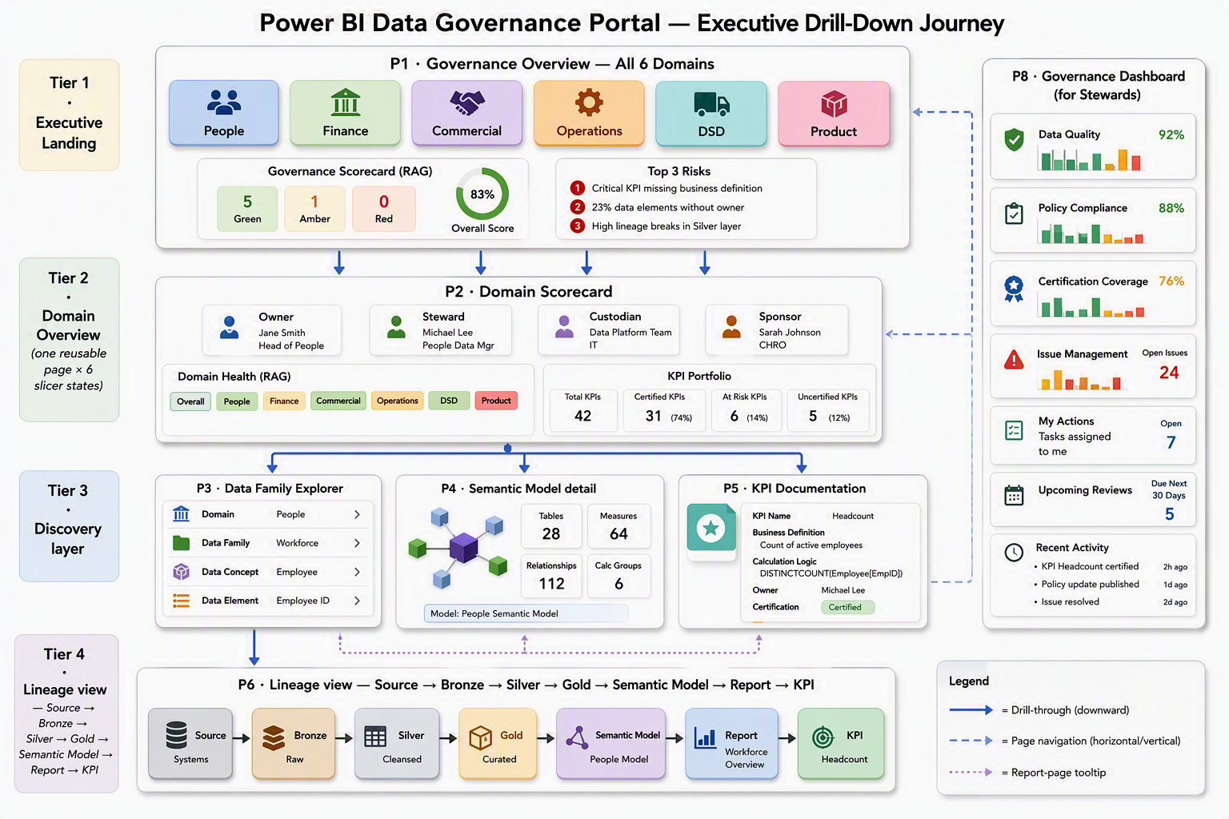 Figure 2: Executive drill-down journey — from a six-domain overview through a single reusable Domain Scorecard to Data Family, Semantic Model, KPI documentation and end-to-end lineage. P8 Governance Dashboard is available as a side-panel for stewards.

4.3 Navigation model — when to use which interaction
Choosing the right interaction pattern is what keeps the executive experience low-clutter while allowing stewards to progressively discover detail. The rules below are grounded in the Microsoft Learn drillthrough and field-parameter guidance.
Interaction | When to use | Example on the Portal
Drill-through (right-click → Drill through) | User is on an overview visual and wants a detail page filtered to the item they clicked. Always drills to a different page with the item as an implicit filter, and offers a Back button. | P1 six-domain matrix → P2 filtered to that domain; P2 semantic-model table → DT_Model; P5 KPI card → DT_KPI
Page navigation (button) | User wants to move between peer pages without a filter context change. | Header nav bar: Overview / Domains / Assets / DQ / Certifications / Issues / Lineage / Audit — always visible on every page
Report-page tooltip | Hover-over hint that reveals a compact detail card without leaving the page. | Hover a KPI on P2 → TT_KPI (4 metrics + certification badge); hover a model on P7 → TT_Model
Bookmarks | Pre-set filter states executives can revisit ("Ownership gaps only", "Failed refreshes only", "Uncertified but Consumed"). | Selection pane on P1 and P8; bookmarks already listed in build checklist Phase 5.4
Field parameters | Let the user swap which measure is shown on an axis (e.g. Ownership Score / DQ Composite / Refresh Success Rate). Used sparingly — executives usually want a single fixed metric. | P1 domain leaderboard bar chart — one Field Parameter Health Metric toggles between five pillars
Cross-highlighting | Default Power BI behaviour that keeps interactivity intra-page. Turn off on cards on P1 to keep the RAG stable when a user clicks a domain. | Edit Interactions → Filter mode for RAG cards
Buttons + Selection pane | Simulate a "domain click" that both navigates to P2 and pre-filters — bookmark + button combo. | P1 six-domain tiles are actually buttons that fire a bookmark navigating to P2 with the domain slicer set

4.4 Explicit drill path (executive test)
"I am the CEO. I open the Governance Portal. I want to answer: is the Finance headline revenue KPI trustworthy, and if not, where is the break?"
- P1 Governance Overview — sees six domain cards. Finance shows 🟡 (Domain Health Score = 78). Clicks Finance tile → P2.
- P2 Domain Scorecard (Finance) — sees Owner/Steward/Custodian named; five-pillar RAG strip; "Group Revenue" KPI card 🟡 with an amber tooltip badge. Hovers over the KPI → TT_KPI hover card shows Formula + Owner + Threshold. Right-clicks → DT_KPI.
- DT_KPI (Group Revenue) — sees full documentation (§9 template). Sees "Business Interpretation" note flags a known GL reconciliation issue. Clicks View lineage → P6.
- P6 Lineage View — sees the horizontal chain: Sirius Finance → finance_bronze.revenue_line → finance_silver.revenue_line → finance_gold.fact_revenue → finance_gold_csm (CSM-Gold) → EQ-UK DAILY MTD MARGIN INCOME REPORT → Group Revenue KPI. Node finance_silver.revenue_line is 🔴 red. Clicks it → drill-through to DT_Family for the Revenue Family.
- DT_Family (Revenue) — sees the failing DQ rule ("Accuracy — GL reconciliation, tolerance ±0.1%, current 0.4% variance"), the responsible Steward with a Teams deep-link, and the open P1 issue with SLA aging.
- Executive reaches the root cause in five clicks — that is the outcome the Word proposal demands: "every navigational action a leader would take must be one or two clicks from the KPI card."4

5. Executive-grade visual blueprint — page by page
Each page follows a 12-column grid at 1280 × 720 (executive laptop) with a 16 × 9 aspect ratio to render cleanly on Teams share and mobile. Header strip = 80 px; nav bar = 40 px; page canvas = 600 px. Colour palette follows the EQ brand: #1F3864 primary, #2E5496 secondary, #70AD47 green, #FFC000 amber, #C00000 red, neutrals #F2F2F2 / #FFFFFF.

5.1 P1 — Governance Overview (executive landing)
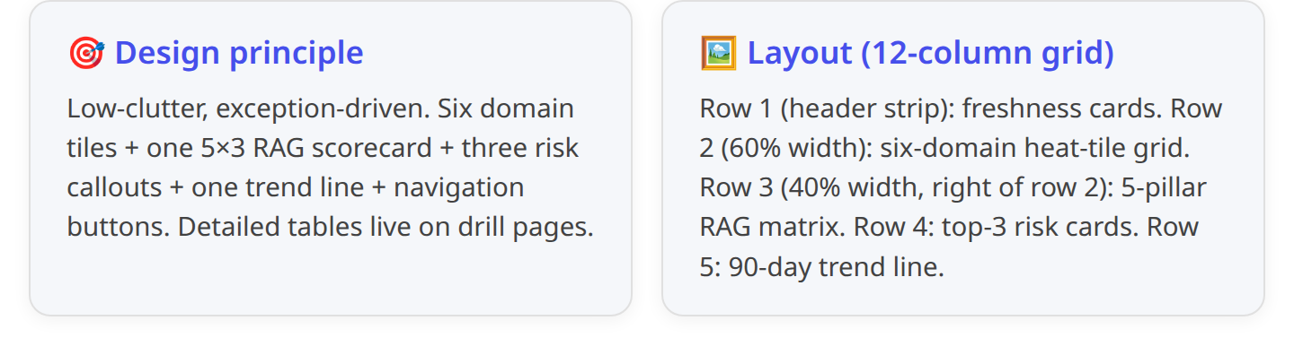
Zone | Visual | Fields / measures | Interaction | Conditional format
Header strip | 4× Card | [Freshness Health], [Last Successful Refresh], [Semantic Models], [KPI Count] | Static | Freshness text: Green/Amber/Red
Six-domain heat tiles | Custom button grid (2 rows × 3 cols) | dim_domain[DomainName] + [Domain Health Score] + [Domain RAG] | Button → bookmark that (a) navigates to P2 and (b) sets Domain slicer. Also acts as drill-through target for P2. | Background colour by [Domain RAG]; overlay score in white 32-pt
5-pillar RAG scorecard | Matrix (5 rows × 3 cols) | Rows: Ownership / Mapping / Certification / Documentation / Reliability; Cols: Score, RAG, Trend (spark-line via Icons > Web URL) | Cross-highlight OFF | Score background: green ≥90, amber 60-90, red <60
Top-3 risks callouts | 3× Card with expression | "Uncertified but Consumed: " & [Uncertified but Consumed], "Stale Models: " & [Stale Models Count], "Ownership Gaps: " & [Ownership Gap Count] | Click → navigate to P7 / P8 / P2 respectively with the relevant filter | Font red if value > 0
90-day trend line | Line | X dim_date[Month]; Y [Refresh Success Rate] (rolling 90-day); reference line at 95% | Cross-filter OFF | Line = #2E5496; reference = dashed grey
Nav bar (below header) | Buttons | Page navigation to P2, P3, P5, P6, P7, P8, P9 | Standard navigation | Selected state = accent bar
Executive test: From P1, a leader reaches (a) any Domain in 1 click, (b) the CSM-Gold risk view (P7) in 1 click, (c) the action queue (P8) in 1 click.

5.2 P2 — Domain Scorecard (one page × six slicer states)
The Word proposal insists every domain page shows: Owner card, Area Owner, Stewards, Custodians, Business Sponsor, Council rep, Domain Purpose, Data Families ribbon, Critical KPIs strip with certification badges, DQ Status, Stewardship Status.1 The design below delivers all of them from one reusable page filtered by a tile slicer at the top.
Zone | Visual | Fields / measures | Interaction | Conditional format
Domain slicer (row 1) | Tile slicer (single-select) | dim_domain[DomainName] (six tiles) | Single-select | Selected tile = #1F3864
Header block (row 2, 60%) | 5-card grid | Domain Owner (from bridge_role_assignment filtered to RoleType=DomainOwner), Data Area Owners (concatenated), Stewards, Custodians, Business Sponsor | Mailto/Teams deep-link via URL column on dim_person | Missing = red pill "TBD"
Council & purpose (row 2, 40%) | 2-card | Council rep, Domain purpose (from dim_domain[DomainDescription]) | Static | —
RAG health strip (row 3) | 5-card | [Domain Ownership Score], [Domain KPI Mapping Score], [Domain Certification Score], [Domain Documentation Score], [Domain Reliability Score] | Click → filter downstream visuals to that pillar | Background by RAG
Data Families ribbon (row 4, 100%) | Button grid | dim_data_family[FamilyName] filtered to selected domain (typically 5-8 families) | Click → navigate to P3 with FamilyCode filter | Each button = tile with icon; hover = tooltip TT_Family
KPI portfolio matrix (row 5, 60%) | Matrix | Rows: dim_kpi[KPIName]; Values: Value (via [Home KPI Value] measure that resolves the KPI's DAX formula), [Threshold], [Owner], Certification badge | Right-click → DT_KPI | Traffic-light on Value vs threshold
Semantic models in domain (row 5, 40%) | Table | dim_semantic_model[DatasetName], [Endorsement], [Certification], [Refresh Success Rate], [Reports Consuming per Model], [Last Refresh (per Model)] | Right-click → DT_Model | Red row if Uncertified & Consumed
DQ Composite (row 6, 33%) | Card + spark | [DQ Composite Score] (large), 90-day spark below | Hover → TT for pillar breakdown | RAG on score
Open Issues (row 6, 33%) | Card | [Open Issues P0-P1] + count of over-SLA | Click → navigate to P8 filtered by domain | Red if > 0
Actions for this domain (row 6, 33%) | Table | Top 5 rows from Governance_Actions calc table filtered to domain | Click → navigate to P8 | Priority colour-coded

5.3 P3 — Data Family Explorer
Persona: Domain Owner, Steward. Answers: "What Data Families sit under my domain? Which Concepts and Elements feed them? Which are CDEs?"
Zone | Visual | Fields / measures
Slicers | dim_domain[DomainName], dim_data_family[FamilyName] | Tile slicers
Decomposition tree | Decomposition tree — Analyse: [Data Elements] (COUNTROWS dim_data_element); Explain by: DomainName → FamilyName → ConceptName → ElementName | Auto-drill on click
Family header block | Card × 5 | Family name, Data Area Owner, Steward, Primary source system, #concepts
Concepts table | Table | dim_data_concept[ConceptName], ApprovedDefinition, IsCDE, Sensitivity, #Elements, Glossary link
Elements table | Table | dim_data_element[TableName + '.' + ColumnName], DataType, PII, Nullable, RetentionYears
CDE spotlight | Ranked bar | dim_cde[CDECode], MaterialityBand — highlights the "vital few" the Framework prioritises1
Nav | Buttons | "View lineage" → P6, "View KPIs" → P5, "View model" → P4 — all pre-filtered to the selected FamilyCode

5.4 P4 — Semantic Model detail
Directly implements Word §11.4.1
Zone | Visual | Fields / measures
Slicer | dim_semantic_model[DatasetName] (single-select) | Tile
Header cards | Owner (domain), Endorsement, Certification, Refresh Success Rate, Last Refresh, Reports Consuming | 6 cards
Measures list | Table | dim_measure[MeasureName], Expression (word-wrap), Description, HomeTable
Definitions & business rules | Table | dim_data_concept[ConceptName], ApprovedDefinition, ApprovedByPersonKey, ApprovedOn — via bridge_family_asset
Lineage inset | Sankey / decomposition tree | Source → Bronze → Silver → Gold → this model — snippet of P6
Usage statistics | Line + column | 90-day [Model Views 30d] + [Distinct Users 30d]
Certification workflow | Card + timeline | Current status + Expiry date + Days-since certified

5.5 P5 — KPI Documentation
Executes the KPI documentation template exactly per Word §9.1.1
Zone | Visual | Fields / measures
Filters | dim_domain[DomainName], dim_kpi[KPIName] | Two slicers
KPI Card | Card | Big number = [KPI Value], RAG dot vs threshold
Documentation block | Multi-card | Business purpose, Business owner (mailto), Steward (mailto), Calculation formula, DAX formula, Source datasets, Refresh frequency, Thresholds, Targets, Certification status + Expiry, Business interpretation, Known exceptions
Trend | Line | 24-month trend of KPI value with target line and RAG bands
Underlying models | Table | Models feeding this KPI via bridge_kpi_measure: DatasetName, Certification, RefreshSuccess%, LastRefresh
Actions | Table | Open issues filtered to this KPI

5.6 P6 — Lineage View
See §6 below for the full lineage design.

5.7 P7 — Certified Data Products
Directly executes the redesign draft P4 spec — kept because it is executive-consumable and answers "which models are consumed but uncertified".4
Zone | Visual | Fields / measures
Header cards | Card × 5 | [Semantic Models], [Certified Models], [% Certified], [Promoted Models], [Unendorsed Models]
Endorsement grid | Matrix | Rows: dim_semantic_model[DatasetName] × Cols: [Endorsement] / [Certification]; Values: [Reports Consuming per Model]
Risk quadrant | Scatter | X: [Reports Consuming per Model], Y: [Refresh Success Rate], Legend: [Certification], Size: [Model Views 30d] — top-right red = Consumed & Broken & Uncertified
Governance risk list | Table | [Uncertified but Consumed]=1; DatasetName, DomainName, Reports Consuming, Certification, Endorsement, Certification Expiry
Certification funnel | Ribbon / stacked bar | Domain × Endorsement counts

5.8 P8 — Governance Dashboard (Steward cockpit)
Answers Word §11.6.1
Zone | Visual | Fields / measures
Header cards | Card × 4 | [Open Issues P0-P1], [Remediation SLA Adherence %], [Ownership Gap Count], [Stale Models Count]
Issues table | Table | dim_kpi/family/model, Severity, Status, DaysOpen, DueDate, AssignedTo (mailto)
DQ heat map | Matrix | Domain × RuleType, values [DQ Pass Rate]
DQ 12-month trend | Line | [DQ Composite Score] by month, by domain
Remediation aging | Bar | Issues grouped by days-open bucket
Ownership gap list | Table | Domains with missing role assignments (from bridge_role_assignment gaps)

5.9 P9 — Metadata Catalogue (technical reference)
Kept as-is from the existing redesign — decomposition tree of Domain → Model → Table → Column, plus three coverage bars.4

5.10 Hidden drill-through / tooltip pages
Hidden page | Drill-through field | Contents
DT_KPI | dim_kpi[KpiKey] | Full KPI documentation card, DAX, lineage inset, open issues, Certification workflow
DT_Model | dim_semantic_model[DatasetName] | Owner, Certification, Endorsement, tables/columns/measures counts, refresh rate, last refresh, consuming reports, DQ proxy
DT_Family | dim_data_family[FamilyCode] | Concepts, Elements, CDEs, DQ pass rate, open issues, assigned Steward, assigned Custodian
TT_KPI | tooltip page (400×300) | Compact — KPI name, Owner, Value, Threshold, Certification badge
TT_Model | tooltip page (400×300) | Compact — DatasetName, Certification, Refresh %, Reports Consuming

6. Lineage discovery — the Data Family drill
The Framework requires end-to-end lineage: source → bronze → silver → gold → semantic model → report → KPI with drill-back from any node to its Data Family and Steward.1

6.1 Node/edge design
Node types (7): SourceSystem, BronzeTable, SilverTable, GoldTable, SemanticModel, Report, KPI. Every node carries DomainCode and FamilyCode — this is what lets the executive filter the graph to a single Data Family, which is exactly the drill target requested.
Edge types (3): Ingest (SourceSystem→Bronze), Transform (Bronze→Silver, Silver→Gold), Consume (Gold→SemanticModel, SemanticModel→Report, Report→KPI).

6.2 Rendering options — recommendation and fallback
Native Power BI does not have a first-class graph visual, so lineage must be built via a chosen strategy:
Option | Suitability | Recommendation
Decomposition tree (native) | Excellent for hierarchical descent; already used on P3. Cannot show many-to-many easily. | ✅ Use on P3 for Data Family hierarchy
Matrix (hierarchical rows) (native) | Reliable, printable, screen-reader compatible. Rows: FromLayer → ToLayer. | ✅ Use on P6 as the always-visible fallback table
Sankey by Microsoft (certified custom visual) | Sankey is the natural fit for source→sink flow. Certified, GA. Executive-friendly. | ✅ Primary visual on P6
Network Navigator / Force-Directed (community, non-certified) | Compelling for full graph but not certified — Sensitivity label + workspace app may block. | ❌ Avoid in production (governance risk)
PowerBI PyGraph / Deneb | Deneb (certified) can render Vega-Lite node-link with full control. Requires Vega-Lite spec. | 🟡 Deneb + node-link Vega spec as a Phase-2 upgrade if Sankey is not expressive enough
Purview / OneLake Catalog embed | Fabric OneLake Catalog surfaces lineage natively; deep-link from Power BI. | ✅ Deep-link "Open in Purview" button on every P6 node for authoritative view
Recommended P6 design:
Zone | Visual | Fields / measures | Interaction
Slicers row | dim_domain[DomainName], dim_data_family[FamilyName] | Tile slicers — start filtered to Family from drill-through | —
Header cards | [Nodes in graph], [Edges], [Layers involved], [Broken edges] | 4 cards | Static
Sankey (primary) | Sankey by Microsoft | Source: dim_lineage_node[NodeType + ':' + DisplayName], Destination: same, Weight: COUNTROWS(bridge_lineage_edge); Legend colour: NodeType | Click node → drill-through to appropriate DT page
Node/edge table (fallback) | Table | FromLayer, FromNode, Edge, ToLayer, ToNode, Confidence, DiscoveredOn — filtered to selected Family | —
Path summary | Multi-row card | Compressed single sentence: Sirius → f_bronze.revenue_line → f_silver.revenue_line → f_gold.fact_revenue → finance_gold_csm → EQ-UK DAILY MTD MARGIN INCOME REPORT → Group Revenue | Static — great for screenshots
DQ overlay on graph | Overlay cards | For each node, [DQ Pass Rate] (RAG) if node is a Silver/Gold table | —
Actions | Buttons | "Open Purview", "Email Steward", "Open source runbook" | External links

6.3 Feeding the graph from the notebook
The Fabric Lineage API + Purview supply the graph. Notebook cell L1:
1 # --- Cell L1 : lineage extraction ------------------------------------
2 lineage_nodes, lineage_edges = [], []
3
4 # 1. Semantic-model → Report edges (already available)
5 for _, r in df_report_dataset.iterrows():
6 _add_edge(f"model:{r.DatasetId}", f"report:{r.ReportId}", "Consume")
7 _add_node(f"model:{r.DatasetId}", "SemanticModel", r.DatasetName, r.WorkspaceName)
8 _add_node(f"report:{r.ReportId}", "Report", r.ReportName, r.WorkspaceName)
9
10 # 2. Gold-table → Semantic-model edges (via dim_relationship source refs
11 # and Fabric Lineage API)
12 lineage_api = fabric_client.get(f"/v1/workspaces/{WORKSPACE_ID}/lineages")
13 for item in lineage_api.json()["value"]:
14 if item["itemType"] == "SemanticModel":
15 for upstream in item.get("upstreams", []):
16 if upstream["itemType"] == "Lakehouse":
17 _add_edge(f"gold:{upstream['itemId']}", f"model:{item['itemId']}", "Consume")
18 _add_node(f"gold:{upstream['itemId']}", "GoldTable",
19 upstream["displayName"], upstream["workspaceName"])
20
21 # 3. Bronze/Silver/Gold chain — from Purview
22 purview_lineage = purview_client.get_lineage(GUID) # per-Gold-table call
23 for edge in purview_lineage:
24 _add_edge(edge["from"], edge["to"], "Transform")
25
26 # 4. Report → KPI edges — from bridge_kpi_measure joined to bridge_report_dataset
27 # (in-notebook Spark SQL)
28
29 spark.sql("""
30 INSERT OVERWRITE dim_lineage_node ...
31 """)
32 spark.sql("""
33 INSERT OVERWRITE bridge_lineage_edge ...
34 """)
Fall-back: if the Fabric Lineage API is unavailable in the workspace, the Purview /atlas/v2/lineage/{guid} call supplies the same graph (Purview is authoritative). If neither is populated, the bridge_report_dataset remains the seed and Domain Owner workshops fill the intermediate transformation edges.

7. Production-readiness checklist
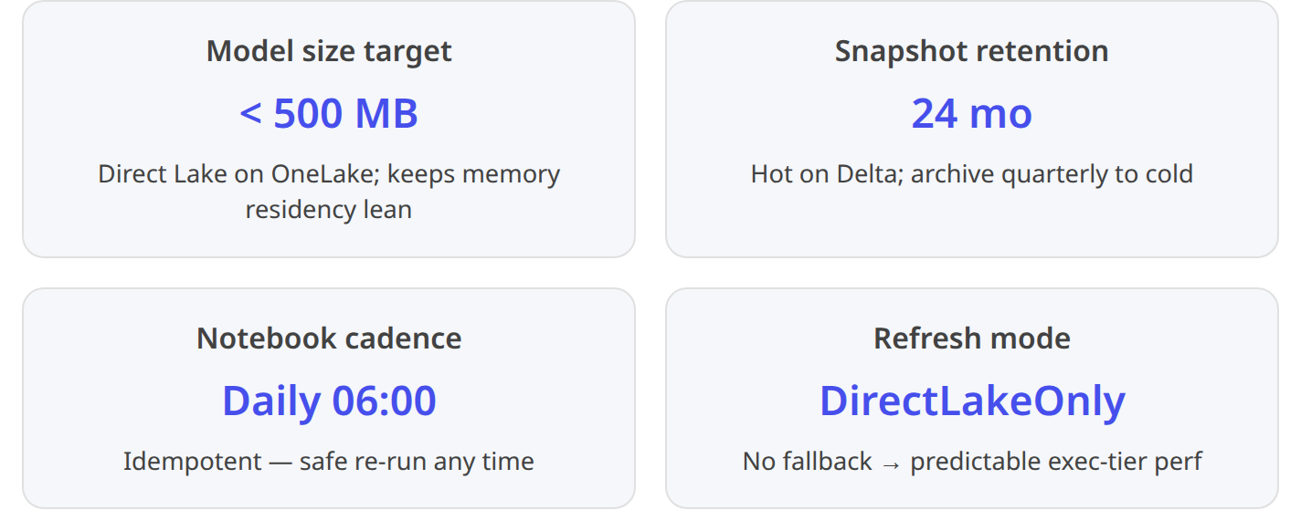 6 4

7.1 Direct Lake / storage-mode decisions
Concern | Decision | Rationale
Storage mode | Direct Lake on OneLake, DirectLakeOnly (no fallback) | Predictable performance; OneLake security for ownership metadata; no refresh schedule to maintain6
Composite model | No — pure Direct Lake | Governance metadata is entirely in one lakehouse; no external DirectQuery sources
Model refresh | None — semantic model reads Delta directly | Notebook (not model) is the schedule4
Delta maintenance | OPTIMIZE + VACUUM weekly on hot tables (fact_refresh_history, fact_report_consumption) | Avoids small-file sprawl that Direct Lake column re-encoding suffers from
Partitioning | Fact tables partitioned by date_trunc('month', <ts>); snapshot facts by SnapshotDate | Reduces columns loaded into memory per query
Storage estimate | ≈ 300 MB after 12 months of daily snapshots (metadata volumes small) | Comfortably within Direct Lake caps

7.2 Security — RLS / OLS / CLS / sensitivity
Concern | Decision
Row-level security (RLS) | Optional: role Domain_Owner_<X> applied on dim_domain[DomainCode] filters entire model to that domain. Do not enable by default — executives need cross-domain view. Enable only for domain-owner personal apps.4
Column-level security (CLS) | dim_person[EmailAddress], TeamsDeepLink restricted to Governance_Portal_Stewards role — protects contact info from anonymous ELT viewers
Object-level security (OLS) | Hide dim_person, bridge_role_assignment from a Governance_Portal_Executive_View role that only sees domain-level roll-ups — cleaner exec field list
Sensitivity label | Confidential — EQ Internal on the report + semantic model; ownership metadata is Framework-defined tier 1 for governance1
Workspace roles | Workspace data_governance_lh: Admin = Data Governance Lead + Data Architecture Manager; Member = Data Governance Analyst; Contributor = Domain Stewards; Viewer = auto-granted through Fabric domain role for ELT via published App
App audiences | Two audiences on the Power BI App: Executives (P1, P2, P6, P7 only) and Stewards (all pages incl. P8, P9)

7.3 Performance
Concern | Mitigation
Ambiguous filter paths across bridges | All non-bridge relationships single direction; use TREATAS for domain-to-model filtering when needed (design already followed in current build)4
Cardinality of dim_column (potentially 10k+ rows across nine models) | Include only the columns needed for reporting; hide IsKey, IsHidden, GUID columns; use aggregations at Domain × Model grain for the % Columns Described measure
DAX push-down | Keep measures leaf-level; avoid SUMX(FILTER(...)) where a CALCULATE(sum, filter) is equivalent per Endorsement Handbook DAX best practice1
Query folding on Direct Lake | Not applicable — Direct Lake reads Delta directly. But do ensure Silver→Gold transforms fold in the upstream Fabric SQL scripts
Report load | Optimise P1 to ≤ 8 visuals (already 8 in the design); use tooltip pages instead of extra visuals

7.4 Deployment pipeline — Dev / Test / Prod
Environment | Workspace | Notes
Dev | data_governance_lh_dev | Semantic model + report — notebook parameterised via Fabric Variable Library (GOV_LAKEHOUSE, WORKSPACE_ID, KPI_CONTAINER_NAME, OVERRIDE_MODELS_ONLY). Introduced in Sept 2025 Fabric release.5
Test | data_governance_lh_test | Deployment rule swaps lakehouse to DataGovernance_metadata_LH_test; sample data; UAT sign-off by Data Governance Lead
Prod | data_governance_lh_prod | Certified endorsement applied; App audiences configured; sensitivity label locked to Confidential
CI/CD | Fabric Git integration + Deployment Pipeline v2 (redesigned GA 2025)5 | Semantic model in TMDL; report in PBIR; Delta table DDLs versioned in notebook

7.5 Endorsement / certification (per EQ Handbook v1.0)
To be Certified, the Governance Portal semantic model must satisfy every criterion in the Endorsement Handbook v1.0:
- ✔ Star schema with conformed dimensions and business-friendly naming
- ✔ dim_date marked as date table with hierarchy
- ✔ Every measure has Description, Format String, Display Folder, Home Table
- ✔ DAX best practice — variables, no unnecessary SUMX(FILTER())
- ✔ Parameterised connection (Fabric Variable Library) for Dev/Test/Prod
- ✔ Remove Unused Tables and Columns; hide keys from report view (checklist Phase 2 already includes this)4
- ✔ ERD + business logic documented (this deliverable satisfies)
- ✔ Cross-functional review — Data Governance Lead, Head of Data Culture (Thacker, Mark), Data Architecture Manager
- ✔ 12-month recertification schedule via CertificationExpiryDate on dim_semantic_model — the model applies to itself1

7.6 Monitoring & alerting
Signal | Tool | Recipient
Notebook run failure | Fabric pipeline notification + audit_run_log red row surfaced on P1 header | Data Governance Analyst + on-call Data Engineer
MappingCoverage% < 90 | audit_run_log warning → Data Activator alert on [MappingCoverage%] measure | Data Governance Lead (Teams + email)
P0/P1 issue opened | Data Activator on [Open Issues P0-P1] | Domain Steward + Data Governance Lead
Certification expiring 90d | Data Activator on [Certification Expiring 90d] | Model owner + Data Office
Refresh failure > 2 consecutive | Data Activator on [Failed Refreshes 30d] per DatasetId | Data Custodian

7.7 Accessibility & mobile
- All colour contrasts ≥ WCAG AA (4.5:1). RAG colours paired with icon (🟢/🟡/🔴) so status is not colour-only.
- Card font size ≥ 14 pt; table row height ≥ 32 px for touch.
- Mobile layout defined for P1 only — mobile executives see the six domain tiles as a 3×2 grid + RAG scorecard; drill remains available via long-press.
- Alt-text on every visual (dim_domain[DomainName] & " current health: " & [Domain RAG]).

7.8 Acceptance criteria (UAT sign-off)
Before promoting the model to Certified, all pass:
- ✅ P1 loads in < 3 s on a cold cache (Direct Lake on OneLake baseline).
- ✅ Every measure returns a value (not blank) when no filter is applied — denominator rule test.
- ✅ Every discovered semantic model appears in the DatasetName slicer (count matches pdf_scope).4
- ✅ Models per Container matches COUNT(bridge_report_dataset WHERE KpiContainerName='KPI Dashboard').
- ✅ No orphan KPIs — every dim_kpi row resolves to a domain via bridge_domain_kpi.4
- ✅ [Refresh Success Rate] reconciles against a manual SQL query of fact_refresh_history.
- ✅ [MappingCoverage%] ≥ 90 — no silent DSD defaults.
- ✅ Executive can reach any DQ issue root cause in ≤ 5 clicks from P1 (drill test).
- ✅ Six-domain heat tiles on P1 are keyboard-navigable.
- ✅ Report reviewed by Data Office; sensitivity label applied; App audiences configured.4

8. Prioritised remediation plan — from current state to production

8.1 What to keep, refactor, add
Component | Action | Effort | Priority
Multi-fallback discovery (Cell 6b) | Keep as-is | — | —
bridge_report_dataset | Keep — extend DiscoverySource values with purview_lineage | XS | P1
dim_semantic_model / table / column / measure / relationship / hierarchy | Keep — add surrogate keys, MappedElementCode on dim_column | S | P1
dim_domain — free-text roles | Refactor into dim_person + bridge_role_assignment | M | P1
dim_kpi — name only | Extend with 14 documentation columns | S | P1
Cell 14 default DSD mapping | Refactor into explicit bridge_dataset_domain_map with MappingSource and validation gate | S | P1
dim_date | Add — marked as date table | XS | P1
bridge_domain_kpi | Keep — add MappingSource column | XS | P1
fact_ownership_snapshot / certification_snapshot / documentation_snapshot | New — snapshot pattern | M | P2
dim_data_family / concept / element / cde | New — Framework hierarchy | M | P2
bridge_family_asset / kpi_measure | New | S | P2
dim_lineage_node / bridge_lineage_edge | New — Fabric Lineage API + Purview integration | L | P3
dim_dq_rule / fact_dq_result / fact_issue | New — Soda + Great Expectations landing | L | P3
fact_report_consumption enrichment | Extend with FUAM composite model | M | P2
audit_run_log | Extend with MappingCoverage, RowsExtracted, WarningsJSON | XS | P1

8.2 Six-sprint delivery sequence
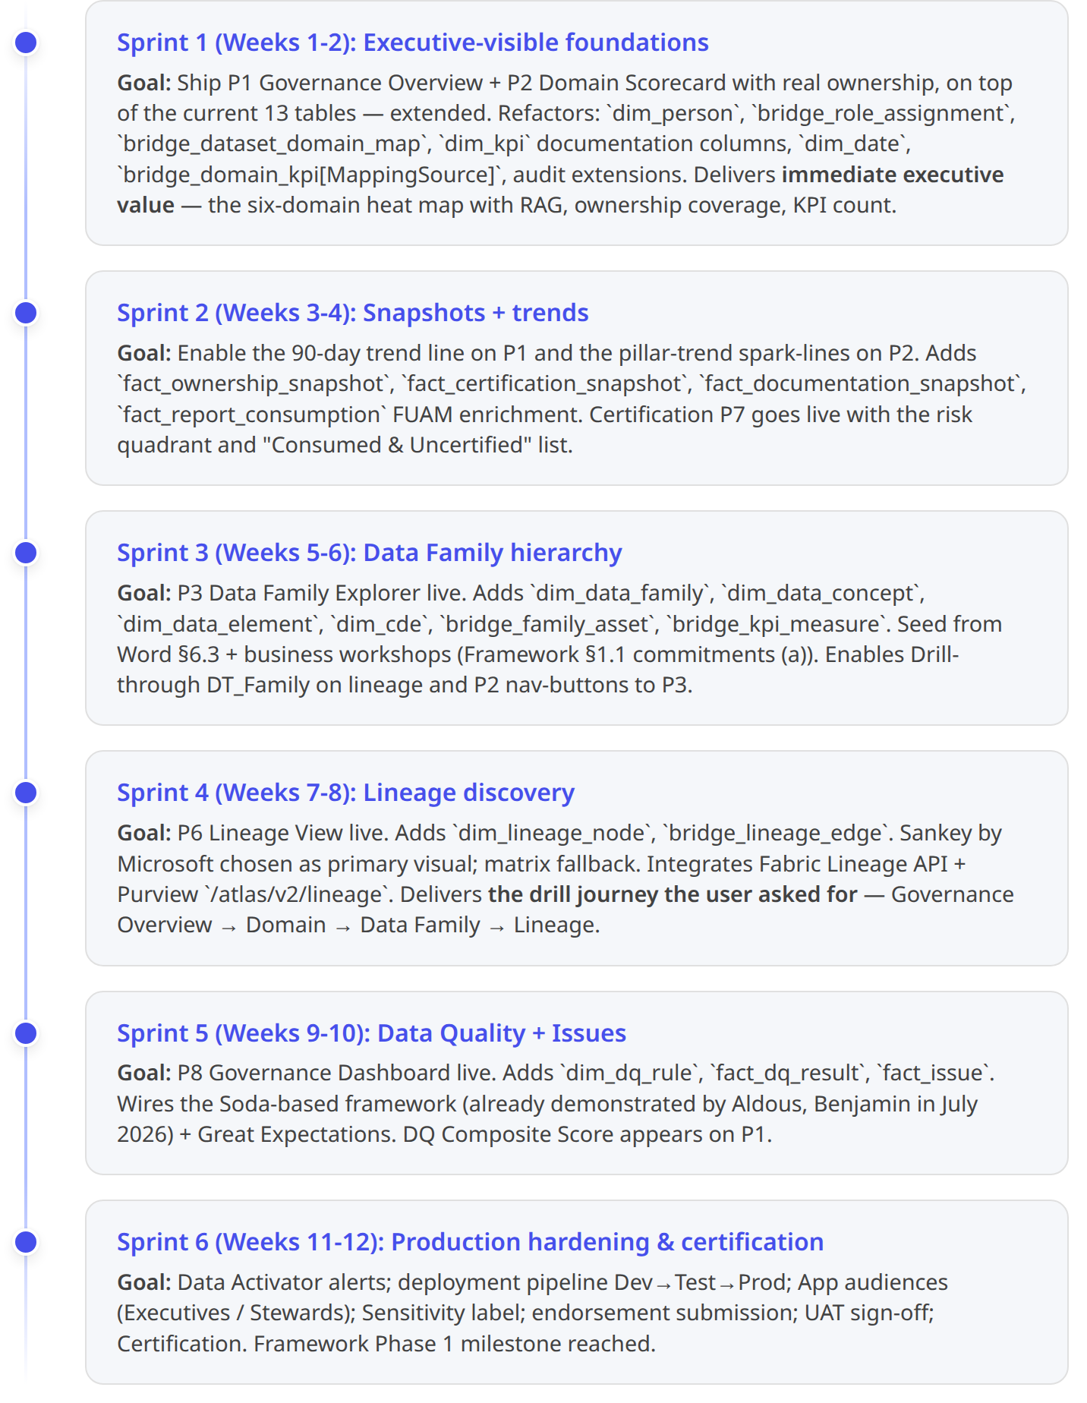

8.3 Notebook cell change log (production version)
Cell | Change type | Purpose
Cell 3 (config) | Extended | Add Fabric Variable Library binding; MIN_MAPPING_COVERAGE = 0.90 gate
Cell 5 (DDL) | Extended | 14 new create_delta_if_absent blocks for new tables
Cell 6a (workspace GUID) | Keep | —
Cell 6b (multi-fallback discovery) | Keep | —
Cell 7 (per-dataset loop) | Keep + Extended 7F for KPI doc columns | —
New Cell 8a | Freshness derived columns per DatasetId | —
New Cell 8b | FUAM composite-model join for fact_report_consumption | —
New Cell B0-B6 | Seed dim_person, dim_date, dim_domain, dim_data_family, dim_data_concept, dim_data_element, dim_cde, bridge_role_assignment | —
Cell 14 (domain mapping) | Rewritten | Consumes bridge_dataset_domain_map; writes MappingCoverage%
New Cell L1 | Lineage extraction — Fabric Lineage API + Purview | —
New Cell DQ1, DQ2 | DQ landing tables (Soda / GE runner output) | —
New Cell ISS1 | Issue queue | —
New Cell SN1 | Snapshot facts | —
New Cell PV1 | Purview asset push | —
Cell 19 (validation) | Extended | MappingCoverage% gate; SnapshotWritten audit; warnings JSON

9. Summary — how this design delivers what the user asked for
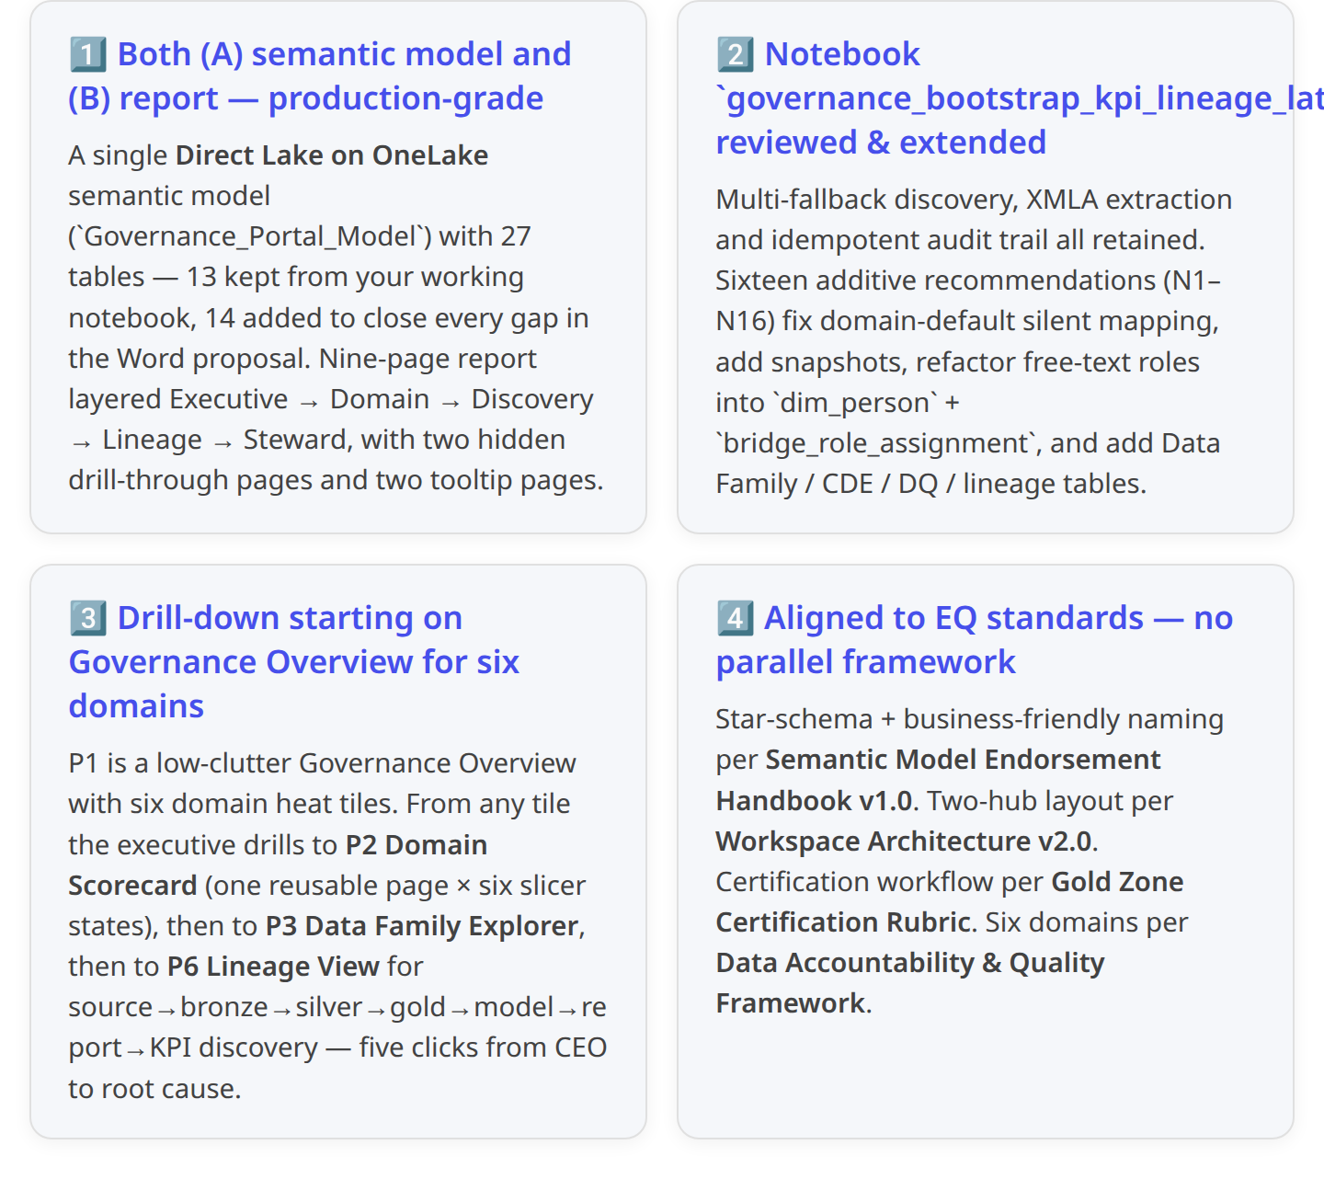 3 2 1
Bottom line: the current 13-table notebook is a great scaffold — the 27-table target adds Data Family hierarchy, ownership as a first-class dim, snapshot history, DQ, issues and cross-layer lineage, without rebuilding what already works. The 6-sprint plan delivers the Governance Overview + Domain Scorecard in the first sprint so ELT sees value immediately, then progressively unlocks lineage and DQ. When ready to start Sprint 1, I can generate the exact TMDL for the semantic model, the updated notebook cells B0-B6 and the P1/P2 PBIR skeleton so you can drop them straight into the data_governance_lh workspace.

