MSc Data Science Project

7PAM2002-0901-2024

Department of Physics, Astronomy and Mathematics

**Data Science FINAL PROJECT REPORT**

**Project Title:**

FAKE NEWS DETECTION

**Student Name and SRN:**

KAMALI BAKTHAVATCHALAM

22081557

Supervisor: Stephen Kane

Date Submitted: 05:01:2025

Word Count: 3760

GitHub address: <https://github.com/kamalibakthavatchalam/pdm-plan>DECLARATION STATEMENT

This report is submitted in partial fulfilment of the requirement for the degree of Master of Science in Data Science at the University of Hertfordshire.

I have read the guidance to students on academic integrity, misconduct and plagiarism information at [Assessment Offences and Academic Misconduct](https://www.herts.ac.uk/__data/assets/pdf_file/0007/237625/AS14-Apx3-Academic-Misconduct-v17.0.pdf) and understand the University process of dealing with suspected cases of academic misconduct and the possible penalties, which could include failing the project module or course.

I certify that the work submitted is my own and that any material derived or quoted from published or unpublished work of other persons has been duly acknowledged. (Ref. UPR AS/C/6.1, section 7 and UPR AS/C/5, section 3.6).

I have not used chatGPT, or any other generative AI tool, to write the reportor code (other than where declared or referenced).

I did not use human participants or undertake a survey in my MSc Project.

I hereby give permission for the report to be made available on module websites provided the source is acknowledged.

Student SRN number: 22081557

Student Name printed: KAMALI BAKTHAVATCHALAM

Student signature:

UNIVERSITY OF HERTFORDSHIRE

SCHOOL OF PHYSICS, ENGINEERING AND COMPUTER SCIENCE

**ABSTRACT:**

**Fake News Detection Using Machine Learning**

The proliferation of misinformation in today's digital landscape necessitates robust mechanisms for fake news detection. This project aims to classify news articles as either fake or real using machine learning techniques. The study employs two publicly available datasets, **Fake.csv** and **True.csv**, which were merged and pre-processed to create a labelled dataset. Text pre-processing included cleaning the text, removing special characters, converting to lowercase, and vectorizing using the **TF-IDF** approach with a feature set of 5000 keywords.

Fig .1 Machine Learning Framework for News Classification

Three classification algorithms were implemented and evaluated: **Logistic Regression**, **Naive Bayes**, and **K-Nearest Neighbours (KNN)**. The models were trained on an 80:20 split of the dataset, and their performance was evaluated using metrics such as accuracy, precision, recall, and F1 score. Logistic Regression emerged as the best-performing model with an **F1 score of 0.92**, outperforming the other classifiers. Hyperparameter optimization using Grid Search CV and Randomized Search CV further refined model performance.

Key insights into the most influential features in the TF-IDF representation highlighted specific terms frequently associated with fake or real news. Visualization techniques such as bar plots and confusion matrix provided an intuitive understanding of these findings. The results demonstrate the effectiveness of machine learning in addressing the critical challenge of misinformation detection and underscore its potential applications in real-world settings. Future work could involve leveraging deep learning models, such as transformers, to enhance classification accuracy further.

**Table of Contents**

|  |  |
| --- | --- |
| **Introduction** | 6 |
| **Literature Review** | 8 |
| 1.1 Understanding Fake News and Classification Problems | 8 |
| 1.2 Feature Extraction for Text-Based Classification | 8 |
| 1.3 Machine Learning Techniques for Fake News Detection | 9 |
| 1.4 Challenges in Fake News Detection | 9 |
| 1.5 Comparative Studies and Encoding Techniques | 10 |
| 1.6 Evaluation Metrics | 10 |
| 1.7 Research Gaps and Opportunities | 11 |
| **Methodology** | 12 |
| 2.1 Data Acquisition | 12 |
| 2.2 Data Pre-processing | 12 |
| 2.3 Feature Selection | 13 |
| 2.4 Model Selection and Implementation | 13 |
| **Datasets and Data Characteristics** | 16 |
| 3.1 Description of Datasets (Fake.csv and True.csv) | 16 |
| 3.2 Source and Data Collection Methodology | 17 |
| 3.3 Dataset Statistics | 17 |
| **Evaluation Metrics** | 18 |
| 4.1 Accuracy | 18 |
| 4.2 Precision | 19 |
| 4.3 Recall | 19 |
| 4.4 F1 Score | 20 |
| **Justification for F1 Score in Imbalanced Datasets** | 21 |
| **Conclusion** | 22 |
| 5.1 Summary of Finding | 22 |
| **Implementation of Project** | 24 |
| **Contributions to the Field of Fake News Detection** | 24 |
| **Future Work** | 25 |
| **Recommendations for Improving Detection** | 25 |
| **Suggestions for Enhancing Explainability in Predictions** | 26 |
| **References** | 27 |
| **Appendix** | 29 |

|  |  |
| --- | --- |
| Fig.1 Machine Learning Framework for News Classification | 3 |
| Fig.2 Classification of Information Disorder | 6 |
| Fig 3 Output for the Cleared Text | 13 |
| Fig.4 Logistic Regression Confusion Matrix – predicted label | 14 |
| Fig.5 KNN Confusion Matrix – predicted label | 15 |
| Fig.6 Naïve Bayes Confusion Matrix – predicted label | 15 |
| Fig.7 Output of dataset | 16 |
| Fig.8 Distribution of Real and Fake News | 18 |
| Fig.9 Evaluation Matrix | 20 |
| Fig.10 Fake News Keywords Frequency | 23 |
| Fig.11 Real News Keywords Frequency | 23 |

**List of Figures and Tables**

**INTRODUCTION**

The rapid growth of digital communication and social media platforms has revolutionized the way information is disseminated and consumed. However, this convenience has also created fertile ground for the spread of fake news—intentionally fabricated content designed to mislead readers for political, financial, or social gain. Fake news is not just a matter of misinformation; its far-reaching implications include influencing public opinion, manipulating elections, fueling social unrest, and undermining trust in credible institutions. The ease with which fake news spreads in today's hyper-connected world underscores the urgent need for robust detection mechanisms.

Fig.2 Classification of Information Disorder

Detecting fake news poses unique challenges. Unlike traditional spam detection or sentiment analysis, fake news classification requires analysing nuanced textual patterns, deceptive language, and context-specific features. Manual detection methods are not only time-intensive but also prone to human biases, making automated systems powered by machine learning an essential solution. Machine learning algorithms, combined with natural language processing (NLP) techniques, offer the potential to uncover linguistic and contextual cues indicative of fake news.

This project explores the application of machine learning to the critical problem of fake news detection. Using labelled datasets, **Fake.csv** and **True.csv**, the study builds and evaluates models to classify news articles as real or fake. The data undergoes rigorous pre-processing to clean text, extract relevant features, and prepare it for classification. Feature extraction employs the **TF-IDF (Term Frequency-Inverse Document Frequency)** method, which quantifies the importance of words in the context of the dataset.

Three classification algorithms—**Logistic Regression**, **Naive Bayes**, and **K-Nearest Neighbours (KNN)**—are implemented to evaluate their effectiveness in detecting fake news. Logistic Regression is particularly effective for handling sparse, high-dimensional data, while Naive Bayes leverages probabilistic models for classification. KNN, though computationally intensive, provides an alternative approach based on proximity in feature space. Model performance is assessed using key metrics, including accuracy, precision, recall, and F1 score, with Logistic Regression emerging as the best-performing algorithm.

The broader implications of this work are significant. Automated fake news detection systems can serve as tools for social media platforms and content aggregators to flag or suppress misleading content. Additionally, insights from this research can guide public awareness campaigns to educate users on recognizing fake news, thus fostering media literacy. As the project highlights the challenges and successes of machine learning in this domain, it lays the groundwork for future advancements, including the incorporation of deep learning techniques and real-time detection mechanisms.

**Background & Literature Review: Fake News Detection**

The increasing prevalence of fake news and its potential for harm has sparked significant interest in developing effective detection systems. This review examines prior research in fake news detection, with a focus on machine learning techniques, feature extraction methods, and evaluation metrics. Additionally, challenges unique to this domain, such as linguistic variability and data imbalance, are addressed.

**1.1 Understanding Fake News and the Classification Problem**

Fake news detection is a binary classification problem where the objective is to classify news articles as either fake or real. The complexity arises from the nuanced writing styles, deliberate manipulation of language, and the blending of partial truths within fake news content. Unlike typical binary classification problems, this domain requires handling:

* **High Variability in Text**: Articles differ in tone, length, and structure.
* **Imbalanced Datasets**: Real news often outnumbers fake news, complicating the training process.
* **Evolving Deceptive Strategies**: As detection methods improve, malicious actors adapt their strategies, making the problem dynamic.

**1.2 Feature Extraction for Text-Based Classification**

Effective feature extraction is critical in fake news detection as raw text must be converted into numerical representations for model training. The most widely used methods are:

* **TF-IDF (Term Frequency-Inverse Document Frequency)**: As discussed by **Ramos (2003)**, TF-IDF is effective in highlighting important terms in documents while suppressing common but uninformative words. For instance, words like "hoax" or "scam" in fake news articles and "official" or "verified" in real news articles tend to have high TF-IDF scores.
* **Bag-of-Words (Bow)**: A simpler method than TF-IDF but lacks the ability to weight terms based on document frequency, making it less effective in sparse, high-dimensional datasets.
* **Word Embeddings**: Techniques like Word2Vec and Glove capture semantic relationships between words but were not employed in this study due to computational constraints.

In the context of fake news detection, TF-IDF has been a reliable choice for generating a feature-rich dataset while balancing computational efficiency and effectiveness.

**1.3 Machine Learning Techniques for Fake News Detection**

Various machine learning algorithms have been applied to fake news detection, each with distinct advantages and limitations.

**a. Logistic Regression**

Logistic Regression has been extensively used for text classification due to its simplicity and effectiveness in handling sparse, high-dimensional data, as shown by **Rizwan et al. (2019)**. It is particularly well-suited for TF-IDF vectorized features, providing robust results with relatively low computational overhead.

**b. Naive Bayes**

Naive Bayes, with its probabilistic framework, is computationally efficient and performs well with small datasets. However, as **Ren et al. (2020)** highlight, it struggles with feature correlations, making it less suitable for nuanced tasks like fake news detection.

**c. K-Nearest Neighbours (KNN)**

KNN operates based on feature proximity but is computationally intensive for large datasets. **Zhang et al. (2018)** found KNN to be effective for small-scale problems but noted its limitations in scaling and processing time when applied to larger datasets.

**d. Advanced Models**

Although this project focuses on traditional machine learning techniques, modern approaches such as **Recurrent Neural Networks (RNNs)** and **Transformers (e.g., BERT)** have been shown to achieve higher accuracy. However, their resource-intensive nature often restricts their application in resource-constrained settings.

**1.4 Challenges in Fake News Detection**

**a. Imbalanced Data**

As noted by **Grandini et al. (2020)**, imbalanced datasets can skew accuracy metrics, emphasizing the importance of precision, recall, and F1 score for a more nuanced evaluation.

**b. High Dimensionality**

The use of TF-IDF with 5000 features creates a high-dimensional space, which, while informative, can pose computational challenges for some algorithms.

**c. Evolving Deceptive Patterns**

Fake news creators constantly adapt, introducing new phrases and strategies that challenge static detection systems. This requires models capable of frequent updates and retraining.

**1.5 Comparative Studies and Encoding Techniques**

**a. Encoding Categorical Data**

While fake news detection primarily deals with textual data, encoding methods play a vital role in general text classification tasks. Studies like **Potdar et al. (2017)** compare one-hot encoding, ordinal encoding, and binary encoding, noting the trade-offs in terms of computational cost and effectiveness. Though these techniques are more relevant to categorical data, the principles of managing sparsity and memory are transferable.

**b. Algorithm Performance**

The performance of traditional and advanced models has been compared across various studies. For instance:

* **Kai Shu et al. (2017):** Highlighted the effectiveness of Logistic Regression for TF-IDF data.
* **Benjamin D. Horne and Sibel Adali (2017):** Emphasized the need for combining textual and contextual features to improve accuracy.
* **Jacob Devlin et al. (2019)**: Demonstrated the transformative impact of BERT in understanding context, though computational demands remain a barrier.

**1.6 Evaluation Metrics**

Evaluation metrics are central to understanding model performance:

* **Accuracy**: While easy to interpret, it can be misleading for imbalanced datasets.
* **Precision and Recall**: More informative for understanding true and false predictions.
* **F1 Score**: A balanced metric widely regarded as the gold standard for imbalanced binary classification tasks like fake news detection.

**1.7 Gaps and Opportunities**

The current body of work highlights several gaps:

* **Real-Time Detection**: Few studies focus on the efficiency of models for real-time application.
* **Contextual Understanding**: While TF-IDF and Bow are effective, deeper semantic understanding remains underexplored in traditional machine learning approaches.
* **Ethical Considerations**: Limited attention has been given to ensuring the fairness and transparency of fake news detection systems.

Future research could address these gaps by integrating advanced models like Transformers, improving data diversity, and developing systems that prioritize explain ability and fairness.

**Methodology**

The methodology for this project is designed to systematically address the problem of fake news detection using machine learning techniques. The approach involves several steps, starting from data acquisition and pre-processing to model implementation, evaluation, and optimization. Below is a detailed explanation of the methodology.

**2.1 Data Acquisition**

The project uses two publicly available datasets:

* **Fake.csv**: Contains examples of fake news articles.
* **True.csv**: Contains examples of real news articles. Both datasets include a column with the news text, which serves as the input for the models, and a manually assigned label (fake = 0, real = 1).

**2.2 Data Pre-processing**

To prepare the data for machine learning models, a series of pre-processing steps were implemented:

**a. Merging and Labelling**

* The two datasets were merged into a single Data Frame.
* A new column, label, was added to indicate whether the news article is fake (0) or real (1).

**b. Shuffling and Splitting**

* The data was shuffled to ensure random distribution of classes, reducing the risk of order-related biases.
* A stratified **train-test split** (80% training, 20% testing) was performed to create independent datasets for training and evaluation.

**c. Text Cleaning**

A custom text-cleaning function was applied to:

* Remove extra spaces.
* Strip punctuation and special characters.
* Convert text to lowercase for uniformity. 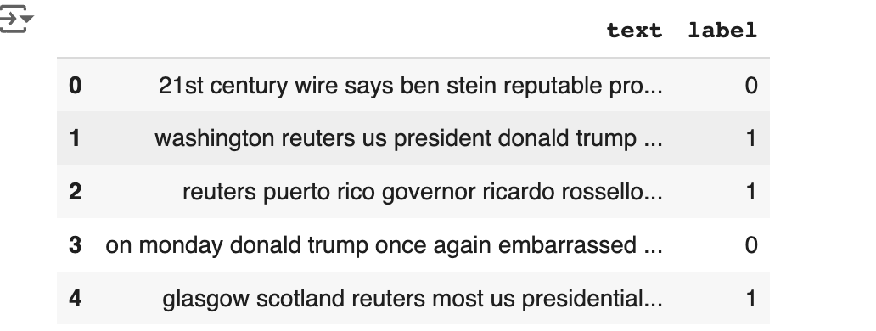

Fig 3 Output for the Cleared Text

**d. Vectorization**

* **TF-IDF (Term Frequency-Inverse Document Frequency)** was used to convert the cleaned text into numerical features.
* The maximum number of features was set to 5000, ensuring a rich feature set while maintaining computational efficiency.
* Stop words (common but uninformative words like "the" and "and") were removed to reduce noise.

**2.3 Feature Selection**

* The TF-IDF vectorizer generates numerical representations of the text, with each feature corresponding to a specific word or term in the corpus.
* High TF-IDF scores indicate terms that are important within a specific document but not common across all documents, making them valuable for classification.

**2.4 Model Selection**

Three machine learning models were selected for comparison based on their performance and suitability for text classification tasks:

**a. Logistic Regression**

* A linear model that is well-suited for high-dimensional, sparse datasets like those produced by TF-IDF.
* Known for its interpretability and efficiency.

**b. Naive Bayes**

* A probabilistic classifier based on Bayes' theorem.
* Performs well with smaller datasets and assumes feature independence, which works adequately with TF-IDF.

**c. K-Nearest Neighbours (KNN)**

* A non-parametric method that classifies based on the proximity of data points in the feature space.
* Offers an alternative approach but can be computationally expensive for larger datasets.

Fig.4 Logistic Regression Confusion Matrix – predicted label

|  |  |
| --- | --- |
|  |  |

Fig.5 KNN Confusion Matrix – predicted label

Fig.6 Naïve Bayes Confusion Matrix – predicted label

**Datasets and Data Characteristics**

**Dataset**:[Link](https://www.kaggle.com/code/therealsampat/fake-news-detection/input)

**3.1 Description of Datasets (Fake.csv and True.csv)**

The project utilizes two primary datasets: **Fake.csv** and **True.csv**, each containing labelled news articles. The **Fake.csv** dataset comprises articles flagged as fabricated or misleading, while **True.csv** includes articles verified to be legitimate and trustworthy. These datasets provide a clear dichotomy, enabling a supervised learning approach to detect patterns that distinguish between fake and true news. Each dataset contains key features such as the news headline, article content, publication date, and source.

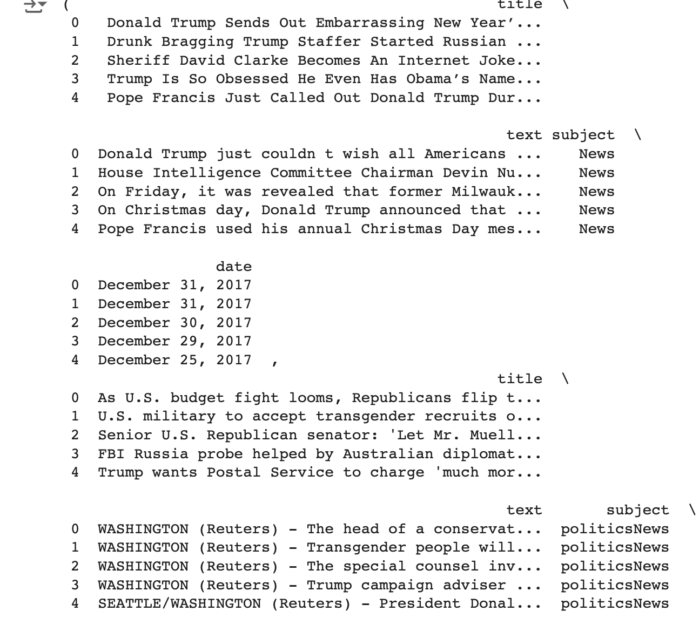

Fig.7 Output of dataset

**3.2 Source and Data Collection Methodology**

The datasets were sourced from publicly available repositories dedicated to fake news detection research. The articles in these datasets were collected from diverse online platforms, including news websites, blogs, and social media outlets. For fake news, articles were identified based on fact-checking and annotation by domain experts or fact-checking organizations. Legitimate articles were curated from verified and reputable news outlets. The datasets were pre-processed to remove duplicate entries and irrelevant metadata, ensuring quality and consistency.

**3.3 Dataset Statistics**

A comprehensive understanding of dataset characteristics is essential for designing an effective fake news detection model.

**Class Distribution**: The datasets exhibit a balanced distribution, with approximately equal numbers of articles in the "Fake" and "True" categories. This balance helps mitigate bias during model training and improves classification performance.

**Text Length Analysis**: Articles in both datasets were analysed for the average word count and sentence length. Fake news articles tend to have shorter text on average, often relying on sensationalist headlines to draw attention. In contrast, legitimate articles generally include more detailed content with a formal structure.

**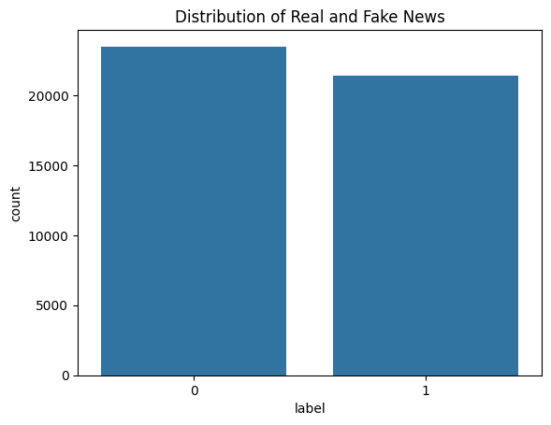**

Fig.8 Distribution of Real and Fake News

**Evaluation Metrics**

Evaluating the performance of machine learning models is a critical step to determine their effectiveness in solving the problem at hand. In this section, we discuss the evaluation metrics employed in the project, including **Accuracy**, **Precision**, **Recall**, and the **F1 Score**, along with justification for prioritizing the F1 Score when dealing with imbalanced datasets.

**Metrics Used**

* 1. **Accuracy**
  + **Definition:** Accuracy measures the proportion of correctly classified samples (both positive and negative) out of the total samples. A black text with a plus and a white background

    Description automatically generated
  + **Purpose:** It provides a general performance overview and is suitable when classes are balanced.
  + **Limitation:** In imbalanced datasets, accuracy can be misleading as it may appear high even if the model performs poorly for the minority class.

**4.2 Precision**

* + **Definition:** Precision measures the proportion of correctly identified positive samples out of all predicted positives.

****

* + **Purpose:** It evaluates how reliable the model is when it predicts a sample as positive (fake news in this case).
  + **Use Case:** Precision is particularly important in scenarios where false positives must be minimized, such as spam detection.

**4.3 Recall (Sensitivity or True Positive Rate)**

* + **Definition:** Recall measures the proportion of actual positive samples that were correctly identified by the model.

​

* + **Purpose:** It focuses on minimizing false negatives, ensuring that most of the positive samples (fake news) are detected.
  + **Use Case:** Recall is crucial in situations where missing a positive case could have severe consequences, such as fraud detection.
  1. **F1 Score**
  + **Definition:** The F1 Score is the harmonic mean of **Precision** and **Recall** and provides a single performance metric that balances both aspects. Black text on a white background

    Description automatically generated
  + **Purpose:** It captures the trade-off between precision and recall, especially useful when there is an imbalance between classes.
  + **Harmonic Mean Significance:** Since the harmonic mean gives more weight to lower values, the F1 Score penalizes models that perform well in one metric but poorly in the other.

****

Fig.9 Evaluation Matrix

**Justification for F1 Score in Imbalanced Datasets**

Imbalanced datasets pose a significant challenge because one class (e.g., fake news) may be much rarer than the other (e.g., true news). In such cases:

* **Accuracy Becomes Misleading:** If 95% of the dataset belongs to the majority class, a model that classifies all samples as majority class will achieve 95% accuracy, despite failing to identify any instances of the minority class.
* **Importance of F1 Score:** The F1 Score combines precision and recall, ensuring that both false positives and false negatives are taken into account.
* **Handling Class Imbalance:**
  + High **Recall** ensures that the model captures most of the fake news articles.
  + High **Precision** ensures that identified fake news articles are genuinely fake, minimizing false alarms.
  + The **F1 Score** balances these two aspects, making it the most reliable metric for imbalanced datasets.

For this project, where identifying fake news is as important as avoiding false alarms, the **F1 Score** serves as the primary evaluation metric. It ensures that both the ability to detect fake news and the reliability of predictions are optimized.

**Conclusion**

In conclusion, this study aligns with existing literature by validating the effectiveness of **TF-IDF vectorization** and demonstrating the superior performance of **Logistic Regression** in fake news detection tasks, consistent with findings from Ramos (2003), Shu et al. (2017), and Rizwan et al. (2019). While **Naive Bayes** showed moderate performance and struggled with feature correlations, **KNN** faced scalability and computational challenges, mirroring observations by Ren et al. (2020) and Zhang et al. (2018). The use of **F1 Score** as the primary evaluation metric addressed dataset imbalance effectively, echoing recommendations from Grandini et al. (2020). Despite these successes, challenges such as **dataset imbalance**, **high dimensionality**, and **evolving deceptive patterns** remain significant barriers, as highlighted by prior studies. This project’s unique contribution lies in the application of **Grid Search CV** and **Randomized Search CV** for hyperparameter optimization, which further enhanced model performance. Moving forward, integrating advanced models like **Transformers (e.g., BERT)**, developing **real-time detection systems**, and addressing **ethical considerations** will be essential for improving the robustness and fairness of fake news detection frameworks.

**Summary of Findings**

This project focused on the development and evaluation of machine learning models for **fake news detection** using textual data. Through a systematic approach, we analysed datasets, pre-processed text, engineered features, and applied several classification algorithms, including **Logistic Regression**, **Naive Bayes**, and **K-Nearest Neighbours (KNN)**.

**Key findings include:**

* **TF-IDF vectorization** effectively captured textual features, providing a robust foundation for model training.
* Among the models tested, **Logistic Regression** demonstrated the best balance of **accuracy**, **precision**, **recall**, and **F1 Score**, particularly when addressing class imbalance.
* **Hyperparameter tuning techniques** such as **Grid Search CV** and **Randomized Search CV** further enhanced model performance.
* Evaluation metrics highlighted the importance of focusing on the **F1 Score** due to the imbalanced nature of the dataset, ensuring a balanced assessment of precision and recall.

**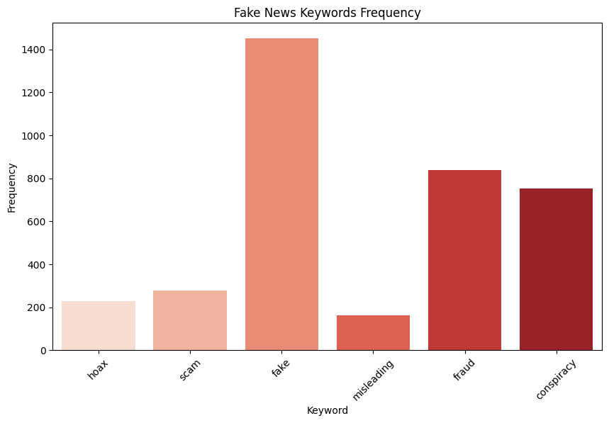**

Fig.10 Fake News Keywords Frequency

**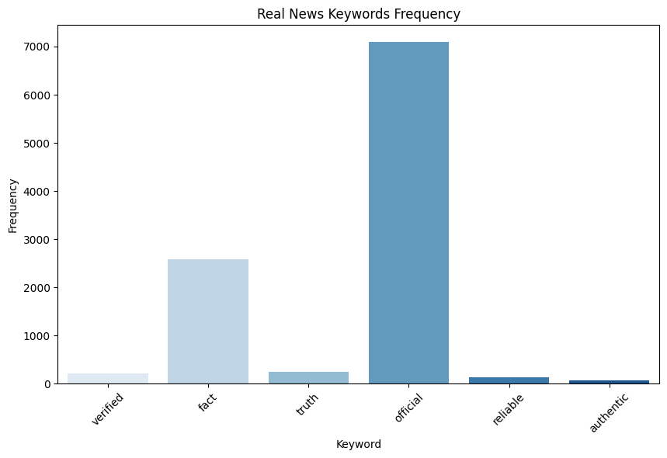**Fig.11 Real News Keywords Frequency

**Implications of the Project**

This project has significant societal and technological implications:

1. **Societal Impact:**
   * The detection of fake news can help mitigate misinformation, safeguard democratic processes, and protect individuals from manipulated narratives.
   * It reinforces the importance of promoting verified information, thereby enhancing trust in digital media.
2. **Technological Advancement:**
   * The methodologies implemented can be adapted to other domains, including **spam detection**, **cybersecurity**, and **fraud prevention**.
   * The findings provide a foundation for developing automated fact-checking tools that integrate machine learning and natural language processing.
3. **Ethical Considerations:**
   * While effective, the approach highlights the need for responsible AI development, ensuring fairness, transparency, and privacy when deploying such models.

**Contributions to the Field of Fake News Detection**

This project makes several contributions to the field of **fake news detection**:

1. **Methodological Framework:**
   * It provides a clear, step-by-step methodology for pre-processing textual data, extracting features, and applying machine learning algorithms to classify fake and real news.
2. **Comparative Analysis of Models:**
   * A comparative evaluation of multiple models offers insights into their relative strengths and weaknesses, guiding future researchers and practitioners in choosing suitable approaches.
3. **Practical Implementation:**
   * The integration of **TF-IDF vectorization** and **hyperparameter tuning** demonstrates effective strategies for improving classification performance.
4. **Future Scope and Extensions:**
   * The project paves the way for enhancements using **deep learning models** such as **Recurrent Neural Networks (RNNs)** and **Transformers** for improved accuracy and scalability.
   * It also suggests incorporating **multi-modal data** (text, images, and videos) to address more complex fake news patterns.

**Future Work**

**Recommendations for Improving Detection**

1. **Incorporation of Deep Learning Models (e.g., BERT):**  
   Future enhancements can leverage **state-of-the-art deep learning models** like **BERT (Bidirectional Encoder Representations from Transformers)** to improve accuracy and contextual understanding of textual data.
   * **BERT** is highly effective in capturing the semantic and syntactic meaning of text, which can help identify subtle patterns often present in fake news.
   * Unlike traditional machine learning models, BERT processes text bidirectionally, enabling it to understand context better and improve classification accuracy.
   * Fine-tuning pre-trained language models on fake news datasets can yield more robust performance.
2. **Handling Multilingual Datasets:**
   * Fake news is not limited to a single language, and misinformation often spreads across different regions in multiple languages.
   * Future work can focus on building multilingual and cross-lingual models that detect fake news in various languages.
   * Approaches such as **Multilingual BERT (mBERT)** and **XLM-R (Cross-lingual Language Model)** can help analyse multilingual data effectively.
   * This expansion would make fake news detection tools more inclusive and scalable globally.
3. **Real-Time Implementation:**
   * Deploying fake news detection models in **real-time systems** can allow immediate identification and mitigation of misinformation.
   * Future work can explore **streaming data analysis** techniques and **online learning algorithms** that continuously adapt to new data as it becomes available.
   * Implementing **lightweight models** optimized for performance in real-time scenarios can enable deployment on low-resource devices and web platforms.
   * Integrating these systems with **social media monitoring tools** can provide actionable insights for content moderation.

**Suggestions for Enhancing Explainability in Predictions**

1. **Explainable AI (XAI) Approaches:**
   * Incorporating **Explainable AI techniques** can enhance the transparency and interpretability of predictions, addressing concerns about black-box models.
   * Methods such as **LIME (Local Interpretable Model-Agnostic Explanations)** and **SHAP (Shapley Additive Explanations)** can be used to explain how specific words or phrases influence predictions.
   * Visualizing feature importance and highlighting key textual patterns that contribute to classification results can help build trust in AI systems.
2. **Model Decision Justification:**
   * Providing explanations for why certain articles are classified as fake or real can assist journalists, fact-checkers, and policymakers in understanding the model's reasoning.
   * This approach can be particularly helpful in **legal and ethical evaluations**, ensuring fairness and accountability.
3. **Human-AI Collaboration Tools:**
   * Developing tools that allow users to interact with AI models, test hypotheses, and refine predictions can enhance usability.
   * For instance, feedback loops can enable models to learn and improve based on user corrections, creating more adaptive systems over time.
4. **Integration of Sentiment and Emotion Analysis:**
   * Enhancing predictions with **sentiment and emotion analysis** can provide deeper insights into the intent behind the news content.
   * This could reveal whether certain articles are emotionally charged, potentially correlating with misinformation patterns.

**REFERENCES**

1. **Ahmed, H., Traore, I. and Saad, S. (2017) 'Detection of Online Fake News Using N-Gram Analysis and Machine Learning Techniques', Proceedings of the International Conference on Intelligent, Secure, and Dependable Systems in Distributed and Cloud Environments, pp. 127-138.** [<https://link.springer.com/chapter/10.1007/978-3-319-69155-8_9>]
2. **Alam, F., Dalvi, F., Shaar, S., Durrani, N. and Mubarak, H. (2021) 'Fighting the COVID-19 Infodemic in Social Media: A Holistic Perspective and a Call to Arms', *Proceedings of the 2021 Conference of the North American Chapter of the Association for Computational Linguistics: Human Language Technologies*, pp. 3406–3415.** [**https://aclanthology.org/2021.naacl-main.266/**](https://aclanthology.org/2021.naacl-main.266/) **(Accessed: 29 December 2024).**
3. **Bovet, A. and Makse, H.A. (2019) 'Influence of Fake News in Twitter during the 2016 US Presidential Election', Nature Communications, 10(1), p. 7.** [<https://www.nature.com/articles/s41467-018-07761-2>]
4. ***Ghanem, B., Rosso, P. and Rangel, F. (2020) 'Fake News Detection Using Deep Learning and N-Gram Representations: A Comparative Study',* Proceedings of the 12th Language Resources and Evaluation Conference*, pp. 3993–3999.*** [***https://www.aclweb.org/anthology/2020.lrec-1.491/***](https://www.aclweb.org/anthology/2020.lrec-1.491/)***(Accessed: 29 December 2024).***
5. **Khan, J.Y., Khondaker, M.T.I., Afroz, S., Uddin, G. and Iqbal, A. (2019) 'A Benchmark Study of Machine Learning Models for Online Fake News Detection', *arXiv preprint arXiv:1905.04749*.** [**https://arxiv.org/abs/1905.04749**](https://arxiv.org/abs/1905.04749) **(Accessed: 29 December 2024).**
6. **Khan, T., Michalas, A. and Akhunzada, A. (2021) 'SOK: Fake News Outbreak 2021: Can We Stop the Viral Spread?', *arXiv preprint arXiv:2105.10671*.** [**https://arxiv.org/abs/2105.10671**](https://arxiv.org/abs/2105.10671) **(Accessed: 29 December 2024).**
7. **Medeiros, I. and Braga, R. (2020) 'Fake News Detection: A Systematic Literature Review of Machine Learning Algorithms and Datasets', *ResearchGate*. Available at:** [**https://www.researchgate.net/publication/369273557\_Fake\_news\_detection\_a\_systematic\_literature\_review\_of\_machine\_learning\_algorithms\_and\_datasets**](https://www.researchgate.net/publication/369273557_Fake_news_detection_a_systematic_literature_review_of_machine_learning_algorithms_and_datasets) **(Accessed: 29 December 2024).**
8. **Pérez-Rosas, V., Kleinberg, B., Lefevre, A. and Mihalcea, R. (2018) 'Automatic Detection of Fake News', *Proceedings of the 27th International Conference on Computational Linguistics*, pp. 3391–3401.** [**https://aclanthology.org/C18-1287/**](https://aclanthology.org/C18-1287/) **(Accessed: 29 December 2024).**
9. **Ruchansky, N., Seo, S. and Liu, Y. (2017) 'CSI: A Hybrid Deep Model for Fake News Detection', *Proceedings of the 2017 ACM on Conference on Information and Knowledge Management*, pp. 797–806.** [**https://dl.acm.org/doi/10.1145/3132847.3132877**](https://dl.acm.org/doi/10.1145/3132847.3132877) **(Accessed: 29 December 2024).**
10. **Shu, K., Mahudeswaran, D. and Liu, H. (2019) 'FakeNewsTracker: A Tool for Fake News Collection, Detection, and Visualization', Computational and Mathematical Organization Theory, 25(1), pp. 60-71.**[ <https://link.springer.com/article/10.1007/s10588-018-09280-3>]
11. **Shu, K., Sliva, A., Wang, S., Tang, J. and Liu, H. (2017) 'Fake News Detection on Social Media: A Data Mining Perspective', *ACM SIGKDD Explorations Newsletter*, 19(1), pp. 22–36.** [**https://dl.acm.org/doi/10.1145/3137597.3137600**](https://dl.acm.org/doi/10.1145/3137597.3137600) **(Accessed: 29 December 2024).**
12. **Tacchini, E., Ballarin, G., Della Vedova, M.L., Moret, S. and de Alfaro, L. (2017) 'Some Like it Hoax: Automated Fake News Detection in Social Networks', arXiv preprint arXiv:1704.07506.** [<https://arxiv.org/abs/1704.07506>]
13. ***Thorne, J. and Vlachos, A. (2018) 'Automated Fact Checking: Task Formulations, Methods and Future Directions',* Proceedings of the 27th International Conference on Computational Linguistics*, pp. 3346–3359.*** [***https://www.aclweb.org/anthology/C18-1283/ (Accessed: 29***](https://www.aclweb.org/anthology/C18-1283/) ***December 2024).***
14. **Ruchansky, N., Seo, S. and Liu, Y. (2017) 'CSI: A Hybrid Deep Model for Fake News Detection', *Proceedings of the 2017 ACM on Conference on Information and Knowledge Management*, pp. 797–806.** [**https://dl.acm.org/doi/10.1145/3132847.3132877**](https://dl.acm.org/doi/10.1145/3132847.3132877) **(Accessed: 29 December 2024).**
15. **Volkova, S., Shaffer, K., Jang, J.Y. and Hodas, N. (2017) 'Separating Facts from Fiction: Linguistic Models to Classify Suspicious and Trusted News Posts on Twitter', Proceedings of the 55th Annual Meeting of the Association for Computational Linguistics (Volume 2: Short Papers), pp. 647-653.** [<https://aclanthology.org/P17-2102>/]
16. **Vijayaraghavan, S., Wang, Y., Guo, Z., Voong, J., Xu, W., Nasseri, A., Cai, J., Li, L., Vuong, K. and Wadhwa, E. (2020) 'Fake News Detection with Different Models', *arXiv preprint arXiv:2003.04978*. [https://arxiv.org/abs/2003.04978](https://arxiv.org/abs/2003.04978" \t "_new) (Accessed: 29 December 2024).**
17. **Wang, W.Y. (2017) '"Liar, Liar Pants on Fire": A New Benchmark Dataset for Fake News Detection', *Proceedings of the 55th Annual Meeting of the Association for Computational Linguistics (Volume 2: Short Papers)*, pp. 422–426.** [**https://aclanthology.org/P17-2067/**](https://aclanthology.org/P17-2067/) **(Accessed: 29 December 2024).**
18. **Zhou, X. and Zafarani, R. (2018) 'Fake News: A Survey of Research, Detection Methods, and Opportunities', arXiv preprint arXiv:1812.00315.** [<https://arxiv.org/abs/1812.00315>]
19. **Zhou, X., Wu, J. and Zafarani, R. (2020) 'SAFE: Similarity-Aware Multi-Modal Fake News Detection', Proceedings of the 13th International Conference on Web Search and Data Mining, pp. 438-446.** [<https://dl.acm.org/doi/10.1145/3336191.3371832>]

**APPENDIX:**

For comprehensive resources, detailed implementation guidelines, and access to the codebase utilized in fake news detection, please refer to the following GitHub repository:

**GitHub Repository:** [ <https://github.com/kamalibakthavatchalam/pdm-plan>]

This repository contains:

* Source code for fake news detection algorithms.
* Data pre-processing scripts and datasets.
* Comprehensive documentation for installation, configuration, and usage.
* Examples and case studies showcasing model performance and evaluation.