**Analyzing Climate Change Trends**

**ABSTRACT**

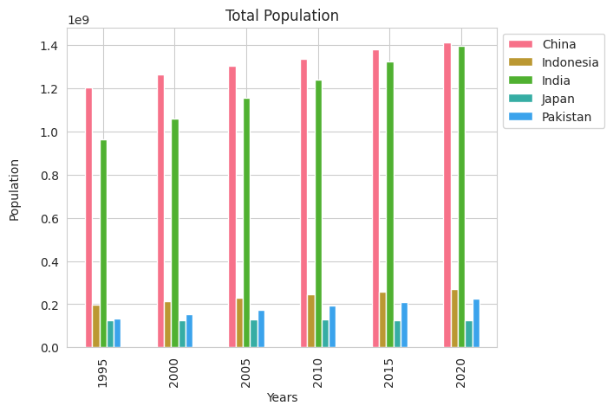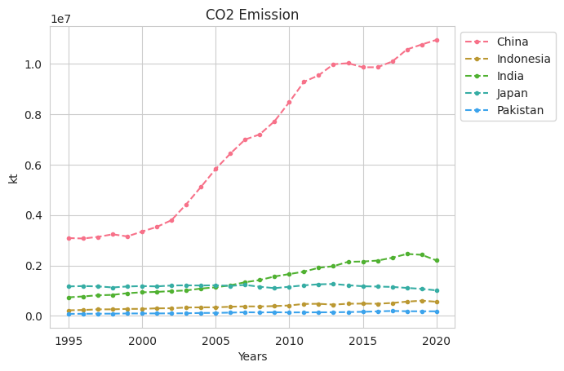Asian countries are responsible for a significant portion of global greenhouse gas emissions and play a crucial role in achieving global mitigation and adaptation goals. This report explores climate change in five Asian countries over 25 years. The analysis specifically examines the relationship of CO2 gas emissions with urbanization, electricity access, forest land usage patterns, renewable energy consumption, and population growth. By focusing on what really drives climate change, the report aims to shed light on the crucial aspects that demand attention. The findings not only highlight challenges but also offer insights and potential solutions for a sustainable future.

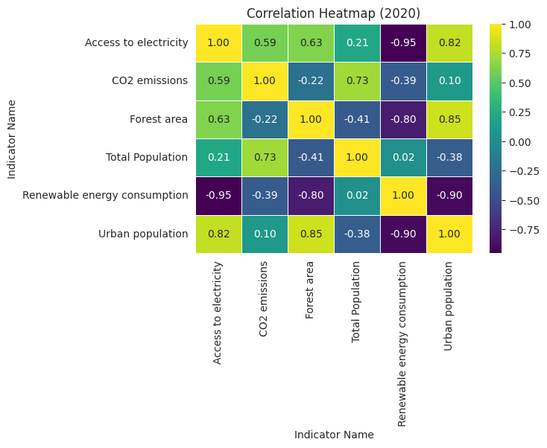CO2, the key driver of climate change, is prominently emitted by China, currently the world's largest contributor. Over the past 25 years, China's emissions have more than doubled, primarily due to rapid industrialization and heavy reliance on coal. India, the third largest CO2 emitter, has experienced steady growth attributed to an expanding industrial sector and increasing energy demand. Notably, India's emissions have shown a slowdown in growth post-2018, reflecting efforts to enhance emission efficiency. Japan, while a significant emitter, has successfully reduced emissions through energy-efficient measures, maintaining stability in its economy. However, Japan's emissions still surpass those of Indonesia and Pakistan.

The correlation between CO2 emissions and total population is notably high at R=0.73. Population growth is a driving factor, contributing to heightened demands in food, and energy subsequently leading to increased CO2 emissions. Rapidly increasing population of China and India aligns with their increased CO2 emission. Japan's population has remained relatively stable indicating its success in reduced emission, while Indonesia and Pakistan have experienced growth but at slower pace.

Population growth often led to increased urbanization.

China rapid urbanization, driven by economic development, resulted in a doubling of its urban population. In India, the increase in emissions can also be linked to urban expansion, fueled by both economic growth and a growing population. Japan despite having high urban population percentage, remained relatively stable in both population growth and CO2 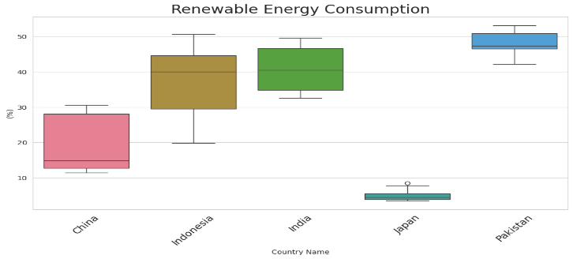emission. Thus, the connection between urbanization and industrialization contributes to the CO2 emission 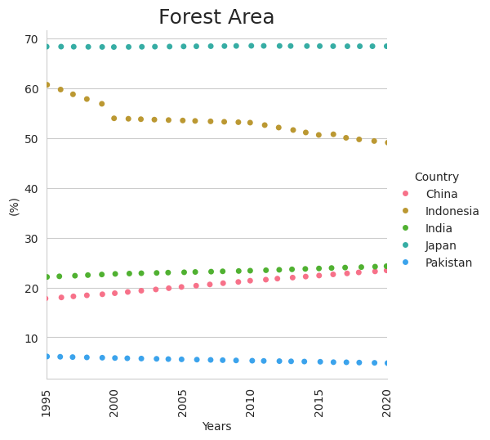trends observed in these countries.

A correlation of -0.22 between forest area (%) and CO2 emissions implies a subtle negative association, suggesting that a decrease in forest land may be linked to a slight increase in CO2 emissions. Similarly, negative correlation R=-0.41 is observed between forest area and total population indicating rise in population may result in deforestation. But the trends for each country differ. Indonesia witnessed a 10% decrease in forest area, potentially linked to deforestation for agricultural purposes and rapid urbanization. China and India remained relatively stable, reflecting efforts to balance development with conservation. Japan despite having high urban population, maintained a consistent level (69%), reflecting strong environmental conservation measures resulting in controlled CO2 emissions.

Urbanization strongly correlates with access to electricity (R=0.82). Japan exhibits the highest electricity access rate (100%) and therefore a significant CO2 emitter (R=0.59). China and India's progress aligns with economic growth and population increase, impacting emissions. Pakistan encounters energy demand challenges due to urbanization and population growth.

Negative correlation (R=-0.39) suggests an increase in renewable energy consumption, tends to decrease CO2 slightly. Pakistan and India have made significant progress in increasing their renewable energy consumption in recent years address environmental concerns. Pakistan highest share align with less CO2 emission in comparison to others. Japan’ share is still relatively low compared to other developed countries.

China's CO2 emissions exhibit a slightly left-skewed distribution with a skewness of -0.08, indicating a minor asymmetry. The kurtosis of -1.62 suggests a relatively flatter distribution with lighter tails compared to a normal distribution.

In Conclusion, reducing CO2 emissions is crucial for mitigating the impacts of climate change. China being the largest emitter needs shift towards cleaner energy sources and sustainable industrial practices. apan's success with energy-efficient measures highlights the role of technology. Embracing renewable energy and conserving forests are key strategies. Encouraging green technologies, sustainable practices, and global collaboration are essential for achieving emission reduction targets and a resilient future.