*INTERNSHIPREPORT*

*Internship of Full Stack Web Developmentat*

*SUBMITTED*

*BY*

KARTHIKA M

Reg.No:24132016504322009

###### Department of Computer Science

*SUPERVISED*

*BY*

###### Dr. K. MANIVASyeda Sumbul Hossain Senior Lecturer

Department ofSoftwareEngineering Daffodil International University

This Internship report hasbeensubmittedinfulfillmentoftherequirementsfortheDegree of BachelorofScienceinSoftwareEngineering.

**APPROVAL**

ThisInternshiptitledon "1nternshipofFulIStackWebDevelopment”,submittedbyChandan Ojha,ID:181-35-2425totheDepartmentofSottwareEngineering,DaffodilInternational University has been accepted as satisfactory for the partial fulfillment of the requirements for the degreeofBachelorofScienceinSofiwareEngineeringandapprovalastoits styleandcontents.

BOARDOFEXAMINERS

Dr.ImranMahmud

AssociateProfessor and Head Departmentof SoftwareEngincering Daffodil 1 nternationalUniversity



Afsana Begum AssistantProfessor

Department of SoftwareEngincering DaffodilInternationalUniversity

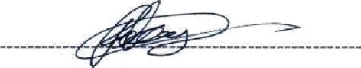

Tapushe Rabaya Toma Senior Lecturer

Department of SoftwareEngineering DaffodilInternationalUniversity

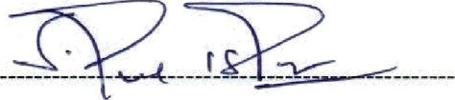

Prof. Dr. Md. Saiful Islam Professor

Institute of InformationandCommunicationTechnology (IlCT) BangladeshUniversityofEngineeringandTechnology(BUET)

Chairman

InternalExaminerI

InternalExaminer2

ExternalExaminer

###### Declaration

IherebydeclarethatIhavetakenthisinternship inTheBugsBDLimited underthesupervisor of Ms. Syeda Sumbul Hossain, Department of software Engineering, Daffodil International University. Ialsodeclarethatneitherthisreport noranypartofthisreport hasbeensubmitted elsewhereforawardofanydegree.



ChandanOjha

ID:181-35-2425

Batch:25*

DepartmentofSoftwareEngineering

FacultyofScienceandInformation Technology

DaffodilInternationalUniversity

Certifiedby:

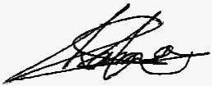

Ms.SyedaSumbulHossain

SeniorLecturer

DepartmentofSoftwareEngineering

FacultyofScienceandInformationTechnology DaffodilInternational University

##### Acknowledgement

First of BallIwouldliketothanksmyGod.AfterthatIwould liketoexpressmyspecialthanksof gratitude to my supervisor Ms. Syeda Sumbul **Hossain, Senior Lecturer,** Department of Software Engineering. Iamextremely grateful and indebted to herforhisexpert, sincere and valuableguidanceandencouragementtome.

I would like to express my sincere thanks to **Dr. Imran Mahmud, Assistant** Professor and Head of Software Engineering Departmentforhidconstant encouragement.

I would like to express my sincere thanks to **Dr. Imran Mahmud, Assistant** Professor and Head of Software Engineering Departmentforhidconstant encouragement.

Iwouldliketothankthemwhowerehelpedinmyinternship bytheirimportant suggestions. I amreallypleasedandproudtoexpress myfeelingofgratefulness andprofound respect toour respectedfacultiesoftheDepartment ofSoftwareEngineering,fortakethisopportunity.

Finally,Iwishtothankmyparentswho havebeenagreatsource ofinspirationtome.Without theirsupport,Iwould nothavereachedwhereIamtoday.

ÏV

###### CERTIFICATE

krrdngc«zxl zBa sazlongnaaze dzślghtadto ófatj4zubwposdlJoricg"FrślgtacśWeb Darałcper”aeIrzam.WevaauIdtksto0d‹aniacppozgaytrcclvu4ixxnajr>uxitecazwPatalafma•

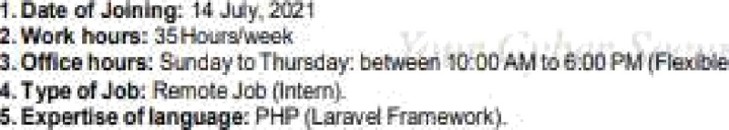rnationalUniversity

##### Internship Summary

AsastudentofSoftwareEngineeringdepartment,IhavechosentobuildmycarrierinFullStack WebDevelopment. FullStackWebDevelopment isoneofthesignificant aspectsofcomputer professional jobs. To Complete of my B.SC degree I have chosen internship and select Full StackWebDevelopmentsectorbecauseitcoverstheoverallinformationtechnologyofdifferent types ofbusiness and system.

This Internship report is aimed to improve my knowledge of Full Stack Web Development acquired during myinternship period. I have internship over FullStack Web Development at SoftwareCompanynamed“BugsBDLtd”.Itwasreallyagoodchancetoimprovemyacademic learningwithnewcultures&newpeople.

BugsBD Ltd isanIT company that provides allkinds ofWebapplication, ERP, Ecommerce, Business and Security related solution. During my internship period I am learning the complication ofFullStackWebDevelopment procedures, client siteconfiguration and many more.

This internship report basically I have tried to show that howIhandled those things andhow efficiently.

VÏ

CDaffodilInternationalUniversity

###### TableofContents

Declaration. iii

Acknowledgement. iv

**Introduction** J

Company Profite. 5

Vii

fiDaffodilInternationalUniversity

* 1. HandlingClients 13
  2. ComparativeAnalysisofOfficeCulture. 13
  3. InterneeLifeCycle. 13
  4. RecruitingPolicies 14
  5. GettingStarted. 14

Chapter4:Techno/ogyEmploying 15

* 1. FundamentalTechnologies 16
  2. SupportiveTechnologies. 16
  3. LogisticSupport. 16

Chapter5:Roles&Responsibility. 17

* 1. TrainingKnowledgeSharing. 18
  2. Project(E-commerce) 18
  3. ProjectPlot 18
  4. AssignedResponsibilities 18
  5. ProjectGoal. 18
  6. SystemAnalysis&Design. 19
     1. FunctionalRequirements. 19
     2. UseCase DiagramforCustomer. 20
     3. UseCase DiagramforAdmin 21
     4. UseCaseDescriptionTable. 22
     5. ActivityDiagram forAddProducttoCart. 26
     6. ActivityDiagramforSetCouponCode. 27
     7. ActivityDiagram forCheckout 28
     8. SequenceDiagram forUserLogin 29
     9. SequenceDiagramforcustomercheckout. 30
     10. ClassDiagram 31
     11. DatabaseDesign 32
     12. Challenges 33
     13. TechnicalFindings. 33
     14. UserManual 33

Chapter6:Experience&Achievements. 38

* 1. OvercomeProblemsandDifficulties. 39
  2. AbilitytoLearn. 39
  3. WorkingPractices 39
     1. FullStackWebDevelopment 39

Viii

* + 1. DesignPattern 39
  1. TechnologyEnhancement 40
  2. Non-TechnicaIGrowth 40
  3. Achievement 40

Chapter7:Conclusions&Recommendations 41

* 1. Summary. 42
  2. FindingandContribution 42
  3. Recommendationforfuturework. 42

*/te/erences. 4J*

ÏX

# Chapter1:Introduction

1

##### Introduction

As a portion of the Internship of Undergraduate program of BSc in Software Engineering at Daffodil International University, I interned in the Software Development Department of BugsBDLimited.Internshipsareoftenverycloselyrelatedtothestudent'sacademicandcareer goalswhichhelp metogainknowledge aboutthejobfield. Icontinuously hadanintrigued in SoftwareDevelopmentandmyinternshipinSoftwareDevelopmentwasagrandopportunityto workonBugsBDLimited,thisreportisbasedonthisexperience.

##### Rational

Internship helps metoget afeel industries, build workplace confidence, etiquette, andhabits whichundoubtedlymotivatestowardssuccess.Theinternshipknowledgegrantsmanyrewards and can be conducted forundergraduate applied/technicalelective credit(s). Internships offer students to enhancement their developing knowledge in more depth and gather abilities for facing real life problems. I am concerned to start this report since I need to uncover the significanceofmytheoreticalunderstandingtogetherwithmypracticalinvolvement.Thismade adifferencethinkinanunexpectedwayandgavemeamorein-depthviewatlessonslearnedin my theory lesson.

##### Background

DaffodilInternationalUniversitygivesthewonderfulopportunitytotheirstudentsofhavingan internship within their bachelor program. I am one of the luckiest ones to study in Daffodil International University and have opportunity to take internship. As a student of Software EngineeringDepartment,Ihavedonealotofworkinfullstackwebdevelopment areainlast3 years.Fullstackwebdevelopmentistheexerciseofworkingonboththefront-endandback-end ofaprogram.Itisatermusuallyused forthoseworking inwebdevelopment. Thedevelopers have background on creating user interface and user experience for front-end, and also have strong knowledge in a programming language that is used for managing the logic of the application,henceback-end.FullStackisalayerofsoftwareorwebdevelopmentcomprising of thefront-end andthe back-end portions ofanapplication.Front-endiswhat theuserswillview

orinteractwithonyourapplication.Back-endpartiswhatusersdonotsee,suchasapplication's logic, database, server, etc.

I have got a lucky opportunity to complete my internship at BugsBD Ltd. This internship allowedmetoincreasemyknowledgeinfullstackwebdevelopment.Thejourneywasnotessay forme.Thereweremanybarriers,newtechnologiesthatIhavetohandlewith,Ihaddiscovered anew potential within myself.

##### Motivation

ThemainreasonfordoingInternshiptoimprovementmydevelopingknowledge inmoredepth. Becauseofitisnotprobabletocovereverythinginboundaries ofacademic curriculum. Since appointmyselfasaroleoffullstackwebdeveloperIhavecoveralotofpointwhichwassohard to me. Another reason for choosing internship is accumulate capacities for facing real life problems. Onthejourneyofthisinternship, Iamexceptionally appreciative to mysupervisor who appears me inreallifework.

#### Objectives

Themainpurposeofthisreportaretofulfilltherequirements oftheBScprogramandtopresent theknowledge and information that hasbeenachieved during the internship period under the organization.

Theotherimportantpurposesareasfollows—

* + - Assistingthedevelopmentmanagerwithallaspectsofsoftwaredesignandcoding.
    - Attendingandcontributingtocompanydevelopmentmeetings.
    - Learningthecodebaseandimproving coding skills.
    - Writingandmaintainingcode.
    - Workingonminorbugfixes.
    - Respondingtorequestsfromthedevelopmentteam.

###### Scopeofthestudy

This report is based on BugsBD Ltd Software Development procedure. Along with this, the reportwillalsopartiallydescribethewholeBugsBDLtdSoftwareDevelopmentprocedure.This reportismainlyimportantfortheSoftwareDevelopmentrelatedorganizationstounderstandthe Software Development procedure that includes gathering & analysis of requirement, design, development, testing, implementation, maintenance development tools and so on. From my internship journey, I have learned those Software Development procedures & this journey expandmyknowledgethatwillhelpmeatmyjobfield.Ihavechancetocorporatelifeproblem solving.That willassistance metoget next job.HereIhave learned different culturessuchas maintain the office rule, my colleague mentalities. Moreover, I have a passion on software development&Igotthatopportunitiesfromthisinternship.

### Chapter2:Organization Overview

###### About

##### Company Profile

BugsBD isimproved byanumber ofyouthful, energetic and talented software engineers and security experts who have already demonstrated their mastery in this field. They have also a strong networking of different skill sets who would help to ensure absolute solution to their valuedclients.Thisisn'tonlyanopenstagefortheexpertsandclientsbutalsoitisaplatformof congregated transmittable of information that makes more mastery as well in this field of security. The also provides two types of services. Services are Development Services and Security Services. The Development Services are Web Application Development, Cloud computing,JavaScriptDevelopment, MobileAppdevelopment &Digitalmarketing.Security Services are Web Application Testing, Network Security, Database Security, Source Code Review, EmailSecurityand manymore.

.

##### TheVision

BugsBD is a driving IT company for Consulting Services and Deployment of best of breed BusinessSolutionstotoptierdomesticandinternationalclients.OurcompanyVisionistoattain 100%customersatisfactionbyconveying qualityproductsandservicesatareasonable costand tostrivetobecomeasubstanceintechnology-basedcorporatesolutions,capableofdemanding anunlimitedreactionfromthetargetedniche.Wealsoofferspecialexpertiseincustomsoftware development providingspecialized products,ITservicesandcustomendtoendsolutionstoour enterprise clients

##### TheMission

OurCompanyMissionistoachievethereputationofaquality,highstandard&solidsolution&service Provider Company within the ICT industry. Ourchallenge istoimprove thebusiness operationsofitsclientsbycreating and/orexecuting premiumITproducts andservices. Weneed tobroadenthebusinessdevelopment ofourclientsbusiness.Weareheretoexceedyourdesires andmakeaneverlasting,mutuallybeneficialbondwithyou.

##### Company Products

Ourcompany hassomeproducts

ERP:

We have ERP System. ERP is an ideal solution for data analysis, automation and full-scale infrastructure integration. Important ERP Features list integration, automation, dataanalysis, reporting,customerrelationship management, accounting,trackingandvisibility.

Ecommerce:

We have ecommerce system. E-commerce is the buying products via the internet, and the transferofmoneyanddatatocompletethesales.Themost important featuresincludecontent management capabilities, promotion and discount code tools, an easy to use checkout, and multiplepaymentoptions(creditcard,stripeetc.)

GeneralWebsiteApplication:

Our company built some general website application for our clients those are Amar Circle web application, Nettcast web application etc.

###### Clients

Forrunningasoftware companyclientsareprimarycomponents allofthetime.Asasoftware company we have a part of local and international clients. Our company tries to extend our clients number.



Figure2.8:Clientslogo

###### CompanyLocation

BugsBdLtd.islocated1/c(5'hfloor)RoadNo:01,Shyamoli,Dhaka,Bangladesh. Phone: +880l889975511.

Email:[info@bugsbd.com](mailto:info@bugsbd.com)

References:https://bugsbd.com/

### Chapter3:CompanyCultureandCarrying Out

##### WorkingEnvironmentsandProtocols

For building a successful carrier the working environment is very important. At this office workingenvironmentisexceptionallygreat.Allofmycolleaguesarefriendly.Eachpeoplehas theirownspace.Basicthingsarealsoprovidedbyourcompany.

###### WorkingTeam

Eachdepartment hasworkinggroupsforcompletingtheirprojects. Causeofnoneofthework canbedonebyindividual. Anemployee whohasworkedunderadepartment isappointed for thatparticulardepartment.Allofourstaffareworkingtogetherasagroup.

#### Rules&Regulations

* + 1. OfficeTime

Ourcompany Office time is11am—7pm.Where wehavegotbreakforlunch &snacks. Employees mustberequiredtogointime.

* + 1. Responsibilities

Everybodyisassignedtohisownwork,sohemustberesponsibleforhisownwork.Therearea fewextraresponsibilitieslike—

* + - * Oneshouldnotbecarelesswith,toolsandequipmentresultinginharmtooffice property.
      * Assoonaspossible,anysignificantlossorharmtocompany propertymust needto inform.
      * Otherpersonalthingsmustnotbetouchedwith hispermission.
      * Withoutmygroupleader'spermission,Idon'thavetotakeoff.
      * Inanemergency,leavemusthavetobeinformedbytheCEO.
    1. Meeting

Itisrequiredtoalltogotoatthemeetingontime.Companyplansarediscussedinthatmeeting.

##### Handling Clients

Customersarethemainsubstanceforrunninganorganization.Eachorganizationhandlesclients in their own strategy. Clients handling operations are not same as in the organization. Each organization follows special strategies to handle their clients. BugsBD Ltd focus on client request. Where a non-technical person can easily do their work with comfort. This company collectsprerequisitesfromtheclientsandbuiltsuchawaythatapersoncaneasilyspeeduphis work. Afterdeployment, thedynamic product iftheclient needs tochange thecompany does thatveryfast.Thisthecompanygainclientsatisfaction.

##### ComparativeAnalysisofOfficeCulture

Thecompanygivestheopportunities fortheintern.Thisisareallygreatcultureinourcountry insteadofothercompany.Theycontractpeoplewhoisfitforthisculture.Thedecisionproducer givestheideathatcomefromanywhere.RealizingthatIamnotseparatedfromtheorganization.

##### InterneeLifeCycle

Theinterneelifecycle basedonafewcriteria.Therewasainterneelifecycle

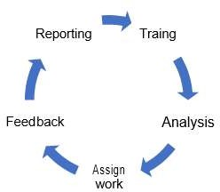

**Figure3.6:Internee LifeCycle**

##### RecruitingPolicies

Each organization follows their recruiting approaches. BugsBD Ltd. follows their own approaches.AftertheonlineapplyIgottheirphonecallforviva.Theyrecruitdifferentpeoples fordifferent position.TheyofferedmeforinternshipandifIdowell,Iwillbeabletocontinue with their organization.

#### GettingStarted

IhavestartedmyjourneyasaninterneeatBugsBDLtd.inJuly14,2021.InthismonthsIhave learned a lot of development skills, new environment which are exceptionally supportive to beginmycarrierinITCompany.Ialsoaccumulateclientsiteknowledge.WhichthingsIneedto doIfoundthatfromthisinternee.IamsoluckythatIgotthatinternshipopportunity.

## Chapter4:TechnologyEmpìoying

15

fiDaffodilInternationalUniversity

##### FundamentalTechnologies

InthischapterIhavedescribed aboutthefundamentaltechnologiesthat Ihave usedbyduring my internship.

* + - **Projectmanagementtool:**BugsBDCRM
    - Version controltool:Bitbucket &Git
    - **Localhost**webServer:Xampp7.4.20
    - **Editor:**VisualStudioCode
    - **FrontEndTechnologies:**Html5,CSS3,Bootstrapv40.0,JavaScriptES6
    - **Backendlanguages:**PHP7.4
    - **Database:**MySQL
    - **Framework:**Laravel7x&8x

##### SupportiveTechnologies

Thereareafewsupportive technologies wehave used.Thecompany follows agileSDLC for software development, software engineering withuser experience &design. Skype for quick codesharing&communication.ThecompanyalsousesBitbucket forcodeandGoogledocsfor reporting.

##### LogisticSupport

Logistic support for develop a soflware is important things what is need to implement to construct up a software. The programing skill, system analysis, designing the model, make prototype etc. arethe most portion oflogistic support. Weare going through eachstage from them while implementing the software. When we going to begin a new project, first our requirement collectiongroupmeet withtheclientsandcollecttherequirements. Afterthatwe makeadesignandappearourdesignstotheclients.Incaseanythingisrequiredtochangethen wemadethecorrectionsintherequirement.Atthatpointwebuilttheprojectwithclient'sview. Andalloftheworkaredonebyourownmanpower.

## Chapter5:Roles&Responsibility

##### TrainingKnowledge Sharing

Afterstartinganewproject,theprojectmanagerdescribeseachpointabouttheproject.Howto begin, what to do and what required to be focused on that project is announced clearly. The project supervisor also gives us a short brief each day before we begin the work. This is so accommodatingformewhenIamappointedinaproject.

#### Project(E-commerce)

AllofmytrainingandknowledgesharingwasE-commerceproject.WearenowdevelopingE- commercesystem.Inthisprojectsomeofthefeaturesdescribinghere.

##### ProjectPlot

TheprojectisaboutE-commerce system.Hereclientwant searchproduct,productsortbyprice &newness,showproductdetails,addproducttocartorwishlist,productsavedforletter,apply couponcode,checkout withcashondelivery&stripepayment gateway,customerdashboard, vieworderdetails,ordercancellation, admincanchangeorderstatus&customer giveproduct review.Andnowourdevelopingteamworkingonthisecommercesystem.

#### AssignedResponsibilities

InthisE-commerceprojectmyresponsibilitiesare

* Productsortingbyprice&newness.
* Addproducttocart/wishlist.
* Productsaved forlater.
* Set&Applycoupon code.
* Checkoutwithcashondelivery &stripepaymentgateway.
* Ordercancellation.
* Giveproductreview.

##### ProjectGoal

Themaingoalsofthisprojectaretotheweb-basedapplication.Mostpeoplearenowdependent ononline,butthereareveryfewe-commercecompaniesthatareeasytobuyandhavereliable product quality. Sowethinkthisproject “E-commerce” willbeusefulformanypeople tobuy product.

##### SystemAnalysis&Design

* + 1. FunctionalRequirements

FR-01



Description

Stakeholders

FR-02

Description Stakeholders

FR-03



Description Stakeholders

FR-04

Description



Stakeholders

ductSorting

nthise-commercesystemcustomercansortproductbyproduct ewness, product pricelowtohigh,hightolow.

omer

addProductToCart

Customercanaddproducttoproductcart Customer

ductSavedForLater

fcustomerwanttobuyproductlaterthenhecansavedproducti roduct saved for later options.

omer

|Set**&ApplyCoupon**Code

dmin cansetcouponcode&customercanbuyproductbyapplying his coupon code.

omer,Admin

|  |  |
| --- | --- |
| **FR-05** | Checkout |
| Description | Afterproductaddtocartcustomercancheckoutwithproductshipping details.Forpaymentcustomercanusecashondeliveryorcard ayment(Stripepaymentgateway). |
| Stakeholders | Customer |

FR-06

Description Stakeholders

FR-07

Description

Stakeholders

**|Order**Cancellation

afterbuythisproductcustomercanhaveproductorderscanceled. Customer

|ProductReview

afterbuyingthisproductcustomerscanreview&ratingthisproduct. Customer

* + 1. UseCaseDiagramforCustomer

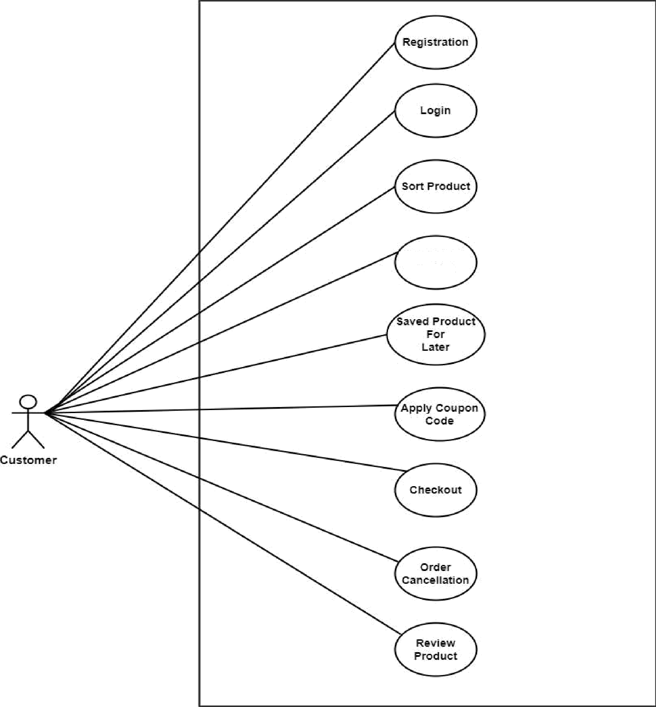

AddProduct To Cart

Figure5.6.2:Usecasediagramforcustomer

* + 1. UseCaseDiagramforAdmin

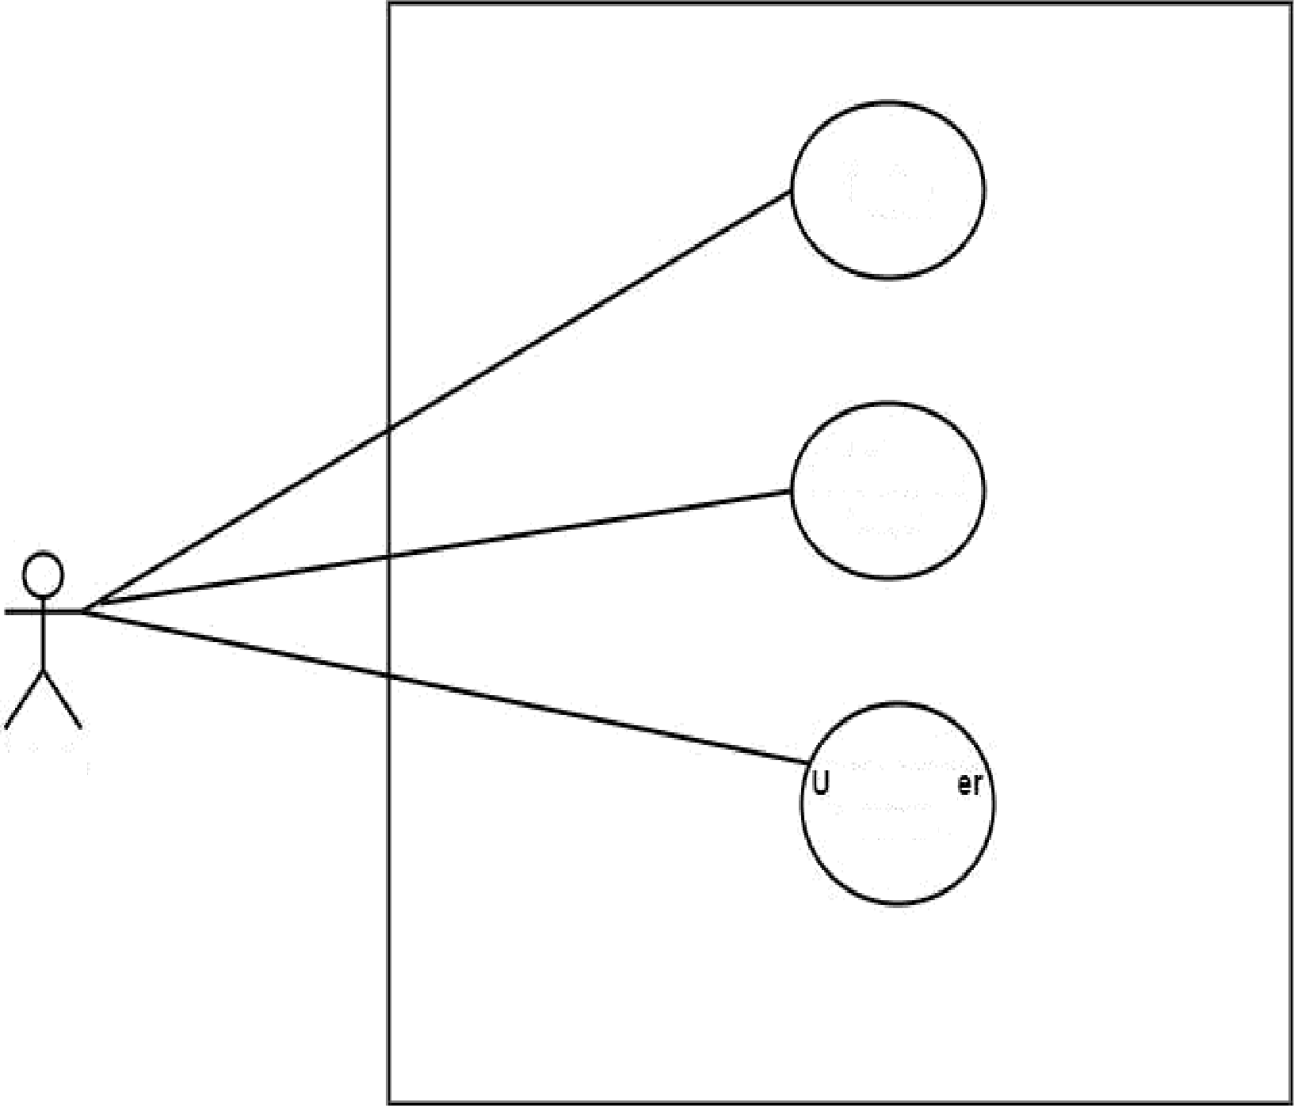

Login

SetCoupon

Code

Admin

pdateOrd Status

Figure5.6.3: Usecasediagramforadmin

* + 1. UseCaseDescriptionTable

Table5.6.4.1:Registration

UseCaseTitle Use Case ID Preconditions Actors



**SuccessEndCondition** Failure**EndCondition** Trigger

Description

Registration Uc-1.0

Userselecttheregisterformandfi11upit. Customer

Usersuccessfullyregister

Displayregistererrormessage“” Show user home page.

Afterallrequirementfieldfillupusercanregisterfor the

system.

Table 5.6.4.2:Login



UseCaseTitle

UseCaseID

**Login**

Uc-2.0

Preconditions

Actors



Success**EndCondition**

1. Usermust beregistered.
2. Userselecttheloginformandfi11upit. Customer, Admin

UsersuccessfullyLogin.

Failure**End Condition** Displayloginerrormessage“”

Trigger Description

Showtheuser homepage&admindashboard.

Aftertheuserloginthenusercanviewthehomepageand admin canviewthe admindashboard.

Table5.6.4.3:AddProducttoCart

UseCaseTitle **Add**ProducttoCart



UseCaseID Uc-3.0

Preconditions Userclicktheaddtocartoption.

Actors Customer

**Success End Condition** Product storeintocartsuccessfully. Failure **End Condition** Productdoesn't storeinto cartsuccessfully. **Trigger** Display success message.

Description Aftertheuseraddproducttocartthenhecancheckout.

Table5.6.4.4:SetCouponCode

UseCaseTitle Use Case ID Preconditions

SetCoupon**Code**

Uc-4.0

1. Adminneedtologin.
2. Adminselecttheaddcouponoption.

Actors Admin

**SuccessEndCondition** Couponaddsuccessfully done.

Failure End **Condition** Coupondoesn'tsuccessfullyadd. Trigger Display success message.

Description Theadmincanaddmultiple couponcode.

Table5.6.4.5:Checkout



UseCaseTitle

UseCaseID

Checkout

Uc-5.0

Preconditions

1. Userneedtologin.
2. Useraddproducttocart.

Actors Customer



**Failure End Condition** Ordercancellationdoesn't successfully done. Trigger Displayordercancellationsuccessmessage.

Description Afterorderproduct customercancancelledproductorder.

**Success End Condition** Product order successfully done. **Failure End Condition** Displaythebillinginformationerror. **Trigger** Displayorderconfirmationmessage.

|  |  |
| --- | --- |
| Description | For customer checkout they have must be registration or login first, fillup the billing information &click the button placeordernowthenshoworderconfzmation message. |

Table5.6.4.6: OrderCancelation

|  |  |
| --- | --- |
| UseCaseTitle | **OrderCancelation** |
| UseCaseID | Uc6.0 |
| Preconditions | 1. Userneedtologin. 2. Customerorder product. 3. Userclicktheordercancellationoptions. |
| Actors Customer,Admin | |
| **SuccessEndCondition** Ordercancellationsuccessfullydone. | |

Table5.6.4.7:UpdateOrderStatus



UseCaseTitle

UseCaseID

**UpdateOrder Status**

Uc-7.0

Preconditions

Actors



SuccessEndCondition FailureEndCondition Trigger

1. Adminneedtologin.
2. Adminselecttheordereditoptions. Admin

Orderstatusupdatesuccessfully.

Orderstatusdoesn't update successfully. Displayorderstatusupdatesuccessmessage.

|  |  |
| --- | --- |
| Description | Aftercustomerorderproductadmincanupdateorderstatus ‘ordered’,‘delivered’, ‘canceled’. |



**Success End Condition** Product review successfully done. Failure **End Condition** Productreviewdoesn'tsuccessfullydone.

Table5.6.4.8:Product Review

|  |  |
| --- | --- |
| UseCaseTitle | **Product**Review |
| UseCaseID | Uc8.0 |
| Preconditions | 1. Customerneedtologin. 2. CustomerOrderproduct. 3. Customer select the‘writeareview’ option. |
| Actors Customer | |

|  |  |
| --- | --- |
| **Trigger** Displaytheproductreview successmessage. | |
| Description | Aftercustomerorderproductstatusis‘delivered’then customergiveareview&ratingforhisorderproduct. |

* + 1. ActivityDiagramforAddProducttoCart

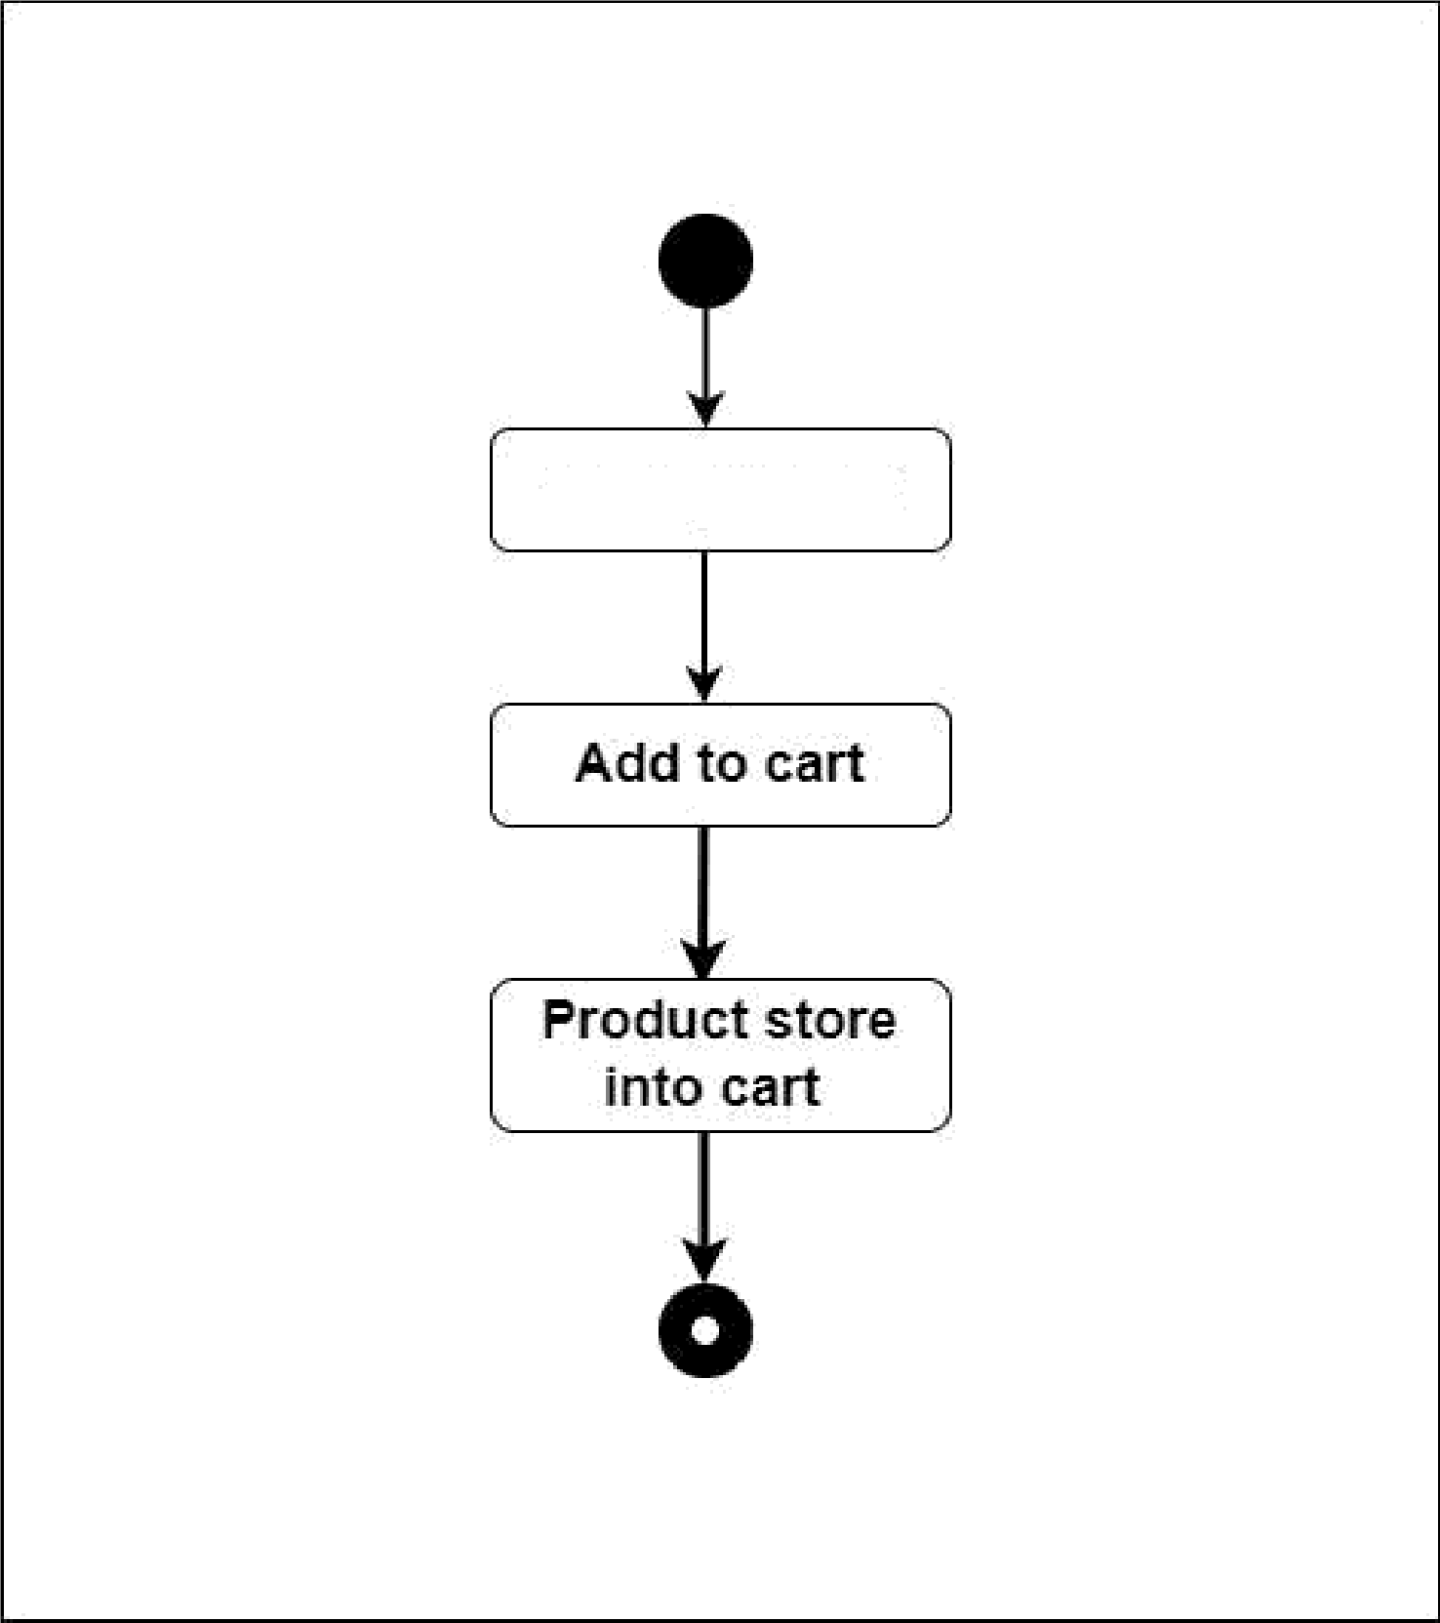

Viewproduct

Figure5.6.5:ActivityDiagramfor AddProducttoCart

* + 1. ActivityDiagramforSetCouponCode

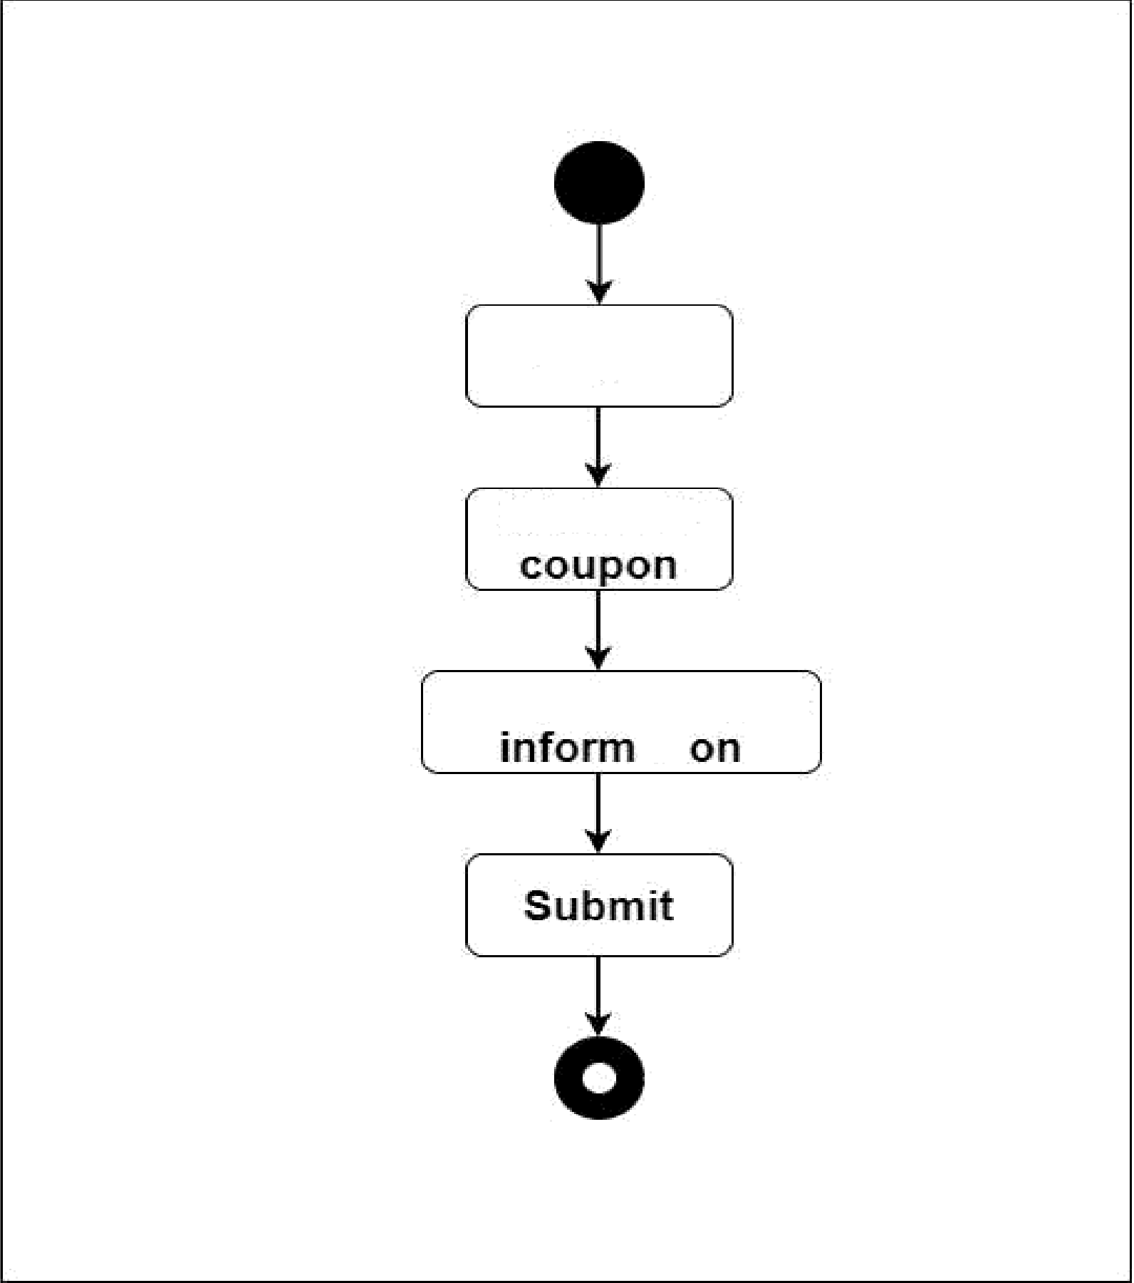

Login

Clickadd

Fillupthecoupon

ati

Figure5.6.6:ActivityDiagramforSetCouponCode

* + 1. ActivityDiagramforCheckout

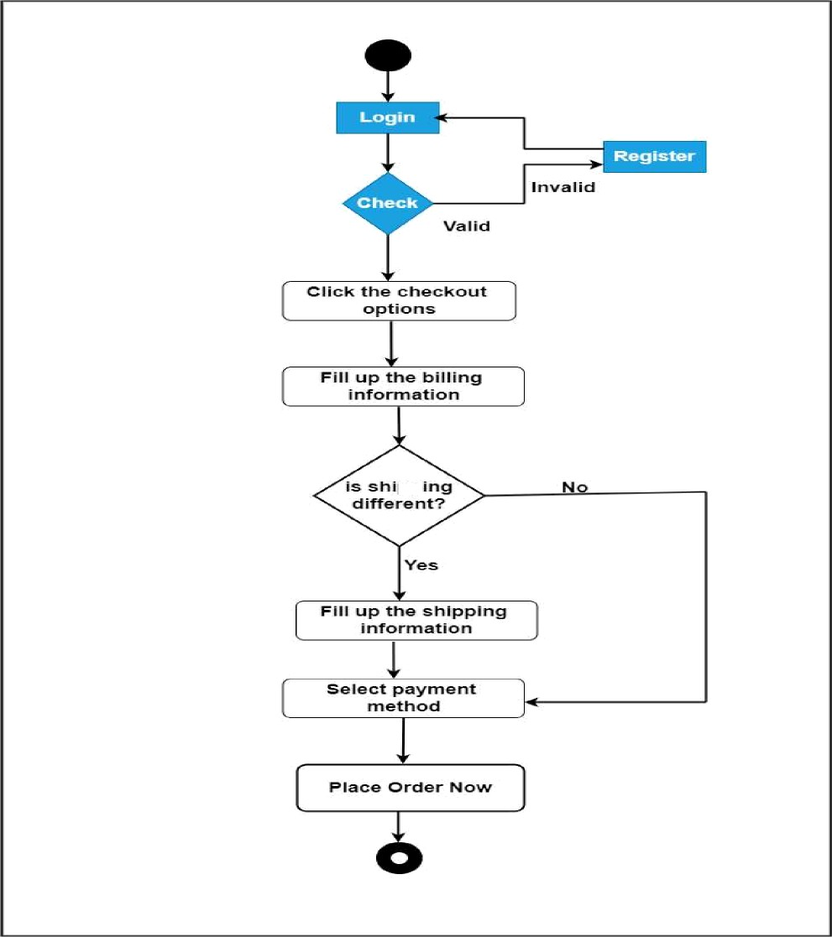

Figure5.6.7: ActivityDiagramforCheckout

* + 1. SequenceDiagramforUserLogin

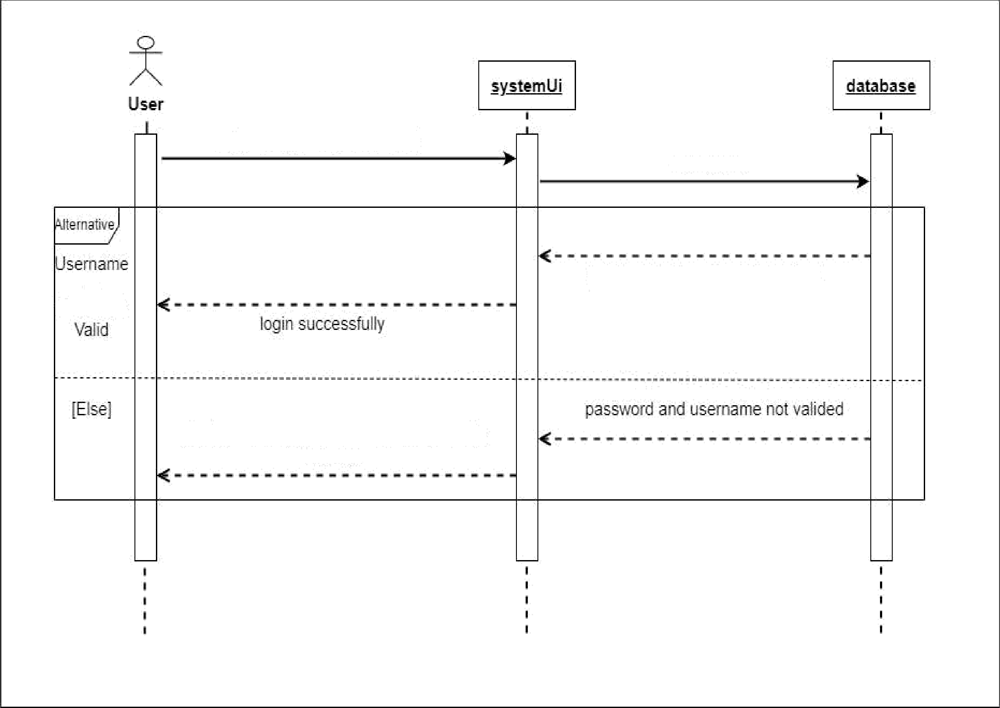

entryusernameorpassword

checkvalid

or

Pass'lord

pass’lardandusernamevalideJ

dsplaymessqeuemameorpavwndis

incorreE

Figure 5.6.8:Sequencediagramforuserlogin

* + 1. SequenceDiagramforcustomercheckout

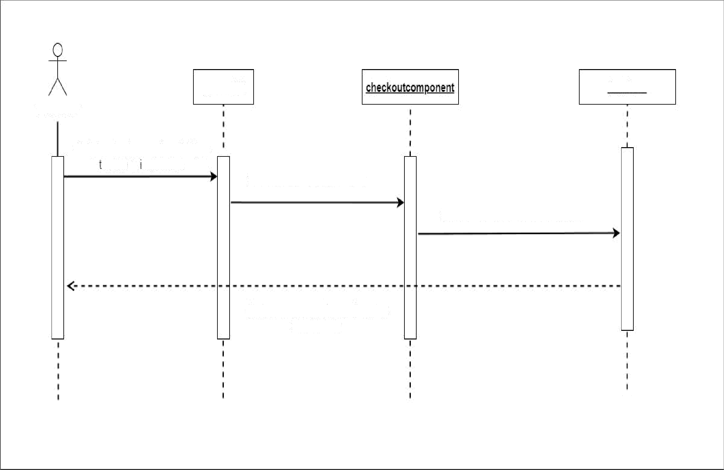

?ystemUi

database

Customer

St0refillinginformationindatabase

Figure5.6.9:Sequencediagramforcustomercheckout

* + 1. 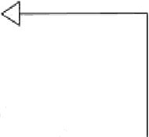ClassDiagram

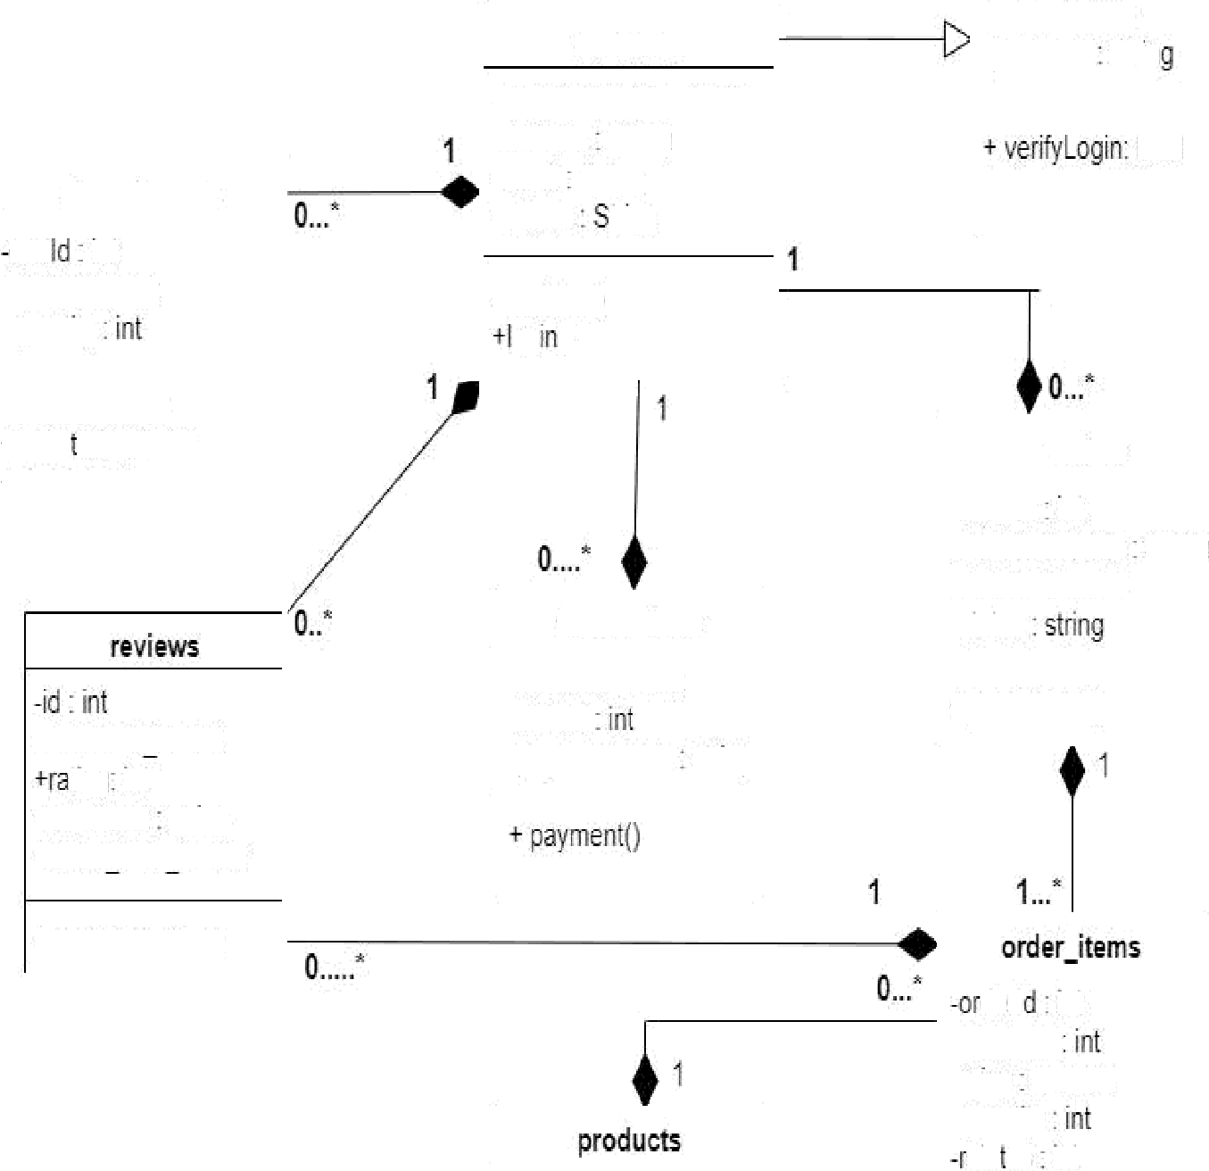

bool

-email:String

-passwordStrin

user

|  |
| --- |
| administrator |
| —adminName:String |
| *updaleCatalog:bool |

1

*place0rder()

-orderldint

-customerNameString

-customerld:int

-status

orders

-rustorrerName:String

-addressString

emailString

-mobile tring

*register()

og()

|  |  |
| --- | --- |
| shoppingcart | |
| cart int  -productld:int  -quantiy | |
| addCartltem()    cherk0ut() | |
|  | -customerid:inttingint  *commentsnng  +orderitemid:int  *subnitRev\ew() |

|  |
| --- |
| cansactions |
| -customerld:int  -orderld  -paymertModestring |
|  |

|  |
| --- |
| order_detaiIs |
| -orderld:int  -proouctld:Int  -proouctName:String  -quantiy:int  -subtotal:decimal  -taxdec›ma!  -totaldecimal |
| *calcPrice{) |

-id:int

*name:string

+image:strong

*pricedecimal

*dE'5CfiDti0flSlfi0g

derlint

-proouctld

-pricedecimal

-ouantigstausint

Figure5.6.10: ClassDiagram

* + 1. DatabaseDesign

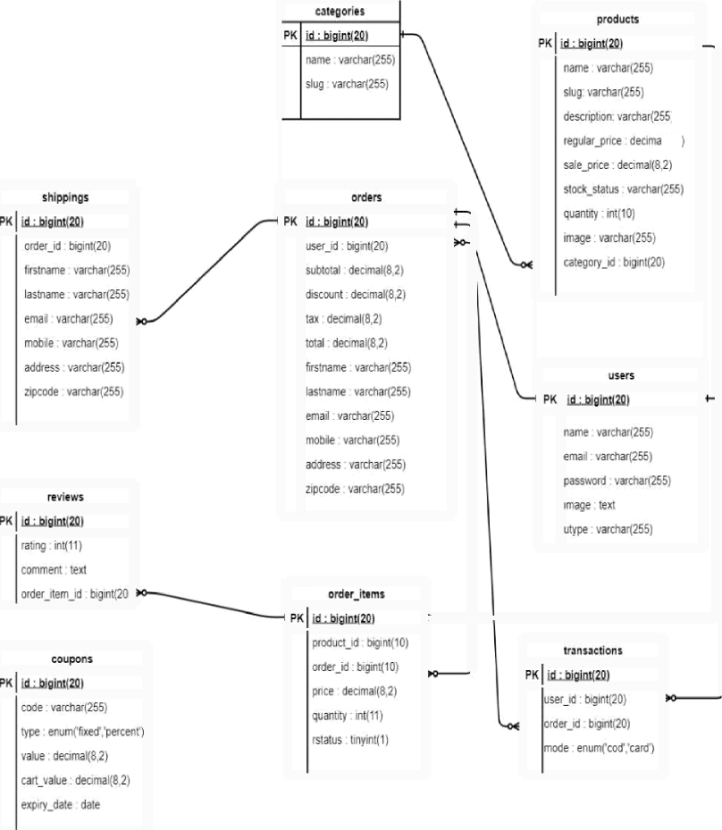

|  |  |
| --- | --- |
|  | |
|  | |
|  | |
|  | |
|  | |
|  |  |
|  |  |

|  |
| --- |
|  |
|  |
|  |

|  |
| --- |
|  |
|  |
|  |

|  |
| --- |
|  |
|  |
| isentiÏiervarchar(255}ins!anccvarCŁai2*č) |

Figure5.6.11:DatabaseDesign

* + 1. Challenges

My challenge in this project is to understand the concept. When I have begun work on this project,Ihave facedsome issues onlogic implementationand Ihave covered those issuesby consulting withourproject manager.

* + 1. TechnicalFindings

When Idoing thisproject, Ihave found some technical terms and different worktypes. From them, I have learned use of the Laravel framework, many laravel packages & JavaScript. Software developmentcanbedoneeasilywiththehelpofLaravel &JavaScript.Also learned howtonormalizedatabasesandwritegoodSQLqueries.

* + 1. UserManual
       1. **Registration**

Thisiscustomerregistrationpage.Herecustomercanregistration.

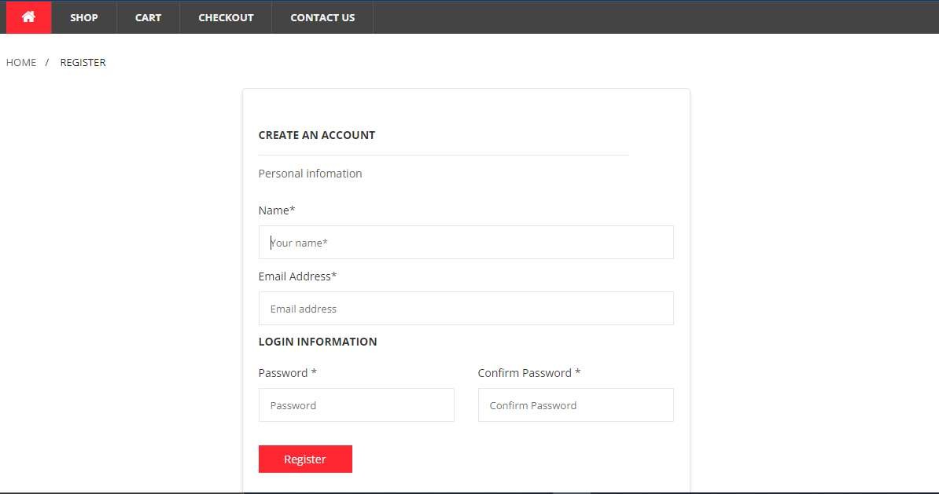

Figure5.6.14.1:Customerregistration

* + - 1. Login

Thisiscustomerloginpage.Herecustomercanlogin.







* + - 1. HomePage

Thisiscustomerhome page.



Figure5.6.14.2:Customerlogin



Figure5.6.14.3:Homepage



* + - 1. ShopPage:

Hereisshop page.Inthis pagecustomercanviewproduct&addtocartproduct.



shop



POPULARPRODUC+S



400



400

.,....



$SOO

 

B4OO



Figure5.6.14.4:Shop page

* + - 1. :ProductDetailsPage:

Inthispagecustomercanviewproductdetailsandproductreview.



c›dto€crI



to

SH.iP.mM

 



Figure5.6.14.5:Productdetailspage

* + - 1. CartPage:

Afteraddproducttocartcustomercanviewthiscartpage.



SMOG CART CHECKOU? CONTACTUS

HOME/CART

PRODUCTSNAME

Laptop

ORDERSUMfdARY

Subtotal



<hiqping

Total

Ihavecouponcode

continueShopping0

CLEARSHOPPINGCART

* + - 1. CheckoutPage:

$400

Figure5.6.14.6:Cartpage

$400.0D



S40D.00

B20.00

Free Shipping

S420.00

Inthispagecustomercanprovideherbillinginformationforcheckout.





Line1:

Phonenumbei

unez:

*'otoe721P cf



Figure5.6.14.7:Checkoutpage

* + - 1. Paymentmethod

Herecustomercanselectpaymentmethod

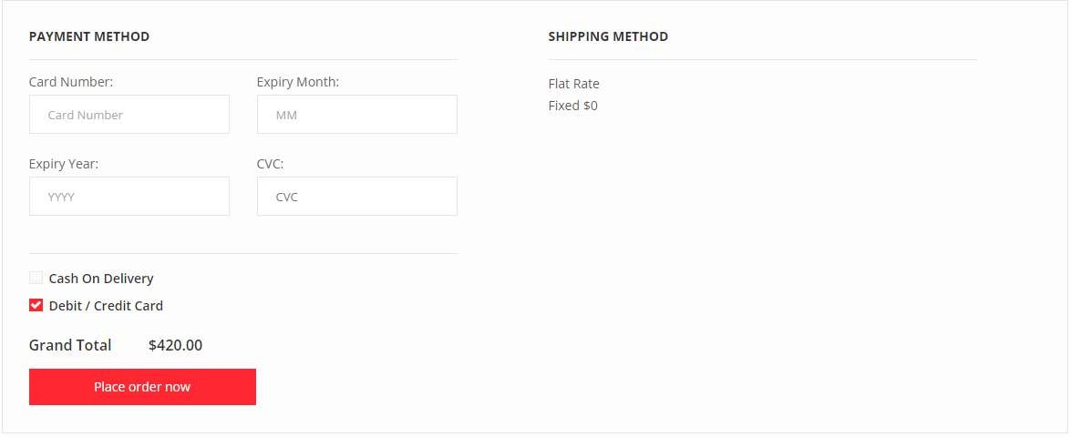

Figure5.6.14.8:PaymentMethod

* + - 1. CustomerDashboard

Thisiscustomerdashboardpage.Here customercanviewhertotalcost,totalpurchase,total delivered&totalcanceledorder.Andalsocanviewherorderdetails.

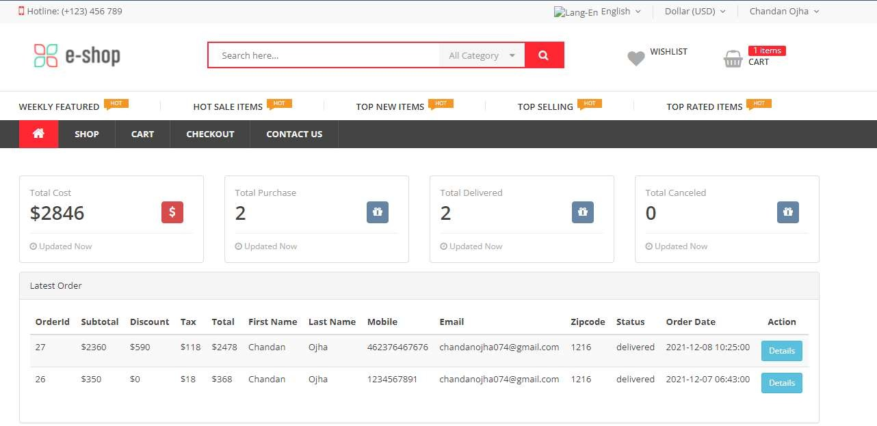

Figure5.6.14.9:Customerdashboard

# Chapter6:Experience&Achievements

##### OvercomeProblems andDifficulties

As a fresher, I had drawbacks on my skill before joining BugsBD Ltd. It takes some time to make me appropriate for working in a company. During my internship period, it was a very challenging time for me. Iuseto come late fromthe office. Itrytodomy best to finish every day's task. Sometimes I don't, so Ihave to work at myhome. But Imanaged it. At first, there wasaproblemwiththeLaravelframeworkbecauseitwasnewtome.Andnotabletosolvethe problemthefirsttime.Asdidnotunderstand howtobeginworkonit.ThenIgothelpfromthe project manager. Ihavemoreover searched forresourcesongoogle.Ihavelearnedalotabout theofficeenvironment,proficientlife,andcolleaguebehavior.AsIwasnewinprofessionallife, therewere afew challenges tome.

##### AbilitytoLearn

Changes can make people either undying or standard. In my case, there happened a radical changeinmetoo.Somewayoranother,Ihavethepoweroflearningworkexceptionally well. Computer made me presented to a few modern tools and technologies to work in a group environment,averyefficient wayforquick knowingsoftwaredevelopment.

##### Working Practices

During myinternship period, Ihavepracticed sometopicstomake myabilitystronger.ThereI havealsopickedupadvanced knowledge aboutclientservice. Ihave learned howtosupply clientservice.Someofmyworkingareasaregivenbelow-

* + 1. FullStackWebDevelopment

From starting work in this company, I have worked on full-stack web development. I have learned the software development life cycle. I have worked on how to make good quality software.WhereIusethetechnologyHTMLS,CSS5,JavaScript, Laravelframework&SQL.

* + 1. **Design**Pattern

Itrytousedesignpatternsinmyproject.Ithelpsfurthermaintain,codereusability.

##### TechnologyEnhancement

Nowadays the technology isincreasing daybyday, but it isnot muchsecure. Thething that I havefacedislakehowtoprovidesecurityforreallifeprojects.Ialsolearnsometechnicalterms laravelsanctum,livewire&voyageradminpackage.

##### Non-TechnicalGrowth

Non-technicaldevelopmentor softskillisthatwhichhelpstoennoblecarryouttechnicalskill

andmethods

•t•StrongWorkEthicatOffice.

•t•PositiveAttitude.

•t•GoodCommunicationSkills.

•t•TimeManagementAbilities.

•t•WorkWithTeam.

##### Achievement

Whenapersonhascontributedhisefforttohisprofessionallife,theresultmustbefoundoutata certaintimelater.Ihavealsoreachedmygoal.WhenIhavestartedworkingwiththiscompany, Ihave faced a lotofissues asbeing present attheoffice indue time, completing theassigned work intime.After Iovercome allthat lack. Ihave also faced technical problems while Iwas appointed thatproject aslikeusing laravel,voyager adminpackage,MySQLstoreprocedure, etc. It took time to move forward with these issues. I have gained both technical and non- technicalknowledge working inthisindustry.Whichisreallyveryhelpfulformetodobetter in myprofessionallifelater.BydoingthisinternshipIammoresustainableaboutthesenseoftime, bemoreeffective onassignedprojects.

Iwould like tothank mysupervisor, myproject manager at BugsBD Ltd. and myteachers in DaffodilInternationalUniversityformyachievement.

### Chapter7:Conclusions&Recommendations

###### Summary

BugsBDLtdisoneoftheleaderinprovidingsoftwaredevelopmentservices.Theyensurethat theircustomersaresuccessfulbyunderstanding andbeingresponsivetotheirneeds,aswellas working collaboratively with them to provide one-stop faster, cost-competitive and scalable services.IhaveworkedwithBugsBDLtdSoftwareDevelopmentteam.Heremanyfindingsand analysisweretalkedabout akeadywherethecompanycanhavethedevelopments. Doingthis study I have gained the practical knowledge of software development. Besides knowing the corporate culture, thisreport hashelped metoget acomprehensive idea to grow inmyfuture endeavor. As a final point I would say that recruitment process of BugsBD Ltd is also contemporaryandharmoniouscompared tootherorganizationsintheindustry.

##### FindingandContribution

Beforestartingthisinternee,Ihavelearnedmanythingsfrommyuniversitycourseswhichhave alotofhelpinmyinternshipresponsibilitieswiththisorganization.Fromthisinternship, Ilearn tosoftware development lifecycleandalsothereIhavegot change touseand implement my learningmanytypesofreallifeproblems &projects.

This internship program made me established to the professional company culture and the technology. It has helped me to develop good judgment, proceed on my own in new technological challenges, andbetteranalytical skills. During teamdiscussions, brainstorming sessions, business process helped me to identify and solve numerous numbers of issues that wouldhavebeenimpossible tosolve.

##### Recommendationforfuturework

Therecentjobmarketisastoughforfresher'sespeciallyincountrieslikeBangladesh.Because ofeachyear,therearelotsofstudent completedtheirgraduates.But mostofthemdidnotfind theirdesirejobs.Oneofthemainreasonsforthisissuethattheyhavenoexperienceonhowto faceaprofessionallifeoracorporatelife.

We areable overcome thisissuetobeutilized toawork life.Forinternship this iswould bea greatchoicefornewgraduates.Asafresher,Ihavealsolotsofdrawbacksthatcouldfallmein bigtroubleifIdidnothavetheopportunitytocompletetheinternship.

References

* + 1. Companywebsiteaddress:https://bugsbd.com/
    2. Bitbucketlink:<https://chandan932@bitbucketorg/chandan932/ecommerce.git>

43

fiDaffodilInternationalUniversity