Superstore Sales Data
Import, Power Query & Data Cleaning
Week 1 – Documentation Report
Prepared in Power BI Desktop – Power Query Editor
Name:Kamali V
Roll.no:E25DA023
Dept:Bsc.DS and AI

Objective
A retail organization wants to analyze its sales data to understand customer purchases, product categories, regional performance, and profitability. Before creating a business intelligence dashboard, the raw Superstore dataset must be imported, cleaned, transformed, and prepared in Power BI using the Power Query Editor.

Tasks Covered
- Load the Superstore CSV file into Power Query Editor.
- Promote headers and correct column data types.
- Standardize text formatting across columns (e.g., convert Ship Mode to uppercase).
- Duplicate and reorder the Order Date column for further transformation.
- Change data types using regional locale settings (Date/Time and Date).
- Extract the Day component from the Order Date column to create a new custom date attribute.

Step 1: Inspecting Data Types and Exploring Transform Options
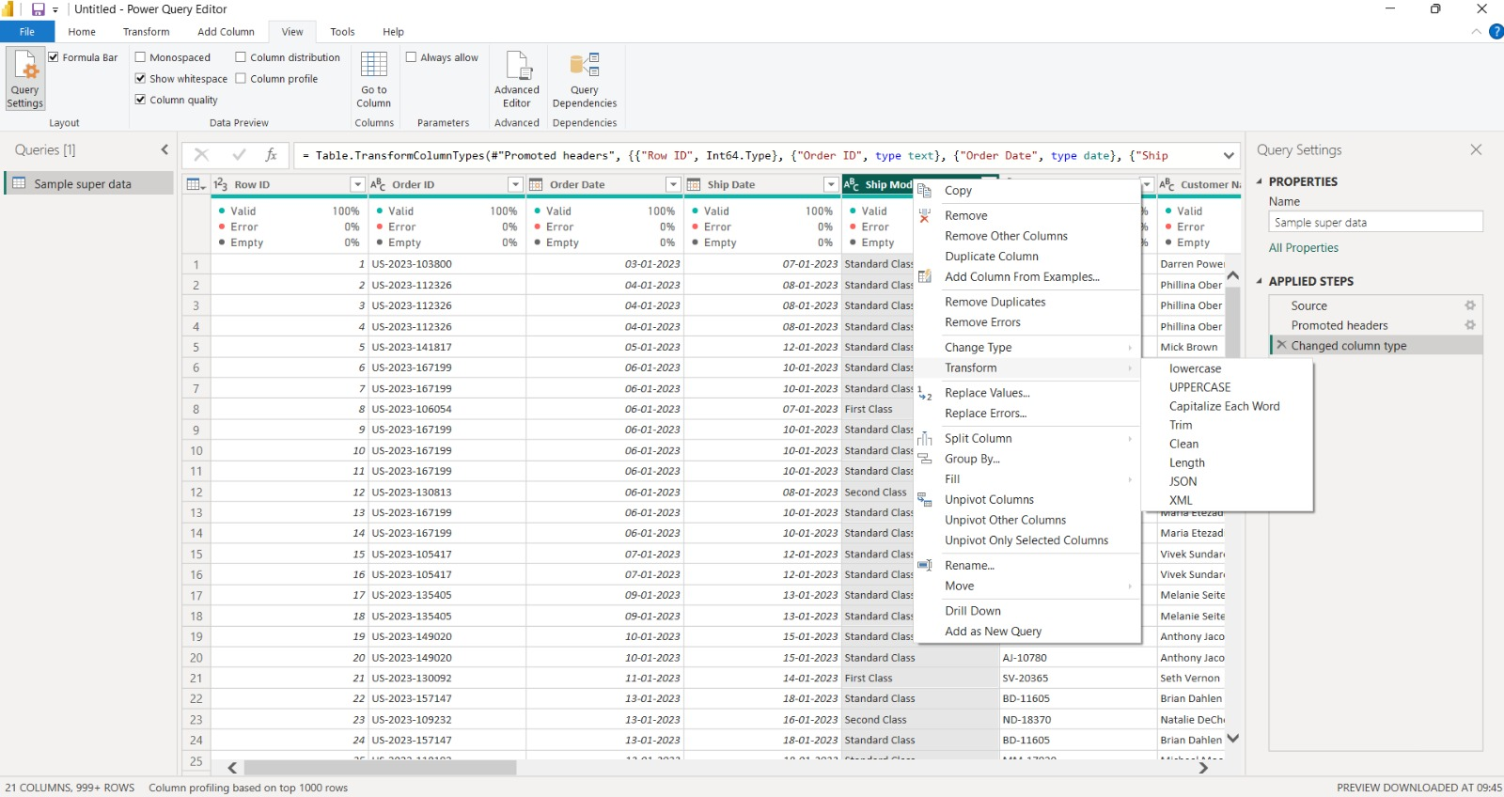

After loading the Superstore dataset into Power Query Editor, the headers were promoted and column data types were set (visible in the Applied Steps pane: Source → Promoted headers → Changed column type).
The formula bar confirms the applied type coercion: Row ID as a whole number (Int64.Type), Order ID as text, and Order Date as a date type.
The right-click context menu on the "Ship Mode" column shows the available Transform options (lowercase, UPPERCASE, Capitalize Each Word, Trim, Clean, Length, JSON, XML), which are used to standardize text formatting across categorical columns.

Step 2: Duplicating and Reordering the Order Date Column
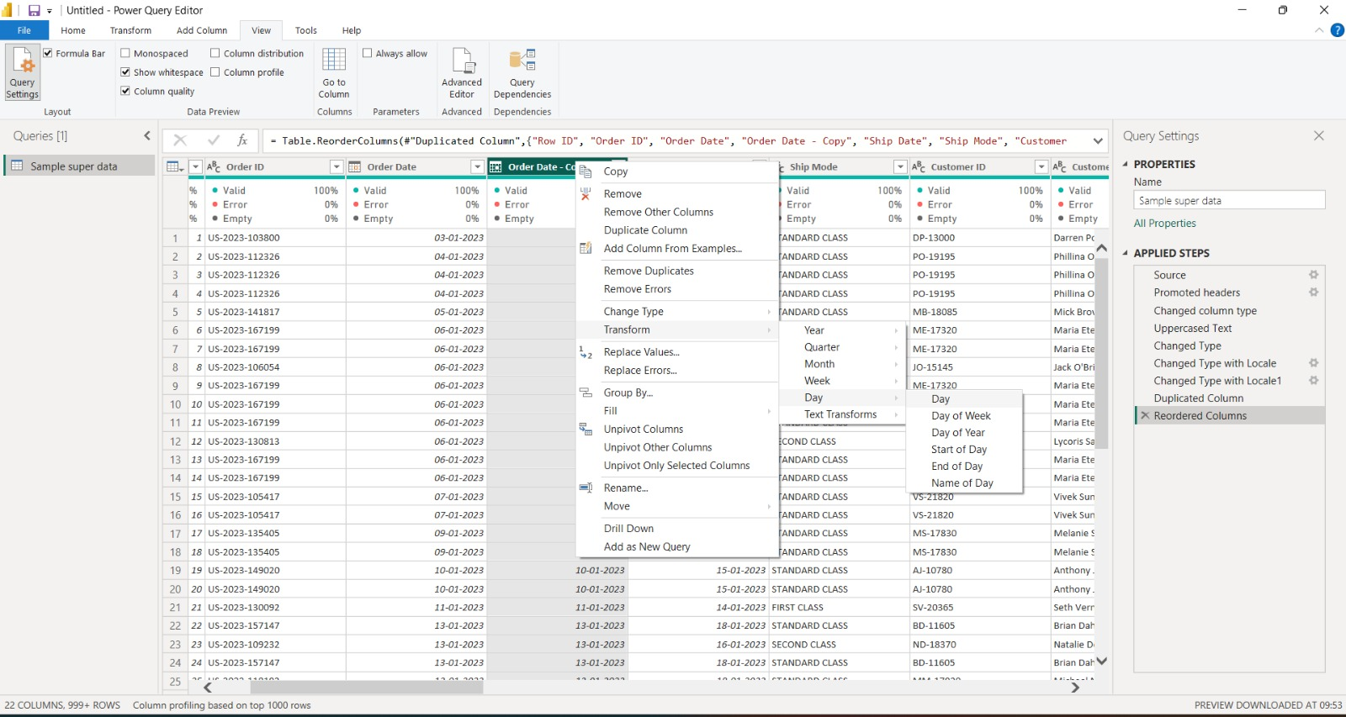

The "Ship Mode" text was converted to UPPERCASE and the Order Date column was duplicated to preserve the original date while creating a working copy ("Order Date - Copy") for extracting date parts.
The Applied Steps pane now shows: Changed Type, Changed Type with Locale, Changed Type with Locale1, Duplicated Column, and Reordered Columns, reflecting the sequence of transformations performed so far.
The right-click Transform menu on the duplicated column displays the Date transformation options, including Year, Quarter, Month, Week, and Day, with the Day submenu expanded to show Day, Day of Week, Day of Year, Start of Day, End of Day, and Name of Day.

Step 3: Changing Type with Locale (Date/Time – English India)
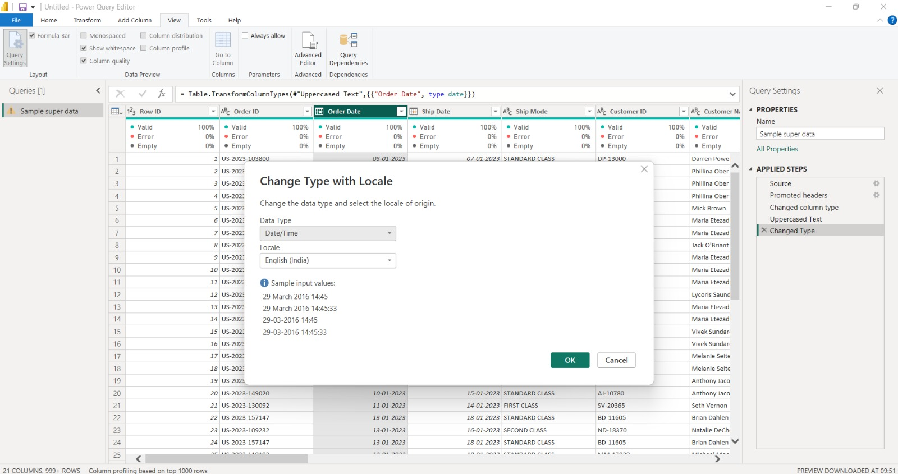

The "Change Type with Locale" dialog is used to explicitly define how the Order Date text should be interpreted when converted, since date formats vary by region.
Here, the Data Type is set to Date/Time using the English (India) locale, and the sample input values (e.g., "29 March 2016 14:45") confirm the day-month-year format expected from the source data.
This step ensures the Order Date values are parsed correctly before further date-based calculations are performed.

Step 4: Extracting the Day Component from the Date
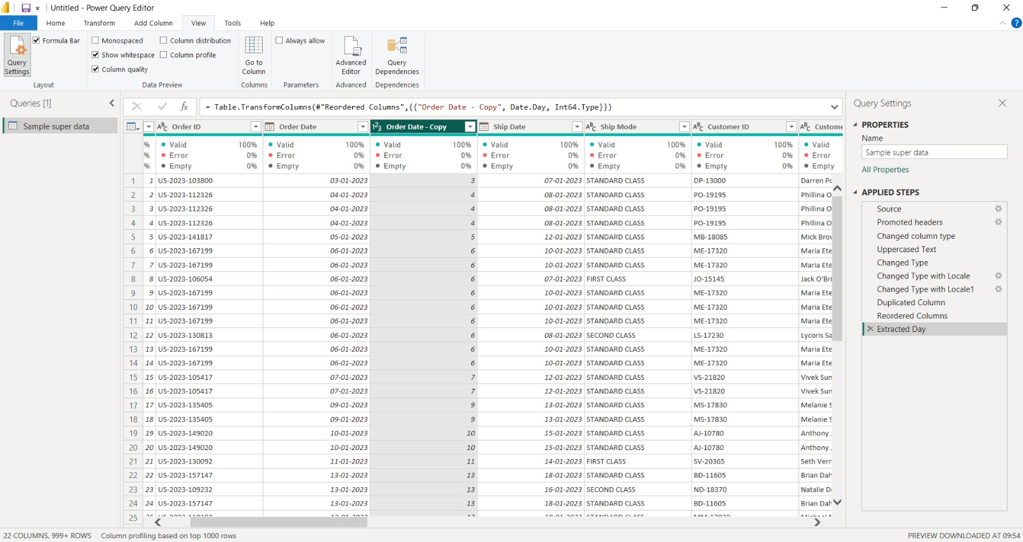

With the Order Date - Copy column reordered next to Order Date, the Date.Day function is applied via Table.TransformColumns to extract just the day number from each date, converting the result to a whole number (Int64.Type).
The Applied Steps list confirms the full transformation chain up to this point: Changed Type with Locale, Changed Type with Locale1, Duplicated Column, Reordered Columns, and Extracted Day.
The preview pane shows the new column now containing only the numeric day value (e.g., 3, 4, 5, 6...) for each order, ready to be used as a custom date attribute in later analysis.

Step 5: Changing Type with Locale (Date – English United States)
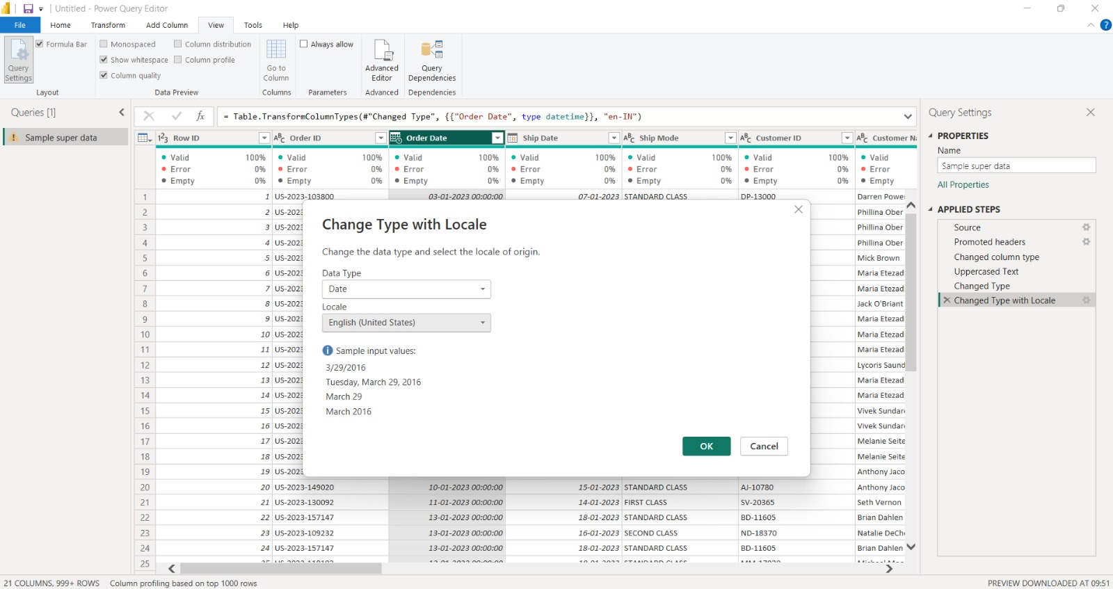

In this step, the Order Date column's data type is changed again, this time to Date only, using the English (United States) locale.
The sample input values (e.g., "3/29/2016", "Tuesday, March 29, 2016") demonstrate how the same underlying date can be displayed in different regional formats depending on the locale selected.
This confirms that locale settings directly affect both how Power Query interprets text as dates and how those dates are subsequently displayed.

Conclusion
Through this Week 1 exercise, the raw Superstore sales dataset was successfully imported into Power BI Desktop and processed using the Power Query Editor. Column headers were promoted, data types were verified and corrected, and text fields such as Ship Mode were standardized to a consistent case.
The Order Date column was duplicated and reordered so that its original values could be preserved while a new custom attribute — the Day of the order — was extracted using the Date.Day function. Along the way, the "Change Type with Locale" feature was used twice: first to interpret the Order Date as a Date/Time value under the English (India) locale, and later to convert it to a plain Date value under the English (United States) locale. This highlighted how locale settings govern the way Power Query parses and displays date and time values, which is critical when source data originates from a different regional format than the reporting locale.
Overall, these transformations demonstrate the core data cleaning workflow required before modeling: inspecting attributes, correcting data types, standardizing text, and deriving new temporal attributes (Day, and by extension Year, Quarter, Month, and Day of Week) from a single date field. The resulting clean, well-typed table is now ready to be loaded into the data model and used as the foundation for the Week 2 tasks — building relationships, DAX measures, and the interactive Superstore Sales Dashboard.

