APPLIED SCIENCE UNIVERSITY (ASU)
FACULTY OF INFORMATION TECHNOLOGY (FIT)



Sentiment Analysis: Analyze and classify the sentiment (positive, negative, neutral)

Course: Natural Language Processing (NLP)
Instructor: Dr.Mohammad Bani Doumi

  - Done By: Zain Dimes (202310639), Renad Imraiziq (202210374), Kamal Hasan (202110466), Laith Aljallad (202320510)

1. Introduction and Objective
Patient feedback is a critical resource for healthcare providers to gauge the quality of their services. The primary objective of this project is to analyze unstructured patient stories and feedback to automatically classify the general satisfaction level as Positive, Negative, or Neutral. By applying Natural Language Processing (NLP) techniques, specifically unsupervised sentiment analysis, we aim to provide a quick and effective overview of patient sentiment without the need for manual labeling of large datasets..

2. Dataset Description
- Source: The dataset consists of patient stories collected from hospital services.
- Size: The dataset contains 199 textual entries.
- Preprocessing: To ensure the quality of the analysis, we applied a rigorous data cleaning pipeline using Python (Regular Expressions):
  - Normalization: All text was converted to lowercase to ensure consistency (e.g., treating "Good" and "good" as the same).
  - Noise Removal: We removed non-alphabetic characters, including numbers, punctuation, and special symbols, to focus solely on the linguistic sentiment.
  - Whitespace Handling: Extra whitespaces and newline characters were removed.

3. Methodology
Since the provided dataset consists of unlabeled text, we adopted an Unsupervised Lexicon-Based approach using the TextBlob library.
- Sentiment Scoring: The model calculates a "Polarity Score" for each story based on a predefined lexicon of adjectives and phrases. The score ranges from -1.0 (Most Negative) to +1.0 (Most Positive).
- Classification Logic:
  - Positive: Polarity Score > 0
  - Negative: Polarity Score < 0
  - Neutral: Polarity Score = 0

4. Model Validation

To evaluate the reliability of our unsupervised model, we conducted a manual validation on a random sample of the data.
- Sampling: We selected a random sample of 10 stories from the dataset.
- Manual Labeling: Each story in the sample was manually read and labeled by the group members.
- Comparison: We compared the manual labels with the TextBlob predictions to check for discrepancies. This step allows us to estimate the accuracy of the model in a real-world scenario.
ID | Story Snippet (First Words) | Model Prediction | Manual Label | Result
34 | "I have struggled with ocd for many years... But at Bromley..." | Positive | Positive | ✅ Match
140 | "I am 26years old. My sister comitted suicide... I am so glad I listened..." | Positive | Positive | ✅ Match
59 | "I used e-consult yesterday... was first rate. I felt privileged..." | Positive | Positive | ✅ Match
96 | "I attended my regular appointment... procedure was excellent..." | Positive | Positive | ✅ Match
64 | "Impossible to contact by phone... No option at all just engaged..." | Negative | Negative | ✅ Match
163 | "Please could you consider making address changes available online..." | Positive | Positive | ✅ Match
111 | "Been on the waiting list for years. No support in place..." | Positive | Negative | ❌ Mismatch
31 | "I felt desperate... But since having counselling... Depression has lifted." | Negative | Positive | ❌ Mismatch
18 | "From bingo to compound karaoke... Big Thanks to all of them :)" | Neutral | Positive | ❌ Mismatch
24 | "I had to go for a CT scan and cannot thank the staff enough..." | Neutral | Positive | ❌ Mismatch

5. Results

After processing the 199 stories, the sentiment distribution was as follows:
- Positive: 168 stories (84.4%)
- Negative: 26 stories (13.1%)
- Neutral: 5 stories (2.5%)
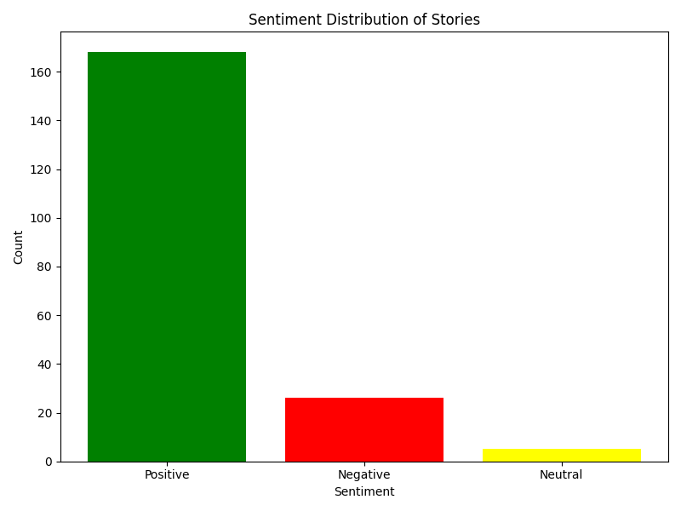

6. Discussion
The analysis reveals an overwhelmingly positive sentiment (approx. 84%) towards the hospital services. Patients frequently used words related to "helpfulness," "efficiency," and "caring staff."
Detailed Error Analysis: Through manual validation of 10 random samples (Table 1), we achieved an accuracy of 60% on this small subset, revealing specific limitations in the lexicon-based approach:

Sarcasm & Complex Negation (Story 111): The model incorrectly classified this story as Positive. The patient wrote "Am I worth support? Clearly not... with the story of severe lack of professionals." The model likely focused on positive keywords like "support," "worth," and "fabulous" (if present in lexicon) while ignoring the complex negation and complaining tone.

Contextual Sentiment (Story 31): Classified as Negative due to words like "desperate" and "torture." The model failed to understand that these words described a past condition that has now been resolved ("Depression has lifted").

Phrase Misinterpretation (Story 24): The phrase "cannot thank the staff enough" is highly positive. However, the model likely interpreted "cannot" as a negation reducing the score, or the sentence was too short to accumulate a positive score, resulting in a Neutral classification.

7. Conclusion
The project successfully implemented an NLP pipeline to analyze patient feedback. The unsupervised method proved effective for generating immediate insights from unlabeled data. The results indicate high patient satisfaction, though manual validation suggests the need for more advanced models to handle complex negative feedback accurately.

8. References
- Bird, S., Klein, E., & Loper, E. (2009). Natural Language Processing with Python. O'Reilly Media.
- Loria, S. (2018). TextBlob Documentation. Release 0.15.2.

