* 1. **Existing System**

Welcome to newly designed website of crypto information and some of the well-known Crypto Exchanges. Currently crypto values are kind of sensitive in time if the value is displayed in latency, it will create a major issue in financial condition. To prevent financial issue we have very limited amount of resources and in that we don’t get all information of different crypto at same time . we need to have more reliable on different web application for all these details.

* 1. **Need for the New System**

Our old system needs to go to different website and different crypto wallet site and need to create profile for view the details of crypto. Some of the famous web applications are having some of the limited functionality.

* 1. **Objective of the New System**

We developed react web application to save time, money and energy. We added some of extra function and create light web application to load data fast. We added some of the extra functionality of check price in different currency .We added some of the modules with we can show the data of different time interval of time with percentage .

**1.4. Problem Definition**

* **PROBLEM STATEMENT**
* **Problem Scenario:**

In current time crypto market has volatile and need to be more sensitive for on time price display. Some of the websites started some of the crypto information with chart but in that they have very limited amount of options to display. In Current crypto web application have too much more load so that sometimes it need more data , storage , processing speed to perform the task.

* **Proposed Solution:**

The main purpose that the big tech giants created more number features with more number of possible and user friendly options. In traditional system need to have only few numbers of crypto coins and has some specific crypto exchange to perform any operation. We have more than 132 pages of crypto coins and each page has 100 coins sorted in market cap . Not only this we have 100 crypto exchange website connected for any kind of financial transaction if user required . The services provided here are,

1. View thousands of crypto coins
2. Have details of crypto in price, chart, difference in price since market open for transaction.
3. Have chart to get more accurate knowledge in difference in price
4. Have 100 crypto Wallet website so that perform financial transaction.

**1.5. Core Components (Feasibility Study): -**

**(1). Technical Feasibility :**

This Page Gives Technical Information About used hardware and software and software in our project.

**1 Editor**: Microsoft word

**2 Browser:** Firefox

**3 Servers**: Coingecko

**4 UI** : Chakra

**5 Frontend:** HTML, CSS, JS, Bootstrap

**6 RAM:**8.00 GB (5.85 GB usable)

**7 Hard disk: 6**4-bit operating system x64-Based processor

**8 Processor:** Intel(R)Core (TM)i3-6006UCPU@2.00GHz1.99GHz

**9 Screen:**17 Inches

**10 Devices:** Keyboard, Mouse

**(2). Economical Feasibility :**

This phase gives economical information about used Hardware and Software in our Project.

**1.Software use**: Microsoft Academic Alliance campus license

– All Microsoft Product

**2. Operating System**: Windows 10 Pro (64 bits)

**(3). Operational Feasibility :**

* **Request Approval: -**

Analysis approved the demands of user and ready to develop the project. We can go through the Investigation process and Ready/agree to develop this project.

**1.6. Project Profile**

* **Project Title**: “Crypto Information Exchange”
* **Hardware**:8.00 GB RAM 64-bit operating systems
* **Operating System** :Windows-10
* **Front End**: HTML, CSS, BOOTSTRAP, React JS
* **UI**: Chakra,
* **Documentation Tools**: Microsoft Word
* **Project Guide**: Prof. Sunil Bajeja
* **Project Duration**:3 Months
* **Prepared By**: Kamal Khakhkhar, Jayesh Nakiya
* **Submitted To**: GTU, Ahmadabad.

**We have created information system. For user module: -**

* **User Module: -**
  + See Crypto exchanges list
  + Redirect to crypto exchange website
  + See crypto coins list
  + See crypto information
  + Redirect to crypto wallet for transaction .

**1.7. Assumptions and Constrains**: -

* **Assumptions:**
  + The requirements stated in the SRS could be affected by the following factors:
    - One major dependency that the project might face is the changes that need to be incorporated with the changes in the policies regarding different services.
    - As the policies changes the system needs to be updated with the same immediately.
    - A delay in doing the same will result to tremendous loss to the organizers.
    - So, this should be changed as and when required by the developer.
    - Another constraint relating to the operating environment is that we are specific to chakra UI based.
    - Such condition shall be taken care of.
    - At this stage no quantitative measures are imposed on the software in terms of speed and memory although it is implied that all functions will be optimized with respect to speed and memory.
    - It is furthermore assumed that the scope of the package will increase considerably in the future.
* **Constrains:**
  + The major constraints that the project has are as follows:
    - The information of all crypto coins are coming from web server user need proper stable connection.
    - The number of coins visit is one at a time.
    - After five unsuccessful fetch of information user need to check connection or need to enter proper page name to redirect.
    - For crypto transaction user need to follow all the condition of respective crypto website.
    - All the data comes from Coingecko .

**1.8. Advantages & limitations of project: -**

* **Advantages:**
  + Web application has light weight API call so it will load fast.
  + With chakra ui user get more attractive look .
  + User can see all available crypto coins in market.
  + Have real time update in price.
  + User can compare price with chart.
  + Users have idea about price in various currency options.
  + User get chart to get more precise information.
  + User get option to get value by many different currency
  + Users have multiple options for crypto wallet.
* **Limitations:**
  + You need internet access. Reliable internet access is required to check price and other information of crypto and crypto wallet websites.
  + User need crypto wallet for transaction .

**2. Requirement Determination &System Analysis: -**

**2.1. Requirement Determination**

We have collected information/requirements from Magic bricks and analyzed the data and then modified the data and developed our system.

**Hardware Requirements:**

|  |  |
| --- | --- |
| **Technical Requirements** | **How Accomplished?** |
| Processor | Intel(R) Core (TM) i3-3217U CPU @ 1.80GHz 1.80 GHz |
| RAM | 4 GB or Above |

**Software Requirements:**

|  |  |
| --- | --- |
| **Technical Requirement** | **How Accomplished?** |
| Front End | HTML, CSS, React JS, Bootstrap, |
| Server | Coingecko |
| Technology Used | React JS |
| Editor Tools | Notepad/ Sublime/ Vs Code |
| UI | Chakra UI |
| Operating System | Microsoft Windows 7, 8, 9, 10, 11/Linux |

**2.2. Targeted Users**

We created this website for users who wants to get only price of different crypto but needs more function to compare at one place with different chart , Time intervals, currency and have wallet in any registered crypto wallet.

**3.System Design: -**

**3.1 Use Case Diagram**

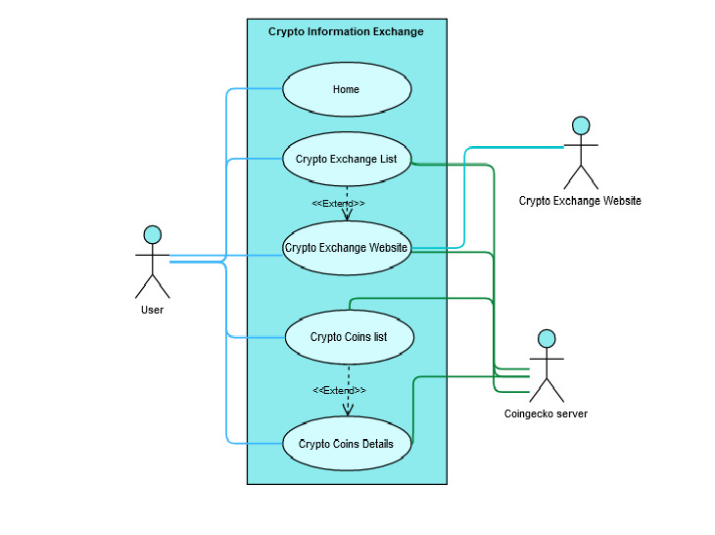

**3.2 Sequence Diagram**

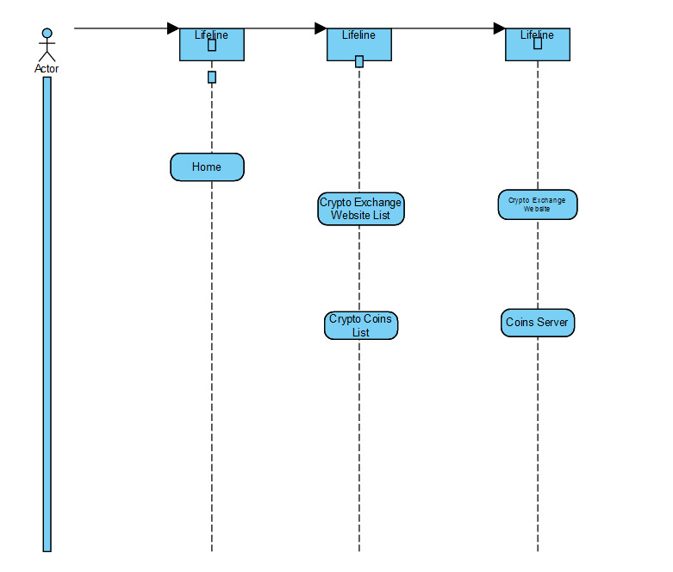

**3.3 Activity Diagram**

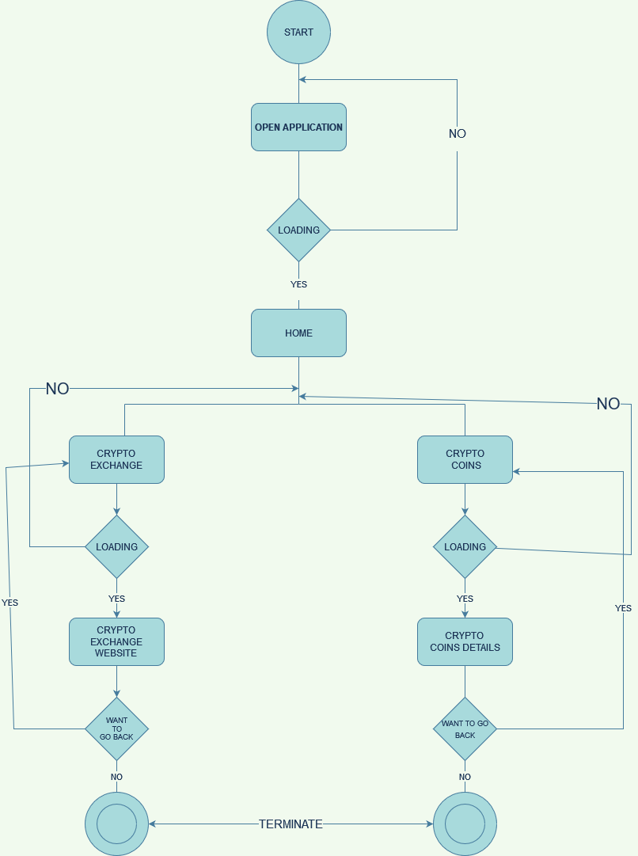

**4.Developement: -**

**4.1. Coding Standards:**

**• React JS naming conventions**

**• Use shorter and more readable syntax where possible**

**• Single responsibility principle Fat models, skinny controllers**

**• Use Attractive User interface to create web application more attractive**

**• Use standard React Js tools accepted by community**

**• Do not get data from the “. env”-file directly.**

**• Memory Optimization.**

**4.2. Screen Shots:**

**User’ View**

* + 1. **Home Screen**

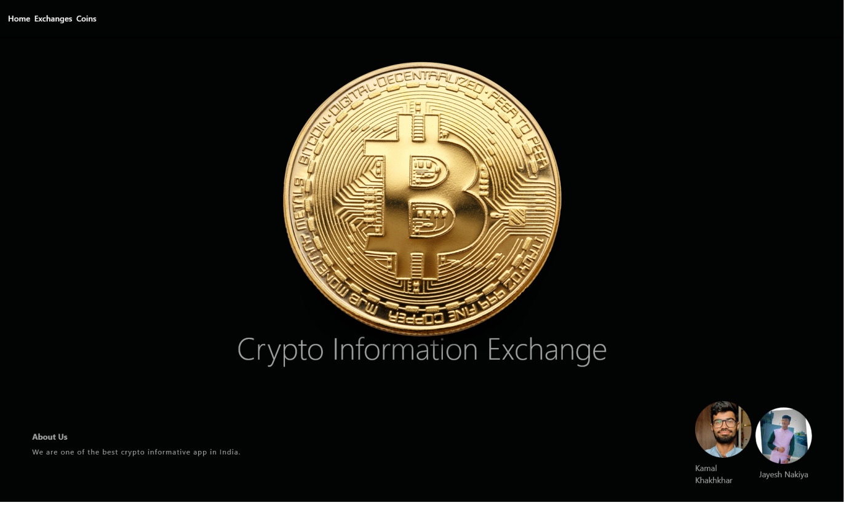

**4.2.2 Crypto Exchange List Page**

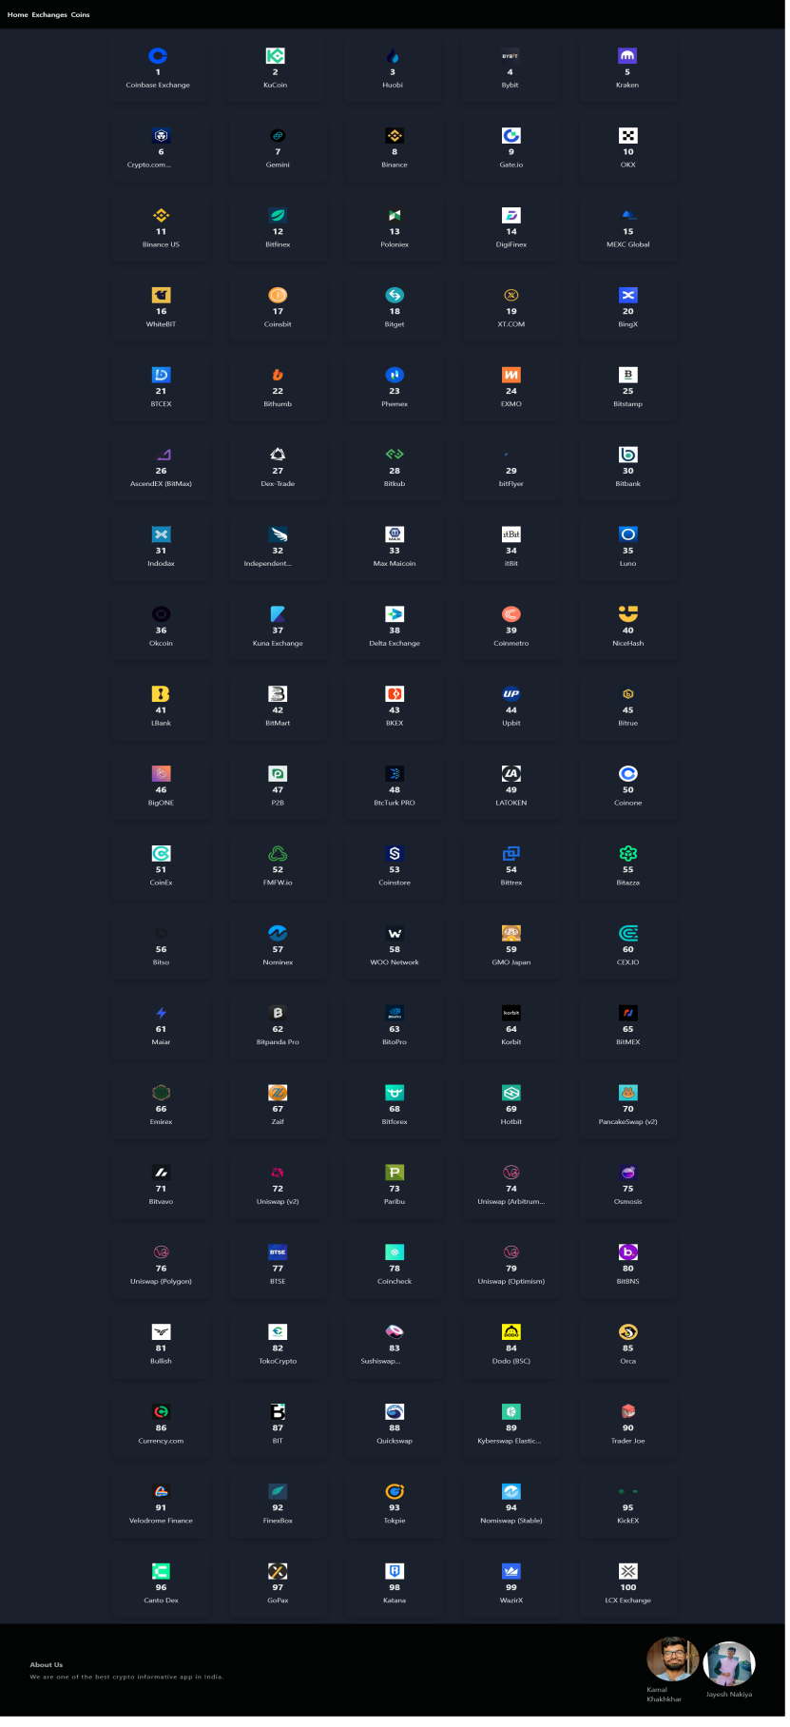

* + 1. **Crypto Exchange Website Page** 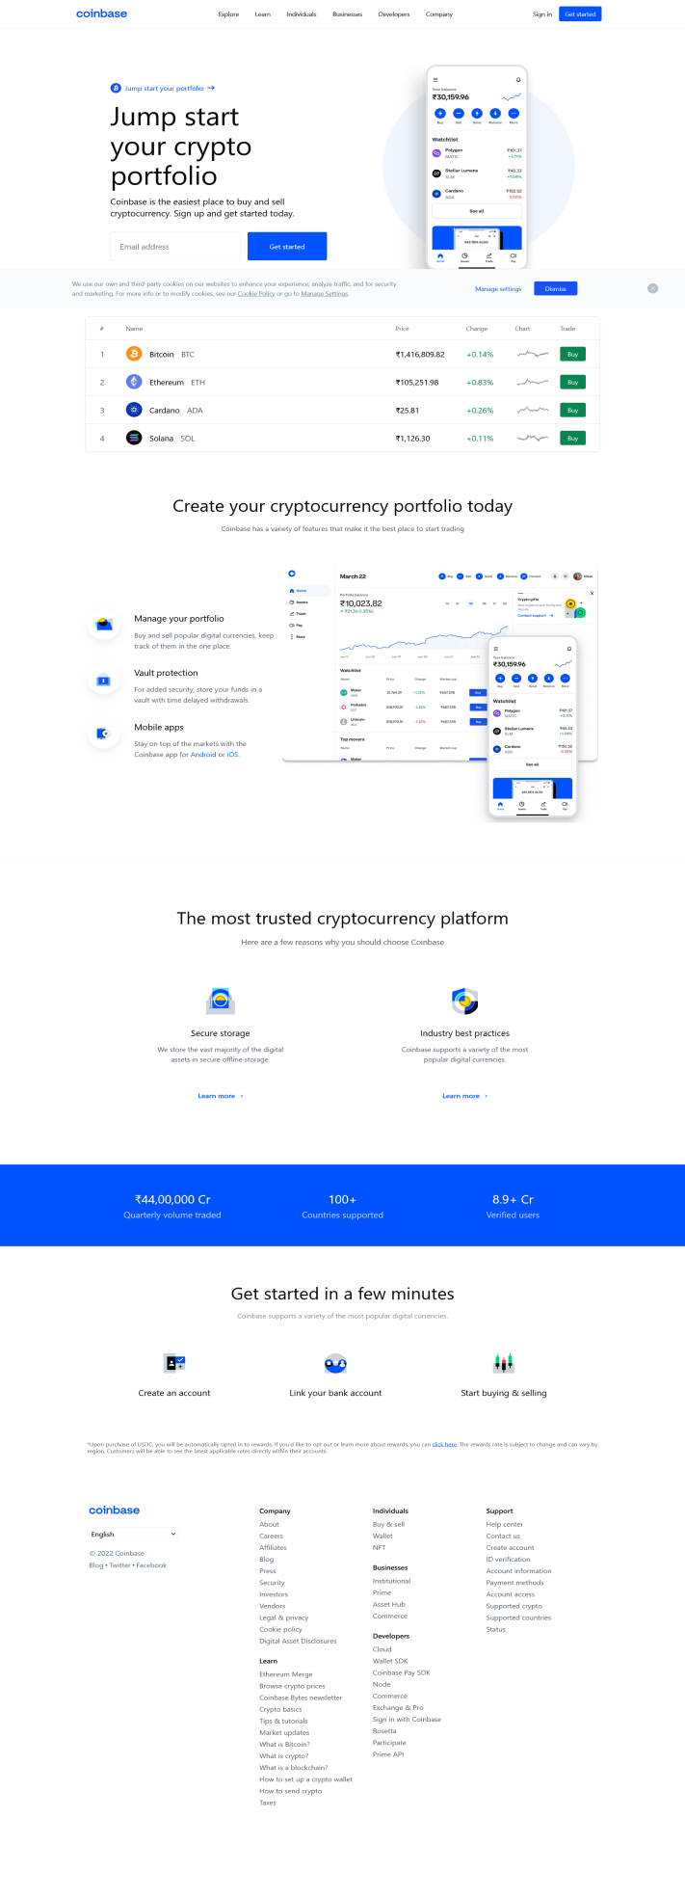
       1. **Crypto Coins List Page In INR**

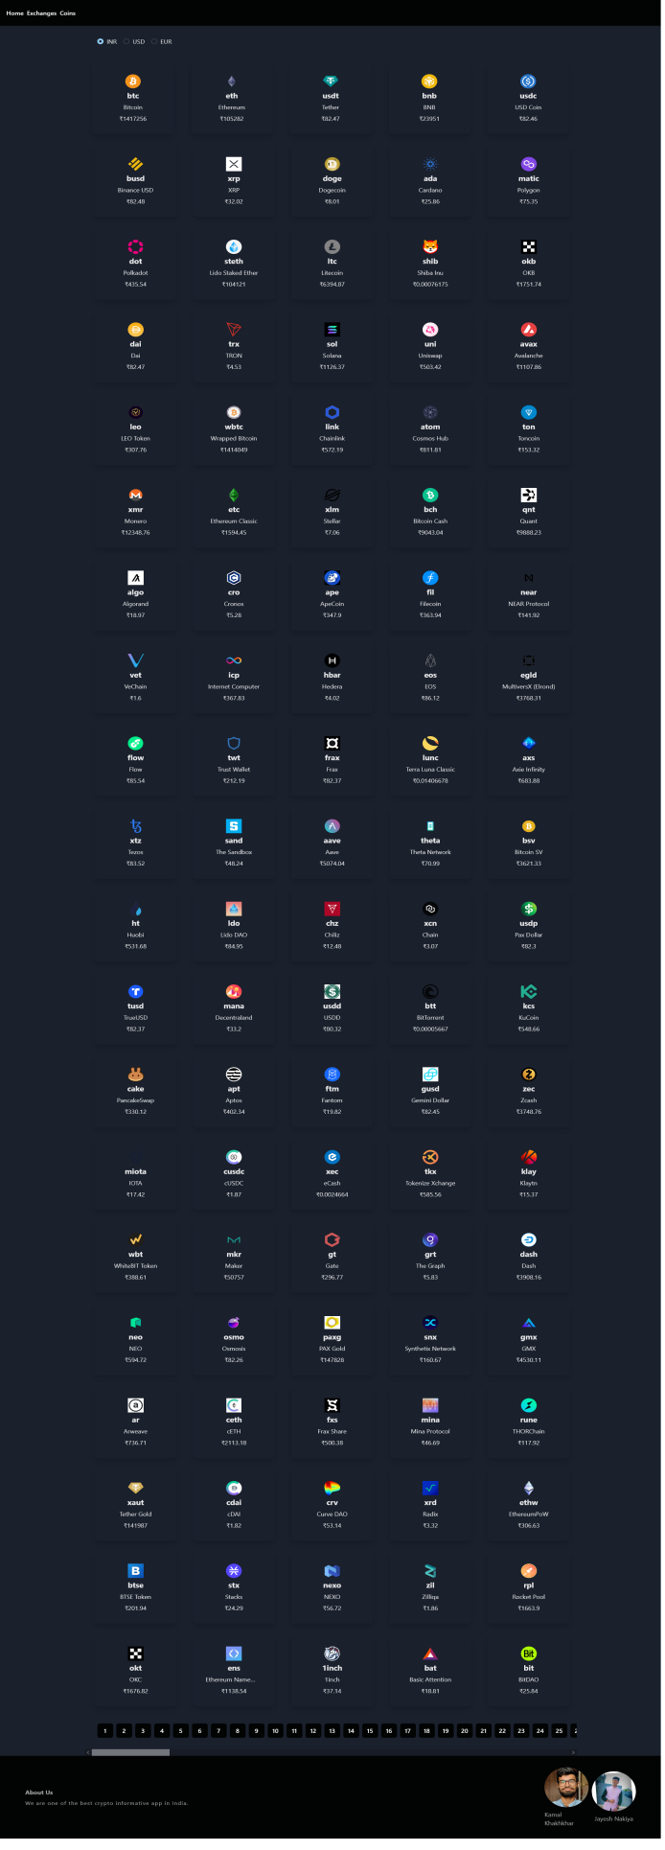

* + - 1. **Crypto Coins List page in Dollar**

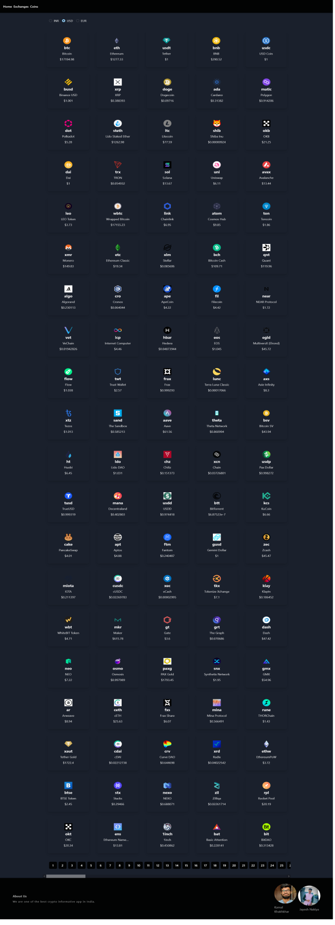

**4.2.5.1 Crypto Coin Info in INR For 24H**

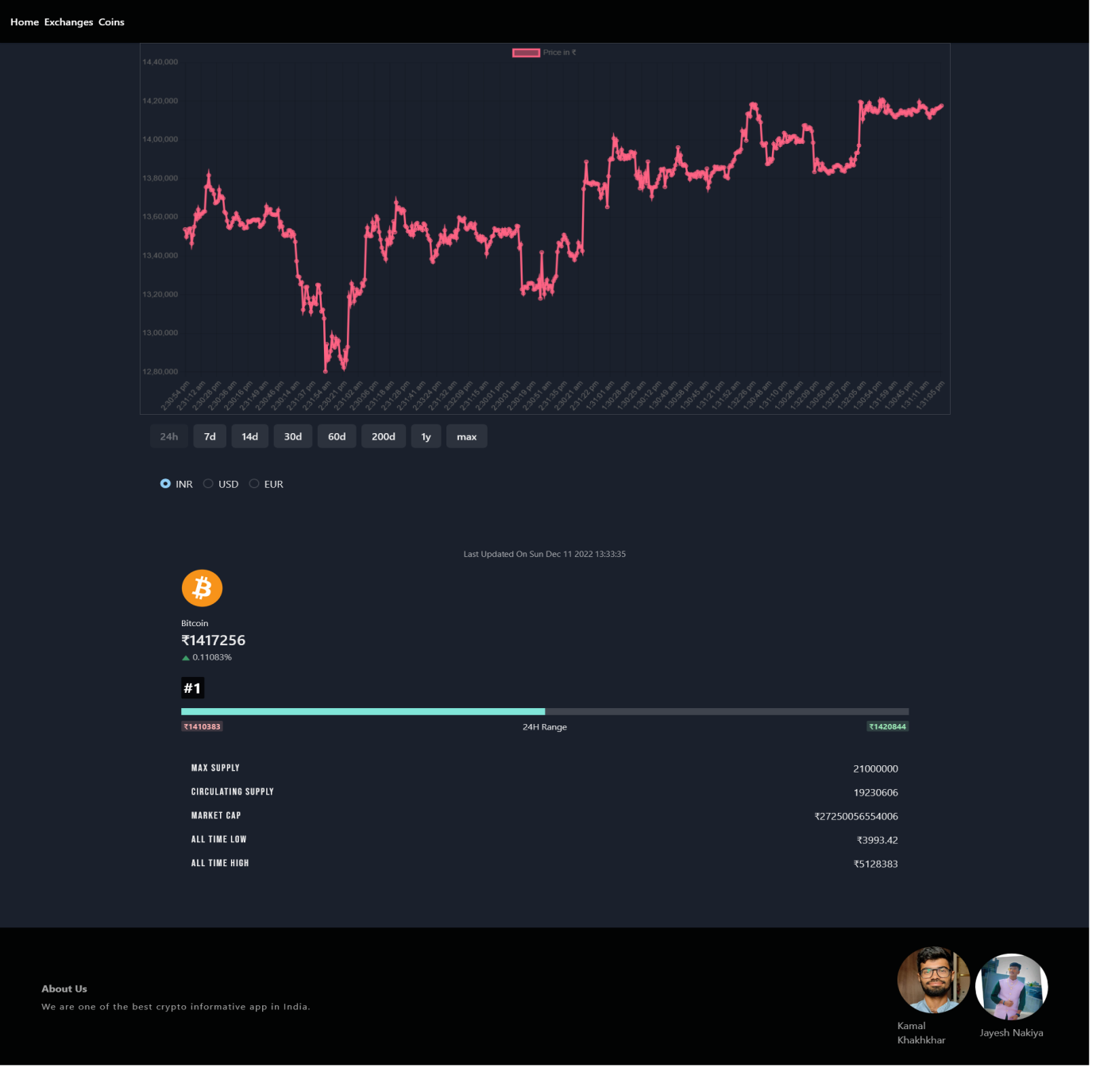

**4.2.5.2 Crypto Coins Info In INR for 60 Days**

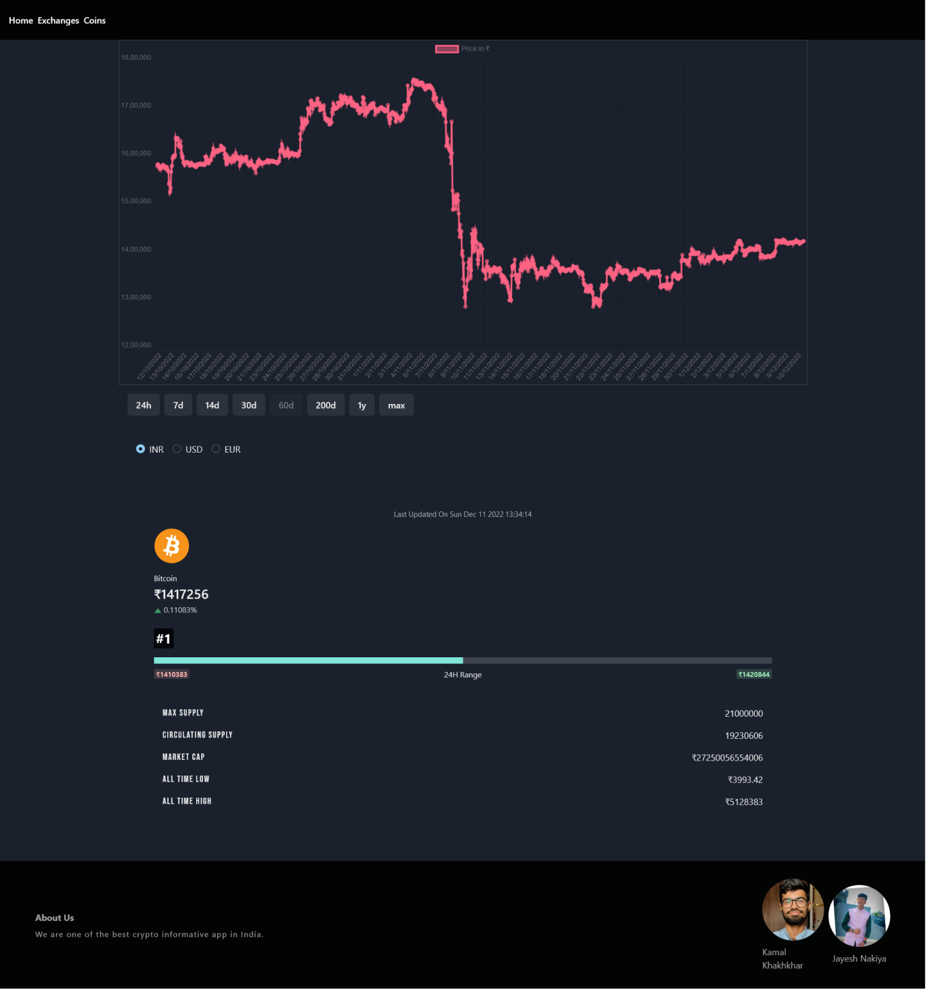

**4.2.5.3 Crypto Coins Info In EURO**

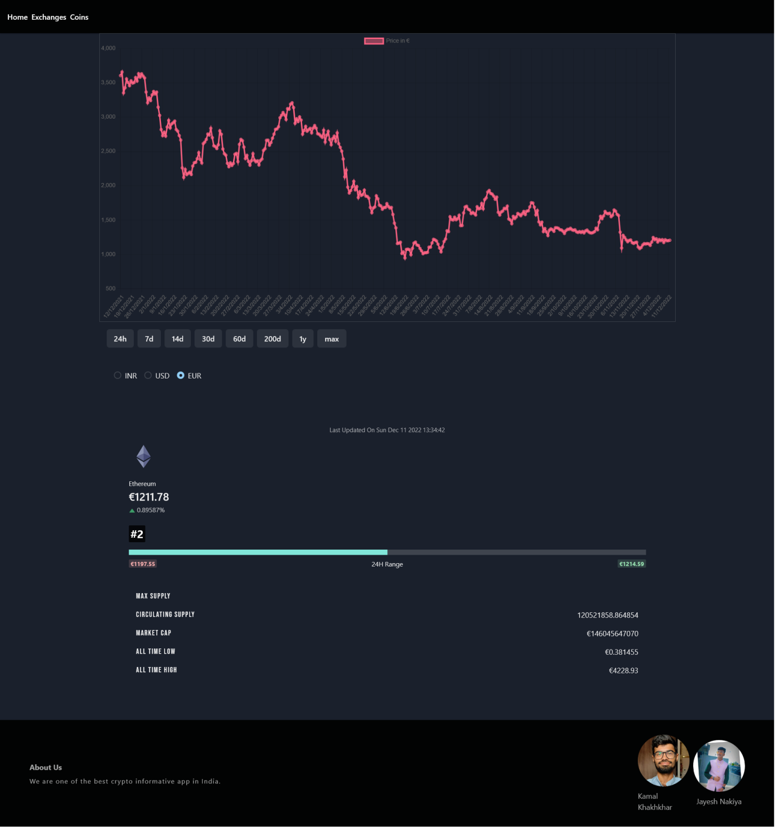

# Agile Documentation

**Table 5.1 Agile Project Charter**

|  |  |  |
| --- | --- | --- |
|  | **Primary Column** | **Description** |
| 1 | **Project Name** | Crypto Information Exchange |
| 2 | **Project Sponsor** | Marwadi Education Foundation Group of Institution Rajkot, Gujarat. |
| 3 | **Project Manager** | Kamal Khakhkhar |
| 4 | **Stack Holder** | 1. Kamal Khakhkhar (Developer) |
|  |  | 1. Jayesh Nakiya (Client) |
| 5 | **Start Date** | 1stOct2022 |
| 6 | **End Date** | 3thDec2022 |
| 7 | **Mission** | 1. To provide better UI Experience. |
|  |  | 1. To provide standard and user friendly web applications. |
|  |  | 1. To provide light weight web application. |
| 8 | **Vision** | To make a web application more valuable and most useful. |
| 9 | **Scope** | Web application provide more crypto exchange option & all most the crypto information. |

**Table 5.2 Agile Roadmap / Schedule**

|  |  |  |  |  |  |  |  |
| --- | --- | --- | --- | --- | --- | --- | --- |
|  |  | **1/11** | **6/11** | **13/11** | **20/11** | **27/11** | **1/12** |
| **Product** | **Roadmap Brief and Feature requirement** | **create an easy Crypto information exchange, which allows Project manager to easily manage job requirement.** |  |  |  |  |  |
| **Feature Requirement** | **Detailed Requirements gathering according to user.** |  |  | **Collect Update requirements of Users Modules.** |  |  |
| **Feature Release** |  | **Version 1 Provide functions involving all Crypto Exchange Website in single page** |  |  |  | **Final Release :Provide updated Product involving Crypto Exchanges Website List & All Crypto Coins List** |
| **Feedback Analysis** |  | **Ask the team members about any refactoring is needed or not.** |  |  | **Final analysis is of the latest beta version by the team** |  |
| **Customer Testing** |  |  |  | **User acceptance testing** |  | **Final testing done by user** |
| **Testing Analysis** |  |  |  | **Resolution of bugs identified by  the user** |  |  |
| **DEVELOPMENT** | **Prototype** | **Start developing initial prototype** |  |  |  |  |  |
| **Assurance** | **Quality Assurance** |  | **Verify all modules with test case** |  | **test remaining modules with updated test cases** |  |
|  |  | **Use Acceptance Testing** |  |  |  |  | **if still any changes needed , perform if time permits** |
|  | **Beta Testing** |  | **continuously resolve the bugs** |  | **Continuously resolve bugs** |  |  |
| **Story Review** |  |  |  | **Get final reviews for the v1** |  | **get final reviews for the final release** |
| **Demo** |  |  | **Demonstrate the function so the system to user** |  | **final user guide preparation** |  |

**Table5.3AgileProjectPlan**

|  |  |  |  |  |  |  |
| --- | --- | --- | --- | --- | --- | --- |
| **Crypto Information Exchange** | | | | | | |
| **PHASE** | **November(WEEK)** | | | | | **December(WEEK)** |
|  | **1** | **2** | **3** | **4** | **5** | **1** |
| **React JS Tutorial** |  |  |  |  |  |  |
| **Web application**  **Template** |  |  |  |  |  |  |
| **Web application details** |  |  |  |  |  |  |
| **Review all template** |  |  |  |  |  |  |
| **Gather all required user interface template** |  |  |  |  |  |  |
| **Prepare a basic view using template** |  |  |  |  |  |  |
| **Get all API related to web application** |  |  |  |  |  |  |
| **Create connection with API** |  |  |  |  |  |  |
| **Apply required changes** |  |  |  |  |  |  |
| **Testing with Multiple Request** |  |  |  |  |  |  |

**Table 5.4 Agile User Story**

Agile is a value-based development methodology, where all those features of the product which can add value to the customer are recognized, prioritized and developed based on customer needs.

These valuable features are best described users own words .Hence finding out who are the users is an important task. Once all the users are recognized, requirements whichaddvaluetotheuserarewrittendownconsideringtheneedsofthosespecificusers.

Since those requirements are coming keeping users in mind, they are called User Stories.

|  |  |  |  |
| --- | --- | --- | --- |
| **ID** | **A User As …** | **I want to…** | **So that I can…** |
| **1** | Project Manager | Get product status from my team leaders from time to time | Verify the status of the project and report back to customer |
| **2** | Testing Manager | To find maximum defects | Customer can get the best product |
| **3** | Developer | Develop the project based on the requirements | Understand the problems faced by customer |
| **4** | Client | Easy user friendly , less complex & time saver web application | Client can ask project manager to provide best solution for product |

**Table 5.4 Agile User Story**

**Table 5.5 Agile Release Plan**

|  |  |  |  |  |  |  |
| --- | --- | --- | --- | --- | --- | --- |
| **Project Name** | **Project Manager** | | **Start date** | | **End date** | |
| Crypto Information Exchange | Kamal Khakhkhar | | 1stNov,2021 | | 3thDec,2022 | |
| **React Js Tutorial** | **Start** | **Finish** | | **Duration**  **(days)** | | **Completed** |
| **React Js Tutorial** | 1-11 | 05-11 | | 4 | | Completed |
| **Web Application details** | 06-11 | 08-11 | | 3 | | Completed |
| **Web application template** | 09-11 | 12-11 | | 3 | | Completed |
| **review all template** | 13-11 | 13-11 | | 1 | | Completed |
| **Gather all required user interface template** | 14-11 | 15-11 | | 2 | | Completed |
| **Prepare a basic view using template** | 16-11 | 19-11 | | 4 | | Completed |
| **Get all API related to web application** | 20-11 | 21-10 | | 2 | | Completed |
| **Create connection with API** | 22-11 | 24-11 | | 3 | | Completed |
| **Apply required changes** | 25-11 | 26-11 | | 2 | | Completed |
| **Testing with Multiple Request Traffic** | 26-11 | 27-11 | | 2 | | Completed |
| **Fixing Bug** | 28-11 | 30-11 | | 3 | | Completed |
| **Retesting** | 1-12 | 03-12 | | 3 | | Completed |

**Table5.6Agile Sprint Backlog**

|  |  |  |  |  |  |
| --- | --- | --- | --- | --- | --- |
| **Task Name** | **AssignTo** | **Start** | **Finish** | **Priority** | **Status** |
| **Website Main Page**  **Design** | Kamal Khakhkhar & Jayesh Nakiya | 09-11 | 12-11 | Medium | Done |
| **Website Ui** | Kamal Khakhkhar &  Jayesh Nakiya | 14-11 | 15-11 | Medium | Done |
| **Crypto Exchange Information gathering** | Kamal Khakhkhar & Jayesh Nakiya | 9-10 | 11-10 | Medium | Done |
| **Crypto Coins Information** | Kamal Khakhkhar & Jayesh Nakiya | 12-10 | 12-10 | High | Done |
| **Create Basic Prototype** | Kamal Khakhkhar & Jayesh Nakiya | 16-11 | 19-11 | Medium | Done |
| **Create Crypto Exchange List Page** | Kamal Khakhkhar & Jayesh Nakiya | 14-10 | 16-10 | High | Done |
| **Create Crypto Exchange Page** | Kamal Khakhkhar & Jayesh Nakiya | 16-11 | 16-11 | medium | Done |
| **Create Crypto coins Page** | Kamal Khakhkhar & Jayesh Nakiya | 18-11 | 18-11 | Medium | Done |
| **Add Crypto Exchange API** | Kamal Khakhkhar & Jayesh Nakiya | 22-11 | 22-11 | High | Done |
| **Add Crypto Information API** | Kamal Khakhkhar & Jayesh Nakiya | 23-11 | 24-11 | High | Done |
| **Add Footer** | Kamal Khakhkhar & Jayesh Nakiya | 25-11 | 25-11 | Medium | Done |
| **Add Motion** | Kamal Khakhkhar & Jayesh Nakiya | 25-11 | 25-11 | Medium | Done |
| **Fixing Bug** | Kamal Khakhkhar & Jayesh Nakiya | 28-11 | 30-11 | High | Done |
| **Retesting** | Kamal Khakhkhar & Jayesh Nakiya | 01-12 | 03-12 | Medium | Done |

**Table5.7AgileTest Plan According Week**

|  |  |  |  |  |  |  |
| --- | --- | --- | --- | --- | --- | --- |
| **Task Name** | **November** | | | | | **December** |
|  | **W1** | **W2** | **W3** | **W4** | **W5** | **W1** |
| **Testing** |  |  |  |  |  |  |
| **1.Unit** |  |  |  |  |  |  |
| **2.Integration** |  |  |  |  |  |  |
| **3.Performance** |  |  |  |  |  |  |
| **4.System** |  |  |  |  |  |  |
| **5.GUI** |  |  |  |  |  |  |
| **6.Regression** |  |  |  |  |  |  |
| **7.Acceptance** |  |  |  |  |  |  |

**Table 5.8 Earned-value and burn charts**

A burn down chart is a graphical representation of work left to do versus time. The outstanding work(or backlog)is is often on the vertical axis, with time along the horizontal. That is, it is a run chart of outstanding work. It is useful for predicting when all of the work will be completed.

Its how’s the total effort against the amount of work we deliver each iteration.

The obvious benefit of a burn down chart is that it provides an updated status report on the progress of the project. Having a visual representation of this most important data keep sever one on the same page. Also, by displaying it prominently for all to see , it keeps everyone involved and encourages the team to deal with issues before they become problems. Therefore, the bigger the chart , the better. It should be the focal point of the workspace, so that it cannot help but direct conversation towards the project and its progress.

The burn down chart doesn’t reveal everything. For example, it only shows the number of story points that have been completed. The burn down chart doesn’t show any changes, for example, in the scope of work as measured by the total points in the backlog.

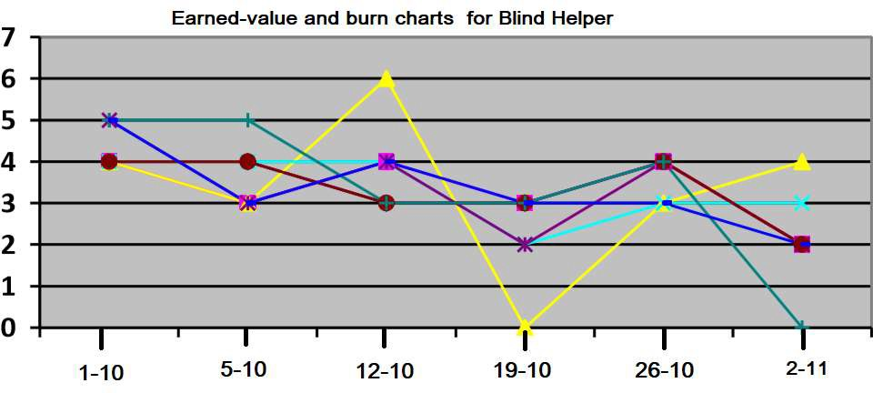

**Table 5.8 Earned-value and burn charts**

**6. Proposed Enhancements: -**

We developed a React Js project with as much as features covered for a first version. We planned some features for next update of website. Some features of future enhancement are listed below:

* Provide more currency to compare price.
* Add comparable chart
* Add search for crypto coins by name
* Add NFT coins
* Add News section about all the crypto space
* And so on.

**7. Conclusion:**

**Advantages & limitations of project: -**

**Advantages:**

* Users can Find Top 100 Crypto Exchange at single page.
* Users can get information of crypto coins by market rank
* User not tied to old traditional approach by which user find few of crypto exchanges only.
* User can get all the real time information about crypto.
* User get chart to display how the market of crypto going.
* User gets more than 1 currency option to get details as per requirements.

**Limitations:**

* User needs internet access.
* If the API connection lost user will not get details.
* User needs to find their favourite coins manually form list.
* If the crypto exchange website is down user won’t be able to redirect their.

**8.Reference and Bibliography**

**Reference Web Sites:**

1. <https://www.binance.com/en>
2. <https://www.coinbase.com/>
3. <https://www.huobi.com/en-us/>