Contents

Introduction: 2

Python: 2

Visual studio: 2

Pylint: 2

Process: 3

TDD and automated testing tool: 6

GitHub: 9

Conclusion: 10

# Introduction:

## Python:

Python is a popular computer programming language used to create software and websites, automate processes, and analyse data. Python is a general-purpose language, which means it may be used to make many various types of applications and isn't designed for any issues. Python has been used to develop many app and software that are famous and used in our daily life. Some of the examples are uber, Dropbox, Reddit, Quora etc.

Assignment:

For the assignment we will be using python to create a famous game of rock, paper, and scissors. The rule of the game is both players must choose between rock, paper and scissors at the same time. In this program, one will be the player and the player will be playing with the computer as a second player. For the game, winning rules are listed below:

* rock vs paper -> paper wins
* rock vs scissor -> rock wins
* paper vs scissor -> scissor wins

For this game to be complete we have to full fil some requirements but can modify the game slightly. The basic requirements are listed below:

1. Scissors, Paper, or Rock is one of the selections that the computer chooses at random.
2. The player is then offered the option to select/enter one of the options of rock, paper, or scissors.
3. The winner receives one point.
4. Whoever scores five points first wins the match. Additionally, a representation of the overall number of rounds played will be available.
5. The player is prompted to end or restart the game after the winner is announced.
6. Player may also leave the game whenever they choose.

## Visual studio:

Microsoft's Visual Studio is an integrated development environment (IDE). It is utilized in the creation of computer programmes, websites, web applications, web services, and mobile applications. Microsoft's software development platforms, including Windows Store, Windows Presentation Foundation, Windows API, and Windows Forms, are used by Visual Studio. Both native and managed code can be generated by it. Visual studio is an ideal IDE to run python and create program thus we’ll be using the visual studio as a platform to create game.

## Pylint:

Pylint is a static code analysis application for the Python programming language. It analyses the python code without actually running it. It verifies the code for errors, upholds a coding standard, searches for code smells, and can offer suggestions for code refactoring. Using its internal code representation, Pylint can extrapolate actual values from your code (astroid).

# Process:

After the coding has been completed for the game, it must be tested. The tests include fulfilling all the requirements given and using TDD and automated unit testing tool to find errors as well as make the code standard.

1. Scissors, Paper, or Rock is one of the selections that the computer chooses at random.



1. The player is then offered the option to select/enter one of the options of rock, paper, or scissors.

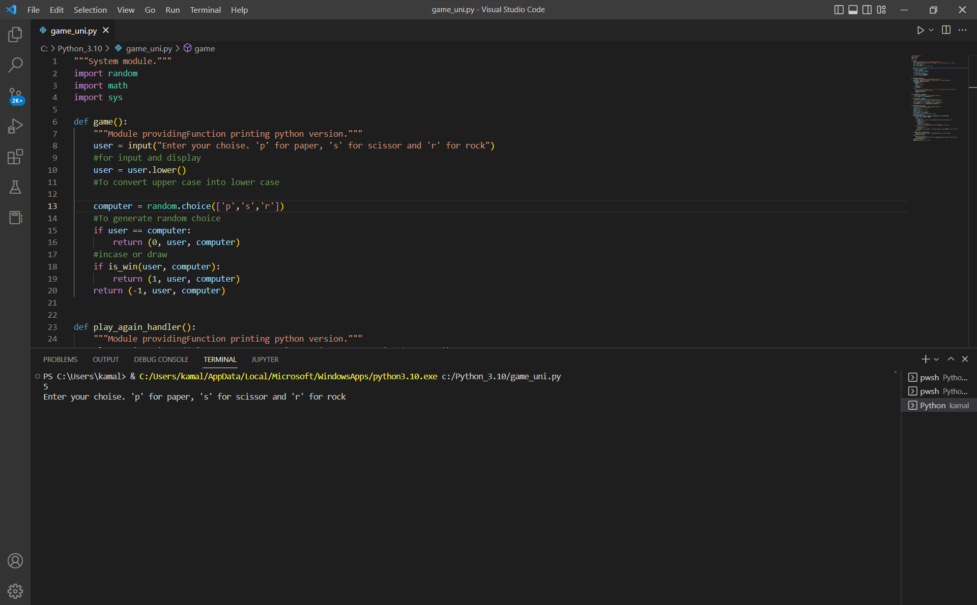

1. The winner receives one point.

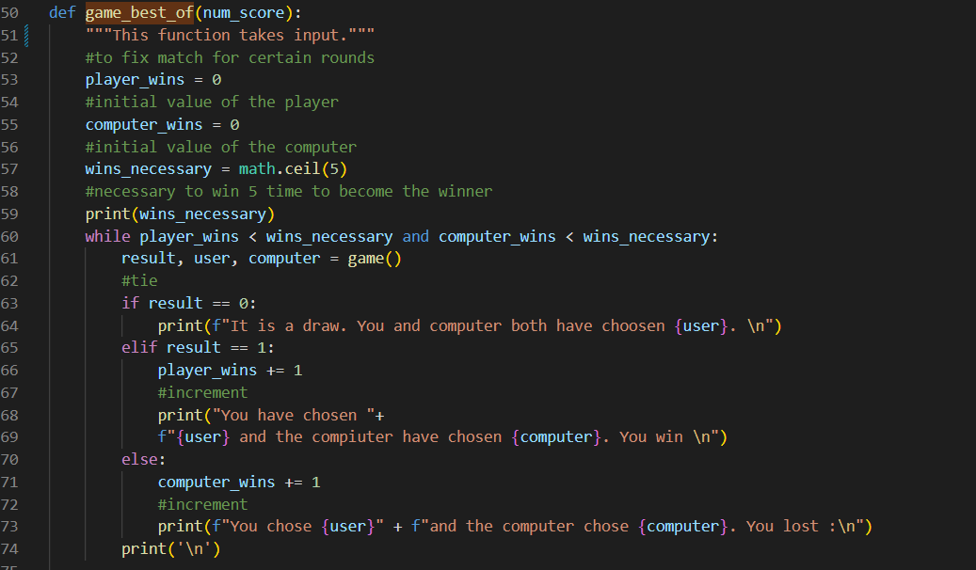

1. Whoever scores five points first wins the match. Additionally, a representation of the overall number of rounds played will be available.

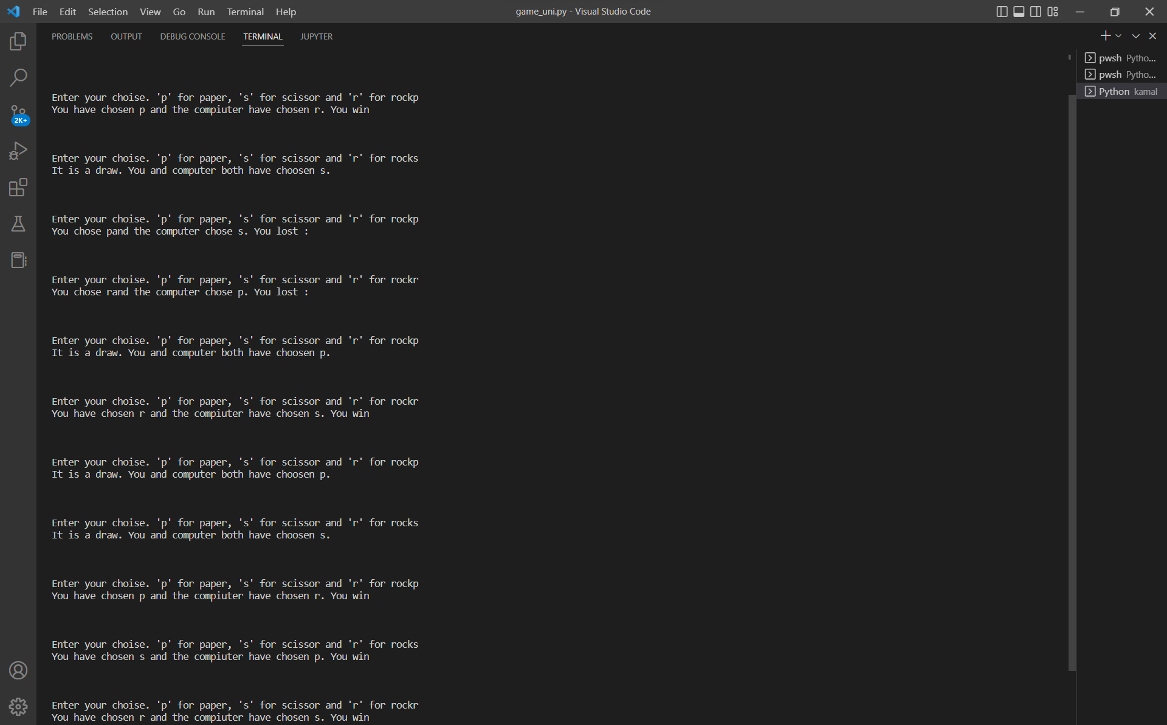

1. The player is prompted to end or restart the game after the winner is announced.

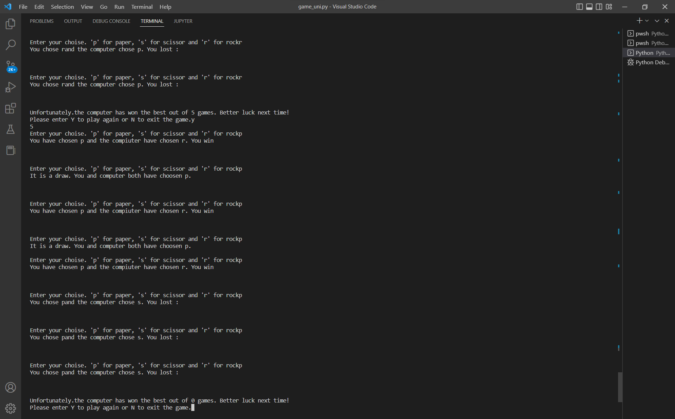

1. Player may also leave the game whenever they choose.

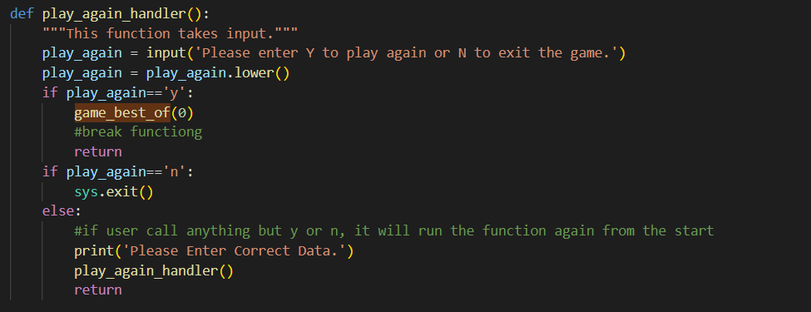

## TDD and automated testing tool:

Among all the testing tools like csUnit, DocTest, Junit, TestNG, Pylint and many others, Pylint was used to test the program for errors and coding standard. First of all Pylint had to installed in visual studio with code “pip install pylint”. Later, after installing the Pylint, checked the code standard and it gave the reding with all the errors. At first, the code was rated 0.64/10 because of the following problems:

1. Trailing-whitespaces
2. Bad indentation
3. Line to long
4. Missing module docstring
5. Snake case naming style
6. Variable name does not match
7. Not using sys.exit()
8. Too many Boolean expressions
9. Missing function
10. Consider-using-fstring

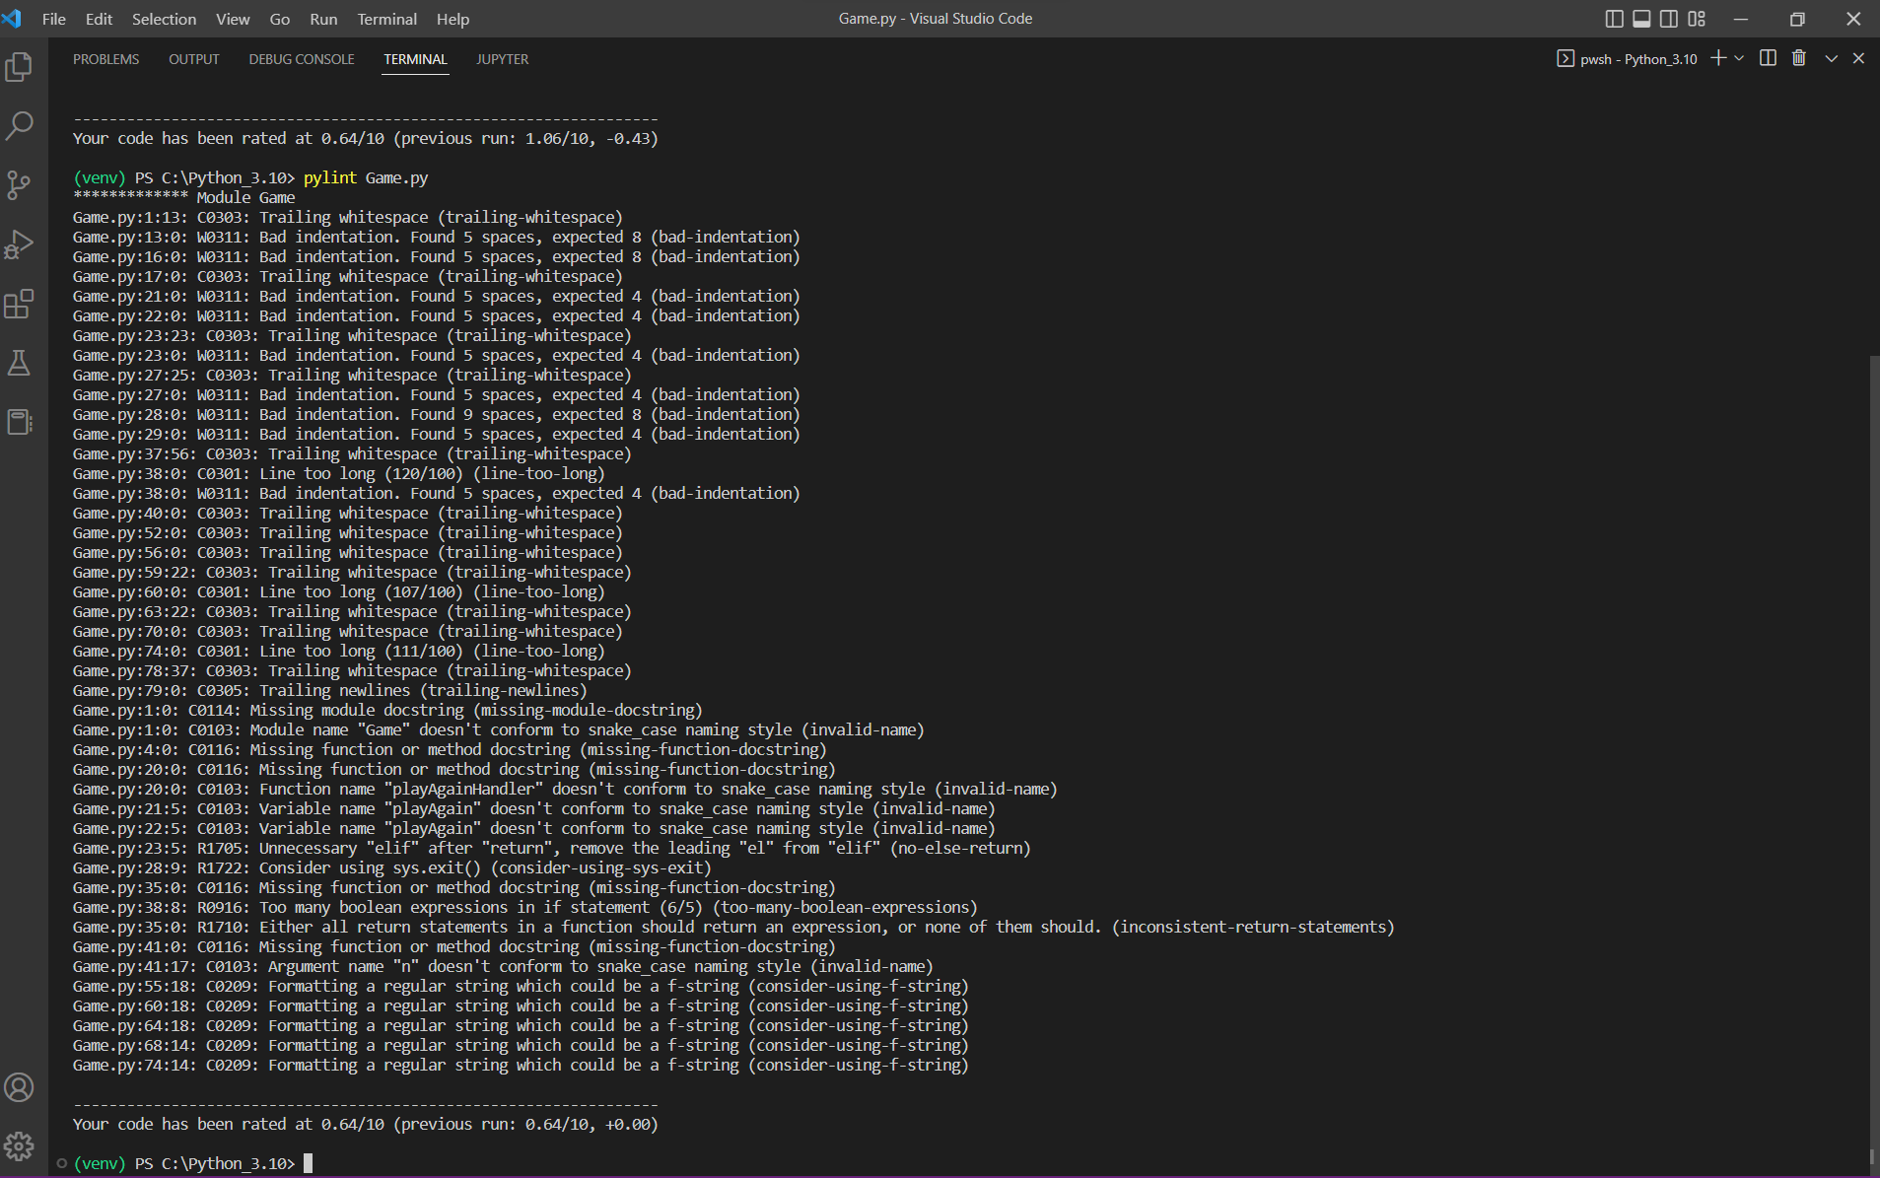

After fixing all the errors one by one, the rating increased to 10/10.

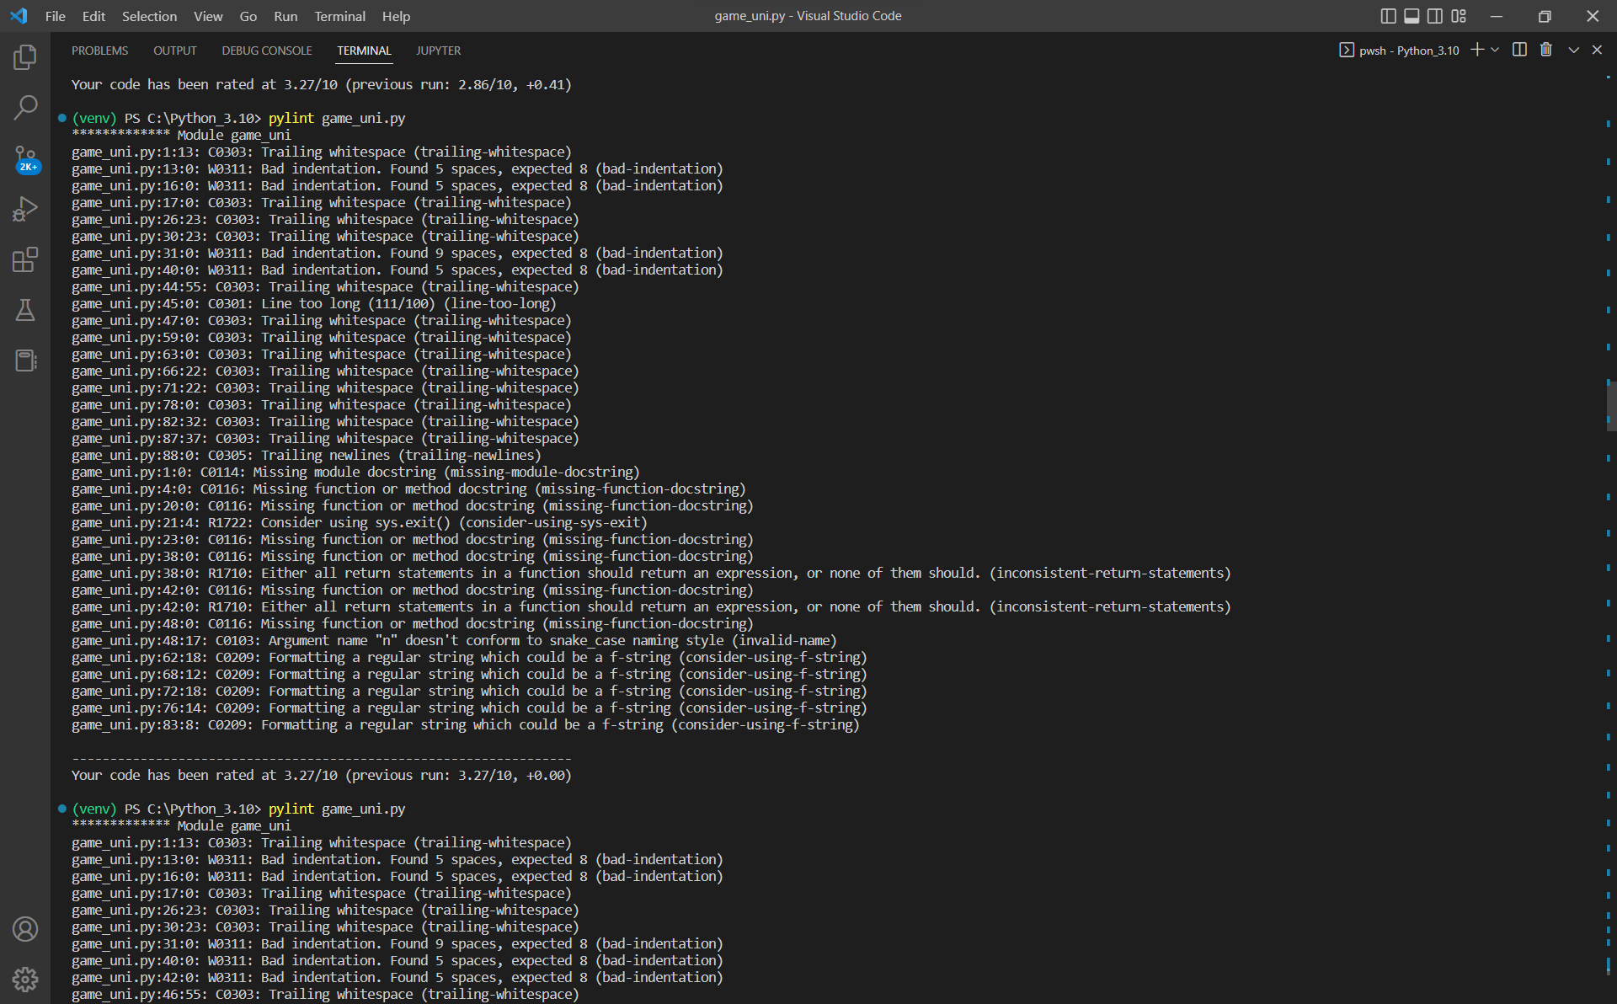

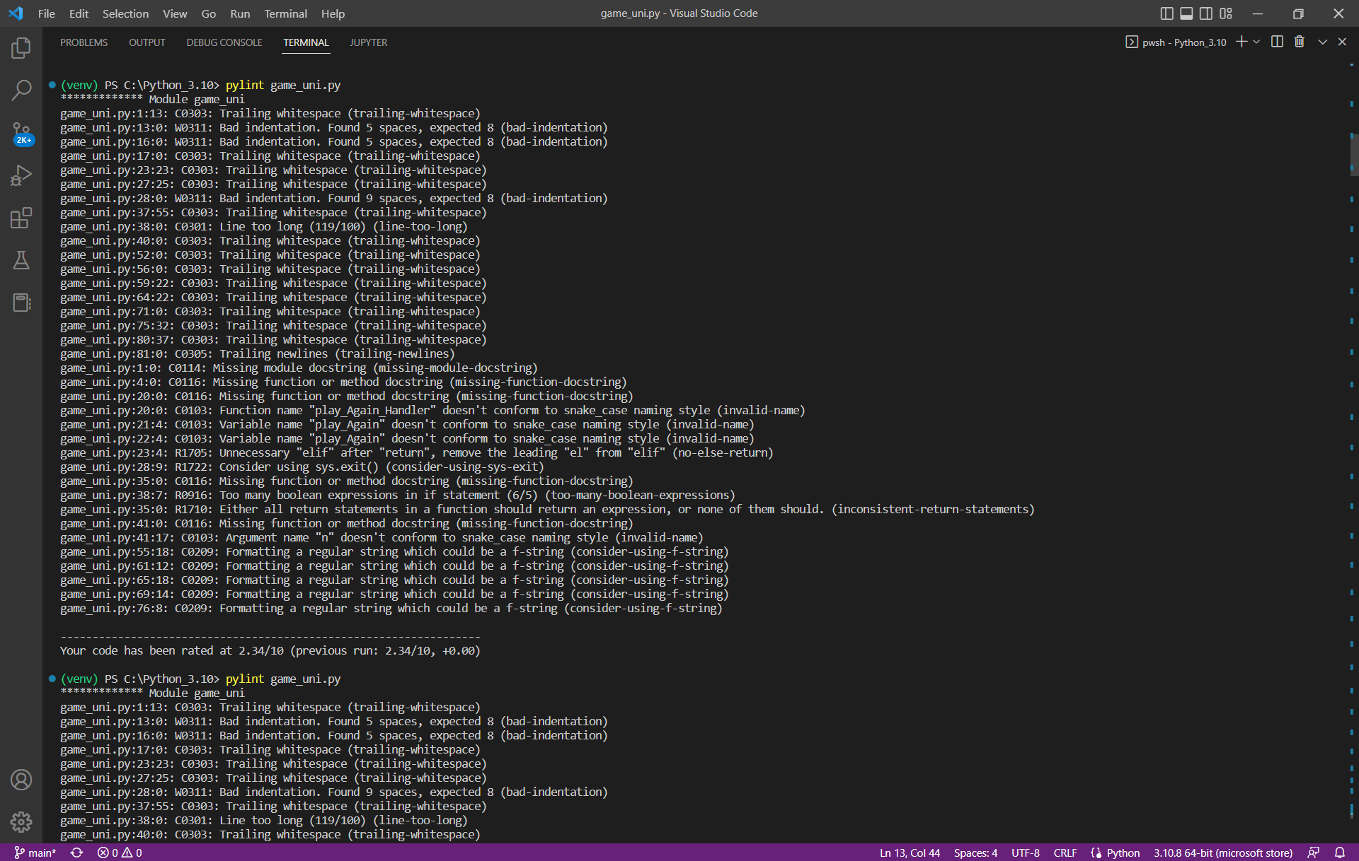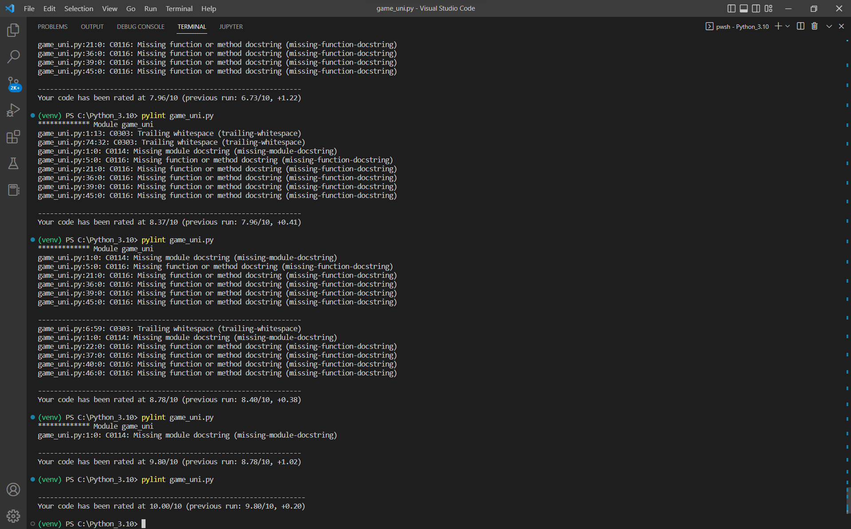

## GitHub:

For the final requirement, we must upload the finalized code and the document to the GitHub Repositories. First of all, we have to make an account in GitHub online and GitHub installed in our computer using an SSH key. Then we push the file from Visual Studio to GitHub online with comments.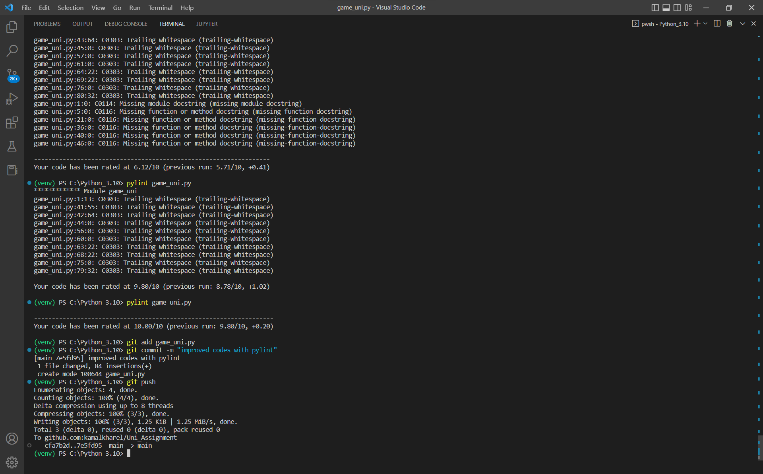

After the code is pushed, the file is displayed in GitHub and any further changes we make and upload there remains a history of the initial file as well as the edited file.

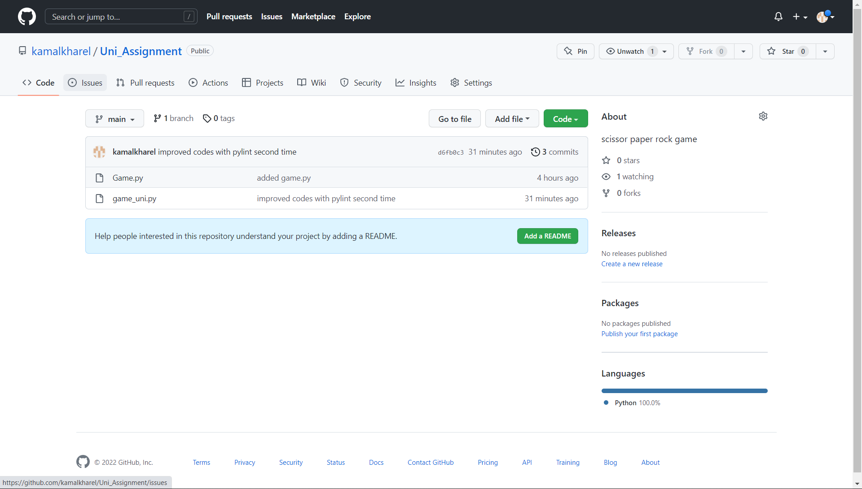

# Conclusion:

To conclude, just completing the coding for a program is not enough but we have to make the code standard. Different TDD and automated testing tools can be used for such program like Pylint. Pylint helps to find errors like syntax error and function errors that are not detected in the platform like Visual studio. It also reduces the extra line of code (unnecessary). We also learned to change the directories for the file and handle different situations with pylint error and fix them.

Knowledge about the GitHub has increased then before as we have worked in a real case and gained experience. Both document and python file with the code of the game have been uploaded in the GitHub. The link for the GitHub is: https://github.com/kamalkharel/Uni_Assignment.git