**QUIZ**

1. **What would this graph represents:-**

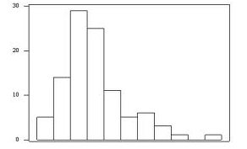

1. Left Skewed Distribution
2. Right Skewed Distribution
3. Normal Distribution

**Answer:- b**

1. **Which of the following is correct:**



1. Mean = Median = Mode
2. Mean > Median = Mode
3. Mean > Median
4. Mean < Median > Mode

**Answer:- c**

1. **What Type of Plot is below :-**

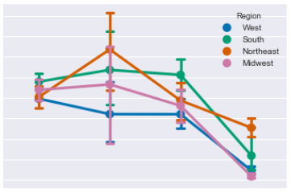

1. Residual Plot
2. Regression Plot
3. Point Plot
4. Count Plot

**Answer:- c**

1. **For the given below input would the shown output will be generated :-**

**Input:-** **sns.distplot(df['price'],**

**kde=False,**

**bins=20)**

**plt.show()**

**Output:-**

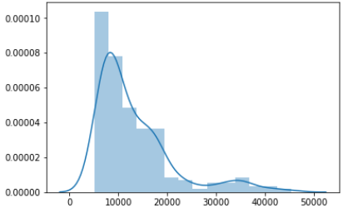

1. True
2. False

**Answer: b**

1. **What does the below plot represents: -**

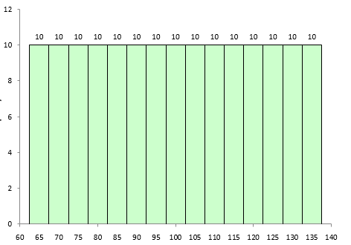

1. Positive Kurtosis
2. Negative Kurtosis
3. Normal distribution
4. Left Skewed

**Answer :- b**

1. **What does the below plot represents:-**

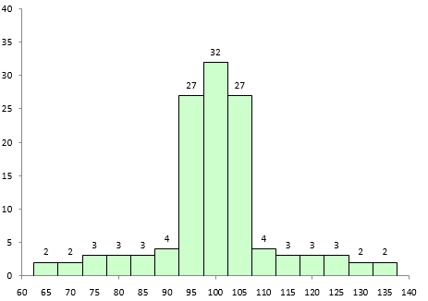

1. Positive Kurtosis
2. Negative Kurtosis
3. Normal distribution
4. Left Skewed

**Answer :- a**

1. **Given a dataframe named df1 containing the following columns:**

|  |  |  |
| --- | --- | --- |
| Student Id | Class | Marks |

A bar plot using seaborn is plotted using the following command:

sns.barplot(df1[‘Class’], df1[‘Marks’])

What does the Y-axiz represent?

a. The sum of marks for each class

b. The count of marks for each class

c. The mean of marks for each class

d. None of the above

**Answer: c**

1. **A box plot for a given dataframe named ‘df’ is plotted using:**

**sns.boxplot(data = df)**

**Which of the following arguments should be added to create horizontal boxplots instead?**

a. direction = ‘horizontal’

b. orient = ‘h’

c. inverted = True

d. None of the above

**Answer: b**

1. **The following command plots a correlation heatmap in seaborn:**

**sns.heatmap(df.corr())**

**In order to see the correlation values printed on top of the heatmap, which of the**

**following arguments should be added to the function?**

a. show_values = True

b. disp_corr = True

c. corr = ‘show’

d. annot = True

**Answer: d**

1. **What information that can be obtained from box plot:**

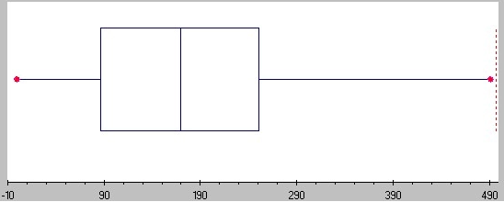

1. Outliers
2. Skewness
3. Quartiles
4. All the above.

**Answer : d**