1. Karyawan + Detail

* Save

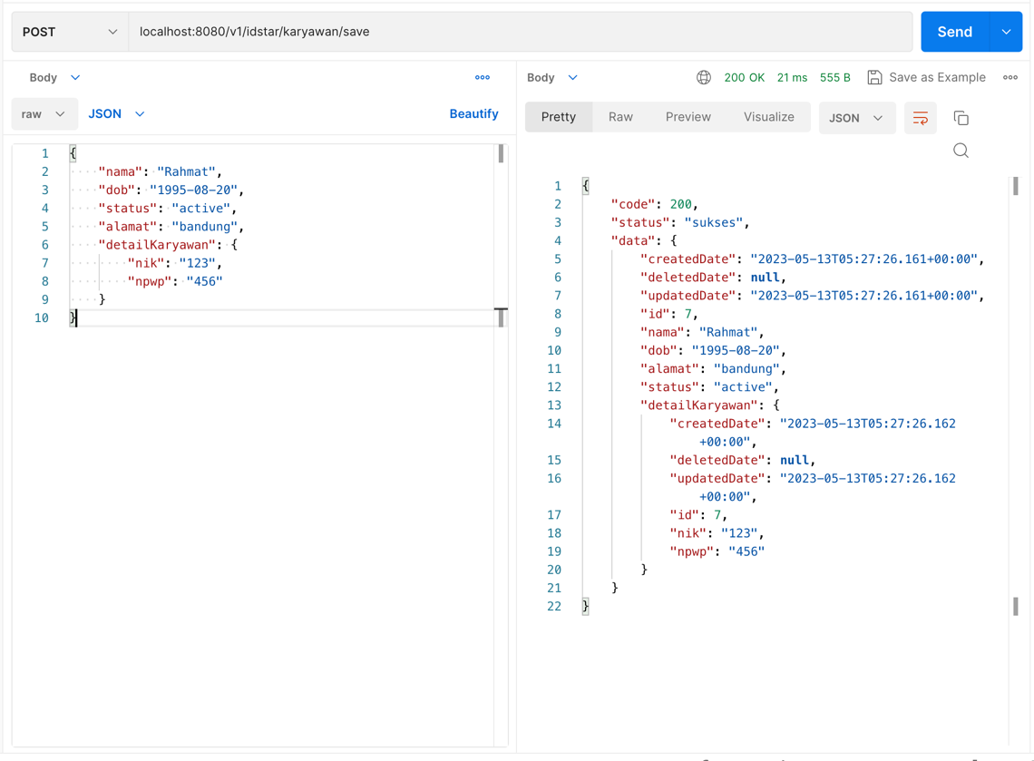

* Update

* List

* Get By Id

* Delete

1. Rekening

* Save

* Update

* List

* Get By Id

* Delete

1. Training

* Save

* Update

* List

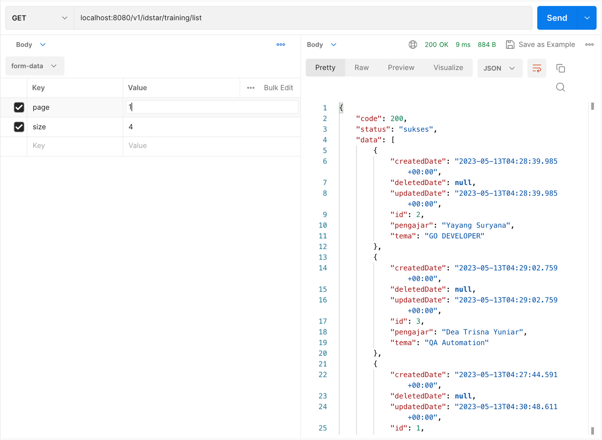

* Get By Id

* Delete

1. Karyawan Training

* Save

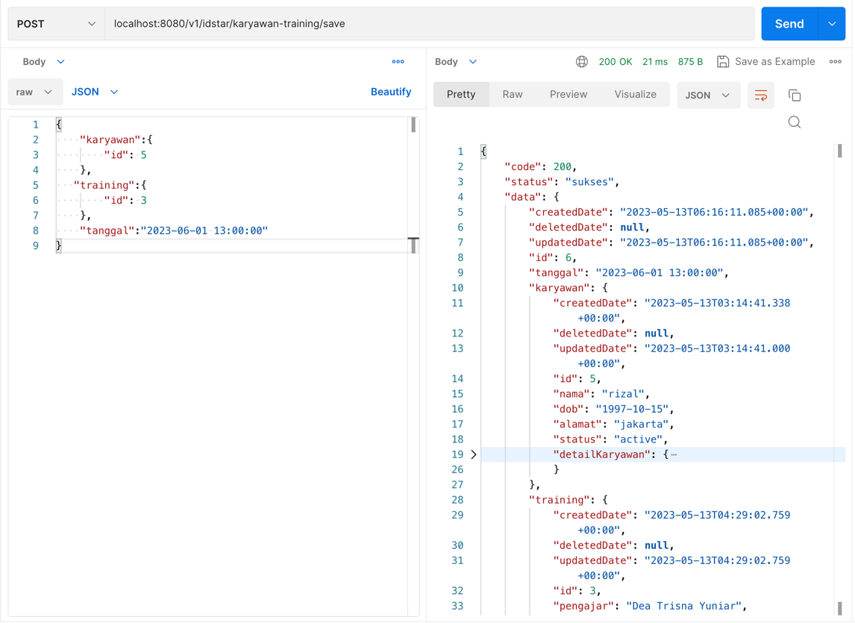

* Update

* List

* Get By Id

* Delete

