Early Detection of Peripheral IV Infiltration/Extravasation Using Intelligent Thermal Video Analytics: A Smartphone–Thermal Camera–Based Nursing Assistant

Computer Engineering
Senior Project Report
Advisor: Tuğba Önal SÜZEK, PhD
Student: Kamal M I Alqedra
Date: 10/01/2026

Table of Contents
ABSTRACT 3
1. Objectives and Goals 4
1.1. Overall Aim 4
Specific, Measurable Objectives 4
Industrial Value Added 4
1.2. Innovative Aspects and Technological Value 5
2. METHODS 6
Rationale and motivation in relation to prior work 6
Experimental setup and data 7
Analytical and/or experimental methods and their link to aims/objectives 7
Direct linkage to aims/objectives: 7
Feasibility of achieving the objectives 8
Evaluation and success metrics 8
Risk mitigation, ethics, and data governance 8
Note on cited literature 8
References 13

ABSTRACT
Delayed recognition of infiltration and extravasation complications in peripheral intravenous (IV) catheterization can lead to tissue injury, prolonged treatment duration, and increased costs. In this proposal, we aim to capture thermal and tissue patterns that emerge before visible swelling by enabling contactless, continuous monitoring of the IV insertion site using a low-cost thermal camera compatible with a smartphone.
Whereas existing approaches in the literature are largely limited to optical sensors or static analyses, this project will jointly leverage temporal pattern analysis and temperature-difference (ΔT) information. The project’s key original contributions are: (i) the design of a temporal early-warning mechanism for preclinical signals, (ii) a lightweight deep-learning architecture suitable for real-time operation on mobile devices, and (iii) a performance evaluation validated against clinically relevant false-alarm-per-hour (FA/h) targets.
The thermal camera will be positioned using a region-of-interest (ROI) protocol centered on the IV site; the frame will include only this area to protect privacy. From the stream, short video clips of 16–32 frames will be extracted, ROI stabilization will be applied, and ΔT channels will be generated. The primary model will be TSM–MobileNetV2, with R(2+1)D- and S3D-based baselines implemented for comparison. After training, the model will be deployed end-to-end on a mobile device using INT8 quantization, targeting real-time inference with ≤2 s latency. An alert will be issued to nurses when the computed risk score remains above a predefined threshold for longer than 10 seconds. Primary outcomes will include AUC, FA/h, and mean early-detection time; secondary outcomes will include AUCPR, sensitivity/specificity, and sensitivity measured on patient-representative files. To prevent patient-level leakage, validation will use a Leave-One-Patient-Out strategy.
The project is planned for completion within 12 months: Months 1–2—procurement of the thermal camera, system setup, and calibration; Months 1–4—data collection and ROI labeling; Months 4–7—model training and validation; Months 6–9—mobile quantization and on-device deployment. The student will be responsible for data collection and software development. The academic supervisor, Assist. Prof. Şengül DOLU KÜBİLAY, will provide scientific guidance, while the industry supervisor, Assoc. Prof. Tuğba SÜZEK, will oversee unbiased development of the mobile deployment and machine-learning software. As the budget is insufficient to test the software clinically upon completion, ethics committee approval will not be sought at this stage.
By the end of the project, we aim to deliver: (i) a low-cost mobile prototype that predicts infiltration using an on-device thermal sensor, and (ii) a mobile software output incorporating a machine-learning model trained and evaluated with early-warning metrics. If the software can be successfully completed using publicly available data, an ethics application will be submitted under the supervision of Assist. Prof. Şengül DOLU KÜBİLAY to enable clinical testing and validation. Additional applications to TÜBİTAK or TÜSEB will be pursued to support clinical trials at the School of Nursing of European University of Lefke. Expected impacts include reducing tissue injury—particularly among chemotherapy patients—through earlier detection of infiltration and extravasation, and improving safety for pediatric and older patients. Dissemination of the project results at a national or international conference is targeted.

1. Objectives and Goals

1.1. Overall Aim
Infiltration and extravasation complications that occur during peripheral intravenous (IV) catheterization are typically recognized only after visible signs (e.g., swelling, erythema) appear. This delay contributes to tissue damage and prolongs the course of treatment, and it can be particularly challenging in chemotherapy patients. The primary aim of this project is to develop an intelligent system that can generate early warnings—before visual findings emerge—by analyzing micro-level temperature changes around the IV insertion site in real time. By integrating this system into nurses’ existing workflow and developing a cost-effective product with global scalability, the project seeks to shorten the time to detection.

Specific, Measurable Objectives
1. Develop an ROI (region-of-interest)–based inference pipeline that automatically identifies the IV site using a phone-mounted thermal camera.
2. Train a lightweight deep-learning model—small enough for deployment on smartphones—that can generate an early risk score from short thermal clips (16–32 frames) and capture temporal changes.
3. Validate model performance using ethics-approved real-world clinical data.
4. Deploy the system on mobile devices so that it can operate offline without an internet connection.
5. Prepare a TÜSEB or TÜBİTAK 1512 BİGG grant proposal to secure the funding required to clinically test the resulting AI model and software components.

Industrial Value Added
This project will directly contribute to the health-technology R&D ecosystem of Kedi Mobil Uygulama A.Ş. It will share the same technical infrastructure as the company’s existing AI-enabled mobile health applications (e.g., the *Orthodontist* app for orthodontic pre-screening from profile photographs, and *OnamForm*, developed for dental clinics and patients in mobile settings), enabling the student to benefit from the company’s image-analysis–based diagnostic technologies.
This thermal-analysis–based early-warning system will further allow the student to leverage Kedi Mobil’s experience in digital health software. If successful on mobile devices, the application can increase usability in both hospital and home-care settings, reduce nurses’ workload, and decrease the risk of complications attributable to human error.
From an industry perspective, an open-licensed model/SDK structure would strengthen Kedi Mobil’s opportunities for co-development with domestic medical device manufacturers and enhance international competitiveness in digital health tourism and remote patient monitoring solutions. With its low-cost design and potential for broad adoption—even in low-resource healthcare settings with limited access to medical devices—the project is expected to expand impact through both scalable deployment and scientific dissemination, thereby reinforcing Kedi Mobil’s global positioning in AI-based healthcare technologies.

1.2. Innovative Aspects and Technological Value
The point of departure for this project is the frequent occurrence of tissue injury and rising care costs in clinical practice—particularly among chemotherapy patients who require intensive IV medication and whose vascular structures may be compromised by chemotherapeutic agents, as well as older adults with reduced venous elasticity—because peripheral IV catheter infiltration/extravasation often cannot be detected before visible findings emerge. Since current approaches rely on nurses’ visual inspection, detection is subjective and frequently delayed until bruising or color changes become apparent, preventing timely recognition of medication leakage. This unmet need motivates a contactless thermal-imaging approach capable of generating an early warning as soon as temperature differences become detectable.
Accordingly, we propose a mobile early-warning prototype that performs on-device inference using a low-resolution thermal module attached to an Android smartphone, together with an accompanying SDK. The machine-learning–based software product is designed to alert nurses to leakage-related thermal changes before bruising or visible discoloration develops. The project will establish a workflow that includes an ROI (region-of-interest) protocol, calibration and privacy standard operating procedures (SOPs), nurse alerting rules (threshold + duration criteria), and a data/ethics governance plan, culminating in an ethics committee application. An academic publication is also targeted to support international dissemination.
Our solution integrates a lightweight video model (TSM–MobileNetV2), ROI-guided processing, INT8 quantization, mobile deployment, and clinical validation. The system will start at Technology Readiness Level (TRL) 1 and is expected to reach TRL 3–4 (prototype) by the end of the project.
Prior studies emphasize that inability to detect peripheral IV infiltration/extravasation before visual signs appear contributes to tissue damage and increased costs. Existing commercial sensor-based systems and thermography studies are typically limited to continuous monitoring with specialized hardware or to single-frame thermal measurements; while thermal imaging can indicate infiltration in some cases, evidence has largely relied on static, case- or study-level analyses, and productization has not been the focus. In another line of related work, sensor-based neonatal applications have demonstrated early notification potential, but these generally require high-cost fixed installations and/or contact sensors. Our proposed system addresses these limitations in three key ways: (1) by using a spatiotemporal video model that jointly learns ΔT trends, spatial patterns, and rewarming dynamics from 16–32-frame thermal clips, we target an early warning on average ≥2 minutes before visible signs occur; (2) by applying IV-site–specific ROI-guided processing and duration-threshold nurse alert rules, we reduce errors due to motion and bandaging while protecting privacy by storing only the necessary data; and (3) by enabling on-device analysis via INT8 quantization, we remove dependence on internet connectivity and cloud/central servers, thereby supporting data sovereignty and minimizing infrastructure requirements. This integrated approach complements and extends single-frame thermographic analyses and contact/fixed sensor solutions by offering a low-cost, contactless, privacy-compliant, and clinically deployable mobile early-warning system.
The project’s innovation elements and concrete advantages over comparable solutions are as follows:
- Spatiotemporal early warning from video: Rather than single-frame thresholding, the model learns ΔT trends, spatial patterns, and rewarming dynamics from 16–32-frame clips. Target performance includes robust discrimination (e.g., AUC) and early warning 2–3 minutes before visible signs.
- ROI-guided intelligent inference: An IV-component detector and ROI stabilization reduce noise caused by motion and dressings; privacy is strengthened by retaining only the ROI. Quantitative targets include supporting FA/h ≤ 0.3 and leakage-free validation on patient-representative videos.
- Real-time, on-device operation: INT8 quantization enables offline use without a cloud connection; data do not leave the device. Quantitative targets include end-to-end latency ≤2 s, offline operation, and model size ≤10 MB.
By project completion, the intended deliverables include a functioning mobile alerting prototype, an SDK, an SOP set, ethics committee approval, and an academic publication. These advantages are framed in terms of: improved timeliness relative to visual inspection; contactless, consumable-free operation relative to contact sensors; and automated spatiotemporal analysis with on-device inference relative to prior thermography-based approaches.
Alignment with the 12th Development Plan and the 2030 Industry and Technology Strategy, and expected benefits: The project directly relates to critical technology domains including Digital Health Technologies, AI Applications, Smart Medical Devices, and Data Security/Privacy. Expected benefits include improved patient safety through early warning, reduced consumable and hospitalization costs, capacity building in the domestic medical device and health software ecosystem via a transferable SDK, compliance with data sovereignty objectives through on-device processing of personal data, and development of exportable software components. These contributions are anchored in concrete performance thresholds such as AUC ≥ 0.85, FA/h ≤ 0.3, mean early warning ≥ 2 minutes, and end-to-end latency ≤ 2 seconds, supported by a working prototype.

2. METHODS

Rationale and motivation in relation to prior work
This study aims to generate early warnings by automatically capturing microscopic thermal patterns that emerge in the peripheral IV site before visible signs occur, using short thermal video clips. Thermography-based studies indicate that complications such as extravasation/infiltration may be anticipated through changes in heat distribution prior to the appearance of clinical findings (as reported in recent clinical case series and review studies). Although optical sensor–based continuous monitoring devices (e.g., ivWatch) can provide earlier alerts than clinician assessment, limitations have been reported, including single-use consumables, sensitivity to placement, and false alarms [4,5]. These constraints motivate a contactless, portable, on-device thermal video approach.
Temporal Shift Module (TSM)–based architectures were selected because they model temporal information efficiently while maintaining low computational cost, making them suitable for real-time requirements in mobile settings [6,7]. For comparison, widely used 3D spatiotemporal architectures—R(2+1)D and S3D—will be implemented as baselines [8,9]. For on-device inference, mature toolchains such as TensorFlow Lite and ONNX Runtime Mobile will be used [10–12]. The student will adapt and optimize these modules from the literature.

Experimental setup and data
Hardware: A low-resolution thermal module used with an Android smartphone (approximately 120×90 pixels; ~8–9 fps in practice) will be mounted on a fixed tripod and positioned 25–30 cm from the IV site. Emissivity will be set to 0.98, and ambient conditions will be recorded. The camera frame will be restricted to include only the IV region to ensure privacy.
Data generation: During early development, the model will be trained using publicly available thermal imagery. In the initial phase, pretraining will be performed on public thermal infrared datasets, including the BU-TIV benchmark (thermal video–based) [14] and the Infrared Thermography Temperature Dataset, which provides per-pixel temperature maps [15]. Unless a long-term clinical study is planned, collecting real patient data within the project period is not realistic, because infiltration events may not occur during data collection. Therefore, software components for core spatiotemporal feature extraction and sensitivity to temperature differences (ΔT) will be developed first.
Once ethics approval is obtained and the project proceeds to clinical data acquisition for software testing at European University of Lefke, short clips of 16–32 frames (approximately 2–4 seconds) will be extracted from continuous streams, with ROI stabilization and micro-motion correction applied. A three-channel input will be used: raw temperature (T), temporally smoothed T, and a temperature-difference image (ΔT) relative to the individual’s baseline. Clinical recordings will be obtained only as ROI crops of the IV site, after ethics approval and in de-identified form.
Labeling: Because real clinical data are not expected to be used in the core development phase, observed thermal differences in publicly available video clips will be labeled as infiltration. If a temperature drop is observed within 0–120 seconds following the end of a clip, the clip will be labeled “positive” for infiltration/extravasation; if no temperature difference is observed for at least 5 minutes, it will be labeled “negative.” Samples with ambiguous timestamps will be excluded from training.

Analytical and/or experimental methods and their link to aims/objectives
Model architecture: The primary backbone will be TSM–MobileNetV2, with 16–32-frame clips at 112×112 resolution. R(2+1)D and S3D will be trained as baselines. Pretraining will use suitable general video/thermal datasets, followed by fine-tuning on collected clinical ROI clips. Optimization will use AdamW [13], with early stopping and learning-rate scheduling.
Real-time inference: After training, the model will be INT8-quantized and deployed on-device using TensorFlow Lite or ONNX Runtime Mobile [10–12]. The target end-to-end latency is ≤2 seconds. An alert will be issued if the risk score remains above the threshold for at least 10 seconds, followed by a 10-minute suppression (“snooze”) window.

Direct linkage to aims/objectives
- H1 (early warning before visible signs): A TSM-based backbone that jointly learns temporal patterns and ΔT trends is expected to capture the dynamics of thermally reported anomalies, increasing the likelihood of early detection [1–3].
- H2 (portable, low-cost implementation): A smartphone plus a low-cost thermal module, together with quantized on-device inference, offers mobility and cost advantages suitable for clinical field use [10–12].
- H3 (clinically acceptable false-alarm rate): ROC-based threshold selection combined with a duration-conditioned alarm rule is intended to reduce false alarms per hour (FA/h), with targets aligned to findings in the optical sensor literature on alarm management [4,5].

Feasibility of achieving the objectives
- H1—Early warning: High. TSM efficiently processes temporal information with low computational burden, and learning jointly with a ΔT channel is appropriate for the targeted mean early warning of ≥2 minutes [1,2,6,7].
- H2—Portability/real time: High. With INT8 quantization and mobile inference stacks, an end-to-end latency target of ≤2 seconds is feasible; hardware cost is low [10–12].
- H3—False alarms: Moderate to high. With a duration-conditioned alarm rule and ROC-based threshold optimization, the FA/h ≤ 0.3 target will be pursued in a manner adaptable to clinical workflow [4,5].

Evaluation and success metrics
Primary metrics: AUC, false alarms per hour (FA/h), and mean early-detection time (target ≥2 minutes).
Secondary metrics: AUCPR, sensitivity, specificity.
Validation protocol: To prevent patient-level leakage, a Leave-One-Patient-Out approach and stratified cross-validation across different video files will be applied. Final reporting will be based on test-set AUC, FA/h, and early-warning time.

Risk mitigation, ethics, and data governance
To address low resolution and frame rate, longer temporal windows and temporal aggregation strategies will be employed. To mitigate inter-device measurement shifts, emissivity standardization, a reference black patch, and daily field checks will be implemented. To improve label quality, samples with uncertain timestamps will be excluded, and independent verification (e.g., ultrasound) will be used where feasible for sub-cohorts. The study will rely on passive, contactless monitoring and will be conducted with ethics committee approval; only ROI crops will be stored and data will be de-identified. Where appropriate, anonymized data and code/policies will be shared under a limited open repository.

Note on cited literature
Multiple recent clinical studies and reviews report thermography-based predictability of extravasation/infiltration [1–3]. Evaluations of optical sensor systems (e.g., ivWatch) are available [4,5]. Core technical references include TSM [6], MobileNetV2 [7], R(2+1)D [8], S3D [9], TensorFlow Lite / LiteRT quantization and mobile deployment documentation [10–12], and AdamW [13]. However, none of the existing work targets bedside early warning for peripheral IV infiltration/extravasation via a low-cost smartphone–thermal camera pair operating in real time and directly integrated into nurses’ routine workflow. This project aims to contribute an original “nursing assistant” prototype by processing thermal video time series on the edge device using a lightweight TSM–MobileNetV2–based deep-learning model, with the goal of alerting nurses several minutes before complications become clinically apparent.
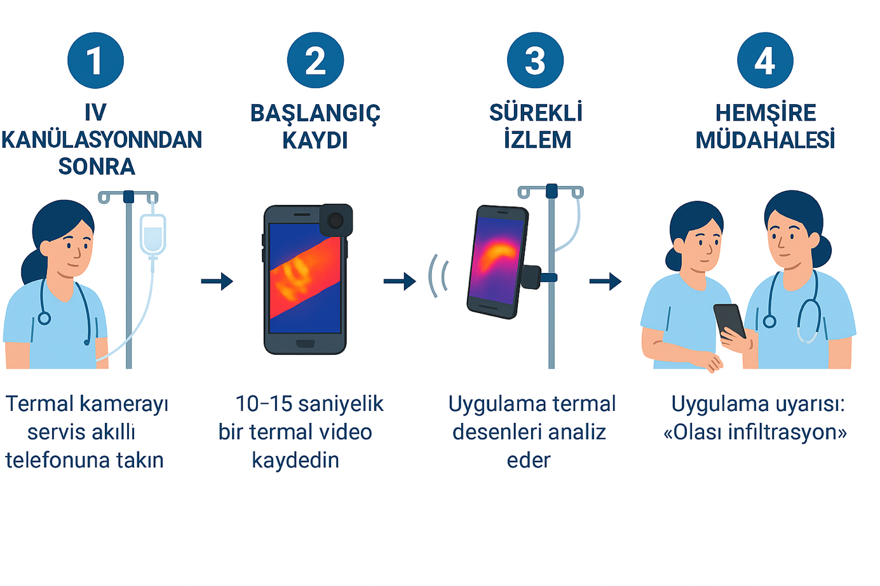
Figure 1. Proposed nursing workflow for early detection of peripheral IV infiltration:
(1) Attaching the thermal camera to the ward smartphone after cannulation,
(2) Recording an initial 10–15-second baseline thermal video,
(3) Contactless, continuous monitoring of the IV site while the application analyzes thermal patterns,
(4) Upon an “Possible infiltration” alert, nurse-led clinical assessment and intervention.

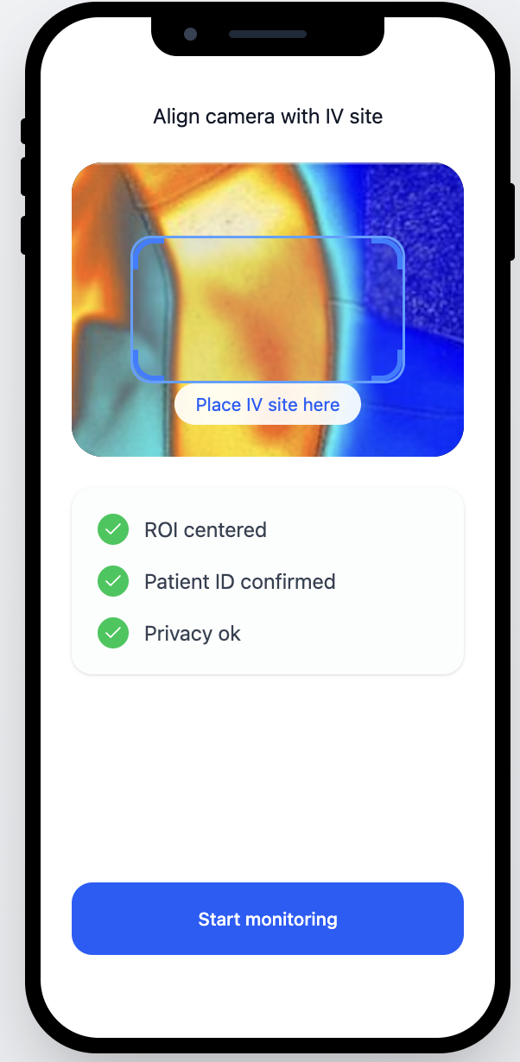
Figure 2. Representative setup screen of the proposed nursing interface for use at the start of monitoring.
The figure provides an example of visual guidance to align the thermal camera with the IV site, define the region of interest (ROI), and perform basic checks related to patient identification and privacy; the design is a conceptual preliminary mock-up for the final version of the application.
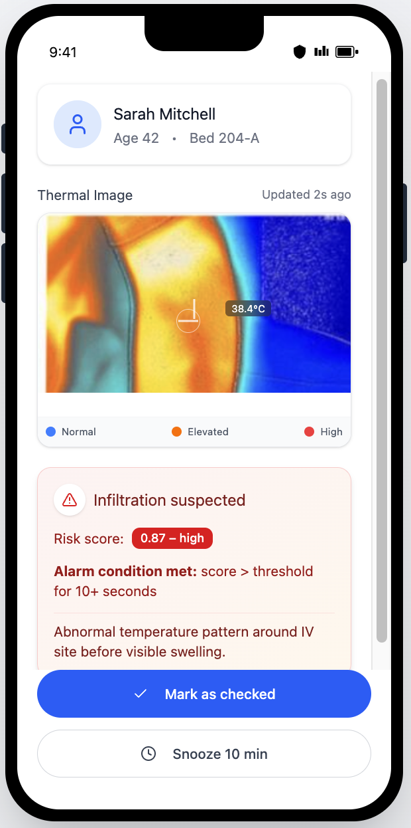
Figure 3. Illustrative main-screen mock-up for notifying nurses of suspected infiltration in the planned mobile application.
The figure presents a representative interface showing how an alert generated from the analysis of thermal images of the IV site, and the nurse’s primary response options (e.g., reviewing the alarm or deferring it for a later reminder), could be displayed.

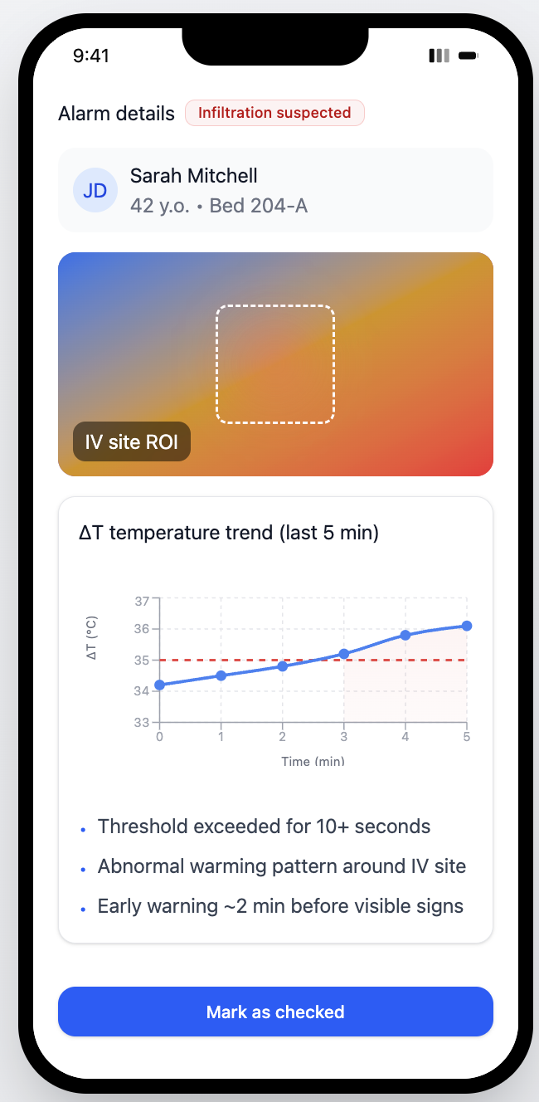

Figure 4. Example detail-screen mock-up for a suspected infiltration alert in the proposed system.
The figure illustrates a representative approach for visualizing the temporal evolution of temperature changes around the region of interest (ROI) at the IV insertion site, and for presenting this information in a manner that supports the nurse’s clinical assessment; the displayed graph and annotations are conceptual in nature.
References
[1] Matsui Y, Murayama R, Tanabe H, Oe M, Motoo Y, Wagatsuma T, Michibuchi M, Kinoshita S, Sakai K,
Konya C, Sugama J, Sanada H. Evaluation of the Predictive Validity of Thermography in Identifying
Extravasation With Intravenous Chemotherapy Infusions. Journal of Infusion Nursing. 2017;40(6):367–374.
doi:10.1097/NAN.0000000000000250.
[2] Nakamura K, Sasaki T, Ohga S, Yoshitake T, Terashima K, Asai K, Matsumoto K, Shinoto M, Shioyama
Y, Nishie A, Honda H. Thermographic visualization of the superficial vein and extravasation using the
temperature gradient produced by the injected materials. Infrared Physics & Technology. 2014;67:514–
520. doi:10.1016/j.infrared.2014.09.029.
[3] Hirata I, Mazzotta A, Makvandi P, Cesini I, Brioschi C, Ferraris A, Mattoli V. Sensing Technologies for
Extravasation Detection: A Review. ACS Sensors. 2023;8(3):1017–1032. doi:10.1021/acssensors.2c02602
[4] van Rens MFPT, Vijlbrief D, Braun S, Hugill K, van Loon FHJ, van de Hoogen A. Peripheral intravenous
therapy infiltration/extravasation (PIVIE) risks and the potential for earlier notification of events using a
novel sensor technology in a neonatal population. Journal of Vascular Access. 2024;25(8):1801–1807.
doi:10.1177/11297298231185536.
[5] van Rens MFPT, Hugill K, van der Lee R, Francia ALV, van Loon FHJ, Bayoumi MAA. Evaluation of
optical sensor technology for the early detection of peripheral intravenous infiltration in neonates: a
retrospective cohort study. BMJ Open. 2025;15(7):e094464. doi:10.1136/bmjopen-2024-094464.
[6] Lin J, Gan C, Han S. TSM: Temporal Shift Module for Efficient Video Understanding. In: ICCV 2019. p.
7083–7093. (OpenAccess/CVF).
[7] Sandler M, Howard A, Zhu M, Zhmoginov A, Chen LC. MobileNetV2: Inverted Residuals and Linear
Bottlenecks. In: CVPR 2018. p. 4510–4520.
[8] Tran D, Wang H, Torresani L, Ray J, LeCun Y, Paluri M. A Closer Look at Spatiotemporal Convolutions
for Action Recognition. In: CVPR 2018. p. 6450–6459. (R(2+1)D).
[9] Xie S, Sun C, Huang J, Tu Z, Murphy K. Rethinking Spatiotemporal Feature Learning: Speed-Accuracy
Trade-offs in Video Classification. In: ECCV 2018. p. 305–321. (S3D).
[10] Google AI Edge. LiteRT 8-bit quantization specification. 2024.
https://ai.google.dev/edge/litert/models/quantization_spec. Google AI for Developers
[11] ONNX Runtime. Quantize ONNX models (dynamic/static).
https://onnxruntime.ai/docs/performance/model-optimizations/quantization.html
ONNX Runtime
[12] ONNX Runtime. Deploy on mobile (Android/iOS). https://onnxruntime.ai/docs/tutorials/mobile/
[13] Loshchilov I, Hutter F. Decoupled Weight Decay Regularization. In: ICLR 2019.
[14] Wu Z, Fuller N, Theriault D, Betke M. A Thermal Infrared Video Benchmark for Visual Analysis.
Proceedings of the 10th IEEE Workshop on Perception Beyond the Visible Spectrum (PBVS), Columbus,
2209-B ÜNİVERSİTE ÖĞRENCİLERİ SANAYİYE YÖNELİK ARAŞTIRMA PROJELERİ
DESTEĞİ PROGRAMI ARAŞTIRMA ÖNERİSİ FORMU
Ohio, USA, 2014.
csr.bu.edu
[15] Wang Q, Zhou Y, Ghassemi P, McBride D, Casamento J, Pfefer T. Infrared Thermography Temperature
[Dataset]. UCI Machine Learning Repository. 2021. doi:10.13026/9ay4-2c37.
[16] Karaoğlan N, Sarı HY, Devrim İ. Complications of peripheral intravenous catheters and risk factors for
infiltration and phlebitis in children. Br J Nurs. 2022 Apr 21;31(8):S14-S23
[17] Oya M, Takahashi T, Tanabe H, Oe M, Murayama R, Yabunaka K, Matsui Y, Sanada H. Low-
temperature infiltration identified using infrared thermography in patients with subcutaneous edema
revealed ultrasonographically: A case report. Drug Discov Ther. 2016;10(2):117-22

