* **Index.html**

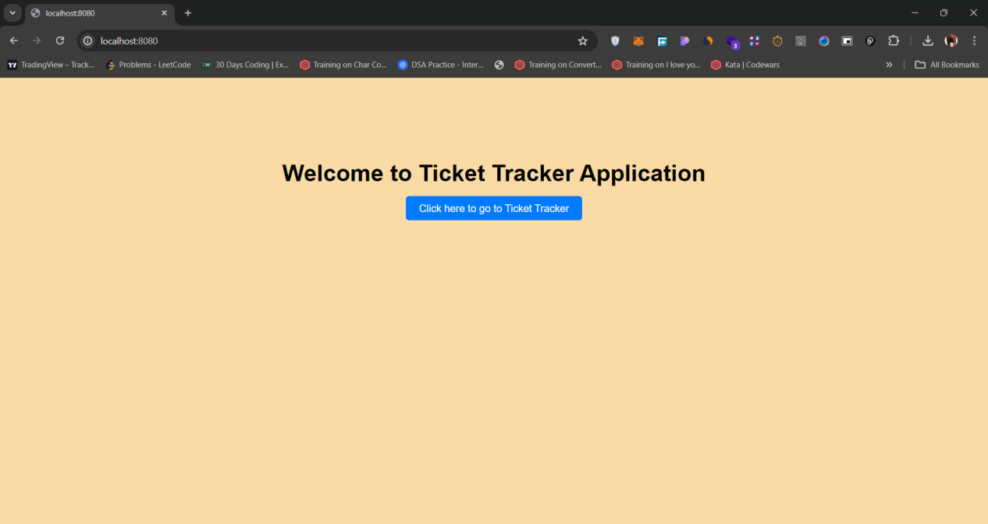

* **showTickets.html(without any ticket created)**

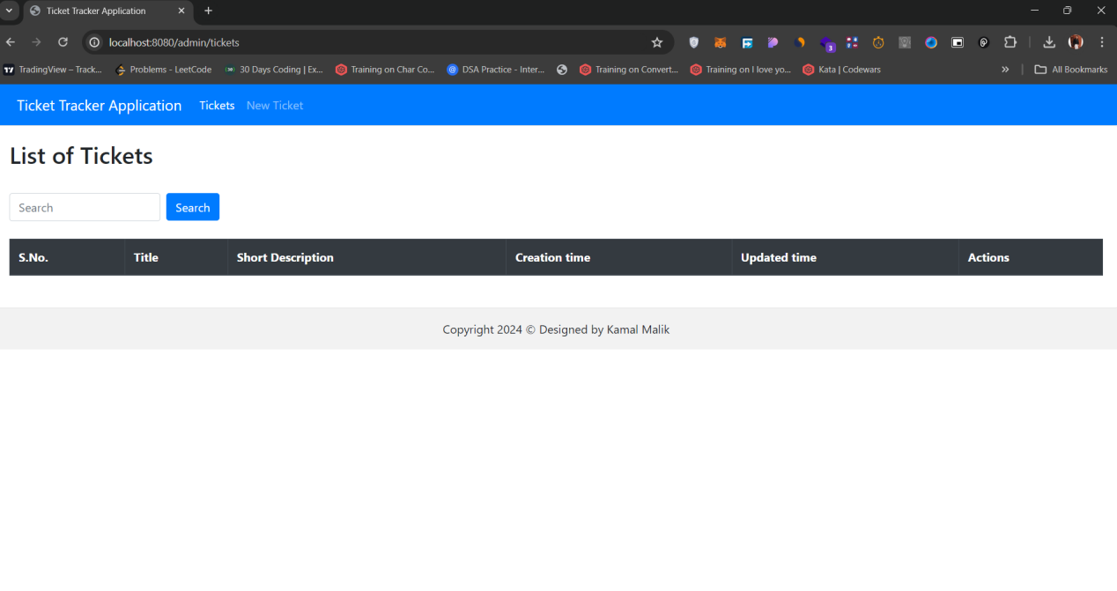

* **newTicket.html(after clicking New Ticket from navbar)**

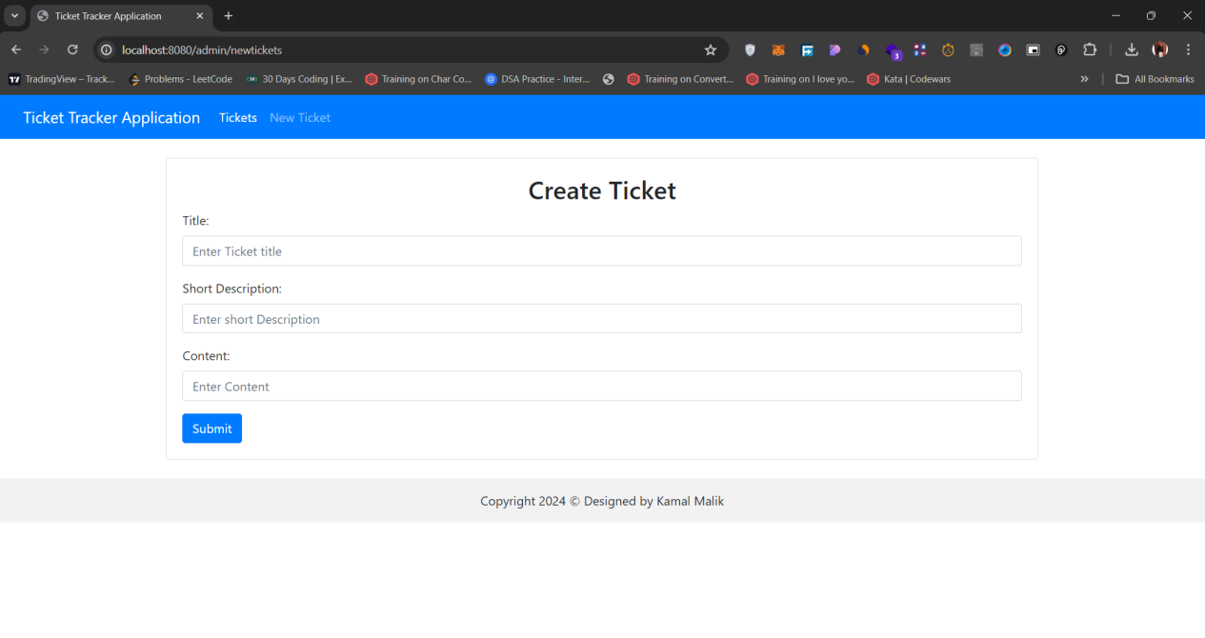

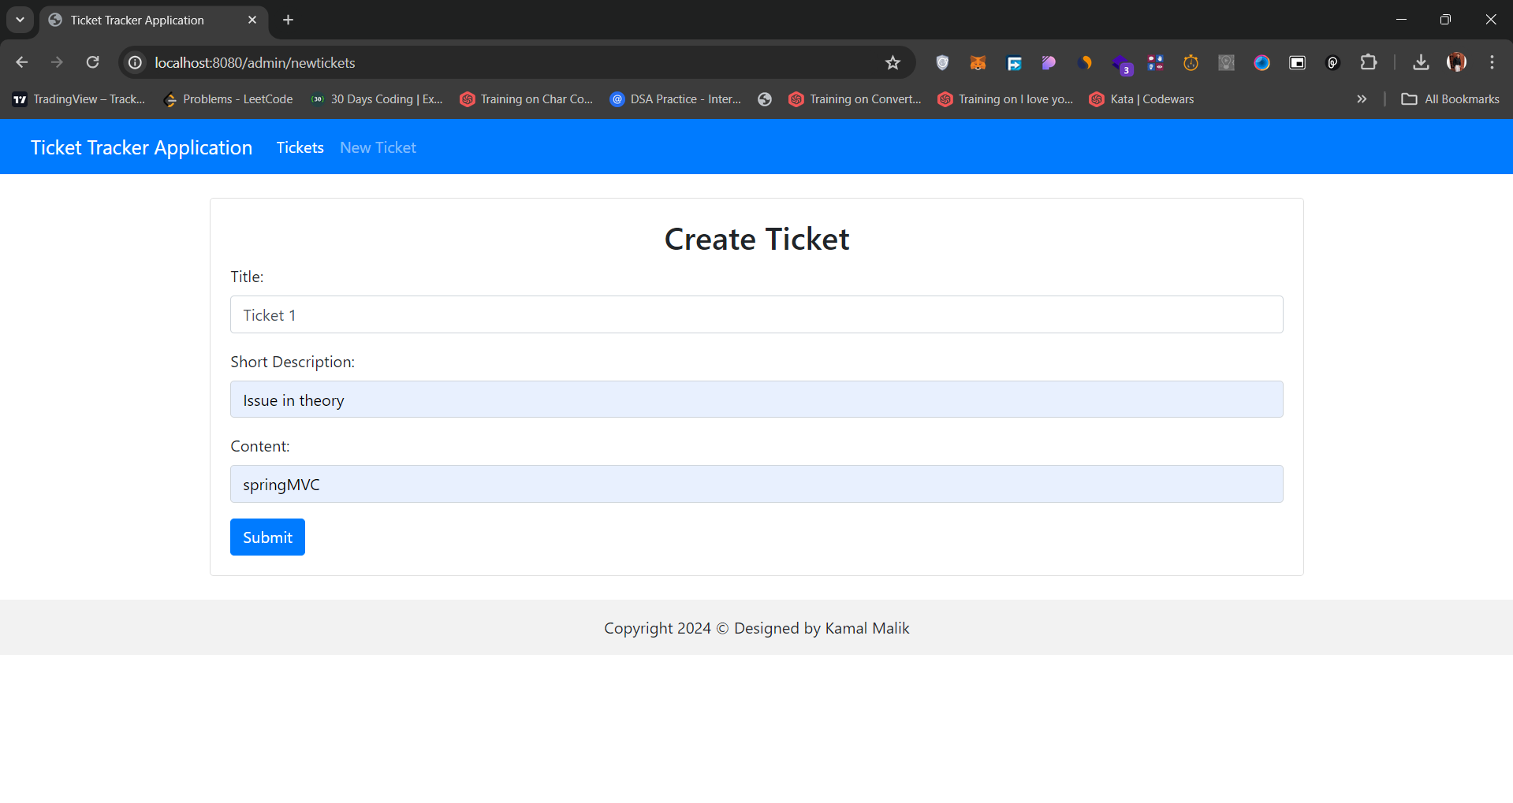

* **After clicking submit button redirecting to showTicket.html**

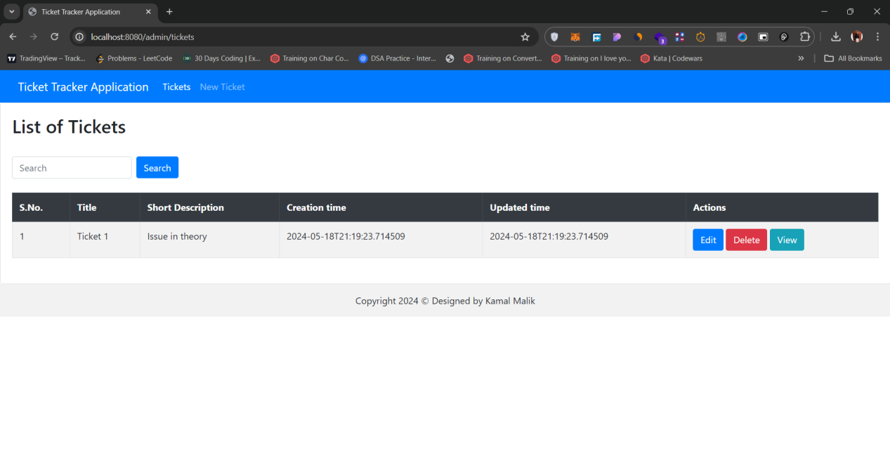

* **Adding more tickets**

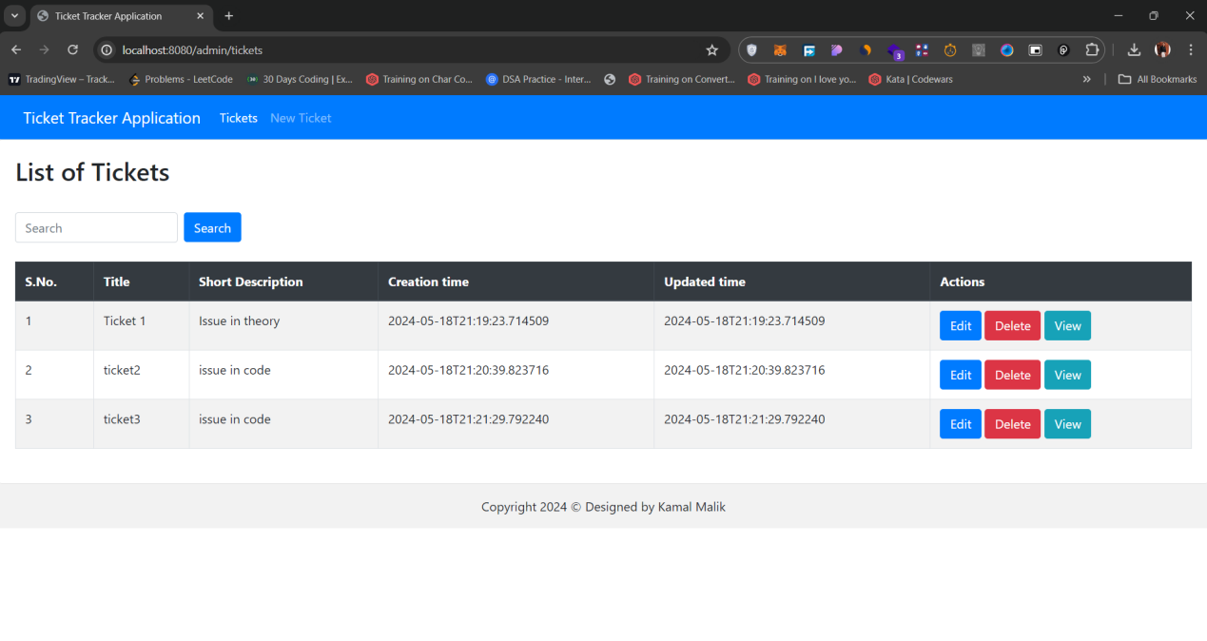

* **After clicking edit button for ticket2 redirecting to UpdateTickets.Html**

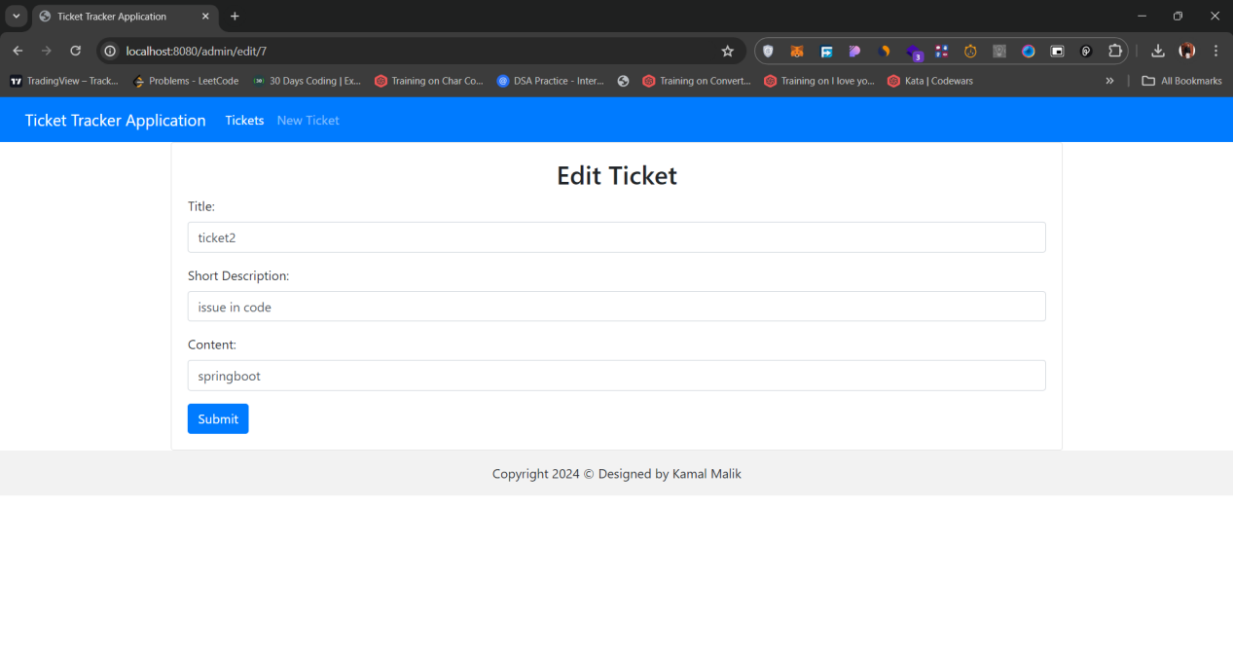

* **Editing title**

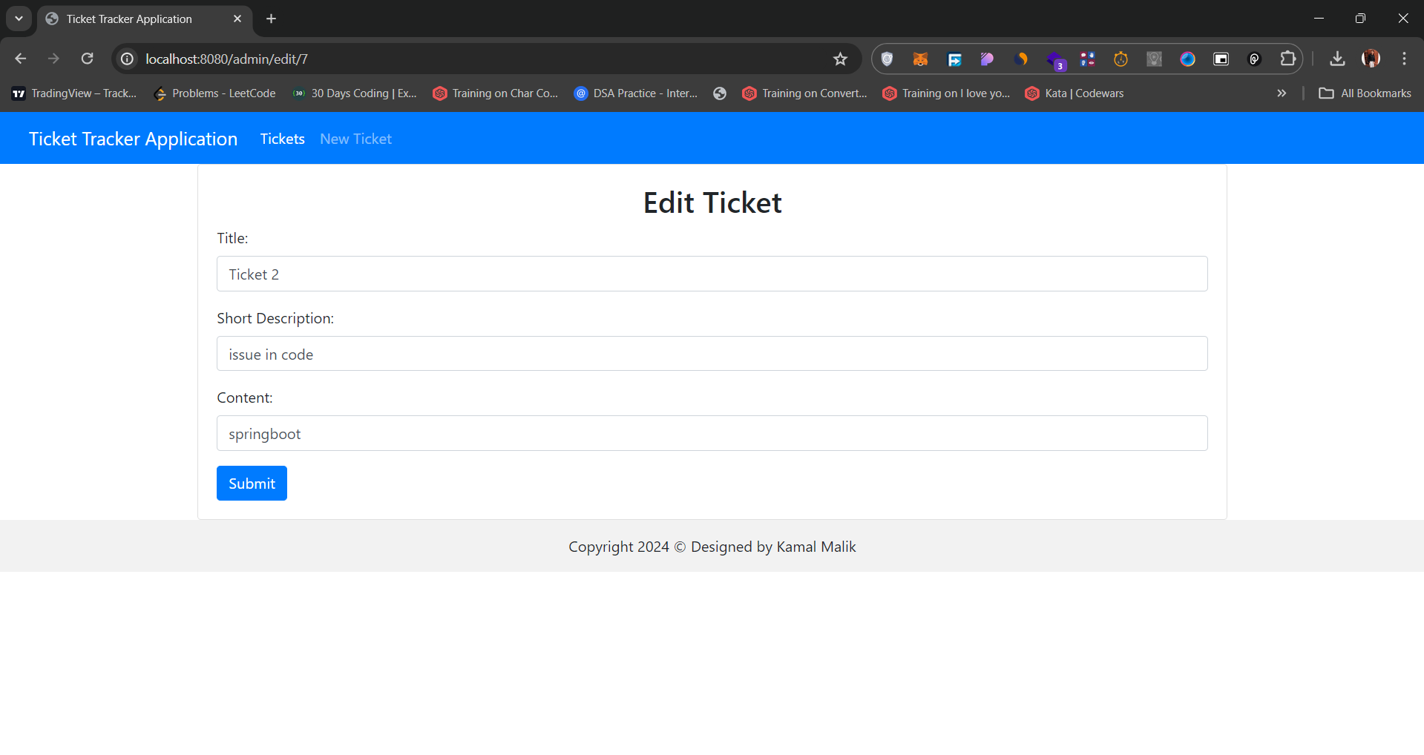

* **After clicking submit button redirecting to showTicket.Html**

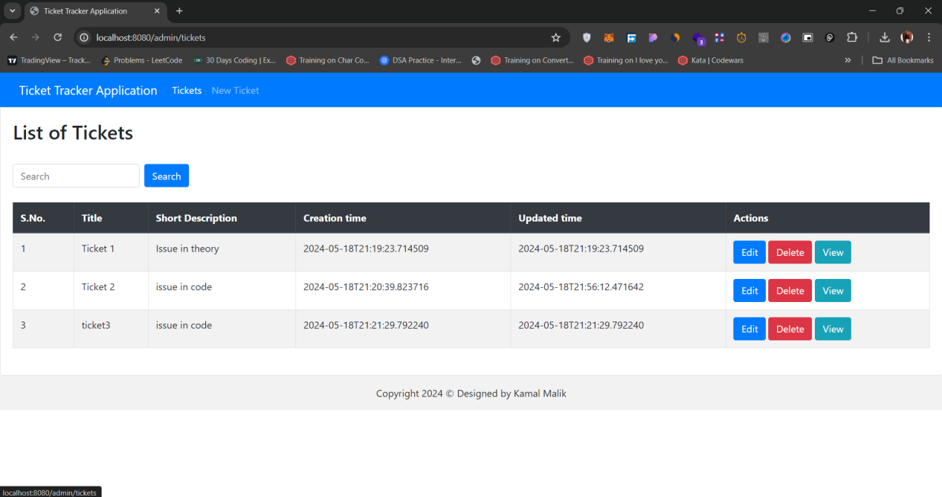

* **viewTicketDetail.Html(clicking view button)**

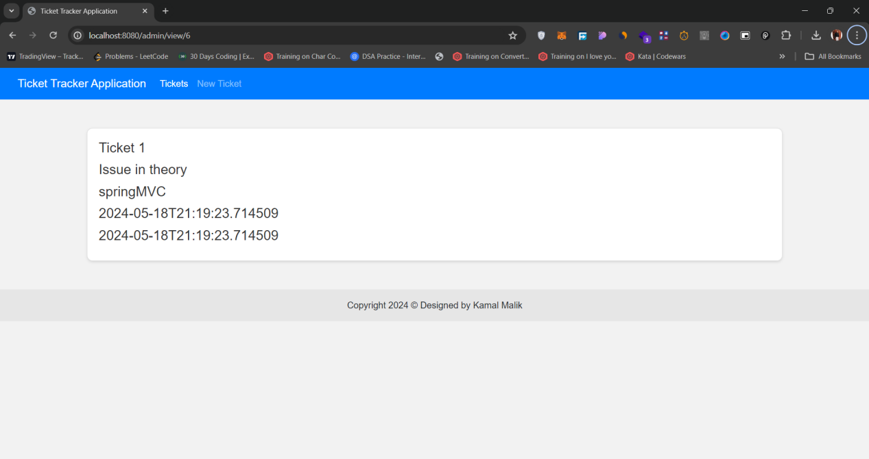

* **After Clicking Delete Button(deleting ticket3)**

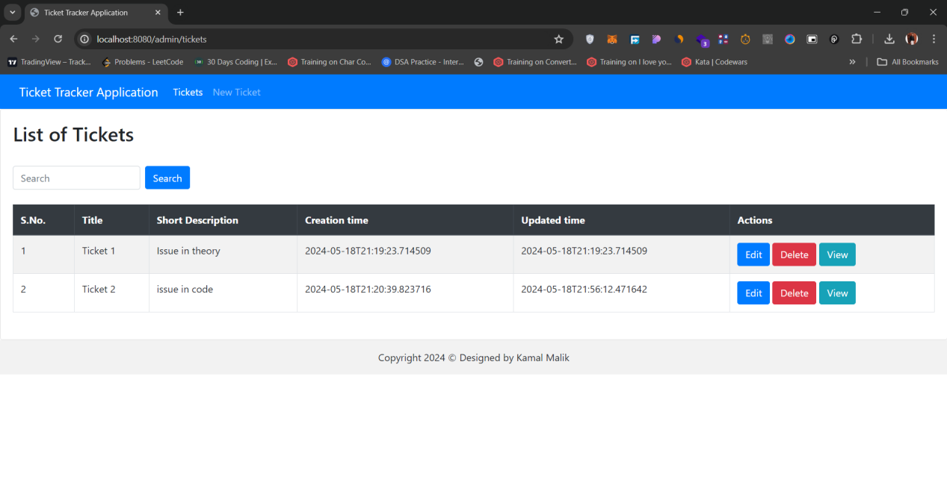

* **After searching by description in search bar**

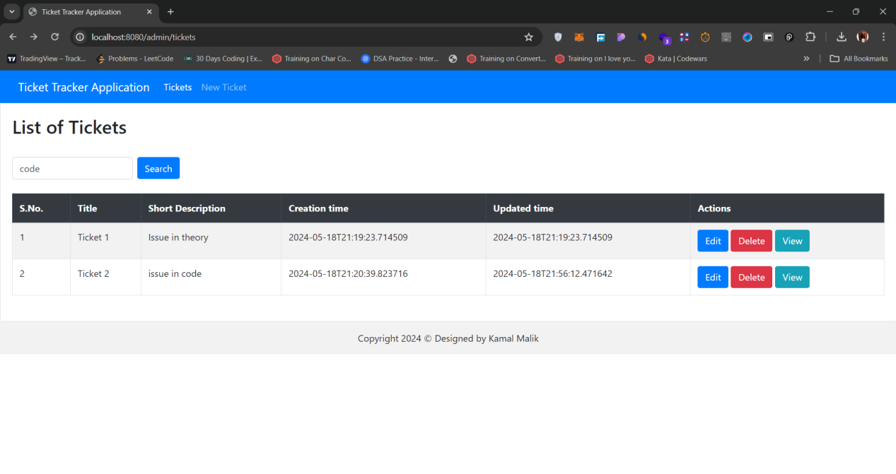

* **Search result**

