 

# SMART LAB

## A PROJECT REPORT

***Submitted by***

**DHARUN KUMAR KSP (16BCS3015)**

**HARIKRISHNAN R (16BCS3024)**

**KAMALNATH LP (16BCS3031)**

**REGUNATHAN S (16BCS3081)**

***in partial fulfillment for the award of degree of***

**BACHELOR OF ENGINEERING**

***in***

**COMPUTER SCIENCE AND ENGINEERING**

**M. KUMARASAMY COLLEGE OF ENGINEERING**

**(Autonomous Institution affiliated to Anna University, Chennai)**

## KARUR – 639 113

**APRIL 2020**

**M.KUMARASAMY COLLEGE OF ENGINEERING**

**(Autonomous Institution affiliated to Anna University, Chennai)**

**BONAFIDE CERTIFICATE**

Certified that this project report **“ SMART LAB”** is the bonafide work of **“DHARUN KUMAR KSP(16BCS3015), HARIKRISHNAN R(16BCS3024), KAMALNATH LP(16BCS3031), REGUNATHAN S(16BCS3081)”** who carried out the project work during the academic year 2016-2020 under my supervision. Certified further, that to the best of my knowledge the work reported herein does not form part of any other project report or dissertation on the basis of which a degree or award was conferred on an earlier occasion on this or any other candidate.

Signature Signature

Mr.K.PREM KUMAR B.Tech., M.E., Dr.S.THILAGAMANI M.E., Ph.D

**SUPERVISOR, HEAD OF THE DEPARTMENT,**

Department of Computer Science and Department of Computer Science and Engineering, Engineering,

M.Kumarasamy College of Engineering, M.Kumarasamy College of Engineering, Thalavapalayam, Karur-639113. Thalavapalayam, Karur-639113.

This project Report has been submitted for the Project Work Phase II - End Semester viva voce Examination held on

**INTERNAL EXAMINER EXTERNAL EXAMINER**

## DECLARATION

We affirm that the Project report titled **“SMART”** being submitted in partial fulfillment for the award of **Bachelor of Engineering** in **Computer Science and Engineering**, is the original work carried out by us. It has not formed the part of any other project report or dissertation on the basis of which a degree or award was conferred on an earlier occasion on this or any other candidate.

|  |
| --- |
| **Signature** |
| Dharun kumar |
| Harikrishnan |
| Kamalnath lp |
| Regunathan |

## ACKNOWLEDGEMENT

Our sincere thanks to **Thiru. M.Kumarasamy, Chairman** and **Dr. K. Ramakrishnan B.E., Secretary** of **M. Kumarasamy College of Engineering** for providing extra ordinary infrastructure, which helped us to complete the project in time.

It is a great privilege for us to express our gratitude to our esteemed **Principal Dr.N.Ramesh Babu M.E., Ph.D.,** for providing us right ambiance for carrying out the project work.

We would like to thank our **Dr.S.Thilagamani M.E., Ph.D., Head and Dean**, **Department of Computer Science and Engineering** for her unwavering moral support throughout the evolution of the project.

We offer our whole hearted thanks to our internal guide **Mrs.K.Prem Kumar M.E., Assistant Professor, Department of Computer Science and Engineering,** for her/his constant encouragement, kind co-operation, valuable suggestions and support rendered in making our project a success.

We would like to thank our project coordinator, **Mr.K.Prem Kumar B.Tech.,M.E., Assistant Professor, Department of Computer Science and Engineering**, for his kind cooperation and culminating in the successful completion of project work.

We glad to thank all the **Faculty Members** of **Department of Computer Science and Engineering** for extending a warm helping hand and valuable suggestions throughout the project.

Words are boundless to thank **Our Parents and Friends** for their constant encouragement to complete this project successfully.

## M.KUMARASAMY COLLEGE OF ENGINEERING

**DEPARTMENT OF COMPUTER SCIENCE AND ENGINEERING**

**Vision of the Institution**

To emerge as a leader among the top institutions in the field of technical education

**Mission of the Institution**

* Produce smart technocrats with empirical knowledge who can surmount the global challenges.
* Create a diverse, fully-engaged, learner-centric campus environment to provide quality education to the students.
* Maintain mutually beneficial partnerships with our alumni, industry and professional associations.

**Vision of the Department**

To achieve education and research excellence in Computer Science and Engineering

**Mission of the Department**

* To excel in academic through effective teaching learning techniques
* To promote research in the area of computer science and engineering with the focus on innovation.
* To transform students into technically competent professionals with societal and ethical responsibilities

**Program Educational Objectives (PEOs)**

* **PEO 1:**  Graduates will have successful career in software industries and R&D divisions through continuous learning.
* **PEO 2:** Graduates will provide effective solutions for real world problems in the key domain of computer science and engineering and engage in lifelong learning.
* **PEO 3:** Graduates will excel in their profession by being ethically and socially responsible.

**Program Outcomes (POs)**

1. **Engineering knowledge:** Apply the knowledge of mathematics, science, engineering fundamentals, and an engineering specialization to the solution of complex engineering problems.
2. **Problem analysis:** Identify, formulate, review research literature, and analyze complex engineering problems reaching substantiated conclusions using first principles of mathematics, natural sciences, and engineering sciences.
3. **Design/development of solutions:** Design solutions for complex engineering problems and design system components or processes that meet the specified needs with appropriate consideration for the public health and safety, and the cultural, societal, and environmental considerations.
4. **Conduct investigations of complex problems:** Use research-based knowledge and research methods including design of experiments, analysis and interpretation of data, and synthesis of the information to provide valid conclusions.
5. **Modern tool usage:** Create, select, and apply appropriate techniques, resources, and modern engineering and IT tools including prediction and modeling to complex engineering activities with an understanding of the limitations.
6. **The engineer and society:** Apply reasoning informed by the contextual knowledge to assess societal, health, safety, legal and cultural issues and the consequent responsibilities relevant to the professional engineering practice.
7. **Environment and sustainability:** Understand the impact of the professional engineering solutions in societal and environmental contexts, and demonstrate the knowledge of, and need for sustainable development.
8. **Ethics:** Apply ethical principles and commit to professional ethics and responsibilities and norms of the engineering practice.
9. **Individual and team work:** Function effectively as an individual, and as a member or leader in diverse teams, and in multidisciplinary settings.
10. **Communication:** Communicate effectively on complex engineering activities with the engineering community and with society at large, such as, being able to comprehend and write effective reports and design documentation, make effective presentations, and give and receive clear instructions.
11. **Project management and finance:** Demonstrate knowledge and understanding of the engineering and management principles and apply these to one’s own work, as a member and leader in a team, to manage projects and in multidisciplinary environments.
12. **Life-long learning:** Recognize the need for, and have the preparation and ability to engage in independent and life-long learning in the broadest context of technological change.

**Program Specific Outcomes**

* **PSO1- Professional Skills:** Ability to apply the knowledge of computing techniques to design and develop computerized solutions for the problems.
* **PSO2- Successful career:** Ability to utilize the computing skills and ethical values in creating a successful career.

**ABSTRACT**

The main contribution of this project is the automation of the laboratory works, based on the Internet of Things (IOT) and cloud computing and desktop application and web application, for the problem of reducing laboratory manual works. The manual work may cause human errors like improper maintenance of system usage registry, electricity wastage. The laboratory works like system usage maintenance report, lab attendance maintenance system, system status, switching on/off of electrical appliances in the laboratory. The existing system for lab attendance system has following disadvantages, while using fingerprint techniques, it may distract the attention of students during lecture time, while using RFID technique, there will be possibilities for fraudulent access may occur, while using face recognition, there may be possibilities for camera ,which can’t capture the image properly and it consume high cost for implementation.

The desktop application collects the data from the users and store it on cloud platform, it will be retrieved using web application. The web application displays the status of laboratory session details to authorized members like HOD, lab admin and it also send the student attendance report, system usage report and laboratory session to staff members, lab admin respectively. The laboratory electrical appliances will be automated using Internet of Things (IOT) and ThingSpeak. The various sensors used sense the data from laboratory environment, send data to ThingSpeak cloud platform and it will be stored and retrieved using ThingSpeak cloud service.

## ABSTRACT WITH POs and POSs MAPPING

|  |  |  |
| --- | --- | --- |
| ASTRACT | POs MAPPED | PSOs MAPPED |
| The main contribution of this project is the automation of the laboratory works, based on the Internet of Things (IOT) and cloud computing and desktop application and web application, for the problem of reducing laboratory manual works. The manual work may cause human errors like improper maintenance of system usage registry, electricity wastage. The laboratory works like system usage maintenance report, lab attendance maintenance system, system status, switching on/off of electrical appliances in the laboratory. The existing system for lab attendance system has following disadvantages, while using fingerprint techniques, it may distract the attention of students during lecture time, while using RFID technique, there will be possibilities for fraudulent access may occur, while using face recognition, there may be possibilities for camera ,which can’t capture the image properly and it consume high cost for implementation. The desktop application collects the data from the users and store it on cloud platform, it will be retrieved using web application. The web application displays the status of laboratory session details to authorized members like HOD, lab admin and it also send the student attendance report, system usage report and laboratory session to staff members, lab admin respectively. The laboratory electrical appliances will be automated using Internet of Things (IOT) and ThingSpeak. The various sensors used sense the data from laboratory environment, send data to ThingSpeak cloud platform and it will be stored and retrieved using ThingSpeak cloud service. | PO1(3)  PO2(3)  PO3(3)  PO4(3)  PO5(1)  PO6(2)  PO7(3)  PO8(2)  PO9(3)  PO10(3)  PO11(2)  PO12(2) | PSO1(3)  PSO2(2) |

SUPERVISOR

HEAD OF THE DEPARTMENT

## ABSTRACT

**TABLE OF CONTENTS**

|  |  |  |
| --- | --- | --- |
| **CHAPTER NO** | **CONTENTS** | **PAGE NO** |
|  | **ABSTRACT** |  |
|  | **LIST OF TABLES** |  |
|  | **LIST OF FIGURES** |  |
|  | **LIST OF ABBREVIATIONS** |  |
|  |  |  |
| 1 | **INTRODUCTION** | **1** |
|  | 1.1 INTERNET OF THINGS | 1 |
|  | 1.2 CLOUD COMPUTING | 2 |
|  | 1.3 DESKTOP APPLICATION | 3 |
|  | 1.4 WEB APPLICATION | 4 |
| 2 | **EXISTING SYSTEM** | **5** |
|  | 2.1 BLOCK DIAGRAM | 6 |
|  | 2.2 DISADVANTAGES | 8 |
| 3 | **PROBLEMS IDENTIFIED** | **9** |
| 4 | **PROPOSED SYSTEM** | **10** |
|  | 4.1 CIRCUIT DIAGRAM | 11 |
|  | 4.2 PIN DIAGRAM | 12 |
| 5 | **SYSTEM REQUIREMENTS** | **14** |
|  | 5.1 HARDWARE REQUIREMENTS | 14 |
|  | 5.2 SOFTWARE REQUIREMENTS | 16 |

|  |  |  |
| --- | --- | --- |
| 6 | **SYSTEM DESIGN** | **17** |
|  | 6.1 USECASE DIAGRAM | 17 |
|  | 6.2 CLASS DIAGRAM | 22 |
|  | 6.3 SEQUENCE DIAGRAM | 25 |
| 7 | **TESTING** |  |
|  |  |  |
|  |  |  |
|  |  |  |
|  |  |  |
|  |  |  |
| 8 | **RESULTS AND DISCUSSIONS** |  |
| 9 | **CONCLUSION** |  |
|  |  |  |

**LIST OF FIGURES**

|  |  |  |
| --- | --- | --- |
| **FIGURE No.** | **TITLE** | **PAGE No.** |
| 2.1 | Block diagram for Fingerprint recognition | 6 |
| 2.2 | Block diagram for RFID based attendance system | 7 |
| 4.1 | Circuit diagram | 11 |
| 4.2 | Pin diagram | 12 |
| 6.1.1 | Use case diagram of desktop application | 17 |
| 6.1.2 | Use case diagram of web application | 18 |
| 6.1.3 | Use case diagram of system usage record | 20 |
| 6.1.4 | Use case diagram of lab record | 21 |
| 6.2.1 | Class diagram of desktop application | 22 |
| 6.2.2 | Class diagram of web application | 24 |
| 6.3.1 | Sequence diagram of General login | 26 |
| 6.3.2 | Sequence diagram of lab session login | 27 |

**LIST OF ABBREVIATIONS**

* IOT - Internet of Things
* RFID - Radio Frequency Identification
* FPS - Fingerprint System
* HTML **-** Hyper Text Markup Language
* CSS - Cascading Style Sheet
* SQL - Structured Query Language
* GPIO - General Purpose Input Output

**SMART LAB**

**CHAPTER 1**

**INTRODUCTION**

**1.1 INTERNET OF THINGS**

Internet of Things (IOT) is emerging technology which makes automation for the manual based work system, it grows rapidly as per development of technological improvement for this world. IOT is platform, which connects various devices to be connected with internet and do the work or process according to automation system for the environment or for the particular system.

The Internet of Things allows objects to be sensed and controlled remotely across existing network infrastructure, creating opportunities for more direct integration between the physical world and computer-based systems, which results in improved efficiency, accuracy and economic benefit. IOT offers connectivity of systems, devices and services that goes beyond the machine-to-machine communications(M2M) and use a variety of protocols for communication, domains, and application. Using this IOT technology makes more automation for smart improvement in real world like smart cities, smart homes. Etc.

Internet of Things (IOT) deals with billions of intelligent objects which would be connected to sense collect the data and also communicate with surrounding people using mobile, wireless and sensor technologies. Smart home plays important role in smart cities, which makes smart development of cities in the world.

**1.2 CLOUD COMPUTING**

The Cloud computing is emerging and world’s trending technology, which has services, such as storage, application and server, which has been accessed and used by most of organization and people from anywhere in the world at any time. The usage of cloud computing services will be increasing day by day, due to its features like user-centric, task-centric, fast accessibility, powerful and fast computational, huge storage, Etc. The term cloud refers to servers that can be accessed through Internet, the software or applications and databases that would run on those servers. Cloud servers were located in data center’s across all over the world.

This technology may reduce work of managing physical servers inside their organization or companies, running applications or software’s on their own machines from their locations. The cloud leads the way to interconnect the group of networks. There are different types of cloud, such as private cloud, public cloud, hybrid cloud. The private cloud is a server or data center or distributed network, which can be accessed only by specific organization or companies or people. Unlike private cloud, it can be accessed by all. The Hybrid cloud is combination of both public and private cloud, some services can only use by some people or organization, some services can be used by all people and organization.

This cloud computing has both client/server computing and peer-to-peer computing. Mainframe is called server and user connected to server called client. The client/server computing has limited and similar centralized storage, doesn’t focus on user-centric. The peer-to-peer computing connects every computer communicate with each other without hitting sever.

**1.3 DESKTOP APPLICATION**

The Desktop Applications are run on the computers and devices of the consumer by themselves. The word used for such desktop applications distinguishes this software from the popular smartphone apps. The key characteristics of mobile application are high code performance and these are often highly tailored according to user requirements and versatility.

The desktop application that runs stand-alone in a desktop or laptop computer. Desktop Applications are always offline, and can be run on any System interface provided it is designed to support major systems, as well as architectures. And it gives user easy access to the software and its functionalities. Also, it is an executable program that need not be viewed over internet. It only needs to be installed on a computer to run as designed by the programmer or producer of the software system. The desktop application is an application which has a graphical user interface and is commonly used with mouse and keyboard. The desktop application will be developed using programming languages like C++, C#, javascript, python, ruby,.etc. The desktop application will also be used in various industry.

Desktop applications are simply programs that can be run on your computer without needing to use a browser. Any program installed on your computer is a Desktop application. The desktop application like Microsoft office applications (word, excel, Etc), photoshop, windows file explorer, photos, skype, Etc.  
 Benefits of desktop application are offline access, Etc. The Features of desktop application are support for big files, integration with client OS. Support for special input/output devices.

**1.4 WEB APPLICATION**

The web application is a software application, which runs on remote server. Most probably, web browsers are used to access web applications, over the network like Internet. Some web applications are used in intranets, in companies and schools. The Web application will need be communicated through the internet access.

The web application is a computer program, which will utilize the web browsers and web technology to perform the tasks over the internet. Millions of business people and other people use the internet as cost effective communication and it lets to exchange the information to target with fast, secure transactions. Web application use a combination of server-side scripts (PHP, Etc.) to handle the storage and retrieval of the information, client-side scripts (javascript, Etc.) to present the information to the users. This web application will allow the users to interact with the company or organisation through online forms, Etc. The web application requires a web server to manage requests from the client, application server to perform the tasks requested and database will be used to store the information and it will also be used with web application for accessing the data.

Benefits of Web application are, it runs on multiple platforms regardless of OS or device. All users will access the same version of application, eliminating any compatibility issues. It will eliminate space limitations, because they are not installed on hard drive. They reduce cost for both business and end user, as there is less support and maintenance required by the business and lower requirements for end user’s computer.

**CHAPTER 2**

**EXISTING SYSTEM**

The Fingerprint based attendance system is one of efficient biometrics. The fingerprint identification is most used, because of inherent ease in acquisition, numerous sources available for collection, A fingerprint usually appears as a series of dark lines that represent the high, peaking portion of friction ridge skin, Etc. Fingerprint identification is mainly based on minutiae, or location and direction of ridge ending and ridge bifurcations along the ridge path. There are steps involved in fingerprint recognition system, first image acquisition, which involve taking input as image from the database, then pre-processing step will be involved ,then feature extraction step will involved to extract and identify the relevant features, which is mainly distinguish each and every person fingerprint characteristics, then template will be created for enrolment and matching purpose, finally a matching is done with help of biometric matcher ,after completion of matching ,score will given dependent on the features. In this existing system, they were using Arduino microcontroller, tkinter and fingerprint sensor. The sensor collects the data from the user and it will be converted into string that will be sent over Bluetooth. Arduino microcontroller parse the data received from the PC and send its appropriate commands to Fingerprint sensor (FPS). At the time of enrolment there will certain procedures to be followed, its for creating template for finger, that are sensed with help of optical sensor, it helps to create template, after completion of certain procedures. This procedure may create unique ID for each enrolled student and that will be stored it with final templates. This existing system may make disturbance to the students because during lab time or lecture time or before, the student wants to record the fingerprint on the configured device to verify it, to make their attendance for that day. This cause distraction the attention of the students. This system takes more time consuming for the students, due to verification. The bock diagram for fingerprint recognition will be given below.

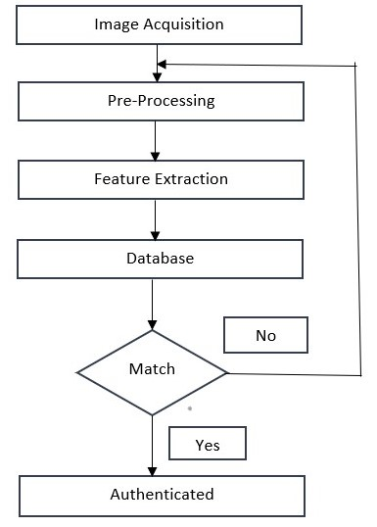

**Figure 2.1 Block Diagram**

Another existing system is RFID based attendance system. This existing system uses RFID reader to read the RFID tag for the detecting the presence or absence of the student data, detected data will be processed according to the programmed instructions on the personal computer (PC). The ease with the system, which RFID can be integrated into current operations depends on the depicts a simple client /server system. Student can visually see their names as they entered class on the screen and they were assured that their presence has been entered in instructor’s database. In RFID systems, an item is tagged with tiny silicon chip plus an antenna collectively called tag. The tag may be mobile or stationary and it can be scanned by stationary or mobile readers, using radio waves. The tag will be encoded with the unique identifier, allowing tagged items to be individually identified by the reader. A reader must scan the tag for the data, it contained with it and then information will be sent to database, which interprets the data stored on the tag. The Tag reader and database are two key components of RFID system. The RFID system offer advantage to the design application, because electronic tags will be embedded into student conventional means of identification (student ID card), but it has some more disadvantages with this system. The block diagram for RFID based attendance system will be given below.

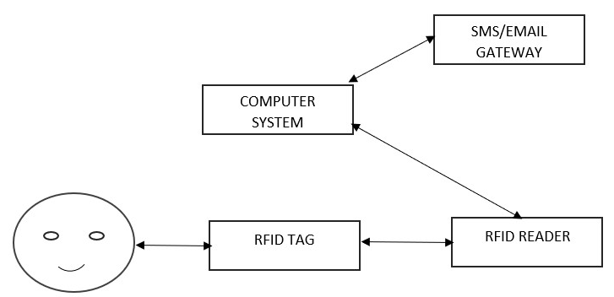

**Figure 2.2 Block Diagram**

Another existing system is Face Recognition based attendance system. This existing system uses the facial recognition technology for recording the attendance through the high-resolution digital camera that should detects and recognizes the face of every student and the machine will compare the recognized face with students’ face images, which is stored on the database. To obtain the attendance for students, position and face images of the students present in the class room or laboratory. Once the face of the students will be matched with stored image, then the attendance will be marked in attendance database for further calculation. If the image captured doesn’t match with stored database, then this image is stored as new image into database. The face of students needs to captured, even they were seating and the posture of the students to be recognized. There is no need for teacher to take the attendance manually because the system records video and further processing steps, then the face is recognized and the attendance database will be updated. The video captured data will convert into image to detect and recognize it.

**2.1 DISADVANTAGES**

* In Fingerprint based attendance system, it may make disturbance or distract the attention for the students.
* Its Time-consuming
* In RFID based attendance system, RFID tag read rates degrade tremendously, while it comes closer to electronic devices and it will consume high cost
* In face recognition-based attendance system, there will be possibilities of camera, not capturing the image properly
* High cost for implementation

**CHAPTER 3**

**PROBLEMS IDENTIFIED**

In the laboratory, the maintenance of laboratory work activity has done with manual work. The manual work like system usage registry maintenance, system status report, laboratory session attendance system, electricity usage. The manual work may cause human errors like improper maintenance of system usage registry, live status of system report, electricity wastage, Etc. There is lot of techniques for smart attendance system, the existing system has solution for making smart attendance system using fingerprint technique, RFID technique, Face recognition technique. From these system , it will provide smart attendance system for the students, but with some demerits , while using fingerprint, it may distract the presence of minds or attention of students during laboratory session time and it will consume more time, while using RFID techniques, its equipment cost will be high for implementation, while using face recognition, it also may have demerits like twins be one of the problem and not capturing the image properly, while attempting to put attendance for the students. The high cost and time-consuming will be one of the problems. Switching on/off of electrical appliances is one of the works done by manually. The information about laboratory session details, laboratory work activity will not be possible to view at any time for authorized members, when they need to view it. This manual work may cause electricity wastage, improper usage of electrical appliances inside the laboratory.

**CHAPTER 4**

**PROPOSED SYSTEM**

Our proposed system will make smart laboratory with help of automation process. In the laboratory, there will be two phases of activity involved with it. The first phase is automatic SWITCHED ON/OFF of the electrical appliance in the laboratory. The second phase is to maintain the system usage registry, system status report, laboratory session attendance system, providing attendance report to staff. The First phase is automation of electrical appliances, which will be switched on/off, according to the presence of human beings inside the laboratory. The laboratory electrical appliances will be operated, based on the data sensed inside the laboratory environment. The various type of sensors will be used in our proposed system. The list of sensors available in our proposed system are PIR Sensor, PIR Sensor, DHT11 sensor, LDR Sensor. The Relay driver will be used to when does particular relay must be SWITCHED ON/OFF. Each relay are connected to each switch. The PIR Sensor will be used for predicting the presence of human being inside the laboratory. LDR Sensor will be used for predicting the presence of light with light intensity level in the laboratory. DHT11 Sensor will be involved in this system for predicting humidity and temperature for our environment(laboratory). The Microcontroller will be involved in this proposed system, ESP32 (ESP32 WROOM) is microcontroller, which used in our system to connect all the devices and relays and sensors and perform some action. The number of these sensors, which is listed above, will be used in our project based on needs and total number of system available inside the laboratory. The data will be transmitted to database through wi-fi connectivity. The PIR Sensor sense the presence of humans with range between 5 meter and 12 meter inside the laboratory, whether the human is inside the laboratory or not, and this sensed data will be sent to Esp32 and it will send signal to relay driver, to select which relay (fan switch) should be switched ON/OFF. LDR Sensor will sense the level of light intensity for the room environment(laboratory), it will send data to esp32 and then, it sends signal to relay drivers to activate or deactivate the light switch. DHT11 sensor sense the temperature of that room environment (laboratory) and send data to esp32 whether Ac or Fan should be switched ON/OFF, according to temperature level of the room (laboratory). The power supply has given to esp32. Esp32 will controls the device and will make the action to be performed. The circuit diagram for laboratory system will be given below.

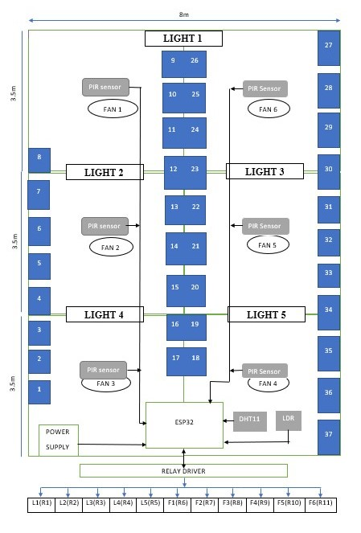

**Figure 4.1 Circuit Diagram**

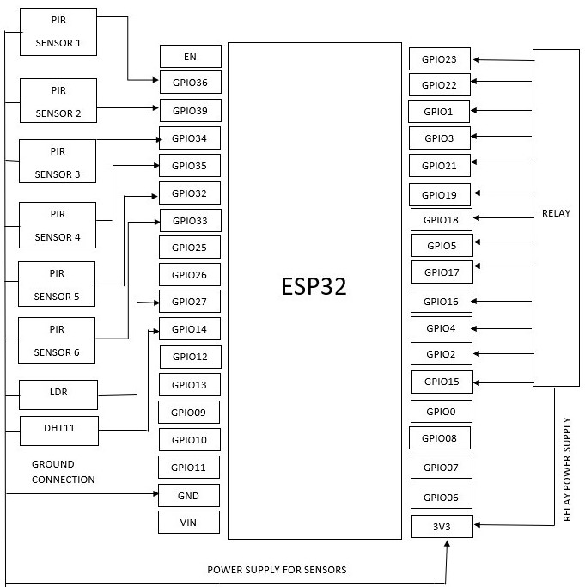

**Figure 4.2 Pin Diagram**

The pin diagram for this system shows that various sensor and other devices connect with the ESP32 pins. Each Relay will also connect with each GPIO pins. Each PIR Sensor will be connected with each GPIO pin. LDR Sensor also connect with one of GPIO pin in ESP32. DHT11 Sensor will be connected with one of the GPIO pin available in ESP32. The relay power supply will take respective pin, which will be default only for voltage purpose, to work with ESP32 board connection.

The second phase is we need to maintain the system usage registry and attendance of the laboratory session, system status report, providing attendance report, Etc have been done using the Desktop application and web application. The data collection from the user is important for report status and also as proof. The Desktop application collects the data from the user and send it to database in google cloud platform. The Desktop application is developed using C# and dot net framework. The Desktop application will block the user activity and it has two category panel. One is laboratory session purpose and another is general work. While in laboratory session panel, it will ask the register number and laboratory session name and OTP for login into desktop home page. The OTP will send to student registered email id for student authentication purpose. While in general work panel, it will ask user id/ register number and description and after completion of filling it, it will move into desktop home page. The desktop application stores the data in the google cloud. The laboratory session name will be taken from the google cloud table. The desktop application keeps track of the system usage registry, live status of every system in the laboratory, system, system live/alive status, Etc. The web application displays the status of system, system damage/repair report to lab admin, providing lab attendance report to staff member. The Front end of application will be developed using HTML, CSS, javascript, jquery. The database is mysql database. The backend connection will be provided with help of Node.js. The web application will show the details of system usage, lab attendance report, Etc to authorized member like HOD, lab admin. The web application has two type of login category for viewing data. The HOD and lab admin has separate login for the web application.

**CHAPTER 5**

**SYSTEM REQUIREMENTS**

**5.1 HARDWARE REQUIREMENTS**

* ESP32 WROOM
* PIR Sensor
* LDR Sensor
* DHT11 Sensor

**5.1.1 ESP32 WROOM**

ESP32 is microcontroller, which is used to perform task or operations. It is powerful tool for IOT applications having inbuilt Bluetooth, temperature sensor, hall sensor, Etc. It will be integrated with wi-fi module and Bluetooth module, with the help of these module to transmit the data. The transmission will be takes place through HTTP communication between two boards or from one board to other. ESP32 is advanced type of ESP8266. ESP32 WROOM will be one type from ESP32 category. The Pin GPIO is for input/output purpose. GPIO pin is General Purpose Input Output pin. 3v3 pin will be used for voltage power supply. ESP32 is series of low cost and low power system on chip microcontroller.

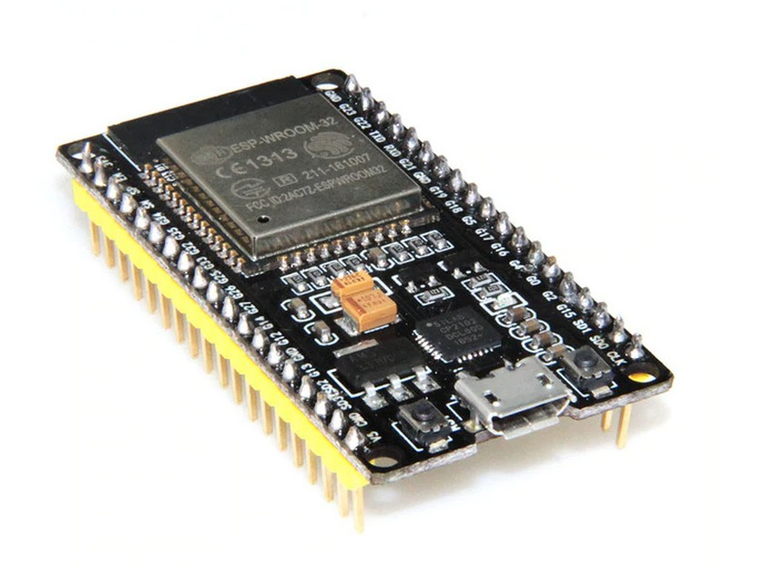

**5.1.2 PIR SENSOR**

PIR Sensor is Passive infrared sensor and its electronic sensor, which measures infrared Radiation (IR) light radiating from the objects. This sensor is used to detect the presence of human beings with help of measuring Infrared radiation (radiant heat) emitted from our body. In our system, this sensor will be used for detecting presence of humans inside the laboratory. PIR sensor detect with range between 5meter and 12meter. Each PIR Sensor will connect different GPIO pins in ESP32. The Total Number of PIR Sensor used for this system is six.

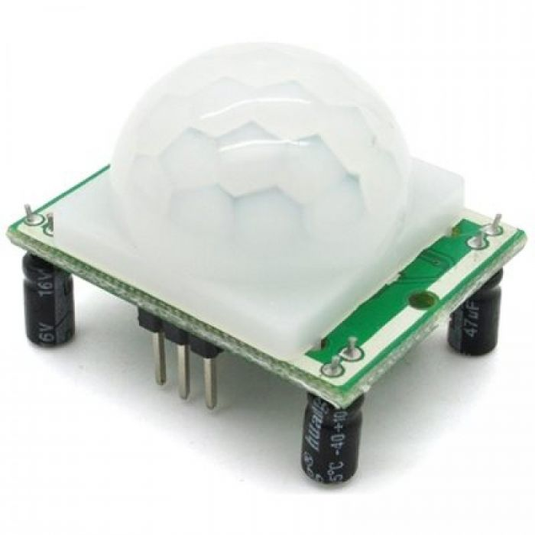

**5.1.3 LDR SENSOR**

LDR Sensor is Light dependent resistor and it’s also called as photo resistor, which is one type of resister, whose resistance variable varies depending on amount of light falling on the surface. When the light falls on the resistor, then the resistance changes. It will be used in many circuits, where need of sensing the presence of light. This is low cost. Most probably, LDR will be used in various electrical and electronic projects. The number of LDR Sensor will be used for this system is one.

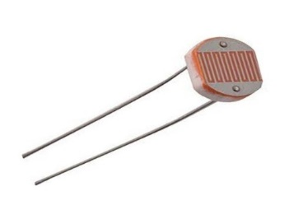

**5.1.4 DHT11 SENSOR**

This sensor is low-cost digital sensor for sensing temperature and humidity. This sensor will be interfaced with any type of microcontroller such as ESP32, Etc to measure humidity and temperature of the environment. DHT11 is relative humidity sensor. To measure the surrounding air, this sensor will use thermistor and capacitive humidity sensor. The Number of DHT11 sensor will be used for this system is one.

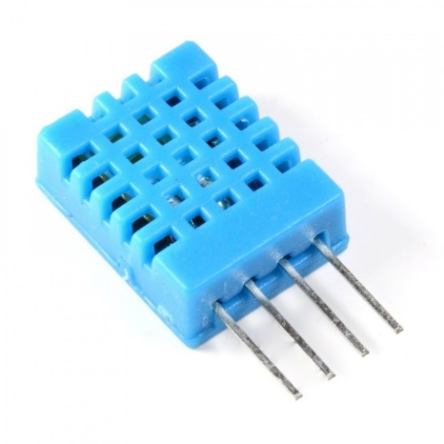

**5.2 SOFTWARE REQUIREMENTS**

* Operating System: UBUNTU
* Visual studio
* Front end: HTML, CSS, javascript, jquery
* Back end: Node js

**CHAPTER 6**

**SYSTEM DESIGN**

**6.1 USE CASE DIAGRAM**

Use case diagrams are usually referred as behaviour diagrams, which is used to describe the set of action (use case) for the system, that can be performed in collaboration with one or more external users for the system(actors). The use case is refers as set of action to be performed, actors who play with use case for the system.

**6.1.1 DESKTOP APPLICATION**

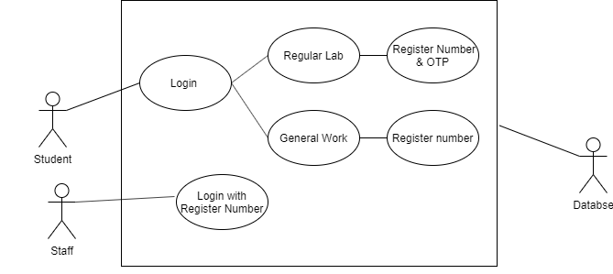

Use case diagram: Desktop Application

The use case of desktop application shows that action of module will be performed by the actors, from this diagram, actors will be student and staff. The desktop application has several modules like login, regular lab, register number and OTP, general work, register number. For each actor role, there will separate login page. While action performed by the student(actor), initially, The Login module, which depicts the login page for login the user or students into desktop home page. That login module will be initial step for login the user to home page. Then There will two categories of module displayed, after that the actor may choose one module from two type of modules. The Regular lab module will be used for Regular laboratory work (i.e) lab session, in that module, it will ask the actor to fill the category of options like Register Number and lab session name and OTP. The OTP will be sent to student registered email-id, then OTP must be entered within that module for permitting the actor or user or student into desktop home page. As like regular lab module, the procedure will be same, but OTP will be excluded, because the student or user doesn’t need attendance for general work in laboratory. The desktop collects the user id/register number and description/ laboratory session name. The collected data will be stored with database in google cloud platform. The staff (Actor) can login with user-id/register number, because they don’t need attendance for using the system in laboratory.

**6.1.2 WEB APPLICATION**

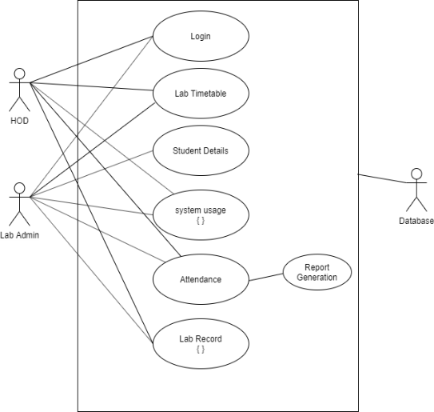

Use case diagram: Web Application

The Use case diagram of Web application depicts the activity of web application using these modules. Here, The Actor will be HOD and lab admin. There will several use case for this system like login, lab timetable, student details, system usage, attendance, lab record. The higher authority actor could have special features than lower authority actor. Each actor will have separate login id for login into web application. The Web application will display the details or information according to the conditions given by the admin. The login module for every actor will vary, the login page asks the actor to fill the user id and password to login into web application. The HOD and lab admin may see the system usage registry report, system repair status, system live status, attendance report for laboratory session. The laboratory timetable module shows that timetable will be uploaded by the lab admin, the laboratory session name will be taken from google cloud database according to timetable of the week, which will be already uploaded. The student details module shows that student roll number, system usage number of that user and laboratory session name or description, starting and ending time of system usage in the laboratory. These details will also be viewed by HOD and lab admin with the help of web application. The system usage report like system active/ inactive status, system damage/repair status, which may be viewed by HOD and lab admin. The student Attendance will be taken according to system usage registry through desktop application, the laboratory session name will be taken from google cloud database, which has already time table, it will be uploaded by lab admin. The Attendance report will be converted into excel sheet, that will be generated and shared it to staff member

**6.1.3 SYSTEM USAGE RECORD**

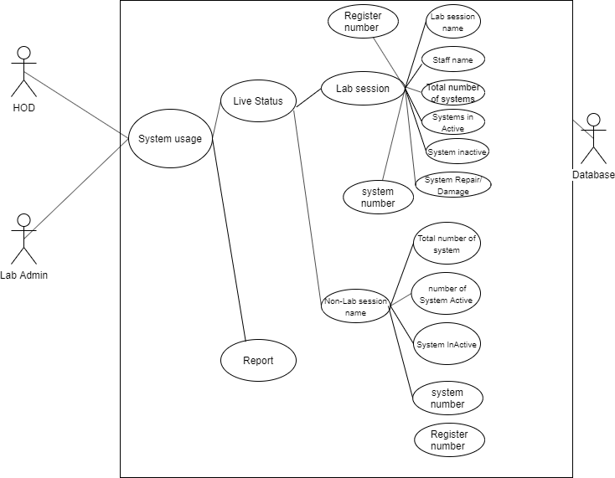

Use case diagram: System Usage Record

The Use case diagram of system usage record will describe the list of modules, that will depict the system usage status and laboratory system status record. The Actor will be HOD and lab admin. There may be several types of use cases or modules like Total number of system available, number of system active, number of system inactive, system numbers, system damage/repair status in the laboratory. The both actors, HOD and lab admin, they will have same view for system usage record or status. They will initially login into system usage module, then there will two options, one is for viewing live status of the system, another option is report generation. As like in desktop application, here there are two categories, one is for laboratory session work time and another one is for general work (i.e.) non-laboratory session work. At the laboratory session work timing ,the laboratory system record details like Register number, which will be important for the students, Staff name, who will be teacher for laboratory session, Total number of system details shows that count of available systems in laboratory, Number of system active, which shows the count of working system or user using the system, Number of system inactive, which shows that count of not working system, system damage/repair status, which shows the damage or repair conditions of system in the laboratory, System number, which shows each system number, which was assigned to every system. Non-laboratory session work timing is same as laboratory session features, but excluding the staff name, because there is no need for staff member to maintain this type of general work timing in the laboratory. The data will be stored in database and it will be retrieved as per their needs. The Report will say about all these features mentioned above for this system.

**6.1.4 LAB RECORD**

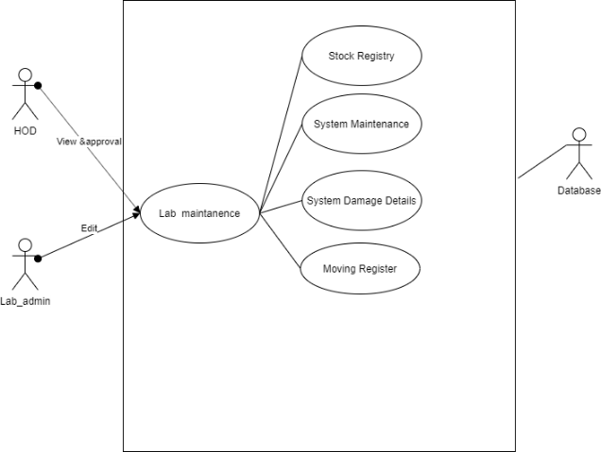

Use case diagram: Lab Record

This use case diagram shows that lab record maintenance for proper laboratory maintenance system. The Actor will be HOD and lab admin. The HOD can played with role of viewing and giving approval for the system in laboratory. The lab admin may play role like editing the status according to condition and live status inside the laboratory. The both actors may connect with lab maintenance, which has further featured or modules like stock registry, system maintenance, system damage details, moving register. The stock registry shows that stock available for the laboratory, system maintenance shows the maintenance status of the system, system damage details shows that damage status if the system available with it, moving register shows that the system will be moved in/out to the laboratory or from the laboratory.

**6.2 CLASS DIAGRAM**

The Class diagram in the UML is a type of static structure diagram that describes the structure of a system with the help of system’s class, their attributes, its operations and relationships among objects. Class diagram is made up of, set of classes and set of relationship between classes.

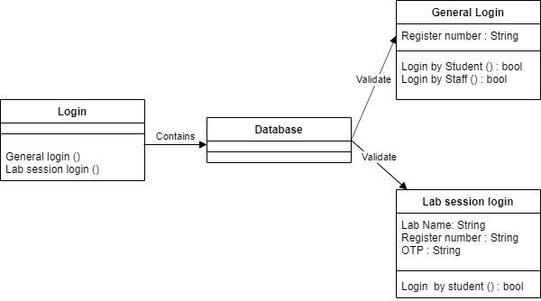**6.2.1 DESKTOP APPLICATION**

Class diagram: desktop application

From the above diagram, it shows the class diagram for desktop application with their modules. Here, set of class in class diagram are login, database, general login, lab session login. In the login class, this class contains two methods for login the desktop application. The Database class will indicate that database connection for storing the data through general login class or lab session login, the validate the credentials and then login to home page. The general login class shows their attributes called register number, and their methods called login by student and login by staff method. The lab session login shows their attributes and methods, the attributes like lab name, register number, OTP and its method like login by student.

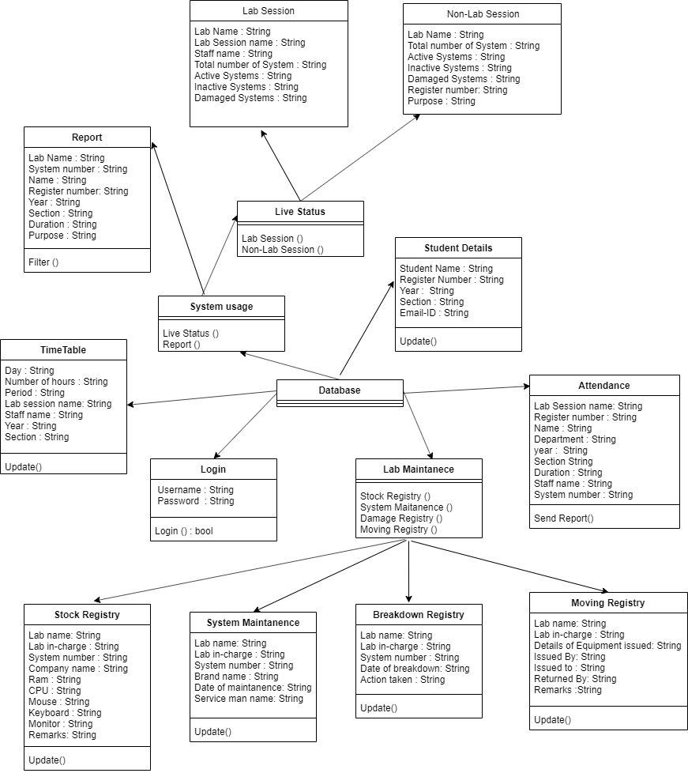**6.2.2 WEB APPLICATION**

Class diagram: Web application

The Class diagram of web application shows that set of their attributes and its operations for the specific classes. The web application has set of classes like lab session, non-lab session, report, live status, system usage, student details, timetable, login, lab maintenance, attendance, stock registry, system maintenance, breakdown registry, moving registry. The lab session class has set of attributes like lab name, lab session name, staff name, total number of systems, active systems, inactive systems, damaged systems. The non-lab session attributes as same as lab session, instead of staff name, purpose will be included with this class. The live status class will have the two methods, that is lab session login and non-lab session login. The report class shows that their attributes like lab name, system number, name, year, register number, section, duration, purpose, and with their method called filter. The system usage class has their method called live status and report. The student details have their attributes and methods, the attributes like student name, register number, year, section, email-id. The login class for web application has attributes like username and password, methods like login. The attendance class has their attributes like lab session name, register number, name, year, department, section, duration, staff name, system number. The lab maintenance class has their methods like stock registry, system maintenance, breakdown registry, moving registry. The stock registry class has their attributes like lab name, lab in charge, system number, company names, ram, cpu, mouse, keyboard, remarks, and their method like update, for updating of stocks inside the laboratory. The system maintenance class has lab name, lab in charge, system number, brand name, date of maintenance, service man name. The breakdown registry class have their attributes and methods, attributes like lab name, lab in charge, system number, date of breakdown, action taken, and their update method for updating of status inside the laboratory. The moving registry has the attributes like lab name, lab in charge, details of equipment’s, issued by, issued to, returned by, remarks and their method called update, its to update the status of system moved in/out inside the laboratory.

**6.3 SEQUENCE DIAGRAM**

The sequence diagram describes the interaction between objects in sequential manner, that means the order in which the interactions take place. Its one of UML diagram. The sequence diagram shows how the operations are carried out. The vertical axis shows the time and horizontal axis shows object.

**6.3.1 GENERAL LOGIN**

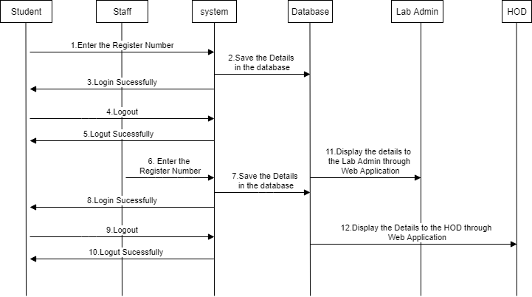

Sequence diagram: General login

This sequence diagram shows that the interaction of objects or operations of the system. From this sequence diagram, how the operations can be performed for further process. From the above diagram, the objects are students, staff, system, database, lab admin, HOD. First step is, student enter the register number to system (i.e. desktop application), then save the details onto database and then successfully login notification will be sent to student from the system. Then logout request will be given to the system, then system will response for it and logout the user and send notification to the student. The staff may enter their register number to the system, then it will be saved into database and then login the staff, then the login successfully notification will be sent by the system to the student. If the logout decision will be needed for the staff, then the logout request will be done by sending it to system for the staff logout, then the response will be sent through notification to the student as with the logout successfully message. Then the web application will display the details to lab admin, with help of retrieving data from database to the lab admin through web application. then display the details from database to HOD with help of web application.

**6.3.2 LAB SESSION LOGIN**

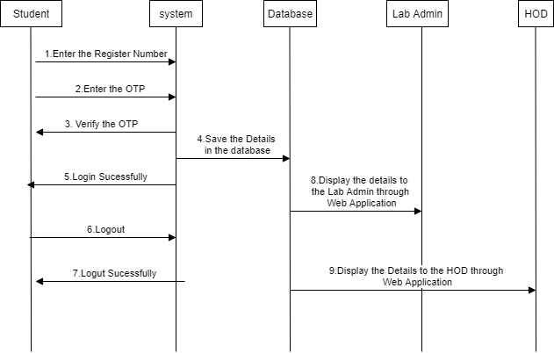

Sequence diagram: Lab session login

From the above diagram, the sequence diagram of lab session will show how the operations will be performed for this system. From the above diagram, the objects are student, system, database, lab admin, HOD Initially, the student will enter the register number and OTP to the system, then system verify the OTP and sent the verification status to the student. The system will send the data to database, then login will be successfully proceeded. The login successfully notification will be sent to the student. If logout situation is needed, then the logout request will be sent to system. The logout notification will be sent to user for response. The details from the database, which will be displayed through web application to lab admin. The collected data from database, details will be displayed to HOD through the web application

**CHAPTER 8**

**CONCLUSION**

This system will reduce the manual work and make it automatically. This leads to reduce human errors, Etc. laboratory manual work will be automated with help of desktop application and web application and IOT Technology, this makes the laboratory into smart laboratory system.