NICHEKALA.
Project Intake Form
Please fill in the details below for your project. Items marked * are required. Everything else helps us tell your story better, but skip anything that doesn't apply.

1. Project Identity
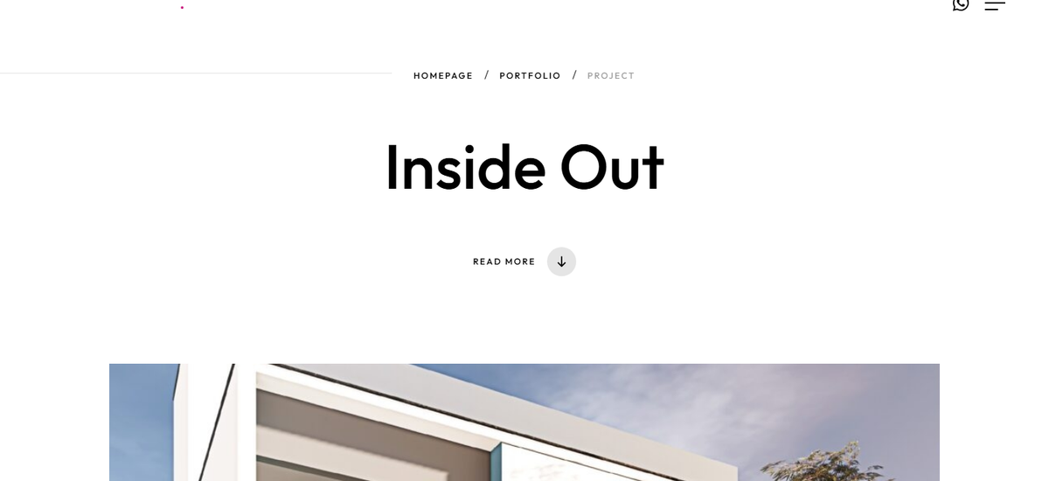
↑ How it appears on the page — breadcrumbs, project title, scroll-down arrow.
Project name * (e.g. "Inside Out Residence", "Coffee and Conversations")
Type project name here…

Tagline / subtitle (optional one-line subtitle that sits below the project name)
e.g. "A 1200 sqft canvas of light and openness"

2. Project Facts
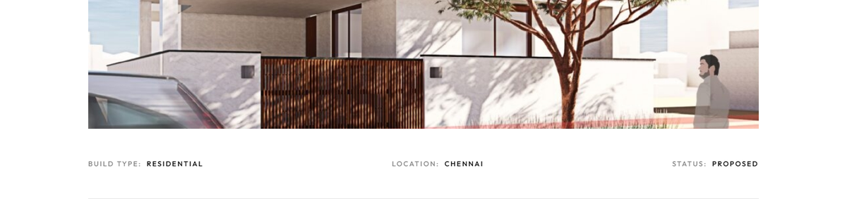
↑ The Build Type / Location / Status row appears below the hero image.
Build type * (pick one: Residential / Commercial / Recreational / Heritage / Pocket Home / Other)
e.g. Residential

Location * (City, State — e.g. "Chennai, Tamil Nadu" or "Goa, India")
Type location here…

Status * (pick one: Proposed / Under Construction / Completed)
e.g. Completed

Year (year of completion or proposal — e.g. "2023" or "2022–2024")
e.g. 2024

Plot size / built-up area (optional — e.g. "1200 sqft plot", "20×60 plot", "3 BHK / 2400 sqft built-up")
Type area details here…

3. The Story
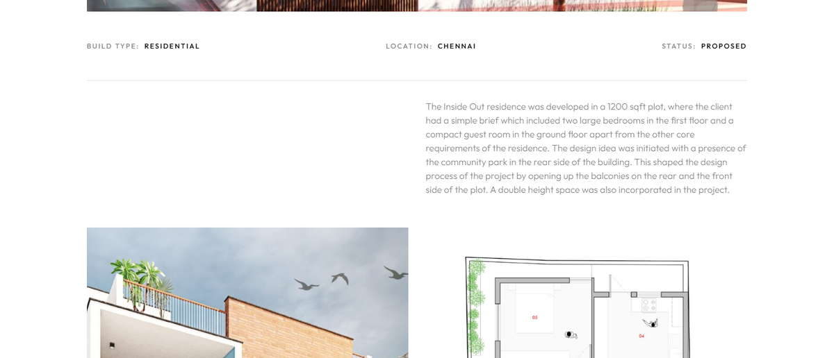
↑ Your narrative paragraph appears here, to the right of the project facts.
One-line summary * (used on portfolio listing + meta description — max ~25 words)
e.g. A 1200 sqft residence in Chennai opening out to the park, with double-height living and rear-facing balconies.

Project narrative * (1–3 paragraphs — the brief, the design idea, what makes it special. Write naturally, our team will edit for the site.)
Paragraph 1: The brief / client need…

Paragraph 2: The design idea / approach…

Paragraph 3: Outcome / what makes it special…

Key design highlights (optional — 3 to 5 short bullets, one feature each)
• Double-height living space
• Rear-facing balconies open to community park
• Compact ground-floor guest room
• …

4. Visuals
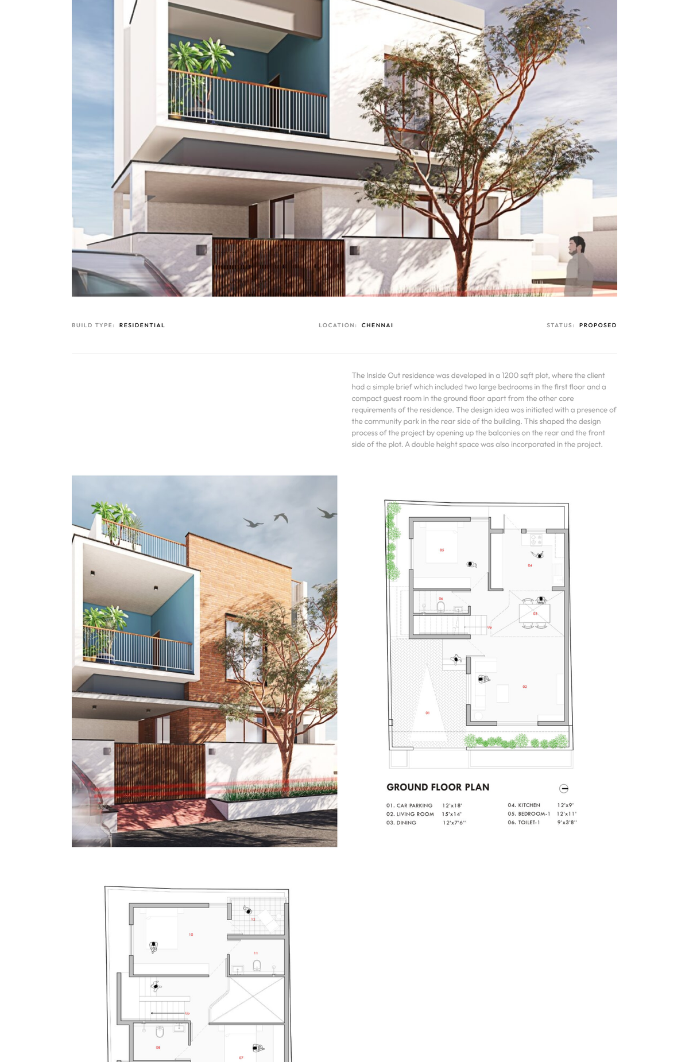
↑ The hero image dominates the banner; gallery photos display in a 2-column grid below.
Note for dev: Hero image is the big banner at the top. Gallery images appear below the description. Recommended specs: hero ≥ 1920×1080 px (landscape), gallery ≥ 1600×1200 px, WebP or high-quality JPG preferred. File names: use lowercase + hyphens, no spaces.
Hero image * (main banner photo — provide filename + short alt text)
Filename: e.g. inside-out-hero.webp
Alt text: e.g. "Inside Out residence rear elevation"

Gallery images * (list 3 to 8 photos in the order you want them shown — filename + alt text each)
1. Filename: __________________ Alt text: __________________
2. Filename: __________________ Alt text: __________________
3. Filename: __________________ Alt text: __________________
4. Filename: __________________ Alt text: __________________
5. Filename: __________________ Alt text: __________________
6. Filename: __________________ Alt text: __________________

Social-share image (optional — the image shown when the page is shared on WhatsApp, Facebook, LinkedIn. Defaults to hero if blank. Ideal 1200×630.)
Filename: __________________ Alt text: __________________

5. Optional Extras
Client testimonial (if you want a quote on the page — name + role + quote)
Quote: "…"
Name & role: __________________

Design team / credits (who worked on it — lead architect, interior designer, contractor, photographer)
e.g. Lead Architect: __________ ; Photographer: __________

Press / publications (any features in magazines, blogs, awards — title + link)
e.g. ArchDaily — “Title of feature” — https://…

Appendix —
the defaults

Page slug (URL path — derived from project name, lowercase + hyphens)
Example: /projects/inside-out

Page <title> (SEO title tag — pattern below)
Pattern: {Project name} | {Build type} {Project type} in {City} | Nichekala
Example: Inside Out | Residential Architecture in Chennai | Nichekala

Meta description (derived from one-line summary; 150–160 chars)
If summary > 160 chars, trim to first complete sentence under 160 chars.

Keywords (generate from build type + location + 2 to 3 design highlights)
Pattern: {Project name}, Nichekala, {build type} {city}, {highlight 1}, {highlight 2}, …

JSON-LD CreativeWork block (populate from sections 1, 2, 3, 4 — see existing projects/Inside-out.html as reference)

Prev / Next project links (dev decides — usually previous / next entry in projects/ folder by recency)

Sitemap + llms.txt + llms-full.txt (add the new URL with priority 0.7)

Internal QA checklist
☐ Page loads at /projects/{slug} (clean URL via .htaccess)
☐ All gallery images have alt text
☐ Fancybox zoom works on every image
☐ Prev/Next/All-projects links wired up
☐ JSON-LD validates (search.google.com/test/rich-results)
☐ Page added to sitemap.xml, llms.txt, llms-full.txt
☐ Card added to portfolio.html grid (with correct data-category)
☐ OG image displays correctly when shared (LinkedIn Post Inspector)

Nichekala Architecture and Design Studio · nichekala.in

